**ANNUAL REPORT**

1 September 2021 – 31 July 2022

**Annual Report**

1 September 2021 – 31 July 2022

Contents

A. Organization & Management 3

Study programs offered by the Department 12

B. Resources 17

Finance 21

IT Resources, Physical Infrastructure and Library Resources 22

C. The Curriculum 26

Graduate Teaching 35

D. Teaching, Learning, Assessment & Research 38

Graduate Students’ List of Theses 58

List of Incoming & Outgoing Students 63

Research Areas and Research Groups 64

List of Publications 67

Participation of Academic Staff in Academic Events 69

Projects 73

E. Support, Resources & Representation 84

List of Students’ Internships 84

Participation in Academic Events 90

Acknowledgements 111

## Organization & Management

Dr. …. Head of Department

Introduction

The Department of Business Administration (BUS Department) aims the development of business knowledge to be applied in the management of business and non-business organizations, big and small, domestic and international (e.g. small family businesses, corporations, cultural associations, nonprofit organizations, social businesses, healthcare organizations, financial institutions, public administration, and others). The students will be able to acquire the necessary skills to operate in Albania and globally due to the systemic and integrated knowledge about organizations. The department’s objective is to qualify new future employees and managers with a strong background on business administration by underlying a systems and constructivist perspective.

In the BUS Department, students can choose to study business administration, business informatics, and international marketing and logistics management. These programs offer a high rate of employment opportunities. By studying in BUS, students can work in different departments as easily configured in an organizational chart. For example, considering their specialization, they might work in the departments of accounting, marketing, sales, human resources, information systems, operations, R&D, etc.

Detailed information on the courses offered in the semester schedules is included in the academic plan. The list of departmental compulsory and elective courses is provided in detail in the academic programs. In addition, for each course the students can check the content from the information system in order to be aware about the subjects, teaching methods, requisites, ECTS credit system, and workload. Furthermore, students will be supported all the time by the academic advisors, which are professors of the BUS Department. The list of courses offered each semester by our department and academic catalogue correlate together. The objective of this department is to fulfill the need for qualified members in this field, and to prepare skilled people to work in different sectors of the global economy.

## ****Strategic Plan 2017-2022****

**1. Mission**

The mission of the Department of Business Administration (BUS Department) is developing business capabilities through holistic teaching methods by cultivating a sense of intellectualism, togetherness, and inclusive leadership.

The final output is educating early professionals for co-creating value among market actors, in terms of employability, continuous improvement, and business system sustainability.

**2. Vision**

The Albanian Business Ecosystem is moving toward a new era, which will be accompanied by best business practices and success stories. The vision of BUS Department is to be the most valuable partner for transforming Albanian business cases into best business practices. Our ambition is to have behind all business case histories, our early professionals.

**3. Motto**

Today knowledge students, tomorrow knowledge workers.

**4. Challenges**

Due to rapid changes in technology and considering the economic environment nowadays it is clear that BUS Department faces several challenges for the upcoming years. Main challenges include offering an environment in which students can use efficiently their analytic skills and take advantage of the technology development. For this purpose, qualified staff, a central library, student co-working areas, and smart classrooms are provided to achieve the challenging academic and professional objectives. Moreover, the BUS Department must ensure strong relationships and furthermore enhance its network with business professionals, academic institutions, research centers, and other stakeholders. Another challenge that the department will be facing is the diversification of research areas and the establishment of research units/clusters, by being able to ensure agreements and memorandum of cooperation with other institutions in order to carry out research according to business necessities. Finally, considering the growing trend of students in the department, especially the business informatics branch, the department should design the suitable scenarios for recruiting ulterior qualified academicians and providing the necessary learning infrastructure. Since businesses and markets are very dynamic, it is the responsibility of BUS Department to be a vigilant observer of complex dynamic business systems in order to fit the curricula with the upcoming market changes.

**4. Sources**

There is a rising market demand for programs such as Business Informatics and International Marketing and Logistics Management. Since the first year these programs opened, respectively 2011 and 2012, the students were very promising, and their employability rate has been high after graduating from BUS Department. Currently, the number of Students in BUS Department is 357 students. Considering the enrollment number of students in BUS Department, given also the trending rise, it is estimated that the number of students will increase furthermore. The number of students that will be studying in Business Administration by 2022 is estimated to be 600. Given these sources, the department must be prepared, as stated also in the “Challenges” paragraph, to afford the new wave.

**5. Achievements**

Since the opening of BUS Department, the network logic was established. Company visits, open forums, Dream Business Competition (this competition aims to select students with excellent results and talented, mainly in the field of business and entrepreneurship) and Brain Ring Competition (this competition aims to select students from high schools with excellent results and talented, mainly in the field of marketing and information technology) were among the milestones of BUS Department. In accordance with the principles of mobility of Bologna Process and Erasmus Program, the BUS Department has established several agreements to offer to the students and the academic and administrative staff the opportunity to learn in a multicultural perspective. Actually, the department has Erasmus Agreements with the University of Applied Sciences Mainz and the Middle East Technical University. Other agreements are also with top universities such as Sapienza University of Rome (Department of Management), University of Salerno, California University of Pennsylvania and others. For the executive education, the department offers a unique joint MBA with EADA Business School (top 24 European business schools and top 31 worldwide according to FT ranking). In terms of research, the BUS Department is the unique in the whole Western Balkans to have established a Research Unit/Cluster for Social Business research in collaboration with the Yunus Social Business Balkans. It is also among the first in the region to have found a master course dedicated to Social Business and Sustainability.

**II.  PRIORITY AREAS**

**Theme 1: Provide a high-quality environment for teaching and learning.**

In order to succeed in terms of teaching and learning the department must have highly qualified and experienced academic staffs that are looking forward to constantly develop their skills and stayed updated to the last social and technological developments. Furthermore, there should be a systematic collection of graduation theses done at the department in order to create a collection of academic and practical materials that are case-based referring to the Albanian and the regional market (i.e. Western Balkans). Also, students and academic staff should have the possibility to access online data sources of the university from outside the campus. The number of prestigious online sources should be enhanced furthermore to make the department competitive also in the international market, and to provide possibilities for students to access the most updated sources during their study period. In addition, the BUS department must have annual subscriptions with newspapers and business journals, to give the possibility to faculty and students having access in cases, videos and other materials. Finally, the department must focus to provide short online courses on behalf of already established platforms (e.g. edX, Coursera, etc), or create its own digital platform.

**Specific goals for theme 1:**

Goal 1.1: Increase the efficiency of academic staff and the quality of their publications.

Goal 1.2: To have a better relationship among the triangle: academic staff-students-industry.

Goal 1.3: To build a “thesis directory data”.

Goal 1.4: To build a good infrastructure to make easier the access to sources for both students and lecturers.

**Measures in order to reach mentions goals under Theme 1:**

Measure 1.1: Arranging flexible working hours for the academic staff and defining goals to be achieved. Design “bonus” payment systems according to the quality of publications and teaching.

Measure 1.2: To create an “industry network directory” (IND) of the department and managed only by the department in full compliance with the regulations of Epoka University.

Measure 1.3: To provide a good thesis guideline, to design a new thesis evaluation system that would be more specific, to take advantage of technology and build an online “Thesis Source Directory” in order to create a handbook of Albanian business cases.

Measure 1.4: Technology infrastructure so that students can study at their places as they were at the university. Recording courses in order to overcome absences (should be done in a controlled manner).

**Theme 2: Recruit, educate and graduate a high-quality and diverse undergraduate student body**

To recruit good student from high schools there should be cooperation with high schools’ representatives, creating competitions, workshops, and other meetings, especially for last year high schools’ students. Moreover, the Department must ensure that the quality of the students will be high during the studies and afterward, by respecting the conditions stated in the previous paragraphs.

**Specific goals for the Theme 2:**

Goal 2.1: Involving students clubs to arrange different competitions in order to get the best high school students.

**Measures in order to reach mentions goals under Theme 2:**

Measure 2.1: “Brain Ring” Competition powered by the student club Marketing Zone should continue. Further competitions should be arranged, like it was the “Dream Business” in the past years.

**Theme 3:** **Recruit, educate and graduate a high-quality and diverse master student body**

The BUS Department is committed to propose and open a Master of Science program in Business Innovation and Informatics in collaboration with the University of Salerno for a double degree diploma. Based on questionnaires distributed by an ad hoc team created within the department for this purpose, the demand to open a master in this field was high. Registered students in the bachelor program in of Business Informatics almost doubled the A.Y. 2016-2017, and the number is expected to grow in the near future. Consequently, more and more they will ask for a master to be represented and proud. In addition, given the market conditions, the BUS Department is planning to design also a master in Service Marketing, Advertising, and Branding to be proposed in the near future.

**Specific goals for the Theme 3:**

Goal 3.1: Opening Master Programs on Business Informatics and Marketing

Goal 3.2: Cooperation with other universities specially to get to know last year students

**Measures in order to reach mentions goals under Theme 3:**

Measure 3.1: There should be a systematic plan on opening these programs

Measure 3.2: Signing agreements to provide the possibility to enter to the courses for guest students as if they were normal students.

**Theme 4: Recruit, educate and graduate a high-quality and diverse PhD student body**

PhD studies should be designed according to the need of the market and according to this, registrations must occur. Enrollment procedures for PhD students should be redesigned and the interview of the Scientific Committee must be added as one of the core evaluation criteria. On the other side, because the number of PhD applicants is low the BUS Department should collaborate with other departments to create one or more hybrid interdepartmental doctoral schools or try to change the advertisement techniques and budget for the PhD program promotion.

**Specific Goals for Theme 4:**

Goal 4.1: Redesigning PhD enrollment procedures

Goal 4.2: Raising the number of well qualified thesis supervisors.

Goal 4.3: Improving budget and advertising.

Goal 4.4: Proposing new PhD routes.

**Measures in order to reach mentions goals under Theme 4:**

Measure 4.1: Collaboration with other departments.

Measure 4.2: Collaboration with university decision making bodies such as the Faculty Board and the Academic Senate.

Measure 4.3: Negotiations with Secretary General Office for dedicating more funds to PhD advertising.

Measure 4.4: Recruiting more Associate Professors as PhD supervisors, according to the law.

**Theme 5: Provide a high-quality environment for research**

Good teaching is strongly related with research and consultancy. One of the classical teaching methods business schools are adopting is the case study method and David Kolb’s experiential learning. In order to deliver high teaching quality to the students, the academic staff must be committed with research and organizational consulting experience. As mentioned also in previous paragraphs, the research environment (newspapers and journal access: e.g. Harvard Business Review materials, like cases, videos and articles) should be inspirational for scholars. Furthermore, a better balance between teaching load, research and service must be aimed.

**Specific goals for Theme 5:**

Goal 5.1: To encourage academic staff to participate in trainings and conferences.

Goal 5.2: To negotiate with business journals, organizations, and research centers by having access for data gathering and elaboration.

**Measures in order to reach mentions goals under Theme 5:**

Measure 5.1: Making the flextime part of department’s culture, by asking at the end of any research process the aimed outcomes.

Measure 5.2: Dedicating a higher budget at departmental level for journal subscriptions.

Measure 5.3: Increasing the number of internal full-time faculty for a better teaching load distribution, by dedicating more time to research and consulting.

Measure 5.4: Making more case study research which will be beneficial also for teachin

## 

## Study programs offered by the Department

## Bachelor in Business Administration

Bachelor Program in Business Administration consists in 180 ECTS including the diploma thesis. The students that have successfully completed a total of 180 ECTS shall be entitled to graduate from the program and shall be conferred the diploma of Bachelor in Business Administration.

A student who has been successful in all courses, summer practices, seminary course and diploma thesis and, through pursuing the academic program, his/her cumulative grade point average is to at least (2.00), without having a FD or FF grade shall be deemed to have met the requirements of graduation by the relevant board decision and be awarded Bachelor Diploma in Business Administration.

The Bachelor in Business Administration provides students with knowledge in management and in business administration, as well as with organizational skills to serve in the public and in private sector. The business administration program is structured around a group of technical courses, which exposes students to the basic tools of quantitative methods, accounting, and economic theory, and a core of management and leadership courses that integrate culture, language, and ethics, to enable future business leaders to meet the challenges of today’s global environment.

## Bachelor in Business Informatics

Bachelor in Business Informatics program is comprised of a three year curriculum at EPOKA University. The educational workload for these three years is 180 ECTS. Each semester, students are expected to cover at least 30 ECTS credits.

Bachelor Program in Business Informatics aims at the qualification of new staff with general knowledge, alert to the challenges in finance, and able to work in the banking sector as well as in the administration of local and foreign private companies.

Bachelor Program in Business Informatics consists in 180 ECTS including the diploma thesis. The students that have successfully completed a total of 180 ECTS shall be entitled to graduate from the program and shall be conferred the diploma of Bachelor in Business Informatics.

## Bachelor in International Marketing and Logistics Management

Globalization is the keyword in today’s marketplace which is highly competitive. A switch of powers took place in the last decades from businesses towards customers. Marketing is one of the most important business` functions that played a crucial role in this. Marketing is responsible of satisfying unlimited customer needs and wants through many important processes. These processes include production, pricing, promotion and distribution of goods and services that have high quality and affordable prices. Customer retention and attraction of new customers is possible by building strong brands.

International Marketing & Logistics program aims to provide knowledge in the field of marketing and logistics to our students, so they can be well-trained individuals, ready for today`s high competitive labor market. Through this program; our students can analyze how critical issues such as customer relationship management, international marketing, consumer behavior, and logistics are applied in the marketplace by the companies. In total accordance with the mission and the vision of Epoka University, International Marketing and Logistics Program also aims to provide well-educated individuals to satisfy the companies` needs in marketing and logistic departments.

## Professional Master in Business Administration

Professional Master in Business Administration consists in 48 ECTS of taken courses and a 12 ECTS Term Project (micro-thesis). The students that have successfully completed a total of 60 ECTS shall be entitled to graduate from the program and shall be conferred the diploma of Master Professional in Business Administration.

A student at the graduation stage who has been successful in all courses, seminary courses and thesis of the study program, and his/her cumulative grade point average is to at least (2.00), without having a FD or FF grade shall be deemed to have met the requirements of graduation by the relevant board decision and be awarded Master Professional in Business Administration Diploma.

Professional Master in Business Administration provides students with knowledge in management and business administration, as well as with organizational skills to serve in the public and in private sector. The program harmonizes contemporary business theory with business practice and problems. The program gains mastery to graduates in the business management field.

## Master of Science in Business Administration

Master of Science in Business Administration consists in 90 ECTS of taken courses and a 30 ECTS Master Thesis. The students that have successfully completed a total of 120 ECTS shall be entitled to graduate from the program and shall be conferred the diploma of Master of Science in Business Administration.

The mission of the Master of Science in Business Administration program is to prepare and graduate students for careers in academia, business, government and non-profit organizations by providing a broad professional education.

The Business Administration program is structured around a group of technical courses, which exposes students to the basic tools of quantitative methods, accounting, and economic theory, and a core of management and leadership courses that integrate culture, language, and ethics, to enable future business leaders to meet the challenges of today’s global environment.

Opportunities:

* + 1. Appropriate and comfortable spaces for students and academicians.
    2. Recent catalogues and educational programs based on the global trade demand of work Diversified staff (foreign and Albanian) with long educational experience.
    3. Possibilities for internships during the studies in local and foreign companies. The spaces are supplied with wireless and cabled internet 24 hours a day so that students can use to develop their research.
    4. The possibility of employment for the graduated students is tightly connected with their academic advances, courage, and conditions that will be provided by the university.
    5. The graduated students will have consolidated knowledge on management, economics and human resources.
    6. Students will be able to situate organizational work in the company and to find relevant solutions to the continuously appearing challenges.
    7. Through the gained experience, the graduated managers will be among the most preferred staff in the specific disciplines due to their profession ethics, acquired theoretical framework, and applied methodology when employed. The department aims at encouraging and motivating the graduated students to organize and manage their private activities.

## PhD in Business Administration

Doctorate (PhD) in Business Administration consists in 60 ECTS of taken courses and 120 ECTS dissertation. The students that have successfully completed a total of 180 ECTS shall be entitled to graduate from the program and shall be conferred the diploma of Doctorate (PhD) in Business Administration.

The persons who are eligible for admission to the PhD program should:

* have obtained a Master of Science/Master of Arts, integrated second cycle studies or any other equivalent diploma in the field of the Doctorate (PhD) program or in a close field previously defined in the requirements established by the respective of the Scientific Committee.
* have a CGPA of at least 2.70 out of 4.00 or 8 out of 10 from the Master of Science/Master of Arts, integrated second cycle studies or any other equivalent diploma in the field of the Doctorate (PhD) program or in a close field previously defined in the requirements established by the respective Scientific Committee or an equivalent CGPA.
* applicants must demonstrate that they have reached the minimum acceptable level of proficiency in use of the English language.
* having studied undergraduate degree in English or the equivalent score for the internationally recognized English Language Exams as stipulated in the Directive of the Minister of Education and Science No. 14, dated 28.03.2011 "On the recognition of English language exams for the second and third cycle study programs.

## Resources

Department Staff

Full time Academic Staff

 Dr. Esmir DEMAJ

edemaj@epoka.edu.al

Head of the Department of Business Administration

Lecturer at Department of Business Administration

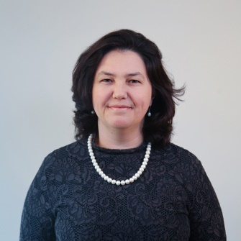Assoc. Prof. Dr. Alba KRUJA

akruja@epoka.edu.al

Dean of FEAS

Lecturer at Department of Business Administration



Prof. Dr.

Waldemar PFOERTSCH

Lecturer at Department of Business Administration

Assoc. Prof. Dr.

Marc PILKINGTON

mpilkington@epoka.edu.al

Lecturer at Department of Business Administration



M. Sc.

Besjon ZENELAJ

[bzenelaj@epoka.edu.a](mailto:bzenelaj@epoka.edu.a)

Lecturer at Department of Business Administration



M. Sc.

Mariola MUÇI

[mmuci@epoka.edu.al](mailto:mmuci@epoka.edu.al)

Lecturer at Department of Business Administration

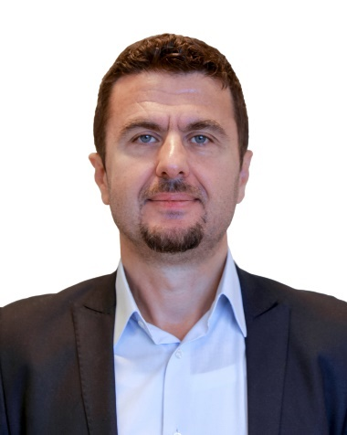

M. Sc.

Saimir MANSAKU

smansaku@epoka.edu.al

Lecturer at Department of Business Administration



M. Sc.

Aida BITRI

abitri@epoka.edu.al

Lecturer at Department of Business Administration

**Part time Academic Staff**

1. MSc. Erjon Saraçi
2. MSc. Florian Tahiri
3. MSc. Sonila Cela
4. MSc. Dafina Shehi
5. Assoc. Prof. Dr. Osman Metalla
6. Dr. Albana Demi
7. Dr. Idaver Sherifi
8. Dr. Jonada Mamo
9. Dr. Teuta Xhindi
10. MSc. Sonila Ҫela
11. MSc. Ervisa Ruka
12. MSc. Ada Bici
13. MSc. Sidorela Meta
14. MSc. Argert Boja
15. Dr. Marsela Luarasi

**Academic Visitors (2021-2022)**

[Guest Lecturer - Mr. Donald Gjika](https://bus.epoka.edu.al/news-guest-lecturer-mr-donald-gjika-5992.html)

[Guest Lecture - Mr. Ardian Jashari](https://bus.epoka.edu.al/news-guest-lecture-mr-ardian-jashari-5993.html)

[Guest Lecturer - Mr. Emiliano Mankolli](https://bus.epoka.edu.al/news-guest-lecturer-mr-emiliano-mankolli-5961.html)

[Guest Lecturer - Mr. Edvin Stefani](https://bus.epoka.edu.al/news-guest-lecturer-mr-edvin-stefani-5890.html)

[Guest Lecture - Mrs. Irida Kovi](https://bus.epoka.edu.al/news-guest-lecture-mrs-irida-kovi-5842.html)

[Guest Lecture - Mrs. Gentiana Josifi](https://bus.epoka.edu.al/news-guest-lecture-mrs-gentiana-josifi-5843.html)

[Guest lecture - Tina Heinicke](https://bus.epoka.edu.al/news-guest-lecture-with-tina-heinicke-5819.html)

**Administrative Staff**

|  |
| --- |
| **Faculty Administrator** |
| Mr. Tekim PEZA  [tpeza@epoka.edu.al](mailto:tpeza@epoka.edu.al) |

|  |
| --- |
| **Department Coordinator** |
| Ms. Blerta Bami  bbami@epoka.edu.al |

## Department Coordinator

Ms. Aldeona Hanija

ahanija@epoka.edu.al

**Finance**

-Income and various financing for **BA in Business Administration** Study Program during the 2021-2022 academic year:

|  |  |
| --- | --- |
| Income (in Euro) | *2021-2022* |
| Tution fees for and during studies | 284,500 |
| *TOTAL* | **284,500** |

-Expenditures for **BA in Business Administration** Study Program during the 2021-2022 academic year:

|  |  |  |  |
| --- | --- | --- | --- |
|  | *2021-2022* | | |
| Expenditures (in EURO) | Salaries | Expenditures | Investements |
| Tuition and other student fees | 143,743 | 85,369 | 19,481 |
| **Total** | **143,743** | **85,369** | **19,481** |

-Income and various financing for **Msc in Business Administration** Study Program during the 2021-2022 academic year:

|  |  |
| --- | --- |
| Income (in Euro) | *2021-2022* |
| Tution fees for and during studies | 69,775 |
| *TOTAL* | **69,775** |

-Expenditures for **Msc in Business Administration** Study Program during the 2021-2022 academic year:

|  |  |  |  |
| --- | --- | --- | --- |
|  | *2021-2022* | | |
| Expenditures (in EURO) | Salaries | Expenditures | Investements |
| Tuition and other student fees | 67,239 | 39,931 | 9,112 |
| **Total** | **67,239** | **39,931** | **9,112** |

Income and various financing for **PM in Business Administration** Study Program during the 2021-2022 academic year:

|  |  |
| --- | --- |
| Income (in Euro) | *2021-2022* |
| Tution fees for and during studies | 15,543.75 |
| *TOTAL* | **15,543.75** |

-Expenditures for **PM in Business Administration** Study Program during the 2021-2022 academic year:

|  |  |  |  |
| --- | --- | --- | --- |
|  | *2021-2022* | | |
| Expenditures (in EURO) | Salaries | Expenditures | Investements |
| Tuition and other student fees | 4,637 | 2,754 | 629 |
| **Total** | **4,637** | **2,754** | **629** |

-Income and various financing for **BA in Business Informatics** Study Program during the 2021-2022 academic year:

|  |  |
| --- | --- |
| Income (in Euro) | *2021-2022* |
| Tution fees for and during studies | 703,310 |
| *TOTAL* | **703,310** |

-Expenditures for **BA in Business Informatics** Study Program during the 2021-2022 academic year:

|  |  |  |  |
| --- | --- | --- | --- |
|  | *2021-2022* | | |
| Expenditures (in EURO) | Salaries | Expenditures | Investements |
| Tuition and other student fees | 362,861 | 215,488 | 49,174 |
| **Total** | **362,861** | **215,488** | **47,174** |

-Income and various financing for **Phd in Business Administration** Study Program during the 2021-2022 academic year:

|  |  |
| --- | --- |
| Income (in Euro) | *2021-2022* |
| Tution fees for and during studies | 1,500 |
| *TOTAL* | **1,500** |

-Expenditures for **Phd in Business Administration** Study Program during the 2021-2022 academic year:

|  |  |  |  |
| --- | --- | --- | --- |
|  | *2021-2022* | | |
| Expenditures (in EURO) | Salaries | Expenditures | Investements |
| Tuition and other student fees | 2,319 | 1,377 | 314 |
| **Total** | **2,319** | **1,377** | **314** |

**IT Resources, Physical Infrastructure and Library Resources**

Information and Communication Technologies Coordinating Office (ICTCO) provides informatics services needed in the University. It plans the informatics infrastructure of the University, provides its security and ensures the continuation of its functions. ICTCO works on the project for effective, legal and extensive usage of the informatics services for students and personnel.

The Information and Communication Technologies Coordinating Office (ICTCO) provides:

Teaching Services:

• **Turnitin** software helps you to understand and avoid plagiarism and develop your understanding of how to cite sources as part of an academic argument. ICTC office manages the users and train the staff about how to use Turnitin.

• **Learning Management System (LMS)** – A service based on Moodle offered for students and instructors in order to access, coordinate and organize course materials online. Students and instructor can login on LMS using the provided official email account.

• **Library Automation System (Koha) -** Koha is an open-source Integrated Library System in use today by hundreds of libraries worldwide. Koha is web based, so there is no software to install on desktop computers. Users can check the books online and reserve them via web. Its features are more than enough to manage the Epoka Library effectively and efficiently.

• **DSpace** – The institutional repository of Epoka University: DSpace is an open-source repository software package typically used for creating open access repositories for scholarly and/or published digital content. The proceedings of the conferences which are organized by Epoka University can be accessed from this repository. Epoka University is the only university who has digital repository in Albania(http://repositories.webometrics.info/en/Europe/Albania). We also give services to other international journals to publish their publications (http://dspace.epoka.edu.al/handle/1/1378) in our digital repository.

**Google Services:**

• **Webmail (Google account) –** Epoka University is using Google Apps for Education services and all students and academic and administrative staff are provided with an email address under

epoka.edu.al domain which is a Google account. Beside official communication, which is done through this email address, this account can be used for authentication to other online systems offered by university.

• **Google Classroom** – A more interactive service offered by Google as part of Google Apps for education in order to access, coordinate and organize course materials on cloud. By using Google Classroom, course materials can be integrated with other Google services where assigned users can collaborate. Students and instructors can access this service using the provided account.

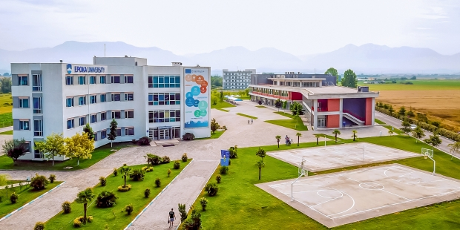**Physical Infrastructure**

The campus extends over a total area of 67,000 m 2. The 2017-2018 academic years is being conducted regularly in the premises of two buildings with a total area of 14352 m 2. This building has a modern infrastructure and a central heating and cooling system. The classrooms are equipped with video projectors and smart boards that enable the normal conduct of the learning process. On September 2013, the construction of A-Building the “Cultural Social Object of Epoka University” was completed. In addition to classes, there are plenty of recreational facilities for students such as cafeterias, cafeterias, libraries, internet cafés, facilities for the Student Council and student clubs, sports facilities, etc. Below are shown and current picture of the building.

**LIBRARY**

The Epoka University Library, which is located on the first floor of A-Building in the Rinas Campus, was founded to support the education and research activities of the university by providing and organizing the needed documents. With its 100-seating capacity, our library has 400 square meters area of use. Our University Library is composed of entrance, book and reading hall. In the entrance, there is a check out desk. The periodicals, including the exhibition of new arrivals, are also shelved in this section. The reading hall is equipped for students to study and to do research.

Epoka University is a member of Balkan Libraries Union which was founded on 29 July 2009 with the participation of 10 institutions from 6 Balkan countries. Our library collection is enriched by purchases and donations. The books to buy are chosen in accordance with the needs and requests of the students, administrative and academic staff. Under the Department of Library and Documentation, the library has a total of about 7500 printed books.

**Digital Databases**

Epoka University has full membership in JSTOR, a shared digital library created in 1995 that includes more than 2,000 academic journals. JSTOR was founded to help libraries and academic publishers transition their activities from print to digital operations, to expand access to scholarly content around the world and to preserve it for future generations. Every member of Epoka staff can access to JSTOR’s collections by going to http://www.jstor.org/ and searching or browsing for content.

**Using the Library**

Our library works on the open shelf system enabling you to reach the books directly. The books in the open shelves are topically sorted in the book hall according to LC classification method. To find the book you are looking for, you should follow these steps:

1. Through the catalog search computers in the library; you can search author name, book name, and publisher, topic, or keyword areas.

2. To get the book, you can go to the shelves with the classification and location numbers of the books appearing on the screen as a result of your search.

**Example of LC number** for the book: "Exchange rates and international finance", Laurence S. Copeland / Financial Times, 2008 HG3821.C782008

The first part of the LC number "**HG**" represents the category of the book by its topic. In the LC system, the first letter **H** stands for **Social Science** class. Each subsequent letter indicates next level of subcategories of the main topic. In the given example **G** stands for **Finance**, **3821** indicates subcategories included between 3810-4000 (Foreign exchange, International finance, International monetary system), C78 indicates the first letter of authors surname, **2008** indicates book publication year.

**Regulations**

Students of Associate Degree, Bachelor’s Degree and Master Students and academic and administrative personnel are the members of the library. They can borrow library materials in accordance with the rules.

Researchers coming from outside the university are not lent books, they are only allowed to use and copy the materials in the library. Readers in this group are requested to fill up the related form Lending Service.

## 

## The Curriculum

**Undergraduate Teaching**

|  |  |  |  |  |  |  |  |  |  |  |  |  |  |  |  |  |  |  |  |  |  |  |  |  |  |  |  |  |  |  |  |  |  |  |
| --- | --- | --- | --- | --- | --- | --- | --- | --- | --- | --- | --- | --- | --- | --- | --- | --- | --- | --- | --- | --- | --- | --- | --- | --- | --- | --- | --- | --- | --- | --- | --- | --- | --- | --- |
| **FACULTY OF ECONOMICS AND ADMINISTRATIVE SCIENCES** | | | | |  | | |  |  | | |  | | | |  | | |  | |  | | |  | | | |  | | |  | |  | |
| **DEPARTMENT OF BUSINESS ADMINISTRATION** | |  |  |  | | |  | | | |  | | |  | | |  | | |  | |  | | |  | | | |  | | |  | |  | |
| **BACHELOR PROGRAM IN BUSINESS ADMINISTRATION (3 YEARS)** | | | | |  |  | | | |  | | |  | |  | | |  | | | | |  | | |  |  | | |
| **First YEAR** | |  |  |
| **First Semester** | |  |  |
| COURSES |  | Course Type | Compulsory /Elective |
| Code | Course Name |  |  |
| ECO 111 | Introduction to Economics | A | Compulsory |
| BUS 103 | Introduction to Business | B | Compulsory |
| LAW 105 | Introduction to Law | A | Compulsory |
| BUS 107 | Essentials of Organizational Behavior | B | Compulsory |
| BUS 101 | Math. for Economics and Business I | A | Compulsory |
| *ENG 107 *ENG 109 | Core English Developing Reading and Writing Skills | D | Compulsory |
| Semestral Total | |  |  |
| * According to entry test APTIS proficiency level. | |  |  |
|  |  |  |  |
| **Second Semester** | |  |  |
| COURSES |  | Course Type | Compulsory /Elective |
| Code | Course Name |  |  |
| BUS 106 | Principles of Programming | A | Compulsory |
| BUS 112 | Management and Organization | B | Compulsory |
| BUS 114 | Communication Skills | C | Compulsory |
| BUS 132 | Introduction To Accounting | B | Compulsory |
| BUS 102 | Math. for Economics and Business II | A | Compulsory |
| *BUS 108 *ENG 109 | Business English Developing Reading and Writing Skills | D | Compulsory |
| Semestral Total | |  |  |
| * According to entry test APTIS proficiency level. | |  |  |
|  |  |  |  |
| **Second YEAR** | |  |  |
| **Third Semester** | |  |  |
| COURSES |  | Course Type | Compulsory /Elective |
| Code | Course Name |  |  |
| ECO 205 | Microeconomics | B | Compulsory |
| BUS 221 | Marketing I | B | Compulsory |
| BUS 201 | Statistics I | A | Compulsory |
| BUS 231 | Financial Accounting I | B | Compulsory |
| XXX xxx | Elective I | D | Elective |
| XXX xxx | Elective II | C | Elective |
| **Semestral Total** | |  |  |
|  |  |  |  |
| **Elective Courses**  **Third Semester** | |  |  |
|  | COURSES | Course Type | Compulsory |
| Code | Course Name |  | /Elective |
| FL 201 | Turkish I | D | Elective |
| FL 203 | German I | D | Elective |
| FL 205 | Italian I | D | Elective |
| FL 207 | French I | D | Elective |
| LAW 203 | Business Law | C | Elective |
| BUS 207 | Project Management | C | Elective |
| BUS 209 | Innovation Management | C | Elective |
|  |  |  |  |
| **Fourth Semester** | |  |  |
| COURSES |  | Course Type | Compulsory /Elective |
| Code | Course Name |  |  |
| BUS 222 | Marketing II | B | Compulsory |
| ECO 206 | Macroeconomics | A | Compulsory |
| BUS 226 | Management Information Systems | B | Compulsory |
| BUS 202 | Statistics II | B | Compulsory |
| BUS 232 | Financial Accounting II | B | Compulsory |
| XXX xxx | Elective | C | Elective |
| **Semestral Total** | |  |  |
|  |  |  |  |
| **Elective Courses Fourth Semester** | |  |  |
| **COURSES** |  | Course | Compulsory |
| Code | Course Name | Type | /Elective |
| BAF 222 | Public Finance | C | Elective |
| BAF 102 | Money and Banking | C | Elective |
| PIR 162 | Introduction to Public Administration | C | Elective |
| PIR 103 | Introduction to Political Sociology | C | Elective |
| BUS 204 | Entrepreneurial Management | C | Elective |
| BUS 234 | Sales Techniques and Management | C | Elective |
|  |  |  |  |
| **Third YEAR** | |  |  |
| **Fifth Semester** | |  |  |
| COURSES |  | Course Type | Compulsory /Elective |
| Code | Course Name |  |  |
| BUS 309 | Professional Practice | D | Compulsory |
| BUS 321 | Operations Management | B | Compulsory |
| BUS 335 | Human Resource Management | B | Compulsory |
| BAF 233 | Fundamentals of Corporate Finance | B | Compulsory |
| XXX xxx | Elective I | B | Elective |
| XXX xxx | Elective II | C | Elective |
| **Semestral Total** | |  |  |
|  |  |  |  |
| **Elective Courses**  **Fifth Semester** | |  |  |
| **COURSES** |  | Course Type | Compulsory /Elective |
| Code | Course Name |  |  |
| BUS 323 | E-Marketing | B | Elective |
| BUS 331 | Cost Accounting | B | Elective |
| BUS 351 | Consumer Behavior | B | Elective |
| BUS 337 | Total Quality Management | B | Elective |
| ECO 321 | International Economics I | C | Elective |
| ECO 331 | Monetary Theory and Policy I | C | Elective |
| BAF 331 | Banking Operations and Service | C | Elective |
| BAF 321 | Financial Institutions and Markets | C | Elective |
| BUS 339 | Innovation and Human Consciousness | B | Elective |
| BUS 325 | Social Media Marketing | B | Elective |
| BUS 353 | Marketing Research | B | Elective |
| BUS 359 | Supply Chain Management | B | Elective |
|  |  |  |  |
|  |  |  |  |
| **Sixth Semester** | |  |  |
| COURSES |  | Course Type | Compulsory /Elective |
| Code | Course Name |  |  |
| BUS 336 | Managerial Accounting | B | Compulsory |
| BUS 324 | Operations Research | B | Compulsory |
| *BUS 302 *BUS 304 | Graduation Project Final Comprehensive Exam | E | Compulsory |
| XXX xxx | Elective I | B | Elective |
| XXX xxx | Elective II | C | Elective |
| **Semestral Total** | |  |  |
|  |  |  |  |
| **Elective Courses Sixth Semester** | |  |  |
| **COURSES** |  | Course Type | Compulsory /Elective |
| Code | Course Name |  |  |
| BAF 338 | Capital Markets and Law | C | Elective |
| ECO 322 | International Economics II | C | Elective |
| ECO 332 | Monetary Theory and Policy II | C | Elective |
| BUS 348 | Customer Relationship Management | B | Elective |
| BUS 356 | Strategic Logistic Management | B | Elective |
| BUS 352 | International Marketing and Management of Multinational Enterprises | B | Elective |
| BUS 358 | Knowledge Management | B | Elective |
| BAF 234 | Financial Management | B | Elective |
| BUS 354 | Branding and Brand Management | B | Elective |
|  |  |  |  |
|  |  |  |  |

**FACULTY OF ECONOMICS AND ADMINISTRATIVE SCIENCES**

**DEPARTMENT OF BUSINESS ADMINISTRATION**

**BACHELOR PROGRAM IN INTERNATIONAL MARKETING AND LOGISTIC MANAGEMENT PROGRAM (3 YEARS)**

|  |  |  |  |  |  |  |  |  |  |  |  |  |  |  |  |  |
| --- | --- | --- | --- | --- | --- | --- | --- | --- | --- | --- | --- | --- | --- | --- | --- | --- |
|  | |  |  |  |  |  |  |  |  |  |  |  |  |  |  |  |
|  |
| **First YEAR** | | |  |  |
| **First Semester** | | |  |  |
| COURSES | |  | Course Type | Compulsory /Elective |
| Code | | Course Name |  |  |
| ECO 111 | | Introduction to Economics | A | Compulsory |
| BUS 103 | | Introduction to Business | B | Compulsory |
| LAW 105 | | Introduction to Law | A | Compulsory |
| BUS 107 | | Essentials of Organizational Behaviour | A | Compulsory |
| BUS 101 | | Math. for Economics and Business I | A | Compulsory |
| *ENG 107 *ENG 109 | | Core English Developing Reading and Writing Skills | D | Compulsory |
| Semestral Total | | |  |  |
| * According to entry test APTIS proficiency level. | | |  |  |
|  | |  |  |  |
| **Second Semester** | | |  |  |
| COURSES | |  | Course Type | Compulsory /Elective |
| Code | | Course Name |  |  |
| BUS 106 | | Principles of Programming | A | Compulsory |
| BUS 114 | | Communication Skills | B | Compulsory |
| BUS 132 | | Introduction To Accounting | B | Compulsory |
| BUS 112 | | Management and Organization | A | Compulsory |
| BUS 102 | | Math. For Economics and Business II | A | Compulsory |
| *BUS 108 *ENG 109 | | Business English Developing Reading and Writing Skills | D | Compulsory |
| Semestral Total | | |  |  |
| * According to entry test APTIS proficiency level. | | |  |  |
|  | |  |  |  |
|  | |  |  |  |
| **Second YEAR** | | |  |  |
| **Third Semester** | | |  |  |
| **COURSES** | |  | Course Type | Compulsory /Elective |
| Code | | Course Name |  |  |
| ECO 205 | | Microeconomics | B | Compulsory |
| BUS 221 | | Marketing I | B | Compulsory |
| BUS 201 | | Statistics I | B | Compulsory |
| BUS 231 | | Financial Accounting I | B | Compulsory |
| XXX xxx | | Elective I | D | Elective |
| XXX xxx | | Elective II | C | Elective |
| **Semestral Total** | | |  |  |
|  | |  |  |  |
| **Elective Courses**  **Third Semester** | | |  |  |
| **COURSES** | |  | Course Type | Compulsory /Elective |
| Code | | Course Name |  |  |
| FL 201 | | Turkish I | D | Elective |
| FL 203 | | German I | D | Elective |
| FL 205 | | Italian I | D | Elective |
| FL 207 | | French I | D | Elective |
| LAW 203 | | Business Law | C | Elective |
| BUS 207 | | Project Management | C | Elective |
| BUS 209 | | Innovation Management | C | Elective |
|  | |  |  |  |
| **Fourth Semester** | | |  |  |
| **COURSES** | |  | Course Type | Compulsory /Elective |
| Code | | Course Name |  |  |
| BUS 222 | | Marketing II | B | Compulsory |
| ECO 206 | | Macroeconomics | B | Compulsory |
| BUS 234 | | Sales Techniques and Management | B | Compulsory |
| BUS 202 | | Statistics II | B | Compulsory |
| XXX xxx | | Elective I | C | Elective |
| XXX xxx | | Elective II | C | Elective |
| **Semestral Total** | | |  |  |
|  | |  |  |  |
| **Elective Courses Fourth Semester** | | |  |  |
| **COURSES** | |  | Course Type | Compulsory /Elective |
| Code | | Course Name |  |  |
| BAF 222 | | Public Finance | C | Elective |
| PIR 162 | | Introduction to Public Administration | C | Elective |
| PIR 103 | | Introduction to Political Sociology | C | Elective |
| BUS 232 | | Financial Accounting II | C | Elective |
| BUS 226 | | Management Information Systems | C | Elective |
| BUS 204 | | Entrepreneurial Management | C | Elective |
| BAF 102 | | Money and Banking | C | Elective |
|  | |  |  |  |
| **Third YEAR** | | |  |  |
| **Fifth Semester** | | |  |  |
| **COURSES** | |  | Course Type | Compulsory /Elective |
| Code | | Course Name |  |  |
| BUS 321 | | Operations Management | B | Compulsory |
| BAF 233 | | Fundamentals of Corporate Finance | B | Compulsory |
| BUS 309 | | Professional Practice | D | Compulsory |
| BUS 353 | | Marketing Research | B | Compulsory |
| BUS 359 | | Supply Chain Management | B | Compulsory |
| XXX xxx | | Elective I | C | Elective |
| **Semestral Total** | | |  |  |
|  | |  |  |  |
| **Elective Courses**  **Fifth Semester** | | |  |  |
| **COURSES** | |  | Course Type | Compulsory /Elective |
| Code | | Course Name |  |  |
| BUS 335 | | Human Resource Management | C | Elective |
| BUS 339 | | Innovation and Human Consciousness | C | Elective |
| BUS 351 | | Consumer Behavior | C | Elective |
| BUS 325 | | Social Media Marketing | C | Elective |
| BUS 331 | | Cost Accounting | C | Elective |
| BUS 337 | | Total Quality Management | C | Elective |
| ECO 321 | | International Economics I | C | Elective |
| ECO 331 | | Monetary Theory and Policy I | C | Elective |
| BAF 331 | | Banking Operations and Service | C | Elective |
| BAF 321 | | Financial Institutions and Markets | C | Elective |
|  | |  |  |  |
| **Sixth Semester** | | |  |  |
| **COURSES** | |  | Course Type | Compulsory /Elective |
| Code | | Course Name |  |  |
| BUS 324 | | Operations Research | B | Compulsory |
| BUS 356 | | Strategic Logistic Management | B | Compulsory |
| BUS 352 | | International Marketing and Management of Multinational Enterprises | B | Compulsory |
| *IML 302 *IML 304 | | Graduation Project Final Comprehensive Exam | E | Compulsory |
| **XXX xxx** | | **Elective I** | **C** | **Elective** |
| **Semestral Total** | | |  |  |
|  | |  |  |  |
| **Elective Courses**  **Sixth Semester** | | |  |  |
| **COURSES** | |  | Course Type | Compulsory /Elective |
| Code | | Course Name |  |  |
| BUS 354 | | Branding and Brand Management | C | Elective |
| BAF 338 | | Capital Markets and Law | C | Elective |
| ECO 322 | | International Economics II | C | Elective |
| BUS 336 | | Managerial Accounting | C | Elective |
| ECO 332 | | Monetary Theory and Policy II | C | Elective |
| BUS 348 | | Customer Relationship Management | C | Elective |

|  |  |  |  |  |  |  |  |  |  |  |  |  |  |
| --- | --- | --- | --- | --- | --- | --- | --- | --- | --- | --- | --- | --- | --- |
| **FACULTY OF ECONOMICS AND ADMINISTRATIVE SCIENCES** | | | |  |  |  |  |  |  |  | | |  |
| **DEPARTMENT OF BUSINESS ADMINISTRATION** | | |  | | | | | | | |  |  | | |  |  |  |  |  |  |  |  |  |  |
| **BACHELOR PROGRAM IN BUSINESS INFORMATICS (3 YEARS)** | | | | | | | |  |  |  | | |  |
| **First YEAR** | |  |  | | | | | | | |
| **First Semester** | |  |  | | | | | | | |
| COURSES | | Course Type | Compulsory /Elective | | | | | | | |
| Code | Course Name |  |  | | | | | | | |
| ECO 101 | Introduction to Economics I | A | Compulsory | | | | | | | |
| BUS 103 | Introduction to Business | B | Compulsory | | | | | | | |
| CEN 111 | Introduction to Algorithms and Programming | B | Compulsory | | | | | | | |
| CEN 103 | Introduction to Computer Engineering | D | Compulsory | | | | | | | |
| BUS 101 | Math. for Economics and Business I | A | Compulsory | | | | | | | |
| *ENG 107 *ENG 109 | Core English Developing Reading and Writing Skills | D | Compulsory | | | | | | | |
| Semestral Total | |  |  | | | | | | | |
| * According to entry test APTIS proficiency level. | | |  | | | | | | | |
| **Second Semester** | |  |  | | | | | | | |
| COURSES | | Course Type | Compulsory /Elective | | | | | | | |
| Code | Course Name |  |  | | | | | | | |
| ECO 102 | Introduction To Economics II | A | Compulsory | | | | | | | |
| BUS 102 | Math. For Economics and Business II | A | Compulsory | | | | | | | |
| BUS 132 | Introduction To Accounting | B | Compulsory | | | | | | | |
| CEN 114 | C and C ++ Programming | B | Compulsory | | | | | | | |
| BUS 112 | Management and Organization | B | Compulsory | | | | | | | |
| *BUS 108 *ENG 109 | Business English Developing Reading and Writing Skills | D | Compulsory | | | | | | | |
| Semestral Total | |  |  | | | | | | | |
| * According to entry test APTIS proficiency level. | | |  | | | | | | | |
|  |  |  |  | | | | | | | |
| **Second YEAR** | |  |  | | | | | | | |
| **Third Semester** | |  |  | | | | | | | |
| COURSES | | Course Type | Compulsory /Elective | | | | | | | |
| Code | Course Name |  |  | | | | | | | |
| BUS 201 | Statistics I | A | Compulsory | | | | | | | |
| LAW 203 | Business Law | A | Compulsory | | | | | | | |
| CEN 385 | Computer Organization | B | Compulsory | | | | | | | |
| CEN 213 | Object Oriented Programing | B | Compulsory | | | | | | | |
| BUS 205 | Principles of Marketing | B | Compulsory | | | | | | | |
| **XXX xxx** | **Elective** | **C** | **Elective** | | | | | | | |
| Semestral Total | |  |  | | | | | | | |
|  |  |  |  | | | | | | | |
| **Elective Courses** | |  |  | | | | | | | |
| COURSES | | Course Type | Elective | | | | | | | |
| Code | Course Name |  |  | | | | | | | |
| BUS 231 | Financial Accounting I | C | Elective | | | | | | | |
| BUS 209 | Innovation Management | C | Elective | | | | | | | |
| BUS 207 | Project Management | C | Elective | | | | | | | |
| BUS 107 | Essentials of Organizational Behaviour | C | Elective | | | | | | | |
| BUS 337 | Total Quality Management | C | Elective | | | | | | | |
| BUS 359 | Supply Chain Management | C | Elective | | | | | | | |
| ECO 205 | Microeconomics | C | Elective | | | | | | | |
|  |  |  |  | | | | | | | |
| **Fourth Semester** | |  |  | | | | | | | |
| COURSES | | Course Type | Compulsory /Elective | | | | | | | |
| Code | Course Name |  |  | | | | | | | |
| BUS 202 | Statistics II | A | Compulsory | | | | | | | |
| BUS 226 | Management Information Systems | B | Compulsory | | | | | | | |
| CEN 252 | Database Management Systems | B | Compulsory | | | | | | | |
| CEN 222 | Web Technologies | B | Compulsory | | | | | | | |
| CEN 254 | Data Structures | B | Compulsory | | | | | | | |
| XXX xxx | Elective | C | Elective | | | | | | | |
| Semestral Total | |  |  | | | | | | | |
|  |  |  |  | | | | | | | |
| **Elective Courses** | |  |  | | | | | | | |
| COURSES | | Course Type | Elective | | | | | | | |
| Code | Course Name |  |  | | | | | | | |
| BUS 232 | Financial Accounting II | C | Elective | | | | | | | |
| BUS 204 | Entrepreneurial Management | C | Elective | | | | | | | |
| BUS 358 | Knowledge Management | C | Elective | | | | | | | |
| BUS 114 | Communication Skills | C | Elective | | | | | | | |
| ECO 206 | Macroeconomics | C | Elective | | | | | | | |
| **Third YEAR** | |  |  | | | | | | | |
| **Fifth Semester** | |  |  | | | | | | | |
| COURSES | | Course Type | Compulsory /Elective | | | | | | | |
| Code | Course Name |  |  | | | | | | | |
| CEN 323 | Web Programing | B | Compulsory | | | | | | | |
| CEN 361 | Computer Networks | B | Compulsory | | | | | | | |
| BAF 233 | Fundamentals of Corporate Finance | C | Compulsory | | | | | | | |
| BUS 321 | Operations Management | B | Compulsory | | | | | | | |
| BUS 309 | Professional Practice | D | Compulsory | | | | | | | |
| XXX xxx | Elective | C | Elective | | | | | | | |
| Semestral Total | |  |  | | | | | | | |
|  |  |  |  | | | | | | | |
| **Electives** | |  |  | | | | | | | |
| COURSES | | Course Type | Elective | | | | | | | |
| Code | Course Name |  |  | | | | | | | |
| BUS 331 | Cost Accounting | C | Elective | | | | | | | |
| BUS 335 | Human Resources Management | C | Elective | | | | | | | |
| BUS 339 | Innovation and Human Consciousness | C | Elective | | | | | | | |
| BUS 325 | Social Media Marketing | C | Elective | | | | | | | |
| BUS 351 | Consumer Behavior | C | Elective | | | | | | | |
| ECO 311 | Econometrics I | C | Compulsory | | | | | | | |
|  |  |  |  | | | | | | | |
| **Sixth Semester** | |  |  | | | | | | | |
| COURSES | | Course Type | Compulsory /Elective | | | | | | | |
| Code | Course Name |  |  | | | | | | | |
| BUS 324 | Operations Research | B | Compulsory | | | | | | | |
| CEN 318 | Operating Systems | B | Compulsory | | | | | | | |
| CEN 302 | Software Engineering | B | Compulsory | | | | | | | |
| *BINF 302 *BINF 304 | Graduation Project / Final Comprehensive Exam | E | Compulsory | | | | | | | |
| XXX xxx | Elective | C | Elective | | | | | | | |
| Semestral Total | |  |  | | | | | | | |
|  |  |  |  | | | | | | | |
| **Electives** | |  |  | | | | | | | |
| COURSES | | Course Type | Elective | | | | | | | |
| Code | Course Name |  |  | | | | | | | |
| BUS 336 | Managerial Accounting | C | Elective | | | | | | | |
| BUS 348 | Customer Relationship Management | C | Elective | | | | | | | |
| ECO 312 | Econometrics II | C | Elective | | | | | | | |
| BUS 354 | Branding and Brand Management | C | Elective | | | | | | | |
| BUS 356 | Strategic Logistic Management | C | Elective | | | | | | | |
| BUS 352 | International Marketing and Management of International Enterprises | C | Elective | | | | | | | |

## 

## Graduate Teaching

|  |  |  |  |  |  |  |  |  |  |  |  |  |  |  |  |  |  |  |  |  |
| --- | --- | --- | --- | --- | --- | --- | --- | --- | --- | --- | --- | --- | --- | --- | --- | --- | --- | --- | --- | --- |
| **FACULTY OF ECONOMICS AND ADMINISTRATIVE SCIENCES** | | | |  | | |  | |  | |  | |  | |  | |  | | |  |
| **DEPARTMENT OF BUSINESS ADMINISTRATION** | | |  | |  |  | |  | |  | |  | |  | |  | | |  | | |  |  |
| **PROFESSIONAL MASTER IN BUSINESS ADMINISTRATION** | | | | | | | | | | | | |  | |  | |  | | |  |
| **First Semester** | |  | | |  | | | | | | | | | | | | |
| **COURSES** | | Course Type | | | Compulsory /Elective | | | | | | | | | | | | |
| Code | Course Name |  | | |  | | | | | | | | | | | | |
| BUS 501 | Research Methods in Business | A | | | Compulsory | | | | | | | | | | | | |
| BUS 514 | Professional Practice | **D** | | | Compulsory | | | | | | | | | | | | |
| XXX xxx | Elective I | **C/B** | | | Elective | | | | | | | | | | | | |
| XXX xxx | Elective II | **C/B** | | | Elective | | | | | | | | | | | | |
| **Semestral Total** | |  | | |  | | | | | | | | | | | | |
|  |  |  | | |  | | | | | | | | | | | | |
| **Elective Courses**  **First Semester** | | | | |  | | | | | | | | | | | | |
| **COURSES** | | Course Type | | | Compulsory /Elective | | | | | | | | | | | | |
| Code | Course Name |  | | |  | | | | | | | | | | | | |
| BUS 527 | International Accounting and IFRS | C | | | Elective | | | | | | | | | | | | |
| BUS 517 | Advanced Managerial Accounting | C | | | Elective | | | | | | | | | | | | |
| BUS 503 | Advanced Organizational Behavior | **C** | | | Elective | | | | | | | | | | | | |
| BUS 507 | New Concepts and Trends in Business Management | B | | | Elective | | | | | | | | | | | | |
| BUS 509 | Leadership | **C** | | | Elective | | | | | | | | | | | | |
| BUS 513 | Strategic Marketing | **C** | | | Elective | | | | | | | | | | | | |
| BUS 515 | Advanced Operations Management | **B** | | | Elective | | | | | | | | | | | | |
|  |  |  | | |  | | | | | | | | | | | | |
| **Second Semester** | |  | | |  | | | | | | | | | | | | |
| **COURSES** | | Course Type | | | Compulsory /Elective | | | | | | | | | | | | |
| Code | Course Name |  | | |  | | | | | | | | | | | | |
| BUS 518 BUS 512 | Micro Thesis* Final Comprehensive Exam* | **E** | | | Compulsory | | | | | | | | | | | | |
| XXX xxx | Elective I | **B** | | | Elective | | | | | | | | | | | | |
| XXX xxx | Elective II | **B** | | | Elective | | | | | | | | | | | | |
| XXX xxx | Elective III | **B/C** | | | Elective | | | | | | | | | | | | |
|  | **Semestral Total** |  | | |  | | | | | | | | | | | | |
| **Elective Courses**  **Second Semester** | | | | |  | | | | | | | | | | | | |
| **COURSES** | | Course Type | | | Compulsory /Elective | | | | | | | | | | | | |
| Code | Course Name |  | | |  | | | | | | | | | | | | |
| BUS 502 | Strategy and Management | B | | | Elective | | | | | | | | | | | | |
| BUS 504 | Advanced Management Information System | **C** | | | Elective | | | | | | | | | | | | |
| BUS 508 | Financial Statements Analysis for Managerial Staff | **B** | | | Elective | | | | | | | | | | | | |
| BUS 524 | Brand Management | B | | | Elective | | | | | | | | | | | | |
| BUS 506 | Social Business And Sustainability | **B** | | | Elective | | | | | | | | | | | | |

|  |  |  |  |  |  |  |  |  |  |  |  |  |  |  |  |  |  |  |  |  |  |  |  |  |  |  |
| --- | --- | --- | --- | --- | --- | --- | --- | --- | --- | --- | --- | --- | --- | --- | --- | --- | --- | --- | --- | --- | --- | --- | --- | --- | --- | --- |
|  |  |  |  | | | | | | |  |  | | |  |  | |  | | |  |  |  |  |  |  |  |
| **FACULTY OF ECONOMICS AND ADMINISTRATIVE SCIENCES** | | | |  |  |  |  |  |  | | |  |  | | |  | |  |
| **DEPARTMENT OF BUSINESS ADMINISTRATION** | | | | | | | | | |  |  | | |  |  | |  | | |  |  |  |  |  |  |  |
| **MASTER OF SCIENCE IN BUSINESS ADMINISTRATION (2 YEARS)** | | | | |  |  |  |  |  | | |  |  | | |  | |  |
| **FIRST YEAR** | |  |  | | | | | | |
| **First Semester** | |  |  | | | | | | |
| **COURSES** | | Course Type | Compulsory /Elective | | | | | | |
| Code | Course Name |  |  | | | | | | |
| ENG 401 | Academic Reading and Writing | A | Compulsory | | | | | | |
| BUS 423 | Small Business Management and Entreprenership | B | Compulsory | | | | | | |
| XXX xxx | Elective I | B | Elective | | | | | | |
| XXX xxx | Elective II | C | Elective | | | | | | |
| **Semestral Total** | |  |  | | | | | | |
|  |  |  |  | | | | | | |
| **Elective Courses**  **First Semester** | |  |  | | | | | | |
| **COURSES** | | Course Type | Compulsory /Elective | | | | | | |
| Code | Course Name |  |  | | | | | | |
| BUS 407 | Business Ethics | B | Elective | | | | | | |
| BUS 425 | Comparative Business Law | B | Elective | | | | | | |
| BUS 451 | International Business | C | Elective | | | | | | |
| ECO 421 | Development and Growth I | C | Elective | | | | | | |
| BAF 411 | Portofolio Management and Investment Analysis | C | Elective | | | | | | |
| BAF 415 | Financial Analysis | C | Elective | | | | | | |
| PIR 431 | World Politics | C | Elective | | | | | | |
| PIR 413 | Nationalism and Ethnic Studies | C | Elective | | | | | | |
| PIR 443 | Human Rights and Humanitarian Interventions | C | Elective | | | | | | |
| PIR 449 | Conflict Resolution & Diplomatic Language | C | Elective | | | | | | |
|  |  |  |  | | | | | | |
|  |  |  |  | | | | | | |
| **Second Semester** | |  |  | | | | | | |
| **COURSES** | | Course Type | Compulsory /Elective | | | | | | |
| Code | Course Name |  |  | | | | | | |
| BUS 426 | Strategic Management | B | Compulsory | | | | | | |
| BUS 434 | Auditing | B | Compulsory | | | | | | |
| XXX xxx | Elective I | B | Elective | | | | | | |
| XXX xxx | Elective II | C | Elective | | | | | | |
| **Semestral Total** | |  |  | | | | | | |
|  |  |  |  | | | | | | |
| **Elective Courses**  **Second Semester** | |  |  | | | | | | |
| **COURSES** | | Course Type | Compulsory /Elective | | | | | | |
| Code | Course Name |  |  | | | | | | |
| BUS 414 | Strategic Analyses on Business | B | Elective | | | | | | |
| BUS 432 | Advertisement Management and Creativity | C | Elective | | | | | | |
| ECO 422 | Development and Growth II | C | Elective | | | | | | |
| BUS 406 | Albanian Tax Law | B | Elective | | | | | | |
| BAF 432 | Bank Management | C | Elective | | | | | | |
| BUS 524 | Brand Management | B | Elective | | | | | | |
| BAF 422 | Risk Management and Insurance | C | Elective | | | | | | |
|  |  |  |  | | | | | | |
|  |  |  |  | | | | | | |
| **Third Semester** | |  |  | | | | | | |
| **COURSES** | | Course Type | Compulsory /Elective | | | | | | |
| Code | Course Name |  |  | | | | | | |
| BUS 501 | Research Methods in Business | B | Compulsory | | | | | | |
| BUS 505 | Seminar on Business Administration | B | Compulsory | | | | | | |
| XXX xxx | Elective I | B | Elective | | | | | | |
| XXX xxx | Elective II | B | Elective | | | | | | |
| Semestral Total | |  |  | | | | | | |
|  |  |  |  | | | | | | |
| Elective Courses - Third Semester | |  |  | | | | | | |
| COURSES | | Course Type | Compulsory /Elective | | | | | | |
| Code | Course Name |  |  | | | | | | |
| BUS 527 | International Accounting and IFRS | B | Elective | | | | | | |
| BUS 517 | Advanced Managerial Accounting | B | Elective | | | | | | |
| BUS 503 | Advanced Organizational Behavior | B | Elective | | | | | | |
| BUS 507 | New Concepts and Trends in Business Management | B | Elective | | | | | | |
| ECO 505 | Managerial Economics | B | Elective | | | | | | |
| BUS 509 | Leadership | B | Elective | | | | | | |
| BUS 513 | Strategic Marketing | B | Elective | | | | | | |
| BUS 515 | Advanced Operations Management | B | Elective | | | | | | |
| **Fourth Semester** | |  |  | | | | | | |
| COURSES | | Course Type | Compulsory /Elective | | | | | | |
| Code | Course Name |  |  | | | | | | |
| BUS 520 | Thesis | E | Compulsory | | | | | | |
| Semestral Total | |  |  | | | | | | |

Teaching, Learning, Assessment & Reasearch

Undergraduate Students’ List of Theses

**Name Surname :** Altea Bardho

**Title of Thesis :** The Future of Development of Electric

**Thesis Supervisor** : Assoc. Prof. Dr. Alba Kruja

Public transport by bus is the most used type of public transportation in Albania. However, for various reasons the efficiency of this mean of transportation is lower compared to the importance that it has in the Albania citizen lives. Also, the pollution caused by buses especially in the cities is one of the main sources of air pollution in Albania. The aim of this thesis is to highlight the conditions of pubic transportation now and to introduce ways how can Albania improve this public service following the example of European countries and China that are substituting traditional diesel buses with electric buses. This study also aims to create a deep understanding what electric buses and electric public transportation means and what are the steps Albania should undertake to implement electric public transportation as a mean of service and environment improvement. Two interviews are conducted to reach the aim of this study. Car dealer and head of city association transportation are asked regarding the awareness toward electric vehicles of public and regarding the future of electrification of public bus transportation. Both interviewees held a skeptical attitude towards the electric buses as the next step in the near future for Albanian public transportation. Improvements need to be done in terms of infrastructure and government policies in order to look at the electric public transportation as the next innovative step for Albania. **Keywords**: Electric, EV, Public Transportation, Charging, Environment, Albania, Technology

**Name Surname** : Amanda Kazaferi

**Title of Thesis :** Analysis, Design And Implementation Of E-Invoicing System To Help Smes During Fiscalization Process In Albania

**Thesis Supervisor :** Igli Hakrama

In these days, the need of process automatization, digitalization, and digitized billing processes have become crucial and vital in business area. Governments all around the world are encouraging businesses to replace manual devices and paperwork with digitalized systems, which will improve and increase their performance. In order to accelerate this process European and other unions have compiled a legislation to promote the adoption and implementation of electronic invoicing across the European Union among government instances and different type of businesses. This particular legislation in Albania requires technology’s involvement and is named “The law on Fiscalization”, The process of fiscalization is a crucial element for the competitiveness among businesses meanwhile they improve business processes. As a result of this new law in Albania, there has been a competition to develop the most sophisticated, but at the same time costly and complicated systems, which will best fit for businesses that have already adopted some technological systems. On the other hand, small and medium sized enterprises have been having difficulties in purchasing these pricy systems. Thus, arises the need to develop a financially affordable system that will help and facilitate the process of fiscalization especially for the Albanian small or medium-sized business. Furthermore, with the increasement of data flow, resources like errors, time and raw materials can be minimized. Fiscalization is the process of issuing, processing and accepting invoices without manual involvement. It helps large enterprises and SMEs to benefit from errors and delays on payments, and also reduce printing and postage costs. This paper will present an electronic invoicing system, which allows business, especially the small and medium-sized ones, with a low-cost, simple and safe access to the world of electronic business. The developed web application solution enables issuing, receiving and viewing electronic invoices, storage of invoice data, and connection to registry of electronic invoice with the SelfCare system created by Albanian Tax Authorities. The system is composed of two main users, which include: the admin and the operator. It is named EasyFiscal and it is created to be help during the process of fiscalization. It includes help for each user and a statistics page, which will be a great contributor during business decision processes. **Key words:** electroni**c** invoicing, fiscalization law, digitized systems.

**Name Surname** : Angjelo Raça

**Title of Thesis** : The impact of foreign direct investment on economic growth: a case study of Albania

**Thesis Supervisor** : MSc. Saimir Mansaku

Since communism was overthrown in 1990, Albania has quickly shifted from a centralised economy to a free market economy. Fast-moving policy adjustments, freer trade, and privatisation have enabled FDI to play a significant role in Albania's economy. The relationship between FDI and Albania's economic expansion is examined in this study. The official website of the World Bank served as the source for all required secondary information. Then, the following tests were performed on variables representing FDI inflows as a per cent of GDP and the annual amount of GDP: Descriptive Statistics; Pearson's Correlation Coefficient; and Regression Analysis. The findings showed a long-term relationship between the two variables. All in all, policymakers should be careful when formulating plans and programs for promoting FDI. It is crucial to formulate policies that would increase the inflow of FDI because both FDI and GDP have a strong relationship.

**Key Words:** Foreign Direct Investment, Gross Domestic Product, economic growth, simple regression analysis, correlation coefficient

**Name Surname** :Arjela Dervishaj

**Title of Thesis** : Talent Management Process Can Lead to Competitive Advantage in The Market: A Study Based on Neptun Electronics And Globe Albania

**Thesis Supervisor** : MSc. Aida Bitri

Many experts in Human Resources worldwide have begun to view Talent Management as an innovative method of obtaining a platform on which to achieve competitive advantages. Talent Management involves every fundamental aspect of human resource management, such as recruiting, selection, recognition, and development of employees. This area of study also offers a wide range of advantages; a company that takes efficient steps to manage its talent pool will enjoy the benefits of recruiting the best personnel, making talented staff feel attached to the company, and maintaining the loyalty of those employees. As a result, businesses in today's world emphasize both the capabilities of individuals and their organizations' capabilities to cultivate a pool of high-potential talent and guide individuals within that pool so that the business can maintain its success in the long term. This study analyzes the positions of two Albanian giants in the consumer electronics goods, Neptun Electronics and Globe Albania, their differences, and how the latter can improve its position through the Talent Management process.

**Name Surname** : Brand Çitozi

**Title of Thesis** : Health Care Management System

**Thesis Supervisor** : Dr. Igli Hakrama

Nowadays, we interfere with technology in an unlimited and inseparable way. Facilitating and automating applications has brought improvement in many different fields and disciplines. Developed countries are setting up big investments to create automated applications that control all the actions made for one employee, from counting the hours worked to pay them. We see that security should be the application’s first important characteristic employees and clients should be trusted and develop their intentions and actions towards the app.

The GO-CARE is a web application used to manage and organize the health care process data. Every individual and hospital facility may use GO-CARE. The app will be used to organize the needed tools and labor force from different cities in Albania. The Employee will be called GO-PRO, and all that he/she would do is download the needed documents approved by administrators of the application to start working and taking shifts and earn money. Each account owner will access this web application through a device with an internet connection according to their user type and credentials. The employees will work more efficiently, the workload will be reduced, and automatized procedures will substitute the time-consuming handwriting documentation method.These and many other functionalities will provide a useful application for one of the main components of population health, such as nurse care for people in need. **Keywords**: web-application, nurse, care, health, work, efficiency, access, automatized procedures

# Name Surname : Deni Maçi

**Title of Thesis** : Analysis, design and implementation of an electronic state-owned land management system in Albania.

**Thesis Supervisor** : Dr. Igli Hakrama

The rapid pace of technology development has undoubtedly come as a result of the demands for increasing the quality of work, minimizing the working time for a certain process, increasing the efficiency at work, accuracy and minimizing human errors at work and many other indicators. We see the results of this technological development today, in every field of economic and social life. Of course, different countries have different approaches and achievements as a result of different levels of economic and social development, but it is certain that the future is moving more and more towards digitalization. On this aspect, in our country, efforts are being made to approximate the best standards of the most developed countries.

In the last decade, the reflections in this direction are visible in every field or sector of economic-social life and one of such sectors of the economy is Agriculture. One of its policies, in order to reduce the costs of agricultural products and promote exports, is stimulating investment in large areas. In order to do this, the Ministry that covers the respective field, currently the Ministry of Agriculture and Rural Development (MARD) has published the list of state-owned lands available for rent. All state-owned lands inside the list are under the administration of MARD. For the record, about 3900 ha of land out of 19000 ha available, have been leased by 53 commercial investment entities. Leasing and renting land, creates certain obligations for both: the landlord and the tenant.

Monitoring this process, although very important, is currently subject to a manual and very voluminous process. Precisely, to minimize the time of this process, the preparation of such an application was intended. This system is built based on information received from the Partnership Sector at MARD. The construction of such a system will serve mostly the employees of the partnership sector at MARD, in terms of speeding up the monitoring processes, accuracy of various calculations, statistical production, communication with the finance sector, etc. Also, the investment entities themselves, will profit from this system by receiving a faster information exchange process. This system can be functional in all municipalities of the country, which perform the same procedures for state-owned agricultural lands that are under their administration. **Keywords:** Agriculture, lease contracts, state-owned land, land management system, investments.

**Name Surname** :Erjon Fida

**Title of Thesis** : An overview of the most common methods for Point Cloud Filtering.

**Thesis Supervisor** : MSc. Florenc Skuka

3D point clouds are becoming increasingly more important in computer imagery and object representation. But when a point cloud has just been scanned it is usually unusable because of distortion, noise, outliers etc. For this reason, there exist algorithms that try to make these point cloud useful by removing the aforementioned problems while also retaining the shape of the point cloud. This paper seeks to analyze the most common algorithms and papers done on the subject and give a comprehensive guide on which algorithms are best for which use case.

# Name Surname :Fjona Kazazi

**Title of Thesis** : Secure Identity Management On The Blockchain

Camera Calibration

**Thesis Supervisor** : MSc. Florenc Skuka

The increase of the need for applications that perform precise measurements requires that the cameras used in the process to be calibrated accurately. The calibration of the cameras, which is the main problem described in this thesis consists of the estimation of the camera parameters which sequentially makes it possible to extract metric information from images. After a brief introduction to the camera system, mapping, parameters and different types of lens distortion, this thesis presents in theory the process of camera calibration. Additionally, existing calibration methods are presented together with an explanation for each. A demonstration of the calibration process is performed using the calibration toolbox provided by MATLAB system. The results of the implementation where the internal and external parameters of the camera. This thesis emphasizes the importance of camera calibration that serves as a necessary step used for performing several engineering tasks.

# 

**Name Surname** : Gerta Bushi

**Title of Thesis** : The Impact of Covid-19 on Jobs, Employment and Work Culture: A Case of Albania

**Thesis Supervisor** : MSc. Aida Bitri

The purpose of this study is to analyze and interpret the impact that COVID-19 has had on businesses, workforce and workplace culture. The influence it has had on the last few years is tremendous and it lies on different aspects and spectrums, starting from schools, companies, organizations, events, traveling and so on. This study will be focused mainly on the effects on companies and businesses, how COVID-19 impacted the workforce and the workplace culture. During COVID-19, the employment rate of workers has drastically changed and decreased since most employees began to reevaluate their priorities in life and considered leaving their current jobs. Despite this, most employees were left jobless during the pandemic because many job positions got closed due to lockdowns and strict measures. Such positions were related to hospitality sector, restaurants, bars, entertainment centers, cinemas, theatres and so on. Moreover, regarding employment, it is shown that almost 70% of companies state that their staff works only two to three days in the office and the rest of the week they work remotely. Businesses are now being prompted to reevaluate and reconsider their team culture and communication among employees so that everyone is supported as they go through the new challenges of this era. Another aspect of the pandemic impacts that is worth to mention, is worklife balance. With the new model of working remotely or hybrid, employees have found it easier to maintain both their private life and career life in balance. This is most common in employees who have some more duties and responsibilities outside their work life, such as having children to raise, a family to keep and maintain, old parents which might need healthcare support, etc. Consequently, employees are shown to be more productive and more efficient in their career life. The final aspect I would like to mention with which companies have dealt with, is managing remote and hybrid working. Some companies have enforced the idea of working two days in the office where the team can catch-up together on some crucial meetings, and the remainder remotely where they can work from home at their own pace by completing their personal tasks. With all of these being mentioned, this study’s aim is to go deeper and analyze the effects of the pandemic in the workforce. **Keywords:** COVID-19, company, workforce, work life, remote, hybrid

**Name Surname :** Tea Haxhimali

**Title of Thesis :** Fast Fashion” İndustry Enhancing Customer Lifetime Value. Case of Zara İn Albania

**Thesis** **Supervisor** : MSc. Mariola Muçi

This thesis talks about fashion industry and it evaluation through years, especially fast fashion industry. It is a research about the indication that fast fashion has in Albania, basing on the case of Zara, the most successful company in fast fashion industry. This kind of fashion industry functions through designing, producing and promoting enormous quantities of apparel. In this way they function through copying the latest trends from the biggest fashion houses and offering these collections at affordable prices to the final customers, but also accompanied with low – quality materials. This phenomena of offering low-cost and trendy copied items has fostered a market and society trend to overconsumption, has its positive and negative points elaborated through the thesis. The reason why Zara is chosen as a case study, specifically Zara in Albania, is because Albania a country located in southeastern Europe with a population at around 3 million people has a high number of fashion lovers.

**Name Surname :** Endi Driza

**Title of Thesis :** Green Marketing: Green Branding and Consumer

**Thesis** **Supervisor :** MSc Mariola Muçi

During recent years, society has been emphasizing and putting more and more importance on the idea of “going green” which means promoting environmentally correct and sustainable practices in everyday life. Therefore, brands have been translating these concepts into putting out more ecological products to meet the needs of the consumers and promote the importance of a greener lifestyle. These items are developing as distinctive products in order to keep track of these value-conscious customers, whose consumption patterns and purchasing decisions are changing. Customers are becoming increasingly aware about environmental issues and want to have a more active role in reducing the environmental impact of their actions. There is no way the earth could possibly be self-sustaining. As a result, it necessitates interaction and contribution from customers and organizations in order to protect it and raise awareness of environmental issues such as global warming, which currently affects everyone on the planet. Another topic is corporate social responsibility, which refers to an organization's responsible acts in society, such as offering and marketing products that are less hazardous to the environment.This project’s goal is to look through the concept of green marketing within itself, concepts and its evolution through the years. There are plenty of reasons why we study sustainable marketing and why companies have been turning to green branding starting from costs, morals and environmental liability. Organizations and individuals have been starting to realize how they can profit from strategic green marketing tactics while also doing a good deed for the environment. This project also analyzes the latter tactics, how consumers perceive them and their behavior towards sustainable brands and products. The goal of this study is to look into customers' perceptions of firms' attitudes when they engage in green marketing activities, as well as how this affects and changes customers' purchasing decisions when they are aware of the environmental impact of their actions. Marketers face multiple challenges and disadvantages when going green, but are met with plenty of advantages, therefore this project will tackle every aspect of it, including greenwashing. Lastly, I have conducted a survey on how consumers in Albania perceive green marketing, how environmentally aware they are and what affects their choices of sustainability. **Keywords**: marketing, customers, products, brands, green, environment, sustainability, marketers

**Name Surname :** Ismail Shpati

**Title of Thesis :** Online shopping platform geared towards small social media centric merchants in Albania

**Thesis** **Supervisor :** MSc. Florenc Skuka

The purpose of this project is to research current popular technologies in the industry with the end goal of creating an effective and efficient online shop platform. This application will serve as a common ground and market for the small merchants that cannot afford the development of a proper individual web page to represent their products. This project will be technical oriented but will also explain some of the functionalities of the application and the business scenarios that they treat. From conversations that I conducted with some owners of these businesses, I came to the conclusion that two major reasons for not having a web page were:

1. The fee’s for having such a service did not justify the expected life span of the business by the owner.

2. Extra work would be required from the business to maintain and keep updated both the web page and social media page. This application will target both these concerns by offering a low-cost subscription based service with the capabilities of managing posts between different platforms from a single point of entry

**Name Surname :** Iris Xhaja

**Title of Thesis :** Branding techniques and approaches in the area of sustainably

**Thesis** **Supervisor :** MSc. Mariola Muçi

Sustainable Brands and the term sustainability in itself seem to have sparked an enormous interest among businesses, investors, consumers and even governments as a vastly critical issue of today’s world. Nowadays, more than ever brands are capable and powerful enough to influence change. They are strongly intertwined to customers all around the globe and deeply ingrained in their daily lives and decisions. Consumers are waking up to the realization that our resources are scarce and our environment whether it be the physical or social environment is in serious need of help. As a result, brands are unavoidably turning their heads towards environmentally friendly and sustainable strategies. Though, regardless of customers' good attitudes toward ethical business practices on the market, a mindset gap regarding sustainable practices exists, leaving the sustainable consumption sector nothing more than a commercial niche group. It may look somewhat easy in theory for a brand to go green, but in practice, evolving into a sustainable business is everything but that. This paper will focus on underlying the importance of sustainable branding strategies in both theory and practice as well as the implementation of successful techniques and approaches by international brands with a focus on environmental awareness and positive change in brand image.

**Keywords**: sustainable brands, sustainability, environment, scarce resources

**Name Surname :** Admir Demaj

**Title of Thesis :** The effect of product design on customer satisfaction. The case of Tesla Motors In Europe

**Thesis Supervisor :** MSc. Besjon Zenelaj

Electric vehicles are a recent and significant innovation in the automobiles industry and the goal is to lower the costs and improve the performance which uses innovation and technology to create an impact to the customers. A lot of automobile industries has been challenging each other for years to introduce products with technologies never seen before. The major purpose of the study is to understand why electric vehicles is the best solution to lower the costs and to save the environment. The objective of this paper is to analyse and identify the technology and benefits of Tesla motors by comparing it with the other automobile makers. Beside these in the end we are going to have a good understanding how product design effects the customer satisfaction in Europe by mentioning and studying Tesla motors cases, their failures and innovative ideas to make things simplier for the customers. Product design basically is the process of imagining, creating and iterating products with the purpose to solve or fullfill specific needs for the customers. The most important step in product design is not the process of designing the product but understanding what the enduser needs are. By knowing this kind of information 70% of the job is done but if don’t have this information companies cannot design anything and in this study we are gong to create an clear view how Tesla manages the product design and how it relates it to the customer satisfaction.

**Name Surname :** Anisa Isufi

**Title of Thesis :** The role of financial and moral incentives on motivating employees. A case study on Albanian market**.**

**Thesis** **Supervisor :** MSc. Saimir Mansaku

Incentives are elements that are introduced to various individuals in order to elicit a specific response, action, or behavior. There seems to be a popular misconception in the Balkans region that having enough money and constructing a solid career are the primary incentive factors. However during a preliminary research it was found that more essential motivational factors were present, and also more important. The goal of this research is to look into how financial and moral incentives affect the employee performance in Albanian businesses and how everything reflects into overall development of the company. A survey questionnaire technique will be the major methodology that we will utilize to provide more thorough information about the thesis. These questionnaires will be handed out to employees after they have been completed. The citizens of Durres Municipality who were members of the working class served as the primary focus of the principal concentrate of this study. For the purpose of this investigation, the Statistical Packages for the Social Sciences (SPSS) software was used. One of most essential discoveries indicated that staff members are offered satisfactory levels of compensation and benefits. The financial incentives came in first, and then the moral incentives came in second place. In addition to this, it was found that the performance of the staff members is at an acceptable level. There was a positive correlation between monetary and moral incentives, on the one hand, and the motivation of workers, on the other. In conclusion, this research has already discovered additional research potentials that could improve the perception of reward systems and motivation of employees in Albanian firms. **Keywords**: Motivation, Financial incentives, Moral Incentives, Albania.

**Name Surname :** Arlisa Hamza

**Title of Thesis :** The influence of Covid-19 in the workplace and human resource management: the challenges and future of remote work. A case study in the Albanian state education sector

**Thesis** **Supervisor :** MSc. Saimir Mansaku

During the Covid-19 pandemic, governments took harsh preventative measures to limit the spread of the infection. Included amongst these measures was remote work through different virtual practices. While almost all workers had to switch to a remote solution, one of the biggest sectors impacted worldwide and in Albania was the Educational Services sector. Schools everywhere were on complete lockdown, with teachers using video conferences to lecture students and learning platforms to grade assignments and conduct exams. Although some universities already used platforms such as Google Classroom to share school materials, digitalization was entirely new to primary and secondary state schools in Albania. This research studies the overall effects of remote virtual environments among staff at 5 educational institutions in Tirana, Albania, four of them public state schools, and the last one, privately-owned Epoka University. To understand their experience and potential struggles in adapting to a virtual work environment, I conducted a secondary data review on the current studies related to Covid-19 and remote work, which was used as a basis to create a quantitative opinion study. The results of the survey highlighted three managerial issues: lack of supervision, bad internet connection, and inability to equip employees with the necessary digital tools. Employees themselves felt as though their overall mental and emotional health decreased during the pandemic, significantly influenced by lack of social interaction. The results were a double-edged sword, however, as regardless of these negative effects and experiences, the majority of employees and managers said they felt ready to switch to a hybrid workspace, which is a combination of virtual work and real-life physical work.

**Name Surname :** Anxhelo Hyka

**Title of Thesis :** Impact Of Covid-19 On Marketing Intermediaries: An Evidence From Albanian Market.

**Thesis** **Supervisor :** MSc. Besjon Zenelaj

COVID-19 became a pandemic officially was declared a global pandemic on 11th March 2020 by the World Health Organization. The COVID-19 pandemic has impacted the field of marketing in many ways. Below, while focusing on Marketing Intermediaries, we have explained both of them, from their meaning to what they encompass, from what they are, their importance to the advantages and disadvantages of marketing intermediaries. The impact of the pandemic on us and on marketing intermediaries as a whole with information gathered from multiple credible sources. Lastly, we have observed a concrete case of how the COVID19 pandemic impacted an actual marketing intermediary in the country of Albania, in this case, AGNA Group, what the company encompasses, which areas were affected, and whether the pandemic proved to be a positive or negative effect on AGNA Group as a whole, completely based on information retrieved directly from the company.

**Name Surname :** Adora Ndrejaj

**Title of Thesis :** Artificial Intelligence Governance: A study on the Ethical and Security Issues that Arise with its Development.

**Thesis** **Supervisor :** Dr. M. Maaruf Ali

One of the fastest growing fields in science and technology, artificial intelligence (AI) is fast becoming integrated into every facet of society. However, current governance leaves a lot to be desired.

Across major global powers such as the United States, the European Union, and China, attempts are currently being made to regulate artificial intelligence with the aim of protecting citizens, corporations, and political realms. Despite this, there have been several serious incidents involving AI in recent years, and current gaps in governance could give way to even greater future problems as artificial intelligence becomes a more pervasive part of society. This research examines both current attempts at governance and common concerns to address using both a case study on Amazon’s Alexa and a previously conducted survey of U.S. public opinion on AI. The results of these studies show that artificial intelligence isn’t necessarily always secure and that citizens’ concerns over AI risks are growing. Overall, this research highlights some of the key areas governing bodies should seek to address as AI regulation becomes more important. **Keywords:** artificial intelligence, governance, security, public opinion, survey, case study

**Name Surname :** Erik Shpofi

**Title of Thesis :** The potential of the textile industry in Albania

**Thesis** **Supervisor :** MSc. Besjon Zenelaj

The aim of this research is to analyze the competitiveness of the textile industry of them Republic of Albania. Textile industry in Albania used to hold a strong position in Albania´s economy from the first world war until the year 1990. During this period many investments were undertaken to build processing facilities for the fibers which were produced in Albania (mainly cotton). However, after the year 1990 the industry experienced many changes in its structure and the production was stopped and restarted as a re-invented industry in the early 2000s. Despite the fact that Albania does not produce natural fibers anymore the textile industry is focused in processing the textiles and then producing end products used from the fashion industry mainly in Europe. The purpose of this research is to show that this industry could become even more competitive compared to the region by including the production of the fibers which could be produced in Albania.

**Name Surname :** Ariel Borakaj

**Title of Thesis :** Entrepreneurship For People With Disabilities: An Albanian Case

**Thesis** **Supervisor :** Assoc. Prof. Dr. Alba Kruja

Entrepreneurship and disability, for too long have been considered as an oxymoron. Disabled persons are often viewed as unproductive citizens, unable to fulfill their responsibilities and duties having their rights being ignored. They are under-represented in the workforce, most of the time facing discrimination by employers and often not protected and served effectively. The aim of this study is to explore the opportunities and the barriers experienced by entrepreneurs with disabilities in a running business in Albania. Also, this paper tries to find out whether these barriers differ from those faced by other entrepreneurs. Unfortunately, many sections of the Albanian population still remain economically deprived. People with disability lag in terms of education and employment which result in poverty and for an equitable distribution of wealth and prosperity among all the sections of the Albanian population, inclusive growth is necessary. Promoting entrepreneurship among the disabled persons is an excellent way to achieve faster and better economic integration. However, entrepreneurship and the disabled still new and needs to be explored more widely for the benefits of persons with disabilities. **Keywords:** disabilities, barriers, opportunity, entrepreneurship, economy, Albania.

**Name Surname :** Ilma Rustemi

**Title of Thesis :** RGB Image Filtering

**Thesis** **Supervisor :** MSc. Florenc Skuka

Digital image processing is advancing at a rapid pace in order to meet the growing needs of processing the huge volume of images generated everyday worldwide. Great technological advances in fields like digital imaging, mass storage devices and processors are the main reasons behind this growth. Today, almost every technological field is affected from digital image processing. There are different type of images. The most used model is RGB image. RGB images are ubiquitous, but processing them is a bit difficult due to their complexity. RGB images suffers degradation from the moment they are captured until they are displayed to the human observer. RGB images are subject to many kinds of noises during the different stages that they go through such as storing, processing, compression and transmission. In order to restore the image quality different filtering techniques are used. The main objective of this thesis is to explain three filtering techniques used to filter salt and pepper and Gaussian noise. These two noises are very popular since RGB images are usually distorted by them. In the first chapter of the thesis an introduction to digital image processing and the steps involved in image processing are explained. Then a short introduction to image acquisition is given. Second chapter deals with types of digital images in terms of colours and types of noises. The third chapter is dedicated to filtering techniques. All the experimental results are given in this chapter. Comparison is done among three filtering techniques in terms of PSNR for both salt and pepper and Gaussian noise. Today, intensive research works are conducted to explore the benefits of different filtering techniques for RGB images. **Keywords**: digital image processing, RGB image, image filtering techniques, salt & pepper noise, Gaussian noise, image denoising techniques, adaptive median filter.

**Name Surname :** Ambra Taullahu

**Title of Thesis :** Mobile Health Technology

**Thesis** **Supervisor :** Dr. M. Maaruf Ali

Technological development has also impacted the field of medicine and healthcare. This impact has led to the development of what is called Mobile Health Technology. Moreover, the growing number of mobile devices is also directly impacting it. The aim of this study is to describe and evaluate the Mobile Health Technology in healthcare and its systems. This study will analyze in detail the Mobile Health Technology and the related concepts such as the components of mHealth Technology, its diagram, mHealth apps’ examples, its advantages and disadvantages, its data security and privacy, and its future. The approaches that I have used to gather information are mostly non-empirical because I have used articles on the Internet and scientific paper as a source of information. But I have also made a research on my own through a questionnaire completed by 111 participants living in Albania. In conclusion, we can say that the future of the Mobile Health Technology is promising because of the benefits and facilities it offers. **Keywords**: Mobile Health Technology, diagram, components, benefits, advantages and disadvantages, data privacy, data security, future, questionnaire.

**Name Surname :** Laura Kukaviqi

**Title of Thesis :** Importance Of Information Systems in The Healthcare Sector

**Thesis** **Supervisor :** Dr. M. Maaruf Ali

This project is the creation of a website with the help of the web programming which will serve as a bridge of communication between interested persons and the institute. It is a site which provides extremely detailed and significantly clear information about each course and program. This site helps not only the trainees who are interested in enriching their knowledge, to go further with the latest developments in technology, to enhance the vocabulary, etc., but also the Leonardo Da Vinci Institute itself because it is a dignified, contemporary way of presentation, advertising and inclusive in terms of age groups. This system will be a great help for the center because professors will no longer have to explain what it is for or what a course or program contains because everything is best explained on the official website. Even students will not have to leave an appointment and wait for days to meet with the professor of the respective course because any answer will be found on the website of the institute and so the purpose of this project is exactly to make the things simple, clear and efficient.Students can open the page and choose which type of course they are interested in attending, for example: IT, Engineering, Graphics, Economics or Foreign Languages, and then see the list of courses contained in that type. After looking at all the lists they choose a course for example: programming in Java, Data Structure, Photoshop etc., and read the descriptive information about the respective course. Once they are convinced, they are asked to come to the institute's offices, where the location is well defined and oriented on the main page. After that the payment is made and the person in charge of the site gives permission to register in the system.All trainees and professors who are part of the Leonardo Da Vinci Institute can register on this site and have their personal account because there they will see the attendance and the grades for any exam or assignment. **Keywords:** web, web programming, IT, engineering, graphics, economics, foreign languages

**Name Surname :** Laura Muçaraku

**Title of Thesis :** Importance Of Information Systems in The Healthcare Sector

**Thesis** **Supervisor :** Dr. M. Maaruf Ali

This paper analyzes the importance of Information Systems in the Healthcare Sector. Information Systems include any electronic software that is used to gather data, process and analyze it, and produce valuable information. Every business benefits from the information it has for its clients because it can use it to reach differentiation and competitive advantage. But more specifically, how do Information Systems affect the businesses that run in the Healthcare Sector? The paper describes and analyzes some of these impacts. For example, Information systems can be used to generate information related to the tendency of each disease, so that the clinics can be prepared beforehand to serve the patients at different times of the year. Furthermore, Information Systems can be used to generate patient information, and identify certain patterns in the data. This helps to generate new ways for diagnosing illness, understanding disease risks and causes and helps in identifying ways how to improve clinical care. Some other important effects that Information Systems have in the Healthcare Sector include demonstrating the safety of certain treatments, providing patients’ health history, and scheduling appointments. By taking into consideration these effects, it is said that the usage of Information Systems in the Healthcare Sector has too many advantages. These include all-time access to patient data, error reduction, cost minimization, improved data security, and improved patient care.Unfortunately, this technique has its own disadvantages too. Setting the system up and later on, maintaining it requires time and money. Also, it can be hard to train employees on how to use the Information System. Cybersecurity risks are also present, as in any other form of computer software. Nevertheless, clinics that are part of the Healthcare Sector are making use of Information Systems each day more, and some of the most used Information Systems are: Electronic Medical Record, Electronic Health Record, Clinical Information Systems, Practice Management Software etc. **Keywords**: information system, healthcare sector, patient information, disease causes, error reduction, cost minimization, EMR, EHR, CIS, PMS.

**Name Surname :** Marjela Proda

**Title of Thesis :** Web Scraping And Implementation Of This Technology

**Thesis** **Supervisor :** Dr. M. Maaruf Ali

We are all aware that, in today's world, rapid technological breakthroughs have enhanced our everyday lives in every way and contributed to even further advancements across a far broader spectrum. Because the internet is continually updated with data from virtually any field imaginable, having tools that can automatically identify these updates and select the information that we are interested in is becoming increasingly crucial. According to First Site Guide's Internet Statistics, there are more than 1.86 billion websites online as of 2021. (Artem Minaev, June 22nd, 2021). In today's competitive environment, anybody with a data-related interest is looking for fresh and imaginative methods to employ new technology. Web scraping, also known as web data extraction, is a solution for people who want to acquire automatic access to structured web data. This type of data extraction is the quickest when it comes to processing web page information, and it's ideal for databases that are constantly changing, such as stock prices, price intelligence, coronavirus instances, real estate, and so on. There are a variety of tools available to help with the process and structuring the data in CSV or Excel files so that it can be interpreted and analyzed. We'll focus on one of the industry's leading software businesses, which I've been researching for two years and have concluded is both userfriendly for users without a deep technological background and, at the same time, offers extensive capabilities that experienced developers may investigate deeper. We will focus on all aspects of the process throughout the thesis, from defining the customer's requirements and data needs to troubleshooting various website structures and delivering the final outcome, to the significant impact this technology has in business.

**Name Surname :** Majola Biro

**Title of Thesis :** Blockchain Technology applications in healthcare. Smart Contracts.

**Thesis** **Supervisor :** Dr. M. Maaruf Ali

Blockchain technology has risen to the forefront of recent technological advancements, capturing the attention of academic and industrial specialists alike. The majority of current study on this new technology is focused on its application to cryptocurrencies, such as Bitcoin, with limited research focusing on other areas that could profit from employing it. Blockchain, in my opinion, is more than just a cryptocurrency, and it can be used in a variety of fields such as finance, accounting, government, and business. The purpose of this article is to provide an overview of blockchain technology by examining its benefits, drawbacks, potential applications in many industries, as well as its limitations. This analysis will be useful in achieving one of the paper's key objectives, namely, assessing the blockchain effect in developing nations, including our own. Smart contracts are discussed next, as they are one of the most essential blockchain uses. Tocomprehend the features and functionalities of this application, the characteristics of a smart contract are first reviewed. The main focus is on smart contract security, which is one of the most important topics to address further in the case study. The process of transmission and control of medical prescriptions is the subject of this micro thesis' case study. The Albanian government attempted to enhance this process in the past with the electronic prescription project, but this effort failed since its inception. Therefore, the feasibility of incorporating this procedure into the blockchain is assessed in the case study, which compares this new solution to the current solution, which is the electronic contract system. **Keywords:** Blockchain technology, Cryptocurrency, Innovation, Smart Contracts, Health Services, Electronic Recipes.

**Name Surname :** Lidia Beka

**Title of Thesis :** Depth Map Segmentation

**Thesis** **Supervisor :** MSc. Florenc Skuka

Depth Map Segmentation is a field of study which in recent years has attracted the attention of many scientists. This field focuses on segmenting 3D objects into an image based on their depth. There are many ways and methods for 3D Data Acquisition and as will be explained in this research paper, they are divided into two categories: Active vision and Passive vision. This paper will also mention and explain their subcategories. Furthermore, concrete examples will be given as well as images that manage to make the purpose of the method even clearer. In the third chapter of this paper we will analyze in Depth Map segmentation and its two divisions: Region Based Segmentation and Edge Map Segmentation. Upon completion of this description a comparison will be made between the two methods. To better understand why we study this topic, in the fourth chapter I will mention some applications of Depth Map segmentation in real life and in various fields such as medicine, automotive, robotics etc. In this paper, two methods for depth map segmentation are going to be presented. The firstmethod uses picture data from both visible light and depth and the second method uses lowresolution Kinect. The results of the two algorithms' preliminary depth segmentation on ascene with a single item and multiple items are shown. A conclusion is drawn by contrastingthe two depth map segmentation techniques after presenting them in detail. This comparison is based on efficiency and standard. **Keywords:** Segmentation, Active vision, Passive vision, Laser Scanner, 3D, Range Cameras,Acquisition, Photometric Stereo, Region Based, Edge Based, Data, Time-of-Flight, Kinect, Pulse shift, Phase Shift, RGB-D.

**Name Surname :** Olivia Berhami

**Title of Thesis :** Technology and Marketing in Tourism Case Study: "Discover Albania”

**Thesis** **Supervisor :** MSc. Mariola Muçi

The main purpose of this thesis is to study practical ways of using technology in the marketing of tourism in Albania based on qualitative results. This research also studies the differences that Covid has brought for tourism and marketing of this industry. In order to see how the tourism industry has changed over the years, on this thesis are introduced some statistics provided from INSTAT and each of them is explained. To have a better view on how technology affects marketing of tourism is interviewed one of the oldest travel agencies in Albania, “Discover Albania”. From this interview it’s known: what are the technologies this company uses to create content, what are the preferred platforms for marketing, what are the countries that visit Albania mostly and also what changes has Covid brought. This thesis also provides first source data from online platforms of “Discover Albania” were can be shown from who are these platforms visited, their age groups, their gender and nationality. According to this study, it’s seen that Albania has been expanding in the tourism industry over the year, with a pause during Covid to starting to recover fast from it. After Covid in Albania, came unexpected tourist from countries that were not a target before. Marketing of tourism in Albania and in “Discover Albania” has great features, but it also has a lot of things that can be changed. Changes that can attract more tourists and bring people closer to the experience they can chose to have. **Key words:** Technology, Marketing, Tourism, Covid

**Name Surname :** Onela Bodini

**Title of Thesis :** Covid-19 Impact on Consumer Behavior On The E- Commerce Market In Albania

**Thesis** **Supervisor :** MSc. Aida Bitri

This study analyzes the changes in the psychology and behavior of Albanian consumers regarding e-commerce market and mainly focuses on the impact of COVID-19 on this behavior. The corona virus has had a major impact worldwide. The pandemic, lockdowns, and other measures has affected consumers, businesses, and the government. In addition to loss of life and disease, COVID-19 causes a reduction in economic growth and an increase in the unemployment rate, bankruptcy of companies and the burden of health care. Digital technology was a support to reduce the damage that COVID-19 brought to our lives. In Albania and beyond, many consumers have started making online transactions due to government restrictions. Quarantine promoted e-commerce globally. Many people's lifestyles and motivations have been influenced by the COVID-19 pandemic, to the point that their purchasing habits have shifted. Following the pandemic, consumer awareness and experience have risen. Albanian consumers that shop online have gained more experience, which has changed their purchasing habits. This study aims to present an analysis of consumer willingness to use e-commerce in Albania after COVID-19. The data were collected from customers in Albania. Some trends in e-commerce will be discovered from this study.

**Keywords**: Albania, consumer behavior, Covid-19, e-commerce

**Name Surname :**  Redina Mishka

**Title of Thesis :** Point Cloud Data Segmentation

**Thesis** **Supervisor :** MSc. Florenc Skuka

Today, 3D models and point clouds are widely used in a variety of industries. The process of separating and grouping point clouds into multiple homogeneous areas where points in the same area have the same ownership is called 3D point cloud segmentation. Many perceptual tasks, such as object detection and recognition, need segmentation methods to be performed. Because of the significant redundancy, inconsistent sample density, and lack of explicit organization, the process of segmentation in point cloud data is difficult. Image segmentation has a wide range of applications such as in robotics, object detection, navigation, video surveillance, medical imaging, autonomous mapping, and machine vision. In this paper, we will analyze point cloud segmentation including all necessary methods needed to acquire 3D data. We will discuss also the algorithms and methods used in the segmentation of 3D point clouds. Finally, we will conduct some experiments by having their results in the end. **Keywords:** image segmentation, point cloud, point cloud data, algorithms, segmentation, 3D point clouds

**Name Surname :** Reisa Haveri

**Title of Thesis :** The Impact Of Technological Innovation In The Loss Of

Jobs In The American Market

**Thesis** **Supervisor :** MSc. Mariola Muçi

Technology, the backbone of nowadays’ society, is the main factor in causing the displacement of millions of people from their jobs. The exponential growth rate of this advancement is not letting people adapt to the changes. Automation is removing the need of human employees but its effect is unavoidable. What this thesis recommends is the immediate action of the government to plan a budget which will help the affected population get the required skills to rehabilitate and make them companions in the road towards innovation.

**Name Surname :** Pamela Gjançi

**Title of Thesis :** Bank Loans Recommendation System Using Content-Based Filtering Method

**Thesis** **Supervisor :** MSc. Enea Mançellari

A consumer loan is very important and it refers to a form of loan given to customers to help them finance certain things or objectives such as property purchases, debt reduction, education, or everyday living expenditures. On the other hand, growing small firms take out loans to cover their working capital needs, equipment purchases, real estate, and inventory needs. There are so many different financial institutions that offer a wide variety of consumer loan products on the market so customers must understand their personal needs before choosing the loan they want to take and where to take it. A recommendation system using a content-based filtering method would be a great idea to help people suggest and inform about financial institutions operating in the Albanian country and the loans they offer based on their needs.

**Keywords**: Recommendation system, Content-based method, Loans, Banks, Financial support

**Name Surname :** Sara Lumani

**Title of Thesis :** The Impact Of Social Networks On The Life Of The Consumer

**Thesis** **Supervisor :**MSc. Besjon Zenelaj

When it comes to connecting with clients and advertising new products or services, social media has seen a lot of use in the corporate world. Social media was easily introduced into the marketing area since there is a clear link between communications and promotion. Similarly, advancements in social media and social communication have had a significant impact on the market research sector. Because there are consumption-related interactions on these platforms, the tremendous expansion of social media usage has an impact on consumer behavior. The conventional brand-consumer relationship has been altered by social media and the capacity of customers to consult one another, putting the consumer in a clear and strong position. By redefining the scale of influence and how people share, assess, and pick information, social media has revolutionized marketing. With the growth of social media such as blogs, online forums, and social networks, the consumer's voice has become more powerful, and businesses have realized that marketing to today's technology-driven consumers requires two-way contact. **Key words:** social media, customer behavior, marketing communications

**Name Surname :** Sebastian Kokonozi

**Title of Thesis :** How To Achieve Competitive Advantage Using E- Commerce

**Thesis** **Supervisor :** MSc. Mariola Muçi

This study aims to explain the importance of having a website for businesses, mainly those who are looking for new ways of growth and development. Through the observation and case study method, an increase in the need for businesses to be present in the digital environment, and to be easily presented on a wider geographical scale, has been noticed. The possibilities for selecting platforms or methods related to the promotion and further development of business activity are endless, so the main goal is that through this study everyone can understand the importance of developing an e-commerce website dedicated entirely to the features of business. Focusing on the use of the most efficient marketing strategies, mainly digital, on the most efficient use of company resources, as well as on creating positive and ongoing relationships with customers, it turns out that it is essential for a business to create a website, where they can promote their mission, activities and values. The above statement is argued through results such as increasing the number of customers that are potentially active in business activities, reducing the average amount of revenue that is dedicated to achieving the objectives of the marketing strategy, creating efficient and up-to-date databases that affect the improvement of customer relations and other benefits that lead to overall revenue and profit growth. It is not a surprise that some of the world’s most successful businesses are e-commerce sites (e.g., Walmart). E-commerce has grown in popularity, and many brands have shifted their business strategies to remain competitive. The importance and popularity of E-commerce became even more observable during the economic downturn caused by COVID-19, where online shopping became customers’ first choice to shop. **Keywords:** website, e-commerce, business, internet, consumer, online, development.

**Name Surname :** Silvi Ruci

**Title of Thesis :** Towards Effective Place Branding For Albania:

Its Impact And How It Can Be Further Improved

**Thesis Supervisor :** MSc. Saimir Mansaku

With the increase of globalization, countries are “fighting” for a share of the worlds’ tourists, customers, visitors, investors and entrepreneurs as well as a good reputation and attention of the international media, governments and other people. Place branding is a recent term that describes the process of how places can use different branding strategies in achieving the aforementioned objectives. It is a conglomerate of promotional techniques, starting from brand image up until the execution of the marketing strategy that guide agencies in developing place branding guidelines for a certain country or region. The purpose of this research is to investigate and assess the efforts made by the Ministry of Tourism and Environment with respect to place branding and how it can be further improved. The research includes preliminary research previously conducted by a Swedish organization “JKL” Group, providing a current-state assessment and potential suggestions for the development of tourism. Furthermore, it includes analysis of how the two most important factors - culture tourism and nature tourism - can be utilized by place branding in order to maximize and realize the program’s potential. The study found that having a clear segmentation and target groups, a well-established brand image and positioning, and worthwhile attractions all contribute to increasing the number of quality visitors to the country. **Keywords:** branding, place branding, tourists, segmentation, target group, positioning

**Name Surname:** Sindi Kallcishta

**Title of Thesis :** Multi-Focus Image Fusion

**Thesis** **Supervisor:** M.SC. Florenc Skuka

Multi-focus image fusion is the technique of combining 2 images that are not all-in-focus into a single image that will be an all-in-focus image and will provide more information than the 2 single images. It has a very important role in image processing. This project begins with an overview and introduction to multi-focus image fusion, as well as why it is crucial to use. The Second chapter will give a review of image fusion categorization. The levels are Pixel-level, Feature-level and Decision-Level. The methods utilized for multi-focus image fusion are then described in the following sections, which are divided into 2 main groups: Spatial Domain, and Transform Domain. The following chapter will describe multi-focus image fusion applications. Each of the methods is firstly described in theory, then is provided a clear view with schematic diagrams and images. Then, the experimental phase is conducted, by running different codes using MATLAB to better describe the methods used and their processes. Finally, the result of these experiments is shown in the project by providing as well the conclusion. **Keywords**: image fusion, depth of field, spatial domain, transform domain.

**Name Surname :** Sueda Sogutlu

**Title of Thesis :** Entrepreneurial Spirit In Albanian Youth

**Thesis** **Supervisor :** Assoc. Prof. Dr. Alba Kruja

Entrepreneurship has been identified as one of the critical mechanisms for a country's long-term economic development. It is a vital engine that propels economic growth and the generation of jobs. In both the academic world and business, the relevance of individuals, teams, firms, cities, regions, and nations, entrepreneurial spirit in establishing competitive economic systems and driving economic growth has been extensively recognized. Entrepreneurs are growing more interested in being innovators as a result of the enhanced business performance that innovation brings. This study used a quantitative methodology, by the use of a Google Forms survey that was distributed to a large number of Albanian young adults. The goals of this study are as follows: to measure the entrepreneurial spirit in Albanian youth by delving into aspects like opportunities in the area they live, fears related to opening a business and reasons why they want or do not want to start a business. In conclusion, this study revealed that the Albanian youth had an entrepreneurial spirit, as evidenced by the variables described earlier in the survey.

**Keywords:** entrepreneurial spirit, opportunities, fears, reasons

**Name Surname :** Vamela Petromilo

**Title of Thesis** : Embracing Cloud And Cyber Security Awareness

**Thesis** **Supervisor :** Dr. M. Maaruf Ali

During the last decade, industry has rapidly shifted to cloud computing in order to gain more comprehensive access, lower costs, and improve performance. In addition, cloud‘s limitations have been properly observed and analyzed in order to transform them as valid opportunities for a better cybersecurity. My research findings indicate that organizations must move beyond time-consuming and manual tasks to future-proof cybersecurity, that is why cloud automation remains a great solution by taking into consideration the speed at which the industry is evolving. Another objective of this research paper is to emphasize the importance of cybersecurity awareness, an issue that nowadays organizations tend to negligent. That is why a survey was conducted by an Albanian company and it reflects that organizations still need to organize additional trainings in order to create employees who fully comply to appropriate security principles and procedures. Confronting with the global pandemic was another challenge that all organizations had to deal with, that is why methods such as VPN, MFA or cloud-based virtualized desktop were used to create a strong and secure network during extraordinary times. Embracing cloud and cybersecurity awareness is a combination that definitely will provide a better cybersecurity with confident and skilled employees who manage to defend against multiple threats that tend to have access to sensitive data. **Keywords:** cybersecurity, cloud computing, data, network, information security, cyberattacks, cyber-defense, threats, cyber security awareness etc…

**Name Surname :** Tesi Zaçe

**Title of Thesis** : Cybersecurity In Organizations: Preventing Social Engineering and Raising Awareness on Information Security

**Thesis** **Supervisor :** Dr. M. Maaruf Ali

The aim of this study is to emphasize the importance of a strong cybersecurity system in an organization. It intends to encourage organizations to make their employees the humanfirewall against cyberattacks. This research paper identifies social engineering as one of the biggest threats to information security and examines ways to raise awareness to ensure data protection. Methods used in conducting this research are case studies and exploring secondary research to interpret how companies in different financial and influence levels deal withcyberattacks, personnel training and data security. Analyzing both, we found that employees do not have to be the weakest link in the matter of cybersecurity, if the organization invests in training and appropriate methods to prevent cyberattacks. **Keywords:** Organizations, Cybersecurity, Social engineering, Cybersecurity awareness,Twitter attack

**Name Surname :** Xheni Meta

**Title of Thesis :** Virtual And Augmented Reality In Marketing

**Thesis Supervisor :** Msc. Besjon Zenelaj

This case study analyzes how marketing is done through virtual and augmented reality and the implementation that has had in some of the companies in the world. Furthermore, there is an analyze how some of the companies in Albania can adopt this technology to benefit from it and satisfy the consumers.

The thesis describes how IKEA, Zillow, and Volvo have been doing VR and AR marketing and in parallel, described prestigious Albanian companies such as Brunes, Volvo, and Balfin group which resemble the foreign companies mentioned above to see how entrepreneurs can use this technology here as well. From a safety perspective, this study throws ideas to implement a new type of marketing strategy through virtual and augmented reality in Albania. This would have a great impact and would attract a lot of attention that people would adopt it with pleasure. **Keywords:** Virtual reality, augmented reality, marketing, companies, headsets, apps.

**Name Surname:** Soend Askushaj

**Title of Thesis** : Customer Reviews And Feedback As A Tool For Value Cocreation

**Thesis Supervisor:** MSc. Besjon Zenelaj

Customers could easily spread their personal experiences and data using online reviews, thanks to the increasing popularity of the web. People value internet reviews as a valuable source of information prior to purchase, and many online reviews have an impact on consumer purchasing decisions. Dealing with the consumers experience through online reviews is thus crucial for the hotel business to guarantee customer happiness and purchase purpose in the long run. The essential selection criteria of customers were analyzed from online evaluations reflecting the hotel customer experience, and their relationship with customer happiness. Tourism nowadays is one of the most key elements that affects in creating customers engagements and value cocreation. Value cocreation as a concept has evolved through not simply a crucial source of innovation for businesses, but also a source of competitive advantage. In this thesis it will be analyzed how customers’ reviews and feedbacks are used as a tool for value cocreation**. Keywords**: customer, reviews, value cocreation

## Graduate Students’ List of Theses

**Name Surname:** Besjana Ajazi

**Title of Thesis:** Business Incubators & Accelerators as a Support Measure for Startups in Albania

**Thesis Supervisor**: Dr. Esmir Demaj

The innovative and entrepreneurship ecosystem in Albania has begun to grow since 2016 when the first startup facilitators were created and began to offer their support for innovative ideas. For more than 6 years now, considering it started back in 2016, the innovative ecosystem in Albania is still lacking innovation, growth and governmental support to continue to grow further and become more sustainable. One of the elements of an innovative ecosystem are also incubators and accelerators, and their support for startups impacts the overall performance of our ecosystem. This study aims to explore the reasons why these incubators and accelerators are not able to support Albanian startups fully and further improve our innovation ecosystem in Albania. In order to explore the role of business incubators and accelerators as a support measure for startups in Albania, detailed desk research and literature review is done for actors that support startups in Albania, where 14 of them registered either as business incubators or accelerators were invited to participate in a survey designed better to understand their role and contribution to the startups. Furthermore, there are some key insights taken from interviews with regional experts in their key insights on how to improve further the innovation ecosystem in Albania, as well as a legal framework analysis to understand better the support this ecosystem is currently receiving from the Albanian government.

**Name Surname**: Maria Balozi

**Title of Thesis** : Customer Behavior, How Purchases Have Changed Because of Covid- 19, the Transition of Physical Stores and Purchases Through Instagram

**Thesis Supervisor**: Dr. Esmir Demaj

The pandemic crisis of COVID-19 did hit the world in all its aspects in a time that no one could predict, by making almost unpreventable changes in our lifestyle. This research work will explore the influence that this pandemic had and still has on the shopping ways of the consumers and importantly how social media – Instagram helped or not consumers purchase products and if it was helpful enough for them; how much did it affect their consumer behavior. The booming of e-commerce, the growth of online sales through Instagram, and the behavior of different consumers during the first wave of covid-19 (as well as postpandemic) and how their lifestyle has changed from that period of time up to today. Studies will be done on different genders and group ages, identifying as close as we can the main reason and how especially Instagram here in Albania affected the consumers' purchases. As well as identify at the end the customers’ behavior regarding their preference when it comes to purchasing, always considered between purchases through Instagram and physical stores, before, during, and after the pandemic of covid-19. **Keywords:** Covid-19, pandemic, buying behaviors, customer behavior, e-commerce, retailing, purchases through Instagram, physical stores, purchases.

**Name Surname:** Deivi Hysa

**Title of Thesis :** Implementing the Micro-Cluster Model in Tirana: The Impact of Coworking Spaces in Knowledge Sharing, Innovation, and Sustainability

**Thesis Supervisor**: Dr. Esmir Demaj

This study aims to determine the impact that coworking spaces (CWS) have on knowledge sharing, innovation and whether this business model is sustainable enough to deliver the values that it proclaims in the long term. Furthermore, it aims to determine whether Tirana has the necessary infrastructure to implement the microcluster model, which provides dynamics like industrial clusters but on a micro-level. Thus, a pool of professionals in a particular area, like Tirana. The data collection methods include semi-structured interviews and in-field observations of the events organized by these CWS in Tirana. This qualitative research follows the exploratory design approach. The research findings are in line with other previous studies. They show that the impact created by CWS in Tirana in terms of knowledge sharing and innovation is quite positive by encouraging new business ideas and new innovative projects. However, findings show that CWS business model sustainability in Tirana is still unclear and under development. Factors like, for example, homogeneity and diversity in terms of the composition of the members of these CWS play an essential role in determining the business sustainability of these CWS. Therefore, careful evaluations must be given to the balance of homogeneity and diversity. This study faces some limitations, mainly because CWS is a relatively new phenomenon in Tirana. Regarding the implications of CWS in knowledge sharing, innovation, and sustainability, these CWS are encouraged to be more selective in terms of the composition of members in these CWS-s to ensure the longevity of the positive attributes provided by this new form of working. Therefore, these CWS are encouraged to create clustered structures. The background from member to member needs to be complementary rather than too diverse. However, a certain degree of diversity is needed in these CWS, which makes the process challenging to find the balance between diversity and homogeneity. **Keywords**: Coworking Spaces (CWS), Knowledge Sharing, Innovation, Sustainability, Business Model, Creativity, Diversity.

**Name Surname**: Kejsi Sula

**Title of Thesis** : Factors Influencing the Water Purchasing Behavior And Customer’s Perception About Bottled Water Brands in Durres City

**Thesis Supervisor:** Prof.Dr. Waldemar Pförtsch

Consumer behavior is a broad and complex term that studies the mind and the behavior pattern of a customer. While making specific behaviors, people get influenced by various factors as they undergo the decision-making process. Brand Performance, Response, and Customer Satisfaction stand as the most influential factors that affect customers’ purchasing behavior. A survey research design method was employed to understand and analyze these brand factors. The survey was applied to a sample size of 303 citizens of one of the biggest cities in Albania. For each two of the mentioned factors, hypotheses were raised to prove the relationship between them. For testing each hypothesis, the statistical analysis consisted of reliability tests, quantitative statistics, and regression analysis. A positive relationship was identified between each aspect when deciding on purchasing from a certain brand. Individually, each brand showed a strong correlation between perceptions of product and quality, and customer satisfaction and purchase behavior. Moreover, empirical research was conducted to identify the most consumed and preferred bottled water brands in the chosen city. From the results derived, the most preferred and consumed bottled water brand arose to be Lajthiza. Out of the seven bottled water brands, Lajthiza had the highest brand response, whereas Selita, had the strongest relationship between brand performance and customer satisfaction due to the construct items analyzed while conducting the study.

**Keywords:** Bottled Water, Brand Performance, Brand Response, Consumer Satisfaction, Purchase Behavior.

**Name Surname:** Enajda Dervishi

**Title of Thesis** : Circular Economy as a new Challenge in Albania

**Thesis Supervisor:** Assoc. Prof. Dr. Alba Kruja

Over the last few years, the circular economy (CE) has been a popular topic in both natural science and management. Implementing a circular business model can achieve a goal of preserving the ecosystem and can create a win scenario for community, the environment, and the business itself.The circular economy is a new economic development strategy that attempts to promote economic grow. In fact, the measure of circularity in many types and sectors of businesses has just recently begun. Measuring progress allows to see where Albania is in the transformation to a circular economy and how quickly it is making progress. Since Albania is during an economic transformation, it is critical to track the success of the economy's primary players: businesses. In this sense the aim of this study is to identify company-level circularity measurement tools and how is Albania doing with circular economy. Especially the focus will be to provide a broad picture of the current state of the circular economy in Albania and also recent advancements in the private sector in the direction of a circular business model. The investigation reveals that incorporating a circular business model allows for the production of new ideas and the reshaping of existing mindsets. This leads to a progressive integration of circular economy principles into business operations and provides a practical example of how to apply them. However, the shift to a circular business model is accompanied by a number of adjustments. The methodology used in the thesis is given through the analysis of three companies based on the questionnaire developed regarding the transition of these companies towards a circulating economy, the steps followed, business models, strengths and challenges towards the future. Research results show that changing to a circular business model requires integrating and engaging different organizational activities, each of which is complimentary and mutually supporting. Multiple stakeholders' engagement and collaboration are critical in the establishment and operation of a circular business model. **Keywords:** Circular Economy, environment, circularity, business models

**Name Surname:** Shila Persinaka

**Title of Thesis :** Transformation and Employee Well-Being in Covid-19 Times. The case of the Kurbin Municipality

**Thesis Supervisor:** Assoc. Prof. Dr. Marc Pilkington

Workers assume a fundamental part in preparing and growing an organization's human and social capital and giving skill and backing to creating and executing sustainable HR. This thought should be reformulated to address a more reasonable way to deal with compelling HRM. The job market is continuously developing, and the representative's position is critical. Has the pandemic affected HR? What has changed? A total of 122 Kurbin Municipality employees participated in the survey. Members were expected to do a webbased self-appraisal survey. The review comprises employees who worked during the Albanian government's lockdown for the COVID19 pandemic crisis. The HR support was well connected with authoritative responsibility and extra-role. These discoveries showed that high worker satisfaction with HRM could advance authoritative commitment by empowering employees with extra-role conduct. Workers are bound to invest more energy in the event that they get help from a profoundly connected HR in remarkable activities. This finding is upheld further by concentrating on what led to cross-examination of the relationships between HR managers frameworks and worker mentalities and well-being. Subsequently, the difficulties given by the ongoing worldwide vulnerability, exacerbated by the pandemic, seem to build up HRM's basic situation in organizations as an accomplice in the essential administration of individuals and cycles that show hierarchical execution. Keywords: COVID-19 pandemic, smart-work, employees, well-being, companies, future, HRM

**Name Surname**: Balvina Demiri

**Title of Thesis :** Information Technology as a Factor in the Realization of Activities in Digital Marketing ( Case study SMEs in the territory of the Municipality in Tirana )

**Thesis Supervisor:** Assoc. Prof. Dr. Marc Pilkington

Information technology is considered to be the greatest technology innovation of the era we are currently living. Information and communication technology offers many positive impacts in some areas such as scientific, social and economic fields. Without a doubt the biggest positive ICT is in the field of economics and the total change of marketing model and strategies applied to business enterprises all over the world. Since the focus of this thesis is on the impact of ICT on online and digital marketing activities, the main purpose of this thesis is to study the positive impact of ICT on new methods and strategies of digital marketing. Data collection methodology refers to two academic ways of data collection, secondary data are collected from studies, research and sources of various online newsletters with data on the impact of information and communication technology on digital marketing activities in medium and small enterprises. Primary data were collected from study participants, who are employees of medium and small enterprises in the territory of the Municipality of Tirana. The semi-structured instrument was used as a tool for data collection by employees of medium and small enterprises in Tirana. The questionnaire contains 22 questions and is divided into 2 sessions, the demographic data session. In the second session it studies the effects of information and communication technology as a factor in the realization of digital marketing activities in medium and small enterprises in Tirana. The participating population and surveyed in the study was 150 employees of medium and small enterprises in Tirana who were randomly selected. After data collection, their analysis was performed and the results can show with certainty that information and communication technology is a crucial factor for digital marketing and the success of a company and as such should invest more in this type of marketing. **Keywords:** information technology, factor, digital marketing, success

**Name Surname**: Sara Gjomakaj

**Title of Thesis** : Strategic Alliances as the Main Dimension of the Development of International Business in Times of Globalization

**Thesis Supervisor**: Assoc. Prof. Dr. Marc Pilkington

Globalization is the course of nations turning out to be more connected. Financial improvement that happens because of developing interconnection between nations for the most part leads to a better quality of living and a higher by and large personal satisfaction. A country's capacity to globalize is basic to its financial advancement. Globalization has an essential part in molding the world's predetermination since the worldwide reconciliation of public economies has such a critical effect. The motivation behind this study is to depict the capacity of globalization and its general effect on monetary turn of events. **Keywords:** globalization, international business, strategic alliances

## List of Incoming & Outgoing Students

|  |  |  |  |  |  |
| --- | --- | --- | --- | --- | --- |
| No. | Student | Program | Host University | Country | Duration of Stay |
| 1. | Aleksandra Kaba | BA BINF | University of Salerno | Salerno Italy | 1 semester |
| 2. | Brijana Mekolli | BA BINF | University of Salerno | Salerno Italy | 1 semester |
| 3. | Fjona Pëllumbi | BA BUS | UNINT University | Roma  Italy | 1 semester |
| 4. | Kejsi Telhaj | BA BUS | UNINT University | Roma  Italy | 1 semester |
| 5. | Megi Lala | BA BINF | UNINT University | Roma  Italy | 1 semester |
| 6. | Efa Cami | BA BUS | UNINT University | Roma  Italy | 1 semester |
| 7. | Klevis Piciri | BA BUS | UNINT University | Roma  Italy | 1 semester |
| 8. | Ada Shehu | BA BUS | UNINT University | Roma  Italy | 1 semester |
| 9. | Eder Dardha | BA BUS | UNINT University | Roma  Italy | 1 semester |
| 10. | Kristiana Stefa | BA BINF | UNINT University | Roma  Italy | 1 semester |
| 11. | Enejda Doko | MSc BUS | University of Applied Sciences | Mainz  Germany | 1 semester |
| 12. | Mirjana Mehmeti | MSc BUS | University of Applied Sciences | Mainz  Germany | 1 semester |
| 13. | Xhoslin Agovi | BA BINF | University of Economics and Human Sciences | Warsaw  Poland | 1 semester |

## Research Areas and Research Groups

Business Administration Department has ensured the direct link of PhD research work of PhD candidates to the departmental Research Areas, which are disclosed as follows:

Research Areas in the department span among various disciplines as follows,

Management and Organization - (Strategy, Leadership, Systems Thinking and Complexity Management, Organizational Behavior, International Business, Operations Management, Supply Chain Management

Team: Assoc. Prof. Dr. David Felsen, Assoc. Prof. Dr. Xhimi Hysa, Assoc. Prof. Dr. Salih Özcan, Assoc, Dr. Esmir Demaj, Dr. Alba Kruja

Accounting - (Critical Accounting Perspectives, Financial Accounting, Cost Accounting, International Accounting and IFRS, Auditing

Team: Asoc. Prof. Dr. Mustafa Üç, Prof. Dr. Agim Kukeli, Dr .Chrysanthi Balomenou

Marketing - (Consumer Behavior, Brand Management, Digital Marketing, Hospitality Management, B2B Marketing and Branding, H2H Marketing, Service Marketing)

Team: Prof. Dr. Waldemar Pfoertsch, Prof. Dr. Teoman Duman

Entrepreneurship and Innovation Management - (Entrepreneurship ecosystems, Entrepreneurship and regional development, Social entrepreneurship, Business Incubation, New Product Development, Digital Transformation, Social Business, Sustainability, SMEs, Blockchain)

Team: Prof. Dr. Gungor Turan, Assoc. Prof. Dr. Eglantina Hysa, Assoc. Prof. Dr. Xhimi Hysa, Dr. Alba Kruja, Dr. Esmir Demaj, Dr. Timothy Hagen

The above research areas are focused on the National Strategy for Science, Technology and Innovation, 2017-2022 (DCM No. 710, dated 01.12.2017). Based on this strategy and on the National Agency for Scientific Research and Innovation, the research areas of Business Administration Department fit with the national research priority area “Social Sciences and Albanology Sciences”.

Coherently, the PhD research work is in full compliance with the provisions of new Higher Education Law, No. 80/2015 dated 22.07.2015.

Furthermore, besides the high correlation between research areas (priorities) of BUS Department and PhD studies carried out in the department, and beside the coherence with the National Strategy for Science, Technology and Innovation, 2017-2022 (DCM No. 710, dated 01.12.2017) and the new Higher Education Law, No. 80/2015 dated 22.07.2015, there is also significant coherence with EPOKA University Framework Strategy 2018-2022 and BUS Department Strategic Plan 2017-2022.

With reference to EPOKA University Framework Strategy 2018-2022:

“Research activities will involve national and international research organizations and have a strong interdisciplinary element” (p.13). Currently BUS Department is collaborating with Department of Business Sciences - Management & Innovation Systems of University of Salerno for supervising through Prof. Dr. Francesco Polese the doctoral thesis of PhD candidate Besjon Zenelaj. Additionally, Mr. Zenelaj is aiming to benefit from the Erasmus+ mobility and spending a semester close to his supervisor at University of Salerno, in coherence with EPOKA University Framework Strategy 2018-2022 that for this matter states: “Departments will continue to facilitate the international mobility of researchers, participation in European wide projects and other international programs” (p.13).

With reference to BUS Department Strategic Plan 2017-2022:

Theme 5: Provide a high-quality environment for research.

Specific goals for Theme 5:

Goal 5.1: To encourage academic staff to participate in trainings and conferences.

Goal 5.2: To negotiate with business journals, organizations, and research centers by having access for data gathering and elaboration.

Currently, the academic staff of BUS department is active in the declared research areas and is enriching research capabilities through participation in trainings, conferences, and publications, as disclosed to the Faculty of Economics and Administrative Sciences by the end of every academic year. Additionally, members of the department are also affiliated with international organizations and journals, with which they gather data and publish research articles. The aforementioned conditions are very favorable also for the PhD students doing research at BUS Department.

In this regard, it is decided that the following PhD students to conduct their PhD research work in the respective research areas of Business Administration Department:

1. Irma Gjana

Research Topic: The impact of national culture on leadership style, organizational culture, and structure of private hospitals.

Research area 4: Management & Leadership – with particular emphasis on group cohesiveness and conformity, behavioral change, dynamic capabilities, and organizational culture.

Supervisor: Assist. Prof. Dr. Xhimi Hysa (Epoka University)

2. Besjon Zenelaj

Research Topic: Brand management in service dominant contexts: empirical evidences by the customer perspective.

Research area 2: Service Marketing & Management – with particular emphasis on Service-Dominant Logic and Viable Systems Approach, as well as hospitality and tourism.

Supervisor: Prof. Dr. Francesco Polese (University of Salerno)

Co-supervisor: Prof. Dr. Teoman Duman (Epoka University)

3. Sonila Cela

Research Topic: Identification and measuring brand identity of Albania and positioning it as a desired destination.

Research area 2: Service Marketing & Management – with particular emphasis on Service-Dominant Logic and Viable Systems Approach, as well as hospitality and tourism.

Supervisor: Prof. Dr. Teoman Duman (Epoka University)

**List of Publications**

Demaj, Esmir. "Learning organisation understanding in HEIs and the impact of learning organisation on knowledge performance: an empirical case study." *International Journal of Learning and Change* 13.2 (2021): 124-147.

Demaj, Esmir, Alba Hasimja, and Amela Rahimi. "Digital Nomadism as a New Flexible Working Approach: Making Tirana the Next European Hotspot for Digital Nomads." *The Flexible Workplace*: 231.

Maione, G., Sorrentino, D. and Kruja, A.D. (2022), "Open data for accountability at times of exception: an exploratory analysis during the COVID-19 pandemic", Transforming Government: People, Process and Policy, Vol. 16 No. 2, pp. 231-243. https://doi.org/10.1108/TG-06-2021-0093  
  
Hysa, X., Kruja, A., Hagen, T., Demaj, E. (2022). Smart-Social Business Cities: The Evolution, Concepts, and Determinants. In: Visvizi, A., Troisi, O. (eds) Managing Smart Cities. Springer, Cham. <https://doi.org/10.1007/978-3-030-93585-6_9>

Hysa, E., & Kruja, A. D. (2022). Advances of Sharing Economy in Agriculture and Tourism Sectors of Albania. In The Sharing Economy in Europe (pp. 365-383). Palgrave Macmillan, Cham.

Panait, M., Hysa, E., Raimi, L., Kruja, A. and Rodriguez, A. (2022), “Editorial for Special issue ”Circular Economy and Entrepreneurship in Emerging Economies: Opportunities and Challenges””, DOI: 10.1108/JEEE-09-2022-0261

Koka, S., Kruja, A., & Hysa, E. (2021). Assessing Perspectives and Opportunities of Airbnb Hosts in Albania. BECOMING A PLATFORM IN EUROPE, 159. <https://www.nowpublishers.com/article/Chapter/9781680838404?cId=978-1-68083-841-1.ch8>

Hysa, E., Demneri Kruja. A., and Vera Sh.. 2021. “Current and  
Prospective Expansion of the Sharing Economy in Albania.” In The Collaborative  
Economy in Action: European Perspectives, edited by Andrzej Klimczuk, Vida  
Česnuitytė, and Gabriela Avram, 22–34. Limerick, Ireland: University of Limerick. <https://kar.kent.ac.uk/90598/1/105999001.pdf#page=23>

Hysa, E., & Kruja, A. D. (2022). Advances of Sharing Economy in Agriculture and Tourism Sectors of Albania. In The Sharing Economy in Europe (pp. 365-383). Palgrave Macmillan, Cham.

Galia Marinova, Aida Bitri “Review on Formalization of Business Model Evaluation for Technological Companies with Focus on the Electronic Design Automation Industry”,  
IFAC-PapersOnLine, Volume 54, Issue 13, 2021, Pages 640-644, ISSN 2405-8963,  
<https://doi.org/10.1016/j.ifacol.2021.10.523>

Galia Marinova, Aida Bitri “Data Analysis Environment to Study the Dynamics in Electronic Design Automation Industry” IFAC-PapersOnLine, Volume 54, Issue 13, 2021, Pages 528-532, ISSN 2405-8963,https://doi.org/10.1016/j.ifacol.2021.10.503

[Galia Marinova, Aida Bitri, Marsida Ibro “The Role of Women in the Digital Age: Balancing professional and personal challenges during the COVID-19 pandemic”, Volume 54, Issue 13, 2021, Pages 528-532, ISSN 2405-8963, https://doi.org/10.1016/j.ifacol.2021.10.505](https://doi.org/10.1016/j.ifacol.2021.10.505)

Galia Marinova, Aida Bitri, “Assessment and forecast of EDA Company Viability in Case of Disruptive Technological Events”, MATHMOD'2022, 27-28 July 2022, Vienna, Austria

Aida Bitri “Business model research: A review of main research issues and methodologies”, 12th International Scientific Conference of Business Faculty, ISCBF 2022, Durrës, Albania, 12-13 May.

Mariola Muci "Customer Loyalty Programs in Achieving Customer Retention: Case study of Neptun Albania"" International Conference in Information Technology and Business 2022

Pilkington, M. 2022. Fintech, virtual currencies and e-money services in Luxembourg: a risk-management approach, Bloomsbury Professional Hart Publishing <https://www.bloomsbury.com/au/money-law-capital-and-the-changing-identity-of-the-european-union-9781509956814/>

Pilkington, M. 2022. The London Whale Scandal under new Scrutiny: A Critical Appraisal of the Concept of Retro-causality. International Review of Financial Analysis, 102050. <https://www.sciencedirect.com/science/article/abs/pii/S1057521922000278>

Pilkington, M. 2022. Editorial, 9th Issue of The JBBA, May 2022. The Journal of The British Blockchain Association, 34727. <https://jbba.scholasticahq.com/article/34727-editorial-9th-issue-of-the-jbba-may-2022>

Pilkington, M. (2022). De Libra 1.0 à Libra 2.0 (Diem): entre échec programmé et pertinence renouvelée pour l’économie politique. Revue d'économie politique, 132(3), 397-420. <https://www.cairn.info/revue-d-economie-politique-2022-3-page-397.htm>

Pilkington, M. 2022. "Can Blockchain Improve Healthcare Management?”, The Technology Innovation Management Review (TIM Review), Blockchain and Digital Transformation special issue, Issue 1/2 2022 Volume 12 <http://doi.org/10.22215/timreview/14>

Pilkington, M., E. Kumaraku, K. Bushi, K. Bushi. 2022. “A Distributed Ledger Technology Roadmap for Albania: Some Preliminary Reflections”, The JBBA, Vol 5 Issue 2, October. <https://jbba.scholasticahq.com/article/37370-a-distributed-ledger-technology-roadmap-for-albania-some-preliminary-reflections>

## Participation of Academic Staff in Academic Events

**Inspirational Cases of Teaching Entrepreneurship in Albania**

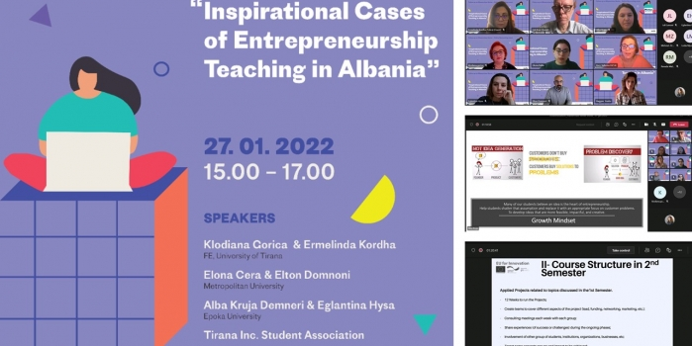

Inspirational Cases of Teaching Entrepreneurship in Albania

On January 27th, EU for Innovation in collaboration with Preneurz.Amsterdam organised an event on “Inspirational Cases of Teaching Entrepreneurship in Albania” with the participation of professors teaching entrepreneurship related courses in various Albanian universities and students of Tirana Inc. Students Association.

The academicians were invited to present actual cases of how they incorporate entrepreneurial learning in their courses: by bringing company use-cases into teaching process, building capacities needed to not only transform an idea into a business adding value to the society & economy, etc.

Dr. Alba Kruja from the Department of Business Administration and Assoc. Prof. Eglantina Hysa from the Department of Economics shared their inspirational cases with the audience.

In her speech, Dr. Kruja explained how she engaged students in her Entrepreneurship course by implementing experimental learning in two main phases. First is where students find problems worth solving. They do this through a journey of developing a growth mindset, generating ideas they are excited to work on, finding and interviewing potential customers, and ultimately validating that they are working on a problem worth solving. In the second phase, students develop solutions based on customers’ problems, build a viable financial model, build prototypes of their product to gather validated learning about customers, and design and execute business model experiments. Students develop these skills through a series of experiences developed using theories, frameworks, and methodologies from a variety of disciplines.

Prof. Hysa shared the experience of the graduate course “Development and Growth” and the follow-up of the projects that students have to engage with for at least 12 weeks. The students have to create teams that cover project leading, funding, networking, and promotion. During the weekly consulting meetings with the course lecturer, each team has a brainstorming on how to overcome the challenges and barrier they face in achieving their project objectives. Moreover, during the general meeting with the other project teams, the students share their experiences of success by providing insightful inspirations for the other peers. Successful projects manage to involve many other students, institutions, organizations or businesses to achieve their targets. Some other components of success are the project feasibility, sustainability, and the state-of-art the project presents.

**“4th Social Business Day” organized by YCSBS of EPOKA University**

## “4th Social Business Day” organized by YCSBS of EPOKA University

On Friday, May 27, 2022, “The Yunus Center for Social Business and Sustainability (YCSBS) in collaboration with the Department of Business and Administration of EPOKA University organized the “4th Social Business Day”, held at Tirana International Hotel. This event was coordinated as a one-day symposium, divided into two sessions, bringing together different personalities related to the social business field but not only. The diversity of the panel was really interesting, and their speeches brought a lot of motivation and useful information. The first session was opened with the opening speech of the director of YCSBS of EPOKA University, Dr. Erinda Imeraj, followed by the welcome speech of Prof. Dr. Ahmet Oztas, Rector of EPOKA University.

The first session continued with Assoc. Prof. Dr. Alba Kruja’s speech, Dean of the Faculty of Economics and Administrative Sciences, EPOKA University, who shared with the audience her experience of teaching social entrepreneurship in HEIs.

Mr. Erind Merkuri, Lecturer of Constitutional Law, Faculty of Law, University of Tirana, shared some key points regarding the Albanian legal framework for social businesses.

Ms. Erila Haska, Director of Strategic Partnerships, Global Innovation Management Institute, shared important information that are very helpful for social innovation and entrepreneurship.

Ms. Suela Kocibellinj, CEO of Vizion NGO, shared another perspective, where she talked about the role of social enterprises in supporting women’s empowerment.

Mr. Marjan Lukani, Director of Arka Youth Center, shared his experience of the operation of Arka Youth Center in Albania.

Mr. Rakip Belishaku, Founder of “Rinora Handmade”, talked about the purpose and aim of this social business.

Mr. Gerti Boshnjaku, CEO and Founder of New Media Group, gave a motivational speech on innovative start-ups.

The second session was dedicated to the student’s innovative social business ideas, moderated by Dr. Esmir Demaj, the Head of the Department of Business and Administration. The jury was composed of well-known academics and entrepreneurs as: Dr. Erinda Imeraj, Dr. Gelanda Shkurtaj, Mr. Gerti Boshnjaku, and Mr. Dritan Mezini.  The student competition gave space to seven groups of students to present their social business ideas, and the jury selected three winning ideas:

“Women Safety Application”- composed by: Belita Hysaj, Eriselda Deda, and Heidi Llagami, with the social purpose to create a safer environment for every Albanian woman regardless of her age, and education, occupation, and where she lives.

“VENDE-E”-composed by: Jona Salobehaj, Friona Poçari, Deborah Hasanago, Kesi Vreto, Kledia Boka, Sorina Hastoçi, and Aldo Daçi with the social purpose to reduce pollution by introducing in Albania a new innovation called “Reverse Vending Machine”.

“DI-Bikes”-composed by:  Enio Yzeiri, Eriksena Dinaj, Ardian Ismailaga, with the social purpose to focus on e-bikes and “go green” by creating a DIY battery kit that transforms a regular bike into an e-bike easily.

Social Business Day by YCSBS of EPOKA University has now become a tradition, which aims to inspire and motivate future collaboration, research, and future social entrepreneurs.

**HoD of Business Administration, Dr. Esmir Demaj attended the 22nd Annual Conference of the European Academy of Management**

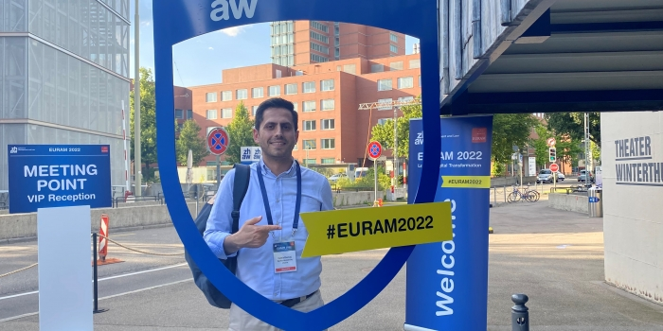Dr. Demaj attended the 22nd EURAM Conference in Winterthur, Zurich, Switzerland during June 15-17, 2022, as a Paper Presenter, Session Chair, and Paper Reviewer. He presented the research paper titled “Organizational Ambidexterity at Top Management Level: An Inductive Approach to Dynamic Managerial Capabilities”, which received support from the Research and Projects Grant Scheme of EPOKA University under the Research Project RP03-003-2019.

The European Academy of Management (EURAM) conference is the most important scientific management conference in Europe and beyond, aiming at advancing the academic discipline of management and related disciplines. Dr. Demaj is Member of the European Academy of Management.

700+ Presenting Authors and 600+ other Participants, Practitioners, PhD students, EURAM members, Panelists from all over the world attended this great gathering.

Among the Key Speakers were,

- Ignazio Cassis, the President of the Swiss Federation

- Nassim Nicholas Taleb author of the bestseller “The Swan” & “The Antifragile” etc.

-  Karin Schwab, Vice President eBay

Summary remarks from the 3-day conference,

The ongoing shift towards information technology, along with (big) data, algorithms, and business analytics, is affecting all sectors (private, public, and non-profit) and is changing how organizations create value. Besides a blurring of industry boundaries, new business models and new definitions of business performance are just some of the consequences of this digital transformation. To succeed, businesses need to be digitally optimized, data-driven, and intelligently analyze the vast amounts of data gathered.

## Projects

**Cross-Border Transfer and Development of Sustainable Resource Recovery Strategies Towards Zero Waste**

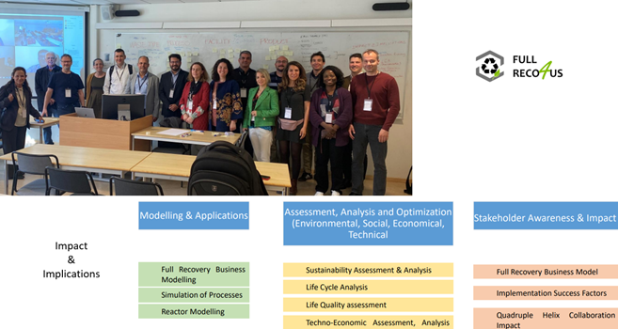

**Cross-Border Transfer and Development of Sustainable Resource Recovery Strategies Towards Zero Waste**

During May 23-24, 2022, Assoc. Prof. Dr. Alba Kruja, Professor of Management and Assoc. Prof. Dr. Eglantina Hysa, Professor of Development Economics, participated in the Management Committee and Working Group meeting of the Cost Action CA20133 - Cross-Border Transfer and Development of Sustainable Resource Recovery Strategies Towards Zero Waste (FULLRECO4US). Due to increasing awareness of the deleterious effects on the environment and human health, policies are being gradually implemented to motivate a mindset shift from linear to circular (bio)economies and decouple economic growth from use of resources. Full waste recycling and valorization will play a crucial role in the establishment of sustainable circular (bio)economies. Although waste recycling and valorization strategies have started to be implemented across borders within Europe, their implementation level is not homogenous, and harmonization is needed. FULLRECO4US is an answer to this need and will function as a discussion platform centered on holistic approaches to waste recycling and valorization, and on the development of new cross-border interdisciplinary and intersectoral networks. The two colleagues from Epoka University have discussed the necessity of incorporating assessment indicators measuring the impact of resource recovery on the economy and society. Their inclusion as management committee members and their active role in the working group discussions were more than welcome, by emphasizing the need to include people from the fields of economy, business, and beyond.

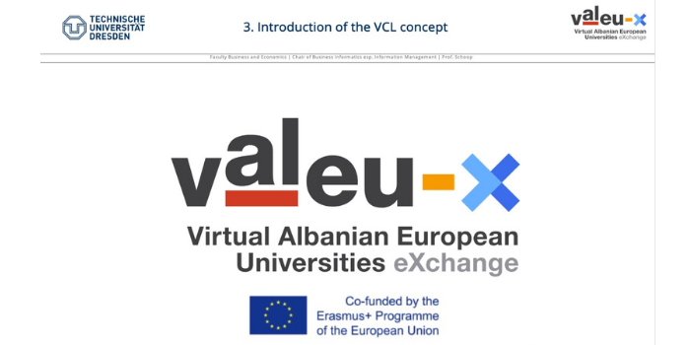**Academic staff members and students from BUS Department attend the E-tutor qualifications 2021 in the framework of VALEU-X Project**

**Academic staff members and students from BUS Department attend the E-tutor qualifications 2021 in the framework of VALEU-X Project**

On April 23rd, Academic staff and students from EPOKA University participated in the Kickoff event of the launching of E-tutor qualifications 2021 in the framework of VALEU-X Project, comprised of a series of four workshops and self-study assignments in between. The event was held via Microsoft Teams Platform and gathered many professionals and students from different universities around the world.The meeting started with a warm welcoming speech from Prof. Dr. Eric Schoop. Participants were then introduced to the course supervisors, VCL concept and task forces. A special attention was paid to the overview of qualification topics and schedule which was followed by a thorough explanation of working environment on the virtual platform. The first session concluded with a Q&A session which witnessed a high interaction among the participants.The aim of the E-tutoring workshops is to prepare academic staff and students to transfer their analogue teaching classes in the Virtual Collaborative Learning (VCL) concept through professional training sessions. A limited number of students have been invited to apply to the E-Tutors qualification for Spring Semester 2021. After the qualification, the E-Tutors will be able to support VCL modules at their home institution, one institutional and one international.The trainings will be held in a flipped classroom format. Students will get access to E-lectures (2 E-lectures per Workshop) and learn self-paced the content of the E-lectures. Self-evaluation tests will be used to test the acquired knowledge. The Workshops will concentrate on the application of the previous learned knowledge with (online) group work in the (live) Workshops.VALEU-X Project is planned as a comprehensive capacity building platform to facilitate intensive know-how transfer among the consortium members to address the problems of outdated instructor-cantered frontal teaching methods and ineffective use of ICT in formal higher education by introducing the Virtual Collaborative Learning (VCL) pedagogical concept.

**EPOKA University representatives participated in the training held at the University College of Enterprise and Administration in Poland, in the framework of the SUCCESS Erasmus+ CBHE Project**

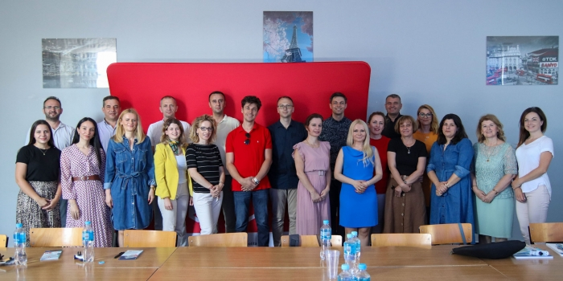

During June 28-30, 2022, a training on practice-oriented teaching methods was held at the University College of Enterprise and Administration in Poland, in the framework of the Sustainable University-Enterprise Cooperation for Improving Graduate Employability (SUCCESS) Erasmus+ CBHE Project. EPOKA University as a partner institution in the SUCCESS project was represented by MSc. Mariola Muçi and MSc. Edra Sota. The following topics were discussed:

Topic 1 - Teaching of how to learn –through experimentation, experience and other methods activating student

Topic 2 - Teaching creativity, innovation, critical thinking and teamwork skill

Topic 3 – Cooperation with business partners in social sciences

Topic 4 – Intercultural entrepreneurship – how to include intercultural aspects in regular classes

Topic 5 - Using digital technologies in the process of teaching and learning

Topic 6 – Cooperation with business partners in IT sector

The topics selected for the three-day training generated great discussions among all participants over the importance of the Intercultural Entrepreneurship, Teaching Creativity, Innovation and Business & University cooperation opportunities. In addition, a visit to the Department of Strategy and Entrepreneurship of the City of Lublin took place on 29th June. [Wiktoria Herun](https://pl.linkedin.com/in/viktoria-herun), the Head of Academic Promotion Office informed the participants on the cooperation between the city, Polish Universities and the business sector.

For more information about SUCCESS project please click [Here](https://success-project.ba/)

**EPOKA students excel in the International VCL-based case design and Pitching Contest in the framework of VALEU-X Project**

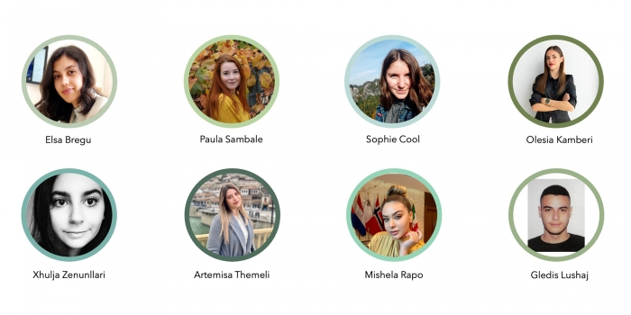

During Spring Semester 2021-2022, VCL (Virtual Collaborative Learning) course content and activities were implemented in the framework of the VALEU-X Erasmus+ CBHE project at MSc Business Administration study program of EPOKA University. 12 Master students from the BUS 426 – Strategic Management course of Dr. Esmir Demaj joined a 2-month international group-work and tutoring/mentoring activities to prepare their start-up ideas for Albania’s Next Unicorn virtual pitching contest. The focus of the VCL-based contest was to prepare business models to address various problems and opportunities in the field of Ecotourism in Albania. During May and June 2022, students from 8 universities and 4 countries worked together in groups to develop their platform business models. Students went through various stages in coherence with their master course topics like External Market Analysis, Competitive Advantage Analysis, Business Analysis, Budget Planning, Revenue Models, Marketing Strategy etc. At the end of the group work and mentoring period, all ideas were presented to an 8-member professional jury in a pitch presentation. The winning group for Albania’s Next Unicorn 2022 is Green'UP Albania. The group comprises 4 students from EPOKA University, 2 from "Fan S. Noli" University, and 2 from Technische Universität Dresden. The winning group developed an eco-travel platform that includes a short quiz. By answering questions regarding the budget, destination, number of travelers, and interest in outdoor activities, the company can suggest to travelers two to three offers from external small and medium-sized Albanian suppliers that match their quiz answers. This allows the traveler to save time in the search and receive only suggestions in the field of eco-travel. In addition to the quiz, the platform also integrates a bonus program. Travelers receive points for booking trips and accommodations, leaving reviews, and tagging the business account in their social media posts. The three travelers with the most points after three months will receive rewards. Through the win, the group can now call itself – Albania's Next Unicorn – and can enjoy their reward to join the special program organized for them during the next VALEU-X Project Meeting in Rome, Italy during September 18-22, 2022. Winning team members:

Artemisa Themeli (EPOKA)

Mishela Rapo (EPOKA)

Gledis Lushaj (EPOKA)

Olesia Kamberi (EPOKA)

Paula Sambale (TUD)

Sophie Cool (TUD)

Elsa Bregu (UniKorca)

Xhulia Zenunllari (UniKorca)

We congratulate the winning team and all EPOKA students and staff that joined and contributed to the international VCL-based case study design and Albania’s Next Unicorn Contest in the framework of VALEU-X project.

**EPOKA University staff attended the VALEU-X Staff Observation and Project Meeting at TU Dresden**

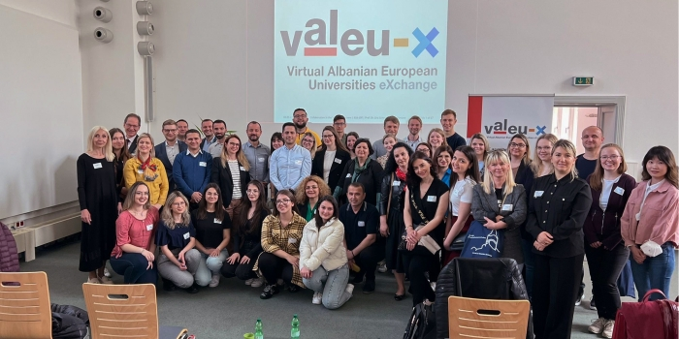

During May 03-07, 2022, Technical University of Dresden hosted the Staff Observation Visit and Project

Management meetings in the framework of the VALEU-X Erasmus+ CBHE Project. EPOKA University was represented by Dr. Esmir Demaj, Head of the Department of Business Administration, Dr. Nertil Mera, Head of the Department of Banking and Finance, Mr. Tekim Peza, Administrator of the Faculty of Economics and Administrative Sciences and PhD cand. Besjon Zenelaj. The activity was intended for Kicking-off the international VCL, Shadowing, Workshops & Observation at TUD. Among others,

The Local Virtual Collaborative Learning VCL course activities were finalized, an experience where 100 Bachelor students from EPOKA University joined for 1 semester.

The project consortium kicked-off the International Virtual Collaborative Learning (VCL) course activities where students from the MSc in Business Administration study program will team-up with other peers from Albania, Germany, and Slovenia in a virtual case design to pitch their solutions to the Ecotourism sector in Albania.

The innovative teaching and learning infrastructure of TU Dresden was observed and the group met with the Pro-Rector for Technology Transfer and Internationalization to discuss about how to further enhance the excellent collaboration we have had so far.

The event started with a Kickoff meeting and a welcoming speech from Professor Eric Schoop and Mattis Altmann who stated the importance of the project and gave important insights about Virtual Collaborative Learning via platforms enabled by communication technologies, and how we can stimulate collaborative learning in general and virtual collaborative learning specifically.

Next, the International Virtual Collaborative Learning (VCL) course activities to be organized with master students from Albania, Germany, and Slovenia were kicked-off in a hybrid setting with physical and virtual participants. The agenda was followed with training on Flipped Classroom, Digital Teaching and Learning. The activity ended with a workshop on the importance of intercultural collaboration. Representatives of each partner university met with the Pro-Rector for Technology Transfer and Internationalization at TU Dresden and his team to discuss about how to further enhance the collaboration between our institutions and they congratulated us on the further initiatives already taken for future projects. Afterwards the group attended a detailed visit to the library of TU-Dresden. The library, alongside the very large collection of online journal and sources, had a very rich archive of around 5.6 million printed sources with more than 200 personnel engaged in its functioning. The group visited the Transparent Factory of Volkswagen Group in Dresden where the electric model ID-3 is currently being manufactured. During the site visit the group observed the assembly line of the parts of ID-3 model. During the visit, the factory engineers hosting the group shared some insightful information about the process and some innovative ideas they plan to implement in the near future. The next stop of this program was a best practice for hybrid teaching and learning in the Knowledge Management course of Professor Schoop. During this event TUD students delivered their well-structured project presentations on the skills and capabilities that are required in virtual learning. The presentations were followed with discussion and feedback from both sides. During this visit, the group also attended some informal meetings with Albanian and Foreign entrepreneurs in the city of Dresden.

**Students from EPOKA University attended the VALEU-X Project Summer School**

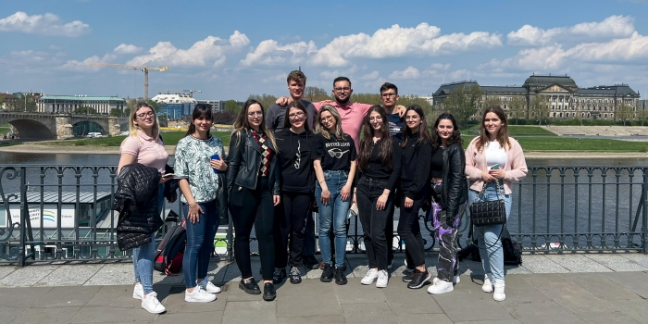

During May 01-07, 2022, TU Dresden welcomed students from EPOKA University for a 5-day Summer School in the framework of the VALEU-X Erasmus+ Project, to which EPOKA University is a partner. Ms. Enejda Doko, Ms. Kejsi Sulaj, Ms. Griselda Alushllari, Ms. Rei Shabani, and Mr. Halit Yildirim represented EPOKA University as E-Tutors by joining both physically and virtually to the activities of the summer school. Students selected to join the summer school had already been engaged in various project activities as E-Tutors by mentoring freshmen students through the virtual collaborative learning course activities implemented at EPOKA University. Below you can find a daily report of the summer school.

**Day 1** –Professor Schoop (Project Coordinator) and Mr. Mattis Altmann introduced the journey of VCL experience and the objectives for VALEU-X project specifically. Being successfully implemented between other EU universities in the past, this learning method aims to add a significant value to the teaching process in Albania by empowering academic staff with contemporary teaching competencies on innovative virtual teaching and learning settings. Cultural and social activities followed.

**Day 2** – Ms. Nelli Ukhova, head of E-Tutors, focused on terminology of culture and ethics. A big emphasis is given to the role of intercultural exchange process, which is an important component in this project. The team from EPOKA University made a presentation on the Albanian culture: values, norms, positive and negative aspects. This was followed by Ms. Ukhova’s interpretation of the German culture and its values by giving real life examples and experiences. Then the students were put into a group task where they had to create a “new country” coming out as a combination of both Albanian and German cultures. This group discussion was based on creativity and assessment of the values from both countries and their respective cultures.

**Day 3 –** The Kick-off of the International VCL course took place. The project tasks were assigned and the groups were allocated. The international VCL is a 6-week program that will help groups develop their business idea into successful Start-ups. Eight experts from universities located in Albania, Slovenia and Germany are leading the VALUE-X incubator and in the timeline of 6 weeks, different tasks will be handed in to the experts and this process will help in preparing the students for the final contest. The E-Tutors are there to assist students and provide the team with feedback for any ambiguity they have, or help needed. The collaboration will be continuously going through virtual collaboration tools and platforms, which will enable effortless and real time team work. The audience was also given a training on the analytics functions and its utility on the project fair evaluation.

**Day 4** – The presentation on cultural interexchange was further explained and the next kick-off event was elaborated in more details. Engaging tasks were given to the audience which evaluated their reaction in specific situations and emphasizing in this way their managerial attitude. To manifest the right understanding and cooperation in a communication process, the participants should try to look at the events from the other party’s perspective. This method affects positively the collaboration and the outcomes of the project. In the evening, the academic staff and the E-Tutors from Albania and TU Dresden universities gathered in a social dinner where a warm welcome and great hospitality was displayed.

**Day 5** - A presentation prepared by a group of students from TU Dresden was held in order to illustrate how to develop and enhance research work. They focused on Knowledge Identification and Knowledge Management, as crucial issues in contemporary business organizations. An extra meeting for further deadlines and important dates of project management was held and later E-Tutors were accompanied by Mr. Malte Mücke in a city tour. This was the last day of training, which was followed by the Albanian team departure on Saturday.

**The second Expert Forum on “Virtual Collaborative Learning Environment” of the VALEU-X project**

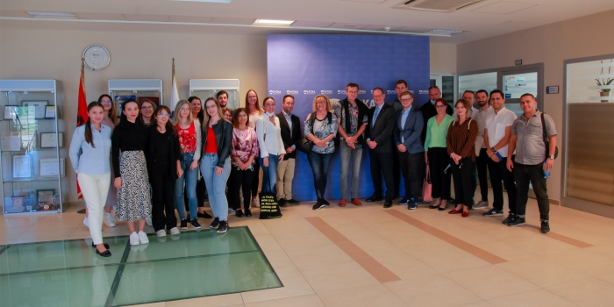

The second Expert Forum of the VALUE-X project was held, at the premises of the Aleksander Moisiu University in Durres during September 23-24, 2021. The Expert Forum was moderated by Prof. Dr. Eric Schoop from TU Dresden and was conceptualized as a best practice sharing and free room for discussion, which provided more advanced expertise about Virtual Collaborative Learning, digitalization, and virtual mobility for al l stakeholders. All participants were very committed to contribute with examples and other descriptions of experiences related to the project topics. Epoka University was represented in the Expert Forum by several academic and administrative staff members. The group of students that attended the summer school organized by TU Dresden participated in the forum too.  
The forum aimed at focusing the discussion around:

* Designing and implementing an integrated Virtual Collaborative Learning environment
* Designing didactical teaching and learning materials of selected pilot VCL courses
* Organizing and facilitating local undergraduate pilot VCL course delivery
* Availability and ability of experts in innovative teaching and learning practices to actively attend and contribute to the experts’ forum in the partner country.

The need to change our conception about nowadays students by highlighting the importance of teamwork through integrating participants form different partner organizations was stressed during the forum. This is further encouraged by the need to shift from ‘manufacturing’ workers to ‘knowledge’ workers. In addition, there is a need to shift from traditional vertical hierarchies to self-managing teams. Therefore, designing and implementing an integrated Virtual Collaborative Learning (VCL) environment is crucial for teamwork. VCL helps academicians to enhance flexibility in online teaching; focus on active learning processes; international teaching partnerships; formative assessment; access to data driven Social Learning Analytics etc. The Expert Forum was organized in a hybrid mode, on-site for the students, academic and administrative staff travelling to Durres, and online for all participants from their home countries. The rationale was to maximize participation and allow everyone interested to join.  
For more information about the VALEU-X Project please visit <https://valeu-x.eu/>

**Midterm Steering Committee meeting of the VALEU-X Project**

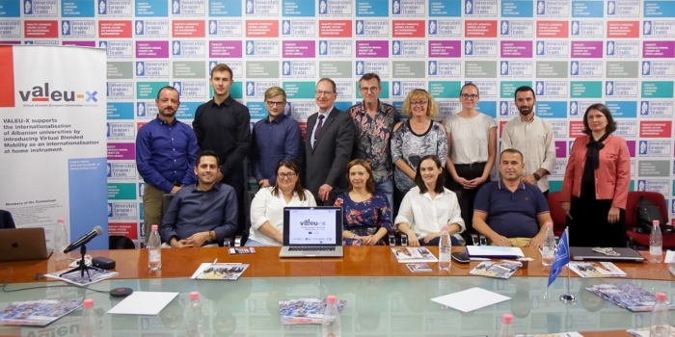

The Midterm Steering Committee Meeting of VALEU-X Project was organized during three days on September 22, 25, 27 at “Aleksander Moisiu” University in Durres, Epoka University, and European University of Tirana. Dr. Esmir Demaj and Dr. Nertil Mera attended the meetings as the project working group members representing Epoka University. Ms. Edra Sota attended the meeting on behalf of the Research and Projects Office. Among the topics discussed during the meeting was the actual status of various work packages of the project taking into consideration the Covid-19 impact to the project deliverables. Quality assurance, financial management and the status of equipment purchased in the context of the project were discussed. The selection of local VCL Pilot courses as one of the deliverables of the project along the curriculum redesign to fit VCL and teaching/learning materials for the pilot collaborative learning courses were among the important points of the agenda discussed. The Virtual Collaborative Learning Room at Epoka University equipped and installed with the equipment purchased from the VALEU-X project was inspected by the consortium partners. The VCL Room is designed as an interactive virtual learning space, where VCL based classes will be held providing students an international experience at their home university by developing and delivering technology-enhanced problem-based learning course materials in the virtual classroom. For more information about the VALEU-X Project please visit <https://valeu-x.eu/>

**Virtual Collaborative Learning (VCL) course activities successfully implemented at EPOKA University in the framework of VALEU-X Project**

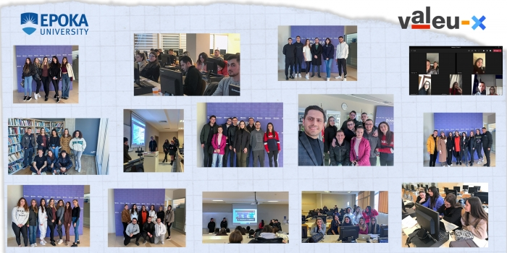

During the fall semester 2021-2022, VCL (Virtual Collaborative Learning) course content and activities were implemented in the framework of the VALEU-X Erasmus+ CBHE project at EPOKA University. The BUS 103 - Introduction to Business course, and Business Informatics freshmen students were selected to pilot the VCL innovative pedagogical approach. The VCL implementation took place for 6 weeks between 01.12.2021 and 14.03.2022. There was 1 Lecturer (Dr. Esmir Demaj), 5 E-Tutors (Enejda Doko, Kejsi Sulaj, Rei Shabani, Griselda Alushllari, Halit Yildirim) and 93 students (BINF 1A & BINF 1C) engaged. Students formed 13 groups, and each of the groups was assigned an E-Tutor. The general topic of the VCL project was to build a business plan for a Social Business Idea that aims to have a social impact alongside the economic profit. Nevertheless, the final project report was not the main objective. Systematic work, virtual team working skills, enhancing digital literacy, remote working, and interactivity were the main principles aimed to be fostered to students through the VCL innovative pedagogic approach. Further to positive student feedback, we believe the objectives were successfully reached. Students were introduced to the concepts of VCL, virtual learning tools and mechanisms. Microsoft Teams, Miro Board and other tools have been used to facilitate and monitor the virtual activities. E-Tutors, who are senior student mentors, were important actors that supervised the student progress throughout the VCL experience and actively contributed to enrich this process.  Students spent 6 weeks of virtual collaborative teamwork; they were closely mentored and monitored for each section of the business plan on weekly basis. Different tasks, quizzes, online working tools and virtual illustrations were used to enhance the comprehension of the main concepts. After general guidance and orientation done physically in class, all activities were held in virtual meetings between E-Tutors and their respective groups in a weekly basis. Students had their own virtual meetings as well. All activities, progress and contributions have been recorded and archived for a post-project evaluation. All these components contributed to producing satisfactory results, students’ project presentations were effortful and accomplished. They showed great willingness and were regularly engaged in earnest and energetic work. Group projects can promote important intellectual and social skills and help to prepare students for a work world in which teamwork and collaboration are increasingly the norm. Students stated that this methodology helped them take the project more seriously, work step by step and it was a more structured way to develop a project, which encouraged greater commitment from each student. VALEU-X project is led by Technical University of Dresden and aims to facilitate the learning process in higher education institutions in Albania through Virtual Collaboration and learning mechanisms. The main objective is to support the qualification of academic staff at Albanian HEIs for innovative virtual teaching and learning settings. For more information about VALEU-X project please click [Here](https://valeu-x.eu/)

## E. Support, Resources & Representation

**List of Student’s Internships**

|  |  |  |  |  |  |
| --- | --- | --- | --- | --- | --- |
| NO. | Name Surname | Study  Program | Professional Practice Period | Company | Department/ Office |
| 1 | Arlina Dumani | BA BINF | 2 months | 2T Sh.P.K | Finance Office |
| 2 | Sara Luka | BA BINF | 1.5 months | 2t Shpk | Finance |
| 3 | Alesio Rizvani | BA BINF | 1 month | Accounting Office Demir Lika | Finance Office |
| 4 | Evis Ahmeti | BA BINF | 1 month | Admir Kajo, Audit & Accounting | IT Department |
| 5 | Anxhelo Hyka | BA BINF | 1.5 months | Agna Group | Main Office |
| 6 | Pamela Gjanci | BA BINF | 2 months | Akh Consulting | Finance |
| 7 | Suada Karruka | BA BINF | 1 month | Alb Building Shpk | Finance |
| 8 | Igla Muça | BA BINF | 3 months | Alba Parts Shpk | HR & Trainings Department |
| 9 | Romina Shahu | BA BINF | 3 months | Alba Parts Shpk | Procurement |
| 10 | Xhoana Nelaj | BA BINF | 1 month | Albania Leasing | Finance Office |
| 11 | Ketjona Shameti | BA BINF | 1 month | Albanian Business Partner | Software Company |
| 12 | Gabrielle Hellen Nase | BA BINF | 1 month | Albanian Business Partner Sh.p.k | IT Department |
| 13 | Leticia Shatro | BA BINF | 1 month | Albpetrol Sh. A. | Information Technology |
| 14 | Hybe Sina | BA BINF | 1 month | Albtelecom | Software Development |
| 15 | Fatjona Jangulli | BA BINF | 1 month | Albtelecom | IT Department |
| 16 | Lidia Beka | BA BINF | 3 months | Albweb | Web Development |
| 17 | Valentin Kote | BA BINF | 1 month | Alpha Bank | Accounting Office |
| 18 | Gleni Lame | BA BINF | 4 months | Alushi-Trans Shpk | IT Department |
| 19 | Eni Keci | BA BINF | 1 month | Autoriteti Portual Durres | IT Department |
| 20 | Kejsi Blushi | BA BINF | 1 month | Balkan Sport | Data Analysis |
| 21 | Anxhela Dauti | BA BINF | 1 month | Balkans Capital | Accounting And Finance Office |
| 22 | Ervelina Poka | BA BINF | 1 month | Banka Kombetare Tregtare | IT Department |
| 23 | Klerta Terziu | BA BINF | 2 months | Bashkia Librazhd | It Department |
| 24 | Bora Idrizaj | BA BINF | 2.5 months | Bold Crest | Digital |
| 25 | Spiro Konomi | BA BINF | 1.5 months | C.C.S Shpk | Business Soultions |
| 26 | Isara Ismaili | BA BINF | 2 months | Café Mondus Company | Finance |
| 27 | Andi Çuku | BA BINF | 1.5 months | Cardo Ai | It Office |
| 28 | Fjona Kazazi | BA BINF | 1 month | Computer & Copier Systems | IT Department |
| 29 | Klea Xhetani | BA BINF | 3 months | Credins Bank | Client Service |
| 30 | Tesi Zace | BA BINF | 1 month | Credins Bank | Hr |
| 31 | Oriado Dani | BA BINF | 1 month | Dani Group | It |
| 32 | Santjola Hasanaj | BA BINF | 1 month | Deliotte Albania | Finance |
| 33 | Elgis Luzi | BA BINF | 2 months | Deloitte Albania Sh.P.K | Risk Advisory |
| 34 | Eralda Hasa | BA BINF | 1 month | Diem Group Ltd | IT Department |
| 35 | Artiola Rama | BA BINF | 1 month | Doan Glass Shpk | Accounting Office |
| 36 | Erdikent Prenga | BA BINF | 1 month | Dode Prenga | IT Department |
| 37 | Ingrida Tako | BA BINF | 1 month | Drejtoria E Mbledhjes Se Detyrimeve Tatimore Te Papaguara. Rajoni Qendror | Finance |
| 38 | Alesia Duda | BA BINF | 1 month | Drejtoria Rajonale E Sigurimeve Shoqerore | Contribution Office |
| 39 | Lulzim Aliaj | BA BINF | 1.5 months | E88 Bar | E88 |
| 40 | Argida Shabani | BA BINF | 1 month | Edea Contable | Accounting Office |
| 41 | Sara Brahollari | BA BINF | 1 month | E-Goals Shpk | It |
| 42 | Esmeraldo Shtaro | BA BINF | 1 month | Elektroitalia | Management Department |
| 43 | Reisa Haveri | BA BINF | 1 month | Epoka University | Ictc Office |
| 44 | Sueda Sogutlu | BA BINF | 1 month | Epoka University | Ictc Office |
| 45 | Griselda Alushllari | BA BINF | 2.5 months | Epoka University | Research And Projects Office |
| 46 | Klea Hoxha | BA BINF | 96 hours | Epoka University, Ictc Office | It Department |
| 47 | Redina Mishka | BA BINF | 2.5months | Fabio Ibrahimi Shpk | Finance |
| 48 | Ismail Shpati | BA BINF | 2 months | Facilization | Core Banking Development |
| 49 | Kevin Besho | BA BINF | 1 month | Fama Tech | It Department |
| 50 | Stela Guri | BA BINF | 2 months | Fed Invest | Finance |
| 51 | Ilma Rustemi | BA BINF | 2 months | Ferra & Co | Accounting |
| 52 | Erjon Fida | BA BINF | 1 month | Fidash Mobileri | IT Department |
| 53 | Ergys Ndoj | BA BINF | 1 month | Fidash Mobileri | Management Department |
| 54 | Kejsi Kurti | BA BINF | 1 month | Flex Business Solutions | Software Company |
| 55 | Agustin Kola | BA BINF | 1.5 months | Flex Business Solutions Shpk | It Office |
| 56 | Klaus Koçi | BA BINF | 96 hours | Fondi Shqiptar I Zhvillimit (AEM) | Finance |
| 57 | Sindi Kallcishta | BA BINF | 1 month | Four Seasons Hotel | Accounting & Tax |
| 58 | Laura Kukaviqi | BA BINF | 1 month | FRB Auditing And Finance | Accountant And Finance |
| 59 | Romario Prifti | BA BINF | 1 month | Galeri Arti Kledio | It |
| 60 | Dejan Nina | BA BINF | 1 month | Greemed Sh.P.K | Finance Office |
| 61 | Kristo Marku | BA BINF | 3 months | Halley Sistemi | Information Technology |
| 62 | Tuana Elif Yozgatli | BA BINF | 1 month | Harmony School | Teaching Assistant |
| 63 | Xhoni Durro | BA BINF | 1.5 months | Hotel Stela | Economic Office |
| 64 | Kristina Opari | BA BINF | 2 months | Ikub Info | Python Unit |
| 65 | Egli Merdosti | BA BINF | 1 month | Info Business Solutions Ltd | It Development Sector |
| 66 | Armonela Prengaj | BA BINF | 1.5 months | Instat | It Office |
| 67 | Brand Çitozi | BA BINF | 1 month | Intelycare Albania Shpk | It Office |
| 68 | Marjela Proda | BA BINF | 1.5 months | Joel Travel Shpk | It Office |
| 69 | Sara Muharremi | BA BINF | 3 months | Joy Travel Shpk | Finance |
| 70 | Erti Hysi | BA BINF | 1 month | Kristal Consulting Shpk | Finance Department |
| 71 | Aridona Dedja | BA BINF | 1 month | Lindi-Al Shpk | Finance Office |
| 72 | Lejdi Loci | BA BINF | 1 month | Loci Sh.P.K | Accountant And Finance |
| 73 | Klajdi Sina | BA BINF | 1 month | Loci Sh.P.K | Accounting And Finance |
| 74 | Megi Loci | BA BINF | 1.5 months | Loci Shpk | Hr |
| 75 | Lorena Zito | BA BINF | 1 month | Luke Kontabel | Finance |
| 76 | Enkel Dervishi | BA BINF | 2 months | Magoware | IT |
| 77 | Inesa Papa | BA BINF | 3 months | Mb Consulting | Finance |
| 78 | Lutfie Veisllari | BA BINF | 1 month | Medreseja E Tiranes | Finance |
| 79 | Flori Xhaferi | BA BINF | 1 month | Megatek Sh.a | IT Department |
| 80 | Ariel Borakaj | BA BINF | 1.5 months | Municipality Of Kavaja | IT Office |
| 81 | Arteu Hasanaj | BA BINF | 2 months | Municipality Of Kavaja | Server Office |
| 82 | Adora Ndrejaj | BA BINF | 1 month | Municipality Of Tirana | IT Office |
| 83 | Denis Myrtaj | BA BINF | 2 months | Municipality Of Tirana | Directory Of Free Trade Zones, Foreign Investment And Diaspora |
| 84 | Joana Caco | BA BINF | 3 months | Nebula Shpk | Software Development |
| 85 | Ervisa Lamce | BA BINF | 1 month | Next Albania Shpk | IT Department |
| 86 | Aluena Hysenaj | BA BINF | 1 month | OLA 1 Shpk | IT Office |
| 87 | Sebastian Kokonozi | BA BINF | 1.5 months | One Telecommunications | It |
| 88 | Thellenxa Cuka | BA BINF | 2 months | Opt Bank | Accounting |
| 89 | Laura Muçaraku | BA BINF | 3 months | Otp Bank Albania | Hr & It |
| 89 | Admir Demaj | BA BINF | 1 month | Otp Bank Albania | It Development Sector |
| 90 | Ambra Taullahu | BA BINF | 3 months | Otp Bank Albania | General Resources Department |
| 91 | Hamite Selimi | BA BINF | 1 month | Pica Tani | Management Department |
| 92 | Enkel Mehillaj | BA BINF | 1 month | Pica Tani | Management Department |
| 93 | Kevin Josifi | BA BINF | 1 month | Pricewaterhouse Coopers Consulting | Tax Technology Department |
| 94 | Argent Bregu | BA BINF | 1 month | Private Accounting Office | Accounting Office |
| 95 | Silvi Ruci | BA BINF | 1.5 months | R&T Avdertising | Marketing |
| 96 | Suela Luzi | BA BINF | 1.5 months | Raiffeisen | Customer Service |
| 97 | Fabiola Kycyku | BA BINF | 1 month | Raiffeisen Bank Albania | IT Department |
| 98 | Migena Illiu | BA BINF | 1 month | Rent A Car Xheni | Customer Service |
| 99 | Klaivert Hoxhaj | BA BINF | 2 months | Ritech | Programming & Database |
| 100 | Redjan Zaci | BA BINF | 1 month | Ritech Solutions | It |
| 101 | Kristi Kadiasi | BA BINF | 1 month | Selishte Shpk | Accountant And Finance |
| 102 | Stiljan Nallbati | BA BINF | 1 month | Sfc Alb | Finance |
| 103 | Ervehe Misiraj | BA BINF | 1 month | SFC ALB Shpk | IT Department |
| 104 | Ajsel Toska | BA BINF | 1 month | Sfc Albania | Medical Billing |
| 105 | Anisa Ceka | BA BINF | 2 months | Spar Albania | Finance Office |
| 106 | Majola Biro | BA BINF | 2 months | Spar Albania | Finance |
| 107 | Vamela Petromilo | BA BINF | 2 months | Spar Albania | Finance Office |
| 108 | Flavio Pisli | BA BINF | 1 month | Spitali Universitar Obstetrik Gjinekologjik "Koco Gliozheni" | IT Department |
| 109 | Tea Govaci | BA BINF | 3 months | Studio Ligjore Novi | Law |
| 110 | Klea Pilavi | BA BINF | 3 months | Tirana Bank | Accounting And Information Technology |
| 112 | Deni Velillari | BA BINF | 2 months | Tirana Bank | Marketing |
| 113 | Gloria Hana | BA BINF | 1 month | Tirana-Albania | IT Department |
| 114 | Miraxh Myrta | BA BINF | 2 months | Trimi Kontabel Shpk | Accounting & Tax |
| 115 | Onela Bodini | BA BINF | 3 months | Twig Company | Sales Department |
| 116 | Orjola Hadroj | BA BINF | 1 month | Twig Company | Sales Department |
| 117 | Gerta Bushi | BA BINF | 1 month | Twig Company | IT Department |
| 118 | Deni Maçi | BA BINF | 1 month | Typedlogic Llc | Typedlogic |
| 119 | Soend Askushaj | BA BINF | 3 months | Univers Reklama | Sales |
| 120 | Laura Iskurti | BA BINF | 1 month | Xhani Sh.P.K. | Economist |
| 121 | Suela Petku | BA BUS | 1 month | Albania Gas Tech SHA | Management Office |
| 122 | Olgert Kote | BA BUS | 1 month | Aroma jote Perfumery | Online Sales Office |
| 123 | Mirjana Shehu | BA BUS | 3 months | BEJD Group | Admissions Office |
| 124 | Sindi Shpati | BA BUS | 1 month | Diamond SHPK | Finance Office |
| 125 | Sara Rusi | BA BUS | 1 month | Evo Construction | Accounting Office |
| 126 | Oliverta Haklaj | BA BUS | 1 month | Facelift Bytyçi | Management Office |
| 127 | Sonja Bejaj | BA BUS | 1 month | Ferra & Co SHPK | Customer Service Office |
| 128 | Merisa Shimaj | BA BUS | 3 months | Floros SHPK | Admissions Office |
| 129 | Otion Beho | BA BUS | 1 month | Free Inter Trade | Admissions Office |
| 130 | Mirjan Marku | BA BUS | 2 months | Kompleksi "The King" | Management Office |
| 131 | Nelind Dedolli | BA BUS | 2 months | MARES Reklama | Finance Office |
| 132 | Xheni Meta | BA BUS | 1.5 months | Neptun SHPK | Marketing Office |
| 133 | Mirel Kastrati | BA BUS | 1 month | Tirana Tobacco Company | Accounting Office |
| 134 | Tea Haxhimali | BA BUS | 2.5 months | Top Channel | Marketing Office |
| 135 | Suada Lleshi | BA BUS | 2 months | UN Youth Albania | Central Office |
| 136 | Nalina Xhafa | BA BUS | 2.5 months | Vila One Beach Hotel | Customer Service |
| 137 | Xhonatan Mehmeti | BA IML | 1 month | Mehmeti SHPK | Logistics |
| 138 | Fjori Ferko | BA IML | 3 months | 2faf Shpk | Finance |
| 139 | Melisa Llungu | BA IML | 1.5 months | American Hospital | Smarketing |
| 140 | Arlisa Hamza | BA IML | 2.5 months | Apollo Digital | Marketing |
| 141 | Alban Bedini | BA IML | 2 months | Argjendari Miluna | Sales |
| 142 | Sebastian Lici | BA IML | 1 month | Bar Fresku | Sales |
| 143 | Drini Avdullahu | BA IML | 1.5 months | Bbd Shpk | Marketing Specialist |
| 144 | Sabina Bushaj | BA IML | 3 months | Bkt |  |
| 145 | Denis Qyta | BA IML | 3 months | Blue Filter | Sales |
| 146 | Fjorda Cangu | BA IML | 2.5months | Bori Agency | Sales |
| 147 | Ambra Ismaili | BA IML | 2.5months | Club Fm | Marketing |
| 148 | Griseld Grabolli | BA IML | 3 months | Colombo Shpk | Economics |
| 149 | Iris Xhaja | BA IML | 1 month | D&E Shpk | Logistics |
| 150 | Anxhela Gjepali | BA IML | 6 months | Dyrrakium Construction |  |
| 151 | Aldea Xhymerti | BA IML | 2.5 months | Dyrrakium Construction | Sales |
| 152 | Sidjola Kapxhiu | BA IML | 2 months | Global Lojistik | Logistics |
| 153 | Sonmario Uruçi | BA IML | 1 month | Evro Jet Services SHPK | Sales Office |
| 154 | Anja Jasimi | BA IML | 3.5 months | Inifinity Al | Marketing |
| 155 | Sara Lumani | BA IML | 2months | Tirana Bank | Marketing |
| 156 | Rrdona Kaleci | BA IML | 2.5 months | Intercall | Sales |
| 157 | Betina Karmaj | BA IML | 2 months | Pocket System | Marketing |
| 158 | Ermira Karmaj | BA IML | 2 months | Pocket System | Marketing |
| 159 | Daniela Demiraj | BA IML | 2.5months | Sfc Alb | Hr |
| 160 | Emil Salija | BA IML | 3 months | Univers Reklama | Sales |
| 161 | Alesia Bali | BA IML | 1 month | Vioner Shpk | Marketing |
| 162 | Gledis Lila | BA IML | 2.5 months | Vioner Shpk | Finance |
| 163 | Ledjan Alldashi | BA IML | 2.5 months | Vocapp | Sales |
| 164 | Endi Driza | BA IML | 2 months | Wilson | Marketing |

## Participation in Academic Events

**Prof. Dr. Waldemar Pfoertsch of the Department of Business Administration participated in the World Marketing Forum**

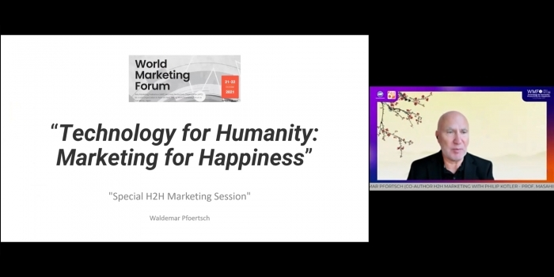

On October 21-22, 2021, the World Marketing Forum was held in Kamakura, Japan with the topic “Technology for Humanity: Productivity for Happiness”. The World Marketing Forum (WMF) is an annual, by-invitation-only event hosted by Asia Marketing Federation (AMF) and devoted to marketing professionals worldwide. The forum aims to promote ongoing discussion on the latest development in marketing and sharing of global best practices. Prof. Dr. Waldemar A. Pfoertsch from the Department of Business Administration participated in this forum and presented the newest marketing insights in the special H2H Marketing Session. In his speech, Professor Pfoertsch mentioned the importance of the H2H Marketing concept, and the tendency to create a better world through marketing. H2H Marketing concept has been elaborated closely for more than 30 years by Professor Philip Kotler (also known as the father of modern marketing) with Professor Waldemar Pfoertsch from EPOKA University. The focus of H2H Marketing is how it would adapt to all changes in the world, especially during Covid-19 pandemic. During the pandemic, the idea for orientation and the advancement of digitalization was greatly pushed. Likewise, further changes have been done on marketing such as the development from B2B To B2B2C then to H2H Marketing, and that of the H2H Marketing Model. During the first day of the conference, Professor Pfoertsch explained: “How Marketing Management has gone through different changes in the last 50-60 years, especially the one from Outbound Marketing to Customer Looking Inbound Marketing or the development of the sales funnel and the customer path”.

**EPOKA University hosted Mr. Samir Mane, President of BALFIN Group**

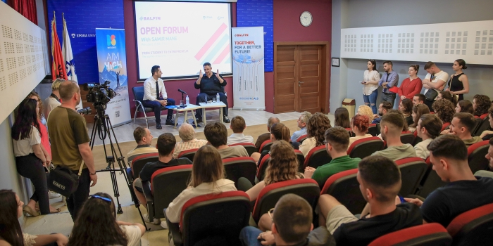

On May 31, 2022, EPOKA University welcomed Mr. Samir Mane, President of Balfin Group for an Open Forum. The visit started with a welcome and discussion at the office of the Rector of EPOKA University, Prof. Dr. Ahmet ÖZTAŞ, where the two explored possible frontiers of collaboration among the two institutions. Mr. Mane congratulated the Rector for the high academic and professional standards that EPOKA University graduates are equipped with and expressed the readiness of Balfin Group to host students for professional practices and new graduates for formal employment. In this context, students are highly advised to follow up with the Career Planning and Alumni Office of EPOKA University for the opportunities offered.

Balfin Group is one of the biggest and most successful investment groups in the Western Balkans and beyond, conducting business activities in a diversified wide range of industries on a national and international scale in 8 countries, including Austria, Switzerland and Netherland, with approximately 5,500 employees, total assets amounting to Euro 1.4 billion, and with a gross revenue of € 639 million in 2020.

The Open Forum, moderated by Dr. Esmir Demaj, Head of the Department of Business Administration, was designed in the form of an open discussion with questions and probes both from the moderator of the forum and the large audience which showed a very high interest for the event. In the event were present more than 120 participants.

Mr. Mane had a lot to say given the 30+ years of experience as an entrepreneur with many successful initiatives. He shared with the audience his perspective on entrepreneurship and especially his entrepreneurial journey of building a successful business from the very beginnings as an electronic devices’ retailer in Vienna until the present day, where Balfin Group has grown exponentially with a diversified portfolio into various industries like Wholesale and Retail, Real Estate, Banking, Mining and Smelting, Education, Logistics and Tourism.

Mr. Mane talked about corporate governance, principles of investment at Balfin Group and care shown to sustainability principles. An important part of the discussion focused on how the industry can collaborate with the higher education sector to co-create value further to what is called as the Triple-helix approach of education. Open questions with students followed in terms of how Balfin Group managed to come so far; What are the managerial skills considered important that new graduates should possess to be competitive in the market and manage future projects; In what areas or industries do they see a future potential in local, regional and global terms; What advice would Mr. Mane give to students who have business ideas and are thinking of becoming an entrepreneur;  What’s in store for the upcoming years for Balfin and Investment advices from Mr. Mane.

We thank Mr. Mane for the productive discussion, and we are looking forward to further enhance the good collaboration we have with Balfin Group!

**Department of Business Administration hosted Prof. Wollny from HS Mainz**

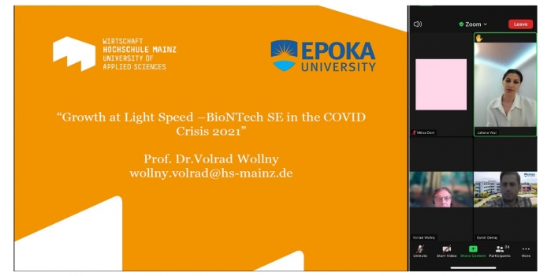

On Tuesday May 10, 2022, Dr. Esmir Demaj hosted Prof. Dr. Volrad Wollny from University of Applied Sciences Mainz, Germany in the BUS 426 – Strategic Management master class in the framework of the successful partnership agreement EPOKA University has with HS Mainz. Dr. Wollny is a professor at the School of Business of University of Applied Science Mainz, Germany since 2001 and teaches Strategic Management, Supply Chain Management, and Operations courses. Professor Wollny talked about the very interesting and innovative start-up case of BioNTech in the context of the “Growth at Light Speed” Project with Pfizer during the COVID Crisis. The focus of the lecture was mainly on the Business Model of BioNTech, the Strategic Alliance with Pfizer, the Funding and Finances, Manufacturing and Supply Chain challenges faced. Open discussion exchange with students followed in terms of what have been the main success factors for BioNTech? Growth strategies followed by BioNTech? How did BioNTech finance its growth? Is its financial strategy in line with its business policy & strategy? The future of BioNTech?

We thank Professor Wollny for the joyful lecture and the very productive discussions with our MSc in Business Administration students.

**Guest Lecture – Mrs. Gentiana Josifi**

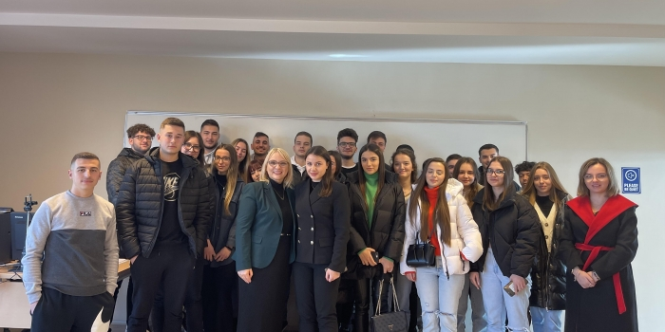

On January 10, Assistant Lecturer Ms. Mariola Muci invited in the BUS 103 Course as a guest lecturer, Mrs. Gentiana Josifi who is the Head of Organization and Talent Development at Vodafone Albania. Mrs. Gentiana presented to the students the strategic and partnering role that HR function plays in an organization. Mrs. Gentiana also shared the great practices that Vodafone Albania has on Talent Strategy and Development programs. The students had the possibility to interact and pose questions to Mrs. Gentiana, who has over 20 years experience in Human Resources Management.

**Guest Lecture – Mrs. Irida Kovi**

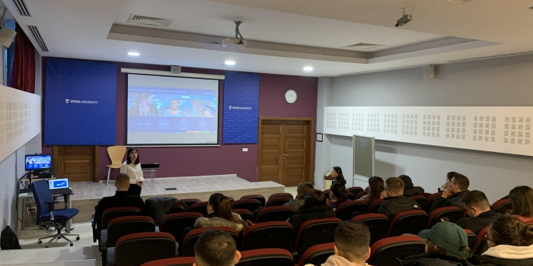

Assistant Lecturer Ms. Mariola Muci organized a guest lecture with Mrs. Irida Kovi, Human Resource Manager of British American Tobacco titled “HR Management in Organizations “held on January 12 in the BUS 103 Course. This lecture set out to outline recruitment and selection process, performance management and employee relations. Career opportunities offered to students by British American Tobacco including Global Graduate Program and Battle of Minds were also discussed.

**Guest lecture with Tina Heinicke**

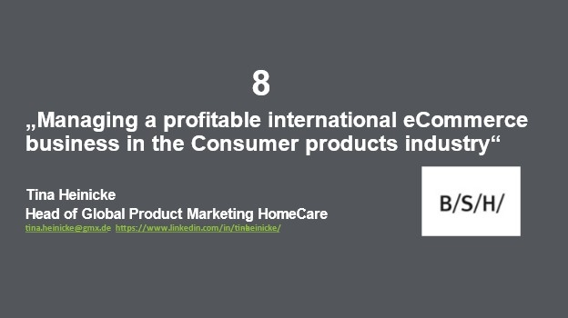

On December 02, 2021, in the master class of Strategic Marketing, taught by our Prof. Dr. Waldemar Pfoertsch, a guest lecturer was invited. Ms. Tina Heinicke is the Head of Global Product eMarketing Home Care in the “BSH Home Appliances Group”, leading a team in Munich, Istanbul, and Singapore.  Ms. Heinicke provided fresh insights from her current knowledge of direct e-Commerce marketing.

During the years 2008-2011, she worked as a Product Group Manager for the coffee filter in the “Melitta Group” (Melitta Group Management GmbH & Co. KG). In November 2011, she joined “BSH Home Appliances Group” (BSH Hausgeräte GmbH), working as a Product Marketing Manager for Indoor Cleaning. Until 2018, she has been working in this position, and then, from January 2019, she was promoted as Head of Global Product Marketing for HomeCare, which covers most of the B/S/H small convenience appliances.

During the presentation, Ms. Heinicke talked about the topic “Managing a profitable international eCommerce business in the consumer products industry”. She introduced first-hand insights about e-Content and its importance, the advantages, and disadvantages that the appliance of e-Commerce has on any business and more particularly on the marketing field.

She provided fundamental information on the product offerings of B/S/H Group and how revenues can be generated by online marketing. This was a very insightful lecture session, as Ms. Heinicke introduced examples from around the world and provided approved e-Commerce concepts, which accelerated the company’s position in cyberspace. It was a great pleasure having Ms. Tina Heinicke at Epoka University Business Master Program.

**Communication strategies at BALFIN Group: from HRM to CRM**

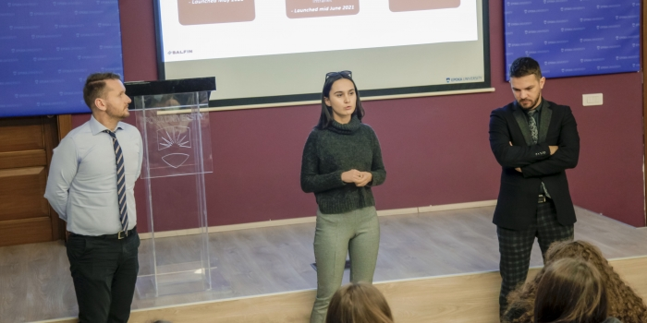

On January 23, 2022, students from HRM course of Prof. Xhimi Hysa participated in a company management training session related to classical and digital communications at BALFIN Group. Guests such as Mr. Gert Zenelaj (Brand & Digital Manager), Mr. Sokol Kondi (PR & Events Manager), and Ms. Kejsi Kurani (Internal Communications Specialist). Ms. Kurani, an alumna of EPOKA University (business administration program), shared with the students internal communication strategies, operations, tools (e.g., BALFIN's intranet, BALFIN App, etc.). In this way, Kejsi emphasized the central focus on employee relations. In addition to that, Gert and Sokol showed how internal and external communications support both employees and customers, while emphasizing the cross-functional culture at BALFIN.

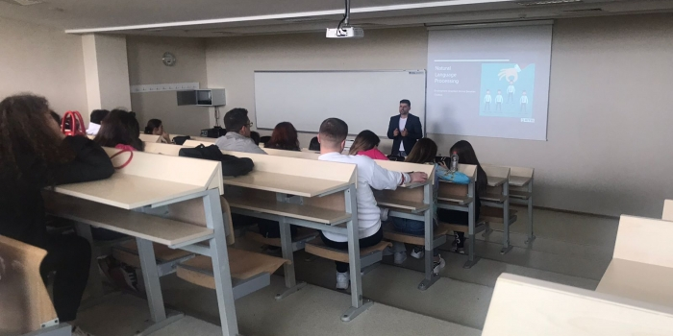**Guest Lecturer - Mr. Emiliano Mankolli**

On May 5, 2022, Mr. Emiliano Mankolli , was a guest lecturer during the Principles of Programming Course lectured by MSc. Aida Bitri at Epoka University.

Emiliano Mankolli is the Head of the Data Science Department at Ritech International AG. Decision-making, process optimization, improvements, and business development are things to strive for in today's fast-paced economy and Data Science has a strong say in all of those. Students of Business Administration, Banking and Finance, International marketing and logistics and economics were introduced with the importance of acquiring programming skills and how to implement current technologies to solve business-related problems.

We thank Mr. Mankolli for his time and for sharing all the interesting information with us.

**Guest Lecturer - Mr. Donald Gjika**

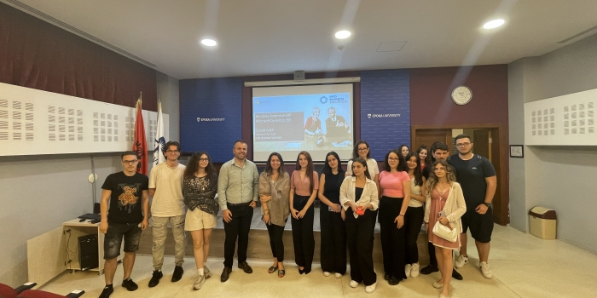

On June 9, 2022, Mr. Donald Gjika, was a guest lecturer during the Management of Information Systems Course lectured by MSc. Aida Bitri at Epoka University.

Donald Gjika is the General Manager of Info Business Solutions. Students of Business Informatics were introduced to different Microsoft products that can be implemented and adapted according to the business needs.

We thank Mr. Gjika for his time and for sharing all the interesting information with us.

**ICT tools for Self-Regulated Learning - Aida Bitri**

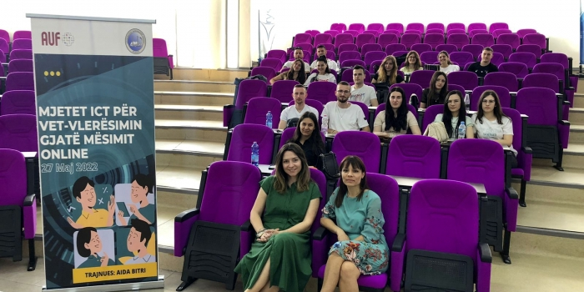

In the framework of " L’intégration des méthodes d’autoévaluation des étudiants dans l’enseignement online" project founded by AUF, Assistant Lecturer Aida Bitri was invited to train UAMD students on ICT tools for Self-Regulated Learning. The ability to “learn how to learn” is considered a key indicator of success in the workplace and society in general.  
ICT-based tools can support different strategies for Self-Regulated Learning and can be a help for eager independent learners.  Students were introduced to some of these tools.

**Guest Lecturer – Mr. Edvin Stefani**

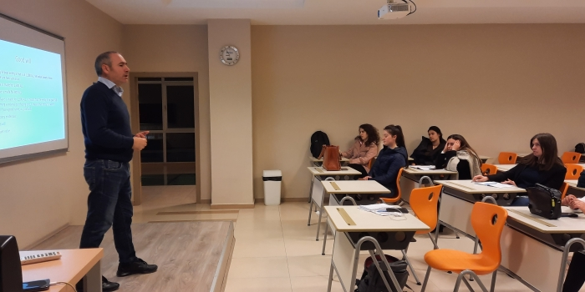

On 18th of February 2022, the leading professor of the master course BUS 527- International Accounting and IFRS, Mr. Erjon Saraçi invited the guest lecturer Mr. Edvin Stefani – a professional expert and academic on the Tax subject – to teach the last lecture "The Deferred tax (IAS 12)".

This lecture was of big interest to the students in order to understand an advanced tax concept and its reporting in the financial statements. The lecture started with a comparison between costs and expenses, the comprehension of which is a basis to understand profit tax base and the deferred tax mechanism. Mr. Stefani thoroughly elaborated the main concepts and made use of several examples and real case studies to better illustrate the information and add value to the lecture. There was a good level of interaction from students’ side, who were engaged and active participants. Different questions were posed to the invited professor, and he was very willing to provide explanatory answers to all of them. Overall, this learning session was interesting and successfully reached the set objectives.

**Guest Lecture - Mr. Ardian Jashari**

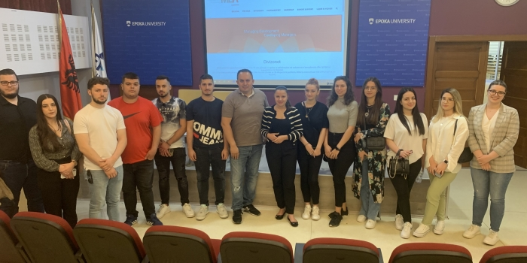

On May 20 Assistant Lecturer Ms. Mariola Muci organized a guest lecture event with the students of International Marketing and Management of Multinational Enterprises course. The guest lecturer was Mr. Ardian Jashari, Managing Partner at MDA Kosovo and Team Leader of the Europe House Project.

Students gained very valuable information regarding Mr. Jashari’s successful experience as an entrepreneur as well as the future opportunities that European Union and Europe House provides to the young undergraduate or graduate students.

Thank you, Mr. Jashari, for joining us and we are looking forward to other fruitful collaborations.

**ERP Systems, Challenges and Opportunities in the Albanian Market**

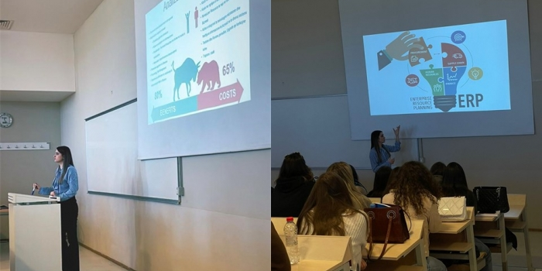

On January 27, 2022, Mrs. Anisa Begaj, was a guest lecturer during the Operations Management Course lectured by Dr. Alba Kruja at Epoka University.Currently working as Business Analyst at Info Business Solutions, Mrs. Begaj was invited to share with 3rd year Business Informatics students her experience in ERP implementation, challenges, and success stories in the Albanian market. The main purpose of an Enterprise Resource Planning system is to increase organizational efficiency of an organization by managing and improving how company resources are utilized. Improving and/or reducing the number of resources necessary without sacrificing quality and performance are keys to effectively improving business growth and profitability.

We thank Ms. Begaj for her time and for sharing all the interesting information with us.

**WB Tourism through the Lens of Youth**

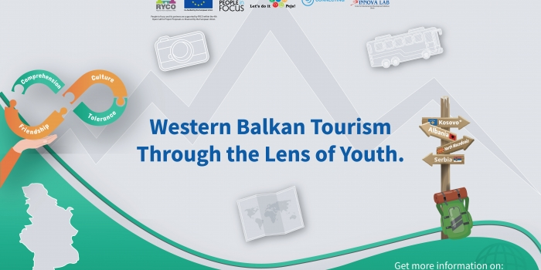In the framework of the implementation of the regional project “WB Tourism through the Lens of Youth”, an informative session was organized on October 27, 2021 with Epoka University students.

In this session representatives from People in Focus which is one of the partners in this project, presented the results of regional survey on young people’s perception about tourism in Western Balkan. Moreover, young people who had participated in youth exchanges in the frame of this project shared their experience in regional activities with their peers. Epoka’s Marketing students exchanged ideas on actions to be undertaken to promote tourism in Western Balkans.

This project aims to increase cooperation, exchange of information, and empower youth with main focus on tourism in WB region. It looks forward to changing past habitudes on tourism and setting new paths of sharing and learning. People in Focus and its partners are supported by Regional Youth Cooperation Office - RYCO within the 4th Open Call for Project Proposals co-financed by the #EuropeanUnion.

**Company visits: “Diamant Logistics”**

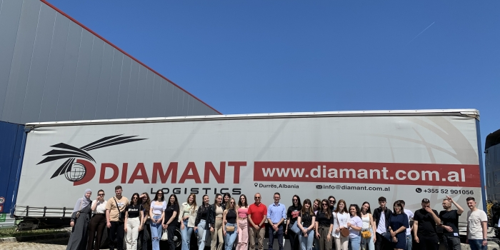

On Friday, May 20, 2022, Assoc. Prof. Dr. Osman Metalla on behalf of Strategic Logistics Management course organized a site visit at Diamant Logistics.

Students visited the company premises, and they had the opportunity to observe different logistics activities such as materials handling, warehousing, inventory control and transportation. They were also informed about job opportunities or internships that the company offers.

Special thanks go to Mr. Klajdi Goga, and we look forward to valuable activities like this!

**Site Visit at Landmark Communications by Prof. Ms. Mariola Muçi**

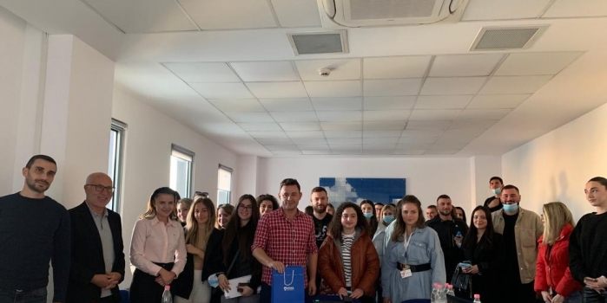

On 19 November 2021, Prof. Ms. Mariola Muçi organized a site visit for students of E-Marketing course at Landmark Communications. The purpose of the visit – was to give students the opportunity to learn through a better experience, by meeting, engaging, and interacting with the management teams and the CEO of the company.

During the 2-hour visit, 30 students had the opportunity to meet with the CEO - Mr. Erion Isufi, the Social Researcher – Ms. Xhesika Banushi and the Human Resources Manager – Ms. Alisa Kike.

The presentation consisted of the company’s overview, their E-Marketing strategies, advertising services and public relations services. Students pointed out some good questions on how the company has changed since it started to meet the demands of a changing market, the company’s plans for the next few years and how do employees embody the company’s culture.  
Making connections at the company was a golden opportunity to solidify connections later since they were interested in the company’s job postings.

A special thanks goes to Prof. Dr Waldemar Pförtsch who accompanied the class at the site visit and who shared his expertise and recommendations as well.

**Forecasting at ABC News**

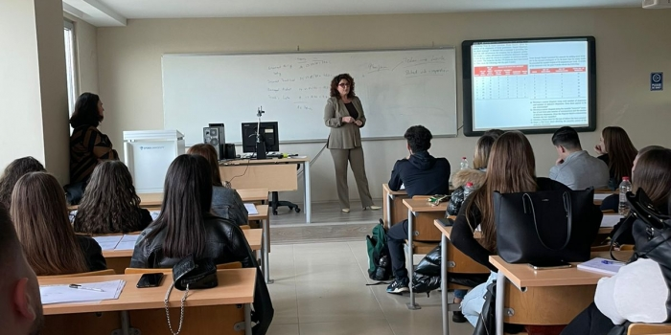

In the framework of the Operations Management course project lectured by Dr. Alba Kruja, on November 18, 2021, Business Informatics 3rd year students Laura Muçaraku, Ambra Taullahu, Redjon Zaçi, Lutfie Veisllari, Argida Shabani, invited for an open discussion about "Forecasting" the Director of Communications of ABC News Albania Ms. Rudina Zeqiri.

The focus of the discussion was forecasting, and its usage related to the television programs and publicity transmitted in ABC News. During the presentation of this topic, Ms. Rudina Zeqiri answered various questions from students, such as forecasting models and techniques, the relation of forecasting and planning process, data collection processes, how often the data collection needed to be updated, budget and profits based on forecasting, etc.

The interest to be involved in the discussion was very high since Ms. Zeqiri caught the student’s attention about everything she explained and answered in detail.

We thank Ms. Zeqiri for her time and for sharing all the interesting information with us.

## Acknowledgements

Department Business Administration expresses its gratitude to all full-time staff, part-time staff, departments’ coordinator, research assistant, teaching assistants and students and for being highly dedicated the whole academic year.

**Department of Business Administration**

Epoka University

Rr. Tirane- Rinas, Km. 12 , 1039, Tirane/Albania

Phone: +355 4 2232 086

Fax: +355 4 2222 117

Email: [info@epoka.edu.al](mailto:info@epoka.edu.al) [bus@epoka.edu.al](mailto:bus@epoka.edu.al)