













**ANNUAL REPORT**

1 September 2020 – 31 July 2021

**Annual Report**

1 September 2020 – 31 July 2021

Contents

1. Organization & Management 2

1.1 Introduction 3

1.2 Strategic Plan 2017-2022 3

2. Study Programs and Curriculum 10

2.1 Bachelor in Business Administration 10

2.2 Bachelor in Business Informatics 12

2.3 Bachelor in International Marketing and Logistics Management 14

2.4 Professional Master in Business Administration 16

2.5 Master of Science in Business Administration 17

2.6 PhD in Business Administration 19

3. Resources 21

3.1 Department Staff 21

3.2 Academic Advisers 24

3.3 IT Resources, Physical Infrastructure and Library Resources 25

4. Teaching, Learning, Assessment & Research 29

4.1 Undergraduate Students’ List of Theses 29

4.2 Graduate Students’ List of Theses 32

4.3 List of Outgoing Students 33

4.4 Research Areas and Research Groups 33

4.5 List of Publications 34

4.6 Participation of Academic Staff in Academic Events 35

4.7 Projects 39

5. Support, Resources & Representation 43

5.1 List of Students’ Internships 43

5.2 Acknowledgements 48

# Organization & Management

**Welcome Speech of Department’s Chair**

Humans, individually and collectively, face several pressing problems in the coming years. Albania is facing high emigration; the wider global economy faces looming disruptions posed by the ongoing Fourth Industrial Revolution; societies everywhere still struggle with the questions of how to best meet our unlimited wants and needs with our limited resources, and how to deal with persistent problems of poverty and other social ills.

Business provides a beautiful instrument with which to respond to many of these problems. Businesses are a powerful instrument for creating value. Businesses provide needed goods and services for consumers and pay many of the taxes that fund the provision of public services. Businesses likewise create employment and provide livelihoods for entrepreneurs and their staff.

Businesses also provide a unique avenue through which to address pressing problems of the Fourth Industrial Revolution, poverty, and other social challenges. A problem-solving approach that seeks to develop sustainable business ideas to address challenges in society can channel immense creative energies into innovative, sustainable entrepreneurial ideas to address such problems. For example, entrepreneurs can use their creativity to develop new fields of meaningful work for those displaced by the Fourth Industrial Revolution. Entrepreneurs can likewise develop sustainable business approaches to address environmental, health, education, and other challenges facing society. As businesses generate value, create employment, and pay taxes, they also fight poverty and attract more businesses and workers to the communities in which they operate.

While businesses can be powerful forces to benefit society, they can also cause great harm to their employees, clients, and environment. Individuals spend much of their waking hours working for or in businesses; management decisions can influence productivity, safety, and the well-being and morale of staff and their families, including children. The instruments of rhetoric, empathic design, and psychology applied in marketing can creatively solve daunting problems or foster exploitive addictions. Businesses can provide positive contributions to their communities or impose unfair costs on others. Thus, learning more about how we can optimize value and well-being within and beyond businesses is essential in improving human life.

The Department of Business Administration, which also houses the Business Informatics and International Marketing and Logistics study programs at Epoka supports students, staff, and the larger ecosystem in optimizing business solutions to create value, solve problems, and improve human well-being.

It is my great privilege to welcome you to our department and invite you to join us in the exciting work at hand.

Faithfully yours,

Esmir DEMAJ, PhD

## 1.1 Introduction

The Department of Business Administration (BUS Department) aims the development of business knowledge to be applied in the management of business and non-business organizations, big and small, domestic and international (e.g. small family businesses, corporations, cultural associations, nonprofit organizations, social businesses, healthcare organizations, financial institutions, public administration, and others). The students will be able to acquire the necessary skills to operate in Albania and globally due to the systemic and integrated knowledge about organizations. The department’s objective is to qualify new future employees and managers with a strong background on business administration by underlying a systems and constructivist perspective.

In the BUS Department, students can choose to study business administration, business informatics, and international marketing and logistics management. These programs offer a high rate of employment opportunities. By studying in BUS, students can work in different departments as easily configured in an organizational chart. For example, taking into account their specialization, they might work in the departments of accounting, marketing, sales, human resources, information systems, operations, R&D, etc.

Detailed information on the courses offered in the semester schedules is included in the academic plan. The list of departmental compulsory and elective courses is provided in detail in the academic programs. In addition, for each course the students can check the content from the information system in order to be aware about the subjects, teaching methods, requisites, ECTS credit system, and workload. Furthermore, students will be supported all the time by the academic advisors, which are professors of the BUS Department. The list of courses offered each semester by our department and academic catalogue correlate together. The objective of this department is to fulfill the need for qualified members in this field, and to prepare skilled people to work in different sectors of the global economy.

## ****1.2 Strategic Plan 2017-2022****

***1. Mission***

The mission of the Department of Business Administration (BUS Department) is developing business capabilities through holistic teaching methods by cultivating a sense of intellectualism, togetherness, and inclusive leadership.

The final output is educating early professionals for co-creating value among market actors, in terms of employability, continuous improvement, and business system sustainability.

***2. Vision***

The Albanian Business Ecosystem is moving toward a new era, which will be accompanied by best business practices and success stories. The vision of BUS Department is to be the most valuable partner for transforming Albanian business cases into best business practices. Our ambition is to have behind all business case histories, our early professionals.

**3. Motto**

Today knowledge students, tomorrow knowledge workers.

***4. Challenges***

Due to rapid changes in technology and considering the economic environment nowadays it is clear that BUS Department faces several challenges for the upcoming years. Main challenges include offering an environment in which students can use efficiently their analytic skills and take advantage of the technology development. For this purpose, qualified staff, a central library, student co-working areas, and smart classrooms are provided to achieve the challenging academic and professional objectives. Moreover, the BUS Department must ensure strong relationships and furthermore enhance its network with business professionals, academic institutions, research centers, and other stakeholders. Another challenge that the department will be facing is the diversification of research areas and the establishment of research units/clusters, by being able to ensure agreements and memorandum of cooperation with other institutions in order to carry out research according to business necessities. Finally, considering the growing trend of students in the department, especially the business informatics branch, the department should design the suitable scenarios for recruiting ulterior qualified academicians and providing the necessary learning infrastructure. Since businesses and markets are very dynamic, it is the responsibility of BUS Department to be a vigilant observer of complex dynamic business systems in order to fit the curricula with the upcoming market changes.

**4. Sources**

There is a rising market demand for programs such as Business Informatics and International Marketing and Logistics Management. Since the first year these programs opened, respectively 2011 and 2012, the students were very promising, and their employability rate has been high after graduating from BUS Department. Currently, the number of Students in BUS Department is 357 students. Considering the enrollment number of students in BUS Department, given also the trending rise, it is estimated that the number of students will increase furthermore. The number of students that will be studying in Business Administration by 2022 is estimated to be 600. Given these sources, the department must be prepared, as stated also in the “Challenges” paragraph, to afford the new wave.

**5. Achievements**

Since the opening of BUS Department, the network logic was established. Company visits, open forums, Dream Business Competition (this competition aims to select students with excellent results and talented, mainly in the field of business and entrepreneurship) and Brain Ring Competition (this competition aims to select students from high schools with excellent results and talented, mainly in the field of marketing and information technology) were among the milestones of BUS Department. In accordance with the principles of mobility of Bologna Process and Erasmus Program, the BUS Department has established several agreements to offer to the students and the academic and administrative staff the opportunity to learn in a multicultural perspective. Actually, the department has Erasmus Agreements with the University of Applied Sciences Mainz and the Middle East Technical University. Other agreements are also with top universities such as Sapienza University of Rome (Department of Management), University of Salerno, California University of Pennsylvania and others. For the executive education, the department offers a unique joint MBA with EADA Business School (top 24 European business schools and top 31 worldwide according to FT ranking). In terms of research, the BUS Department is the unique in the whole Western Balkans to have established a Research Unit/Cluster for Social Business research in collaboration with the Yunus Social Business Balkans. It is also among the first in the region to have found a master course dedicated to Social Business and Sustainability.

**II.  PRIORITY AREAS**

**Theme 1: Provide a high-quality environment for teaching and learning.**

In order to succeed in terms of teaching and learning the department must have highly qualified and experienced academic staffs that are looking forward to constantly develop their skills and stayed updated to the last social and technological developments. Furthermore, there should be a systematic collection of graduation theses done at the department in order to create a collection of academic and practical materials that are case-based referring to the Albanian and the regional market (i.e. Western Balkans). Also, students and academic staff should have the possibility to access online data sources of the university from outside the campus. The number of prestigious online sources should be enhanced furthermore to make the department competitive also in the international market, and to provide possibilities for students to access the most updated sources during their study period. In addition, the BUS department must have annual subscriptions with newspapers and business journals, to give the possibility to faculty and students having access in cases, videos and other materials. Finally, the department must focus to provide short online courses on behalf of already established platforms (e.g. edX, Coursera, etc), or create its own digital platform.

**Specific goals for theme 1:**

Goal 1.1: Increase the efficiency of academic staff and the quality of their publications.

Goal 1.2: To have a better relationship among the triangle: academic staff-students-industry.

Goal 1.3: To build a “thesis directory data”.

Goal 1.4: To build a good infrastructure to make easier the access to sources for both students and lecturers.

**Measures in order to reach mentions goals under Theme 1:**

Measure 1.1: Arranging flexible working hours for the academic staff and defining goals to be achieved. Design “bonus” payment systems according to the quality of publications and teaching.

Measure 1.2: To create an “industry network directory” (IND) of the department and managed only by the department in full compliance with the regulations of Epoka University.

Measure 1.3: To provide a good thesis guideline, to design a new thesis evaluation system that would be more specific, to take advantage of technology and build an online “Thesis Source Directory” in order to create a handbook of Albanian business cases.

Measure 1.4: Technology infrastructure so that students can study at their places as they were at the university. Recording courses in order to overcome absences (should be done in a controlled manner).

**Theme 2: Recruit, educate and graduate a high-quality and diverse undergraduate student body**

To recruit good student from high schools there should be cooperation with high schools’ representatives, creating competitions, workshops, and other meetings, especially for last year high schools’ students. Moreover, the Department must ensure that the quality of the students will be high during the studies and afterward, by respecting the conditions stated in the previous paragraphs.

**Specific goals for the Theme 2:**

Goal 2.1: Involving students clubs to arrange different competitions in order to get the best high school students.

**Measures in order to reach mentions goals under Theme 2:**

Measure 2.1: “Brain Ring” Competition powered by the student club Marketing Zone should continue. Further competitions should be arranged, like it was the “Dream Business” in the past years.

**Theme 3:** **Recruit, educate and graduate a high-quality and diverse master student body**

The BUS Department is committed to propose and open a Master of Science program in Business Innovation and Informatics in collaboration with the University of Salerno for a double degree diploma. Based on questionnaires distributed by an ad hoc team created within the department for this purpose, the demand to open a master in this field was high. Registered students in the bachelor program in of Business Informatics almost doubled the A.Y. 2016-2017, and the number is expected to grow in the near future. Consequently, more and more they will ask for a master to be represented and proud. In addition, given the market conditions, the BUS Department is planning to design also a master in Service Marketing, Advertising, and Branding to be proposed in the near future.

**Specific goals for the Theme 3:**

Goal 3.1: Opening Master Programs on Business Informatics and Marketing

Goal 3.2: Cooperation with other universities specially to get to know last year students

**Measures in order to reach mentions goals under Theme 3:**

Measure 3.1: There should be a systematic plan on opening these programs

Measure 3.2: Signing agreements to provide the possibility to enter to the courses for guest students as if they were normal students.

**Theme 4: Recruit, educate and graduate a high-quality and diverse PhD student body**

PhD studies should be designed according to the need of the market and according to this, registrations must occur. Enrollment procedures for PhD students should be redesigned and the interview of the Scientific Committee must be added as one of the core evaluation criteria. On the other side, because the number of PhD applicants is low the BUS Department should collaborate with other departments to create one or more hybrid interdepartmental doctoral schools or try to change the advertisement techniques and budget for the PhD program promotion.

**Specific Goals for Theme 4:**

Goal 4.1: Redesigning PhD enrollment procedures

Goal 4.2: Raising the number of well qualified thesis supervisors.

Goal 4.3: Improving budget and advertising.

Goal 4.4: Proposing new PhD routes.

**Measures in order to reach mentions goals under Theme 4:**

Measure 4.1: Collaboration with other departments.

Measure 4.2: Collaboration with university decision making bodies such as the Faculty Board and the Academic Senate.

Measure 4.3: Negotiations with Secretary General Office for dedicating more funds to PhD advertising.

Measure 4.4: Recruiting more Associate Professors as PhD supervisors, according to the law.

**Theme 5: Provide a high-quality environment for research**

Good teaching is strongly related with research and consultancy. One of the classical teaching methods business schools are adopting is the case study method and David Kolb’s experiential learning. In order to deliver high teaching quality to the students, the academic staff must be committed with research and organizational consulting experience. As mentioned also in previous paragraphs, the research environment (newspapers and journal access: e.g. Harvard Business Review materials, like cases, videos and articles) should be inspirational for scholars. Furthermore, a better balance between teaching load, research and service must be aimed.

**Specific goals for Theme 5:**

Goal 5.1: To encourage academic staff to participate in trainings and conferences.

Goal 5.2: To negotiate with business journals, organizations, and research centers by having access for data gathering and elaboration.

**Measures in order to reach mentions goals under Theme 5:**

Measure 5.1: Making the flextime part of department’s culture, by asking at the end of any research process the aimed outcomes.

Measure 5.2: Dedicating a higher budget at departmental level for journal subscriptions.

Measure 5.3: Increasing the number of internal full-time faculty for a better teaching load distribution, by dedicating more time to research and consulting.

Measure 5.4: Making more case study research which will be beneficial also for teaching.

# Study Programs and Curriculum

## 2.1 Bachelor in Business Administration

Bachelor Program in Business Administration consists in 180 ECTS including the diploma thesis. The students that have successfully completed a total of 180 ECTS shall be entitled to graduate from the program and shall be conferred the diploma of Bachelor in Business Administration.

A student who has been successful in all courses, summer practices, seminary course and diploma thesis and, through pursuing the academic program, his/her cumulative grade point average is to at least (2.00), without having a FD or FF grade shall be deemed to have met the requirements of graduation by the relevant board decision and be awarded Bachelor Diploma in Business Administration.

The Bachelor in Business Administration provides students with knowledge in management and in business administration, as well as with organizational skills to serve in the public and in private sector. The business administration program is structured around a group of technical courses, which exposes students to the basic tools of quantitative methods, accounting, and economic theory, and a core of management and leadership courses that integrate culture, language, and ethics, to enable future business leaders to meet the challenges of today’s global environment. The table below shows the curricula of the Business Administration program throughout three years of bachelor studies.

|  |  |
| --- | --- |
| FIRST YEAR | |
| Introduction to Economics I | Introduction To Economics II |
| Introduction to Business | Management and Organization |
| Introduction to Law | Communication Skills |
| Essentials of Organizational Behavior | Introduction To Accounting |
| Math. for Economics and Business I | Math. for Economics and Business II |
| Core English Developing Reading and Writing Skills | Business English Developing Reading and Writing Skills |
| SECOND YEAR | |
| Microeconomics | Marketing II |
| Marketing I | Macroeconomics |
| Business Law | Management Information Systems |
| Statistics I | Statistics II |
| Financial Accounting I | Financial Accounting II |
| Elective I | Elective I |
| SECOND YEAR ELECTIVE COURSES | |
| Government, Politics and Public Policy in Albania | Public Finance |
| Research Methods in Social Sciences | Money and Banking |
| Turkish I | Introduction to Public Administration |
| German I | Introduction to Political Sociology |
| Italian I | Turkish II |
| French I | German II |
|  | Italian II |
|  | French II |
|  | Sales Techniques and Management |
|  |  |
| THIRD YEAR | |
| Professional Practice | Managerial Accounting |
| Operations Management | Financial Management |
| Human Resource Management | Graduation Project Final Comprehensive Exam |
| Fundamentals of Corporate Finance | Elective I |
| Elective I | Elective II |
| Elective II |  |
| THIRD YEAR ELECTIVE COURSES | |

|  |  |
| --- | --- |
| E-Marketing | Capital Markets and Law |
| Cost Accounting | International Economics II |
| Consumer Behavior | Monetary Theory and Policy II |
| Total Quality Management | Customer Relationship Management |
| International Economics I | Strategic Logistic Management |
| Monetary Theory and Policy I | International Marketing and Management of Multinational Enterprises |
| Banking Operations and Service | Knowledge Management |
| Financial Institutions and Markets | Branding and Brand Management |
| Innovation and Human Consciousness | Operations Research |
| Social Media Marketing |  |
| Marketing Research |  |
| Supply Chain Management |  |

## 2.2 Bachelor in Business Informatics

Bachelor in Business Informatics program is comprised of a three year curriculum at EPOKA University. The educational workload for these three years is 180 ECTS. Each semester, students are expected to cover at least 30 ECTS credits.

Bachelor Program in Business Informatics aims at the qualification of new staff with general knowledge, alert to the challenges in finance, and able to work in the banking sector as well as in the administration of local and foreign private companies.

Bachelor Program in Business Informatics consists in 180 ECTS including the diploma thesis. The students that have successfully completed a total of 180 ECTS shall be entitled to graduate from the program and shall be conferred the diploma of Bachelor in Business Informatics. The table below shows the curricula of the Business Informatics program throughout three years of bachelor studies.

|  |  |
| --- | --- |
| FIRST YEAR | |
| Introduction to Economics I | Introduction To Economics II |
| Introduction to Business | Math. For Economics and Business II |
| Introduction to Algorithms and Programming | Introduction To Accounting |
| Introduction to Computer Engineering | C and C ++ Programming |
| Math. for Economics and Business I | Management and Organization |
| Core English Developing Reading and Writing Skills | Business English Developing Reading and Writing Skills |
| SECOND YEAR | |
| Statistics I | Statistics I |
| Business Law | Business Law |
| Computer Organization | Computer Organization |
| Object Oriented Programing | Object Oriented Programing |
| Principles of Marketing | Principles of Marketing |
| Elective BUS | Elective BUS |
| SECOND YEAR ELECTIVE COURSES | |
| Financial Accounting I | Financial Accounting II |
| Essentials of Organizational Behavior | Knowledge Management |
| Total Quality Management | Communication Skills |
| Supply Chain Management | Macroeconomics |
| Microeconomics | Turkish II |
| Turkish I | German II |
| German I | Italian II |
| Italian I | French II |
| French I |  |
|  |  |
| THIRD YEAR | |
| Professional Practice | Managerial Accounting |
| Operations Management | Financial Management |
| Human Resource Management | Graduation Project Final Comprehensive Exam |
| Fundamentals of Corporate Finance | Elective I |
| Elective I | Elective II |
| Elective II |  |
| THIRD YEAR ELECTIVE COURSES | |
| Cost Accounting | Managerial Accounting |
| Human Resources Management | Customer Relationship Management |
| Innovation and Human Consciousness | Econometrics II |
| Social Media Marketing | Branding and Brand Management |
| Consumer Behavior | Strategic Logistic Management |
| Econometrics I | International Marketing and Management of International Enterprises |

## 2.3 Bachelor in International Marketing and Logistics Management

Globalization is the keyword in today’s marketplace which is highly competitive. A switch of powers took place in the last decades from businesses towards customers. Marketing is one of the most important business` functions that played a crucial role in this. Marketing is responsible of satisfying unlimited customer needs and wants through many important processes. These processes include production, pricing, promotion and distribution of goods and services that have high quality and affordable prices. Customer retention and attraction of new customers is possible by building strong brands.

International Marketing & Logistics program aims to provide knowledge in the field of marketing and logistics to our students, so they can be well-trained individuals, ready for today` high competitive labor market. Through this program; our students can analyze how critical issues such as customer relationship management, international marketing, consumer behavior, and logistics are applied in the marketplace by the companies. In total accordance with the mission and the vision of Epoka University, International Marketing and Logistics Program also aims to provide well-educated individuals to satisfy the companies` needs in marketing and logistic departments. The table below shows the curricula of International Marketing and Logistics Management program throughout three years of bachelor studies:

|  |  |
| --- | --- |
| FIRST YEAR | |
| Introduction to Economics I | Introduction To Economics II |
| Introduction to Business | Communication Skills |
| Introduction to Law | Introduction To Accounting |
| Essentials of Organizational Behavior | Management and Organization |
| Math. for Economics and Business I | Math. For Economics and Business II |
| Core English Developing Reading and Writing Skills | Business English Developing Reading and Writing Skills |
| SECOND YEAR | |
| Microeconomics | Marketing II |
| Marketing I | Macroeconomics |
| Business Law | Sales Techniques and Management |
| Statistics I | Statistics II |
| Financial Accounting I | Financial Accounting II |
| Elective I | Elective I |
| SECOND YEAR ELECTIVE COURSES | |
| Management Information Systems | Public Finance |
| Government, Politics and Public Policy in Albania | Introduction to Public Administration |
| Research Methods in Social Sciences | Introduction to Political Sociology |
| Turkish I | Turkish II |
| German I | German II |
| Italian I | Italian II |
| French I | French II |
|  | Money and Banking |
|  |  |
|  |  |
| THIRD YEAR | |
| Operations Management | Operations Research |
| Fundamentals of Corporate Finance | Strategic Logistic Management |
| Professional Practice | International Marketing and Management of Multinational Enterprises |
| Marketing Research | Graduation Project Final Comprehensive Exam |
| Supply Chain Management | Elective I |
| Elective I |  |
| THIRD YEAR ELECTIVE COURSES | |
| Human Resource Management | Branding and Brand Management |
| Innovation and Human Consciousness | Capital Markets and Law |
| Consumer Behavior | International Economics II |
| Social Media Marketing | Managerial Accounting |
| Cost Accounting | Monetary Theory and Policy II |
| Total Quality Management | Customer Relationship Management |
| International Economics I |  |
| Monetary Theory and Policy I |  |
| Banking Operations and Service |  |
| Financial Institutions and Markets |  |

## 2.4 Professional Master in Business Administration

Professional Master in Business Administration consists in 48 ECTS of taken courses and a 12 ECTS Term Project (micro-thesis). The students that have successfully completed a total of 60 ECTS shall be entitled to graduate from the program and shall be conferred the diploma of Master Professional in Business Administration.

A student at the graduation stage who has been successful in all courses, seminary courses and thesis of the study program, and his/her cumulative grade point average is to at least (2.00), without having a FD or FF grade shall be deemed to have met the requirements of graduation by the relevant board decision and be awarded Master Professional in Business Administration Diploma.

Professional Master in Business Administration provides students with knowledge in management and business administration, as well as with organizational skills to serve in the public and in private sector. The program harmonizes contemporary business theory with business practice and problems. The program gains mastery to graduates in the business management field. In the table below is shown the curricula for one year of studies in Professional Master Program:

|  |  |
| --- | --- |
| FIRST YEAR | |
| Research Methods in Business | Micro Thesis* Final Comprehensive Exam* |
| Professional Practice | Elective I |
| Elective I | Elective II |
| Elective II | Elective III |
| FIRST YEAR ELECTIVE COURSES | |
| International Accounting and IFRS | Strategy and Management |
| Advanced Managerial Accounting | Advanced Management Information System |
| Advanced Organizational Behavior | Financial Statements Analysis for Managerial Staff |
| New Concepts and Trends in Business Management | Brand Management |
| Leadership | Social Business And Sustainability |
| Strategic Marketing | Strategy and Management |
| Advanced Operations Management | Advanced Management Information System |

## 2.5 Master of Science in Business Administration

Master of Science in Business Administration consists in 90 ECTS of taken courses and a 30 ECTS Master Thesis. The students that have successfully completed a total of 120 ECTS shall be entitled to graduate from the program and shall be conferred the diploma of Master of Science in Business Administration.

The mission of the Master of Science in Business Administration program is to prepare and graduate students for careers in academia, business, government and non-profit organizations by providing a broad professional education.

The Business Administration program is structured around a group of technical courses, which exposes students to the basic tools of quantitative methods, accounting, and economic theory, and a core of management and leadership courses that integrate culture, language, and ethics, to enable future business leaders to meet the challenges of today’s global environment.

Opportunities:

* + 1. Appropriate and comfortable spaces for students and academicians.
    2. Recent catalogues and educational programs based on the global trade demand of work Diversified staff (foreign and Albanian) with long educational experience.
    3. Possibilities for internships during the studies in local and foreign companies. The spaces are supplied with wireless and cabled internet 24 hours a day so that students can use to develop their research.
    4. The possibility of employment for the graduated students is tightly connected with their academic advances, courage, and conditions that will be provided by the university.
    5. The graduated students will have consolidated knowledge on management, economics and human resources.
    6. Students will be able to situate organizational work in the company and to find relevant solutions to the continuously appearing challenges.
    7. Through the gained experience, the graduated managers will be among the most preferred staff in the specific disciplines due to their profession ethics, acquired theoretical framework, and applied methodology when employed. The department aims at encouraging and motivating the graduated students to organize and manage their private activities.

Table below shows the curricula of Master of Science program throughout two years of studies:

|  |  |
| --- | --- |
| FIRST YEAR | |
| Academic Reading and Writing | Strategic Management |
| Small Business Management and  Entrepreneurship | Auditing |
| Elective I | Elective I |
| Elective II | Elective II |
|  |  |
|  |  |
| FIRST YEAR ELECTIVE COURSES | |
| Business Ethics | Strategic Analyses on Business |
| Comparative Business Law | Advertisement Management and Creativity |
| International Business | Development and Growth II |
| Development and Growth I | Albanian Tax Law |
| Portfolio Management and Investment Analysis | Bank Management |
| Financial Analysis | Risk Management and Insurance |
| World Politics |  |
| Nationalism and Ethnic Studies |  |
| Human Rights and Humanitarian Interventions* |  |
| Conflict Resolution & Diplomatic Language |  |
| SECOND YEAR | |
| Research Methods in Business | Thesis |
| Seminar on Business Administration |  |
| Elective I |  |
| Elective II |  |
| SECOND YEAR ELECTIVE COURSES | |
| International Accounting and IFRS |  |
| Advanced Managerial Accounting |  |
| Advanced Organizational Behavior |  |
| New Concepts and Trends in Business Management |  |
| Managerial Economics |  |
| Leadership |  |
| Strategic Marketing |  |
| Advanced Operations Management |  |

## 2.6 PhD in Business Administration

Doctorate (PhD) in Business Administration consists in 60 ECTS of taken courses and 120 ECTS dissertation. The students that have successfully completed a total of 180 ECTS shall be entitled to graduate from the program and shall be conferred the diploma of Doctorate (PhD) in Business Administration.

The persons who are eligible for admission to the PhD program should:

* have obtained a Master of Science/Master of Arts, integrated second cycle studies or any other equivalent diploma in the field of the Doctorate (PhD) program or in a close field previously defined in the requirements established by the respective of the Scientific Committee.
* have a CGPA of at least 2.70 out of 4.00 or 8 out of 10 from the Master of Science/Master of Arts, integrated second cycle studies or any other equivalent diploma in the field of the Doctorate (PhD) program or in a close field previously defined in the requirements established by the respective Scientific Committee or an equivalent CGPA.
* applicants must demonstrate that they have reached the minimum acceptable level of proficiency in use of the English language.
* having studied undergraduate degree in English or the equivalent score for the internationally recognized English Language Exams as stipulated in the Directive of the Minister of Education and Science No. 14, dated 28.03.2011 "On the recognition of English language exams for the second and third cycle study programs."

Table below provides the curricula of Doctorate (PhD) in Business Administration studies:

|  |  |
| --- | --- |
| FIRST YEAR | |
| Research Techniques in Business Administration | Advanced Quantitative Methods for Management Science Research |
| Elective I | Elective I |
| Elective II | Elective II |
|  |  |
|  |  |
|  |  |
| FIRST YEAR ELECTIVE COURSES | |
| Accounting Theory | Advanced Human Resources Management |
| Strategic Management | Knowledge Management |
| Operations Management | Strategic Management Accounting |
| Entrepreneurship Perspectives | Strategic Brand Management |
| Game Theory | Systemic Management and Complexity |
| Finance Theory and Management | Strategic Marketing |
| WRITING OF DISSERTATION STAGE | |
| Thesis | |
|  | |

# 3. Resources

## 3.1 Department Staff

**Full time Academic Staff**



**Dr. Esmir DEMAJ**

Head of the Department



**Dr. Timothy Hagen**

Lecturer

**Dr. Xhimi Hysa**

Lecturer

**Prof.Dr. Teoman Duman**

Lecturer

**Assoc. Prof. Dr. Mustafa Üç**

Lecturer



**Assoc. Prof. Dr. David Felsen**

Lecturer

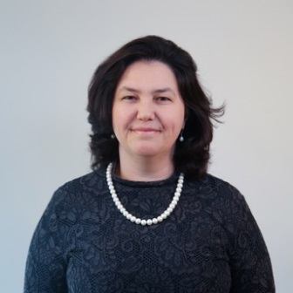

**Dr. Alba Kruja**

Lecturer

**MSc. Besjon Zenelaj**

Assistant Lecturer

**Part time Academic Staff**

1. Dr. Idaver Sherifi
2. M.Sc. Anuela Ristani
3. MSc. Enigerta Halilaj

**Administrative Staff**

**MSc. Blerta BAMI**

Department Coordinator

**MSc. Tekim Peza**

Faculty Administrator

## 3.2 Academic Advisors

Duties and Responsibilities

* To help the students to register the courses during pre-registration, registration and add and drop weeks and approve them at the beginning of each semester.
* To inform and provide new students with the documents containing information about passing the courses of the undergraduate and graduate level, rules and regulations about examinations and about other rules and regulations concerning students.
* To be aware of the changes made in the regulations and inform students about these changes.
* To be aware of the changes in the program curriculum, inform students about these changes and help students selecting their courses based on the curriculum changes.
* To make possible that the students read the content of the Elective Courses or Non-Technical elective courses and to help students in selecting their courses by ensuring that they do not surpass the maximum 45 ECTS credits limit per semester.
* To provide students with information regarding Student Exchange programs, Study Abroad Opportunities and European Credit Transfer System (ECTS), consulting with the International Relations Office of Epoka University.
* After the advisor has approved the course registration in compliance with points 4 and 5 of the list, s/he prints out the course registration form in three copies, one for the student, one for the advisor her/himself and one for the Registrar’s Office. The advisor gives one signed copy of the course registration form to the student whereas s/he keeps the copy for the Registrar’s Office. The advisor submits all these forms to the Registrar’s Office at the end of the Add and Drop Week. One copy of the course registration form of each student is always stored by the respective advisor.
* To provide students with information regarding Minor and Double Major Programs and also give information about the conditions students must fulfill in order to be part of these programs.
* To provide students with information regarding the conditions to be graduated by the Epoka University (a GPA of at least 2.00 with no failed courses).
* To provide students with information about prerequisite courses as determined by the respective departments.
* To prepare the list of candidates who fulfill all the requirements of graduation at the University and submit the list to the respective Head of Department.
* To inform last-year students who have no more than two failed courses to use their right to take additional exam (Referring to the Article 27 of the Undergraduate Studies Regulation).
* To provide orientation to students regarding their post-graduation career.
* To provide information and to orient students to the respective units of the University about issues related to accommodation, scholarships, health issues and extra-curricular activities.

## 3.3 IT Resources, Physical Infrastructure and Library Resources

Information and Communication Technologies Coordinating Office (ICTCO) provides informatics services needed in the University. It plans the informatics infrastructure of the University, provides its security and ensures the continuation of its functions. ICTCO works on the project for effective, legal and extensive usage of the informatics services for students and personnel.

The Information and Communication Technologies Coordinating Office (ICTCO) provides:

Teaching Services:

• **Turnitin** software helps you to understand and avoid plagiarism and develop your understanding of how to cite sources as part of an academic argument. ICTC office manages the users and train the staff about how to use Turnitin.

• **Learning Management System (LMS)** – A service based on Moodle offered for students and instructors in order to access, coordinate and organize course materials online. Students and instructor can login on LMS using the provided official email account.

• **Library Automation System (Koha) -** Koha is an open-source Integrated Library System in use today by hundreds of libraries worldwide. Koha is web based, so there is no software to install on desktop computers. Users can check the books online and reserve them via web. Its features are more than enough to manage the Epoka Library effectively and efficiently.

• **DSpace** – The institutional repository of Epoka University: DSpace is an open-source repository software package typically used for creating open access repositories for scholarly and/or published digital content. The proceedings of the conferences which are organized by Epoka University can be accessed from this repository. Epoka University is the only university who has digital repository in Albania(http://repositories.webometrics.info/en/Europe/Albania). We also give services to other international journals to publish their publications (http://dspace.epoka.edu.al/handle/1/1378) in our digital repository.

**Google Services:**

• **Webmail (Google account) –** Epoka University is using Google Apps for Education services and all students and academic and administrative staff are provided with an email address under epoka.edu.al domain which is a Google account. Beside official communication, which is done through this email address, this account can be used for authentication to other online systems offered by university.

• **Google Classroom** – A more interactive service offered by Google as part of Google Apps for education in order to access, coordinate and organize course materials on cloud. By using Google Classroom, course materials can be integrated with other Google services where assigned users can collaborate. Students and instructors can access this service using the provided account.

**Physical Infrastructure**

The campus extends over a total area of 67,000 m 2. The 2017-2018 academic years is being conducted regularly in the premises of two buildings with a total area of 14352 m 2. This building has a modern infrastructure and a central heating and cooling system. The classrooms are equipped with video projectors and smart boards that enable the normal conduct of the learning process. On September 2013, the construction of A-Building the “Cultural Social Object of Epoka University” was completed. In addition to classes, there are plenty of recreational facilities for students such as cafeterias, cafeterias, libraries, internet cafés, facilities for the Student Council and student clubs, sports facilities, etc. Below are shown and current picture of the building.



**LIBRARY**

The Epoka University Library, which is located on the first floor of A-Building in the Rinas Campus, was founded to support the education and research activities of the university by providing and organizing the needed documents. With its 100-seating capacity, our library has 400 square meters area of use. Our University Library is composed of entrance, book and reading hall. In the entrance, there is a check out desk. The periodicals, including the exhibition of new arrivals, are also shelved in this section. The reading hall is equipped for students to study and to do research.

Epoka University is a member of Balkan Libraries Union which was founded on 29 July 2009 with the participation of 10 institutions from 6 Balkan countries. Our library collection is enriched by purchases and donations. The books to buy are chosen in accordance with the needs and requests of the students, administrative and academic staff. Under the Department of Library and Documentation, the library has a total of about 7500 printed books.

**Digital Databases**

Epoka University has full membership in JSTOR, a shared digital library created in 1995 that includes more than 2,000 academic journals. JSTOR was founded to help libraries and academic publishers transition their activities from print to digital operations, to expand access to scholarly content around the world and to preserve it for future generations. Every member of Epoka staff can access to JSTOR’s collections by going to http://www.jstor.org/ and searching or browsing for content.

**Using the Library**

Our library works on the open shelf system enabling you to reach the books directly. The books in the open shelves are topically sorted in the book hall according to LC classification method. To find the book you are looking for, you should follow these steps:

1. Through the catalog search computers in the library; you can search author name, book name, and publisher, topic, or keyword areas.

2. To get the book, you can go to the shelves with the classification and location numbers of the books appearing on the screen as a result of your search.

**Example of LC number** for the book: "Exchange rates and international finance", Laurence S. Copeland / Financial Times, 2008 HG3821.C782008

The first part of the LC number "**HG**" represents the category of the book by its topic. In the LC system, the first letter **H** stands for **Social Science** class. Each subsequent letter indicates next level of subcategories of the main topic. In the given example **G** stands for **Finance**, **3821** indicates subcategories included between 3810-4000 (Foreign exchange, International finance, International monetary system), C78 indicates the first letter of authors surname, **2008** indicates book publication year.

**Regulations**

Students of Associate Degree, Bachelor’s Degree and Master Students and academic and administrative personnel are the members of the library. They can borrow library materials in accordance with the rules.

Researchers coming from outside the university are not lent books, they are only allowed to use and copy the materials in the library. Readers in this group are requested to fill up the related form Lending Service.

# 4. Teaching, Learning, Assessment & Research

## 4.1 **Undergraduate Students’ List of Theses**

|  |  |  |  |  |
| --- | --- | --- | --- | --- |
| No. | Student | Program | Supervisor | Thesis |
| 1 | Maja Memishaj | BA BUS | Msc. Besjon Zenelaj | Evidence on the Effect of Self-Identity in the Behavior of Consumers |
| 2 | Megi Babaramo | BA BUS | Prof. Dr. Waldemar Pfoertsch | Consumer Behavior Post COVID Crisis: A Shift Towards Healthier Eating Choices. |
| 3 | Artemisa Themeli | BA BUS | Assoc. Prof. Dr. Xhimi Hysa | How Inter-Organizational Co-Working Attenuates Complexity, Enhances Resilience, Drives Open Innovation and Knowledge Co-Creation. |
| 4 | Ledia Myzeqari | BA BUS | Prof. Dr. Waldemar Pfoertsch | One Rebrand to Another  A Case Study of One Telecommunications |
| 5 | Altea Stefa | BA BUS | Prof. Dr. Waldemar Pfoertsch | No More Play with Lost and Find”: A Research on Customer Behavior and Willingness to Pay |
| 6 | Nensi Bedo | BA BUS | Dr. Alba Kruja | The Importance of Circular Economy for Businesses in Albania |
| 7 | Kler Pula | BA BUS | Assoc. Prof. Dr. David Felsen | Fund Management of the Non-Profit Organizations |
| 8 | Xhesika Leka | BA BUS | Assoc. Prof. Dr. David Felsen | The Impact of Albanian Businesses Towards the Environment: The Vjosa River Case |
| 9 | Zerina Begu | BA BUS | MSc. Besjon Zenelaj | The Effects of Animation on Consumer Behavior in the Advertising Industry |
| 10 | Mishela Rapo | BA BUS | MSc. Besjon Zenelaj | The Effects of Facebook on Increasing Business Activity.  (The Case of Travel Agencies in Albania) |
| 11 | Bestjana Manga | BA BUS | MSc. Besjon Zenelaj | Corporate Social Responsibility-The Case of IKEA |
| 12 | Suada Hoxha | BA BINF | Dr. Igli Hakrama | Analysis, Design and Implementation of an Electronic Blood Management System in Albania. E-Bloodbank |
| 13 | Tomas Muça | BA BINF | Dr. Alba Kruja | The Implementation of Fiscalization in Albania: An Overview of Businesses Perceptions |
| 14 | Miger Shkrepa | BA BINF | Dr. Esmir Demaj | The Importance of a Proper Infrastructure on the Implementation of Cryptocurrencies in Albania |
| 15 | Stiliana Jano | BA BINF | Dr. Igli Hakrama | Analysis, Design, and Implementation of a Custom ERP System for an SME |
| 16 | Flavjo Tomorri | BA BINF | Assoc. Prof. Dr Mustafa Üç | How is Blockchain Technology Perceived by Albanian University Students? |
| 17 | Armena Keshi | BA BINF | Dr. Esmir Demaj | Diagnosing Albanian Companies Internal Environment for Intrapreneurship: A Case Study of the Albanian Food and Beverage Production Industry |
| 18 | Siola Cevani | BA BINF | Dr. Alba Kruja | Cyber Security in Small and Medium Enterprises. |
| 19 | Iris Çenga | BA BINF | Dr. Alba Kruja | Electronic Commerce in Mobile Applications. The Case of Albania. |
| 20 | Enajda Sula | BA BINF | Dr. Alba Kruja | The Process of Automation in Healthcare Industry: Case of Albania |
| 21 | Aleksia Perdhiku | BA BINF | Dr. Alba Kruja | Youth Skills in The Albanian Labor Market: A Study on Perspectives of Graduates and Employers |
| 22 | Kristjan Çareri | BA BINF | Dr. Alba Kruja | Challenges of Health Care Contributions with the Ageing Population and Rising Numbers of Non-Communicable Diseases |
| 23 | Mirjana Mehmeti | BA BINF | Dr. Esmir Demaj | How Popular Brands Create Brand Awareness? |
| 24 | Ambra Mallunxa | BA BINF | Assoc. Prof. Dr. Xhimi Hysa | Models and Tools of Circular Economy: A Descriptive Case Study |
| 25 | Melisa Miri | BA BINF | Assoc. Prof. Dr Mustafa Üç | Models and Tools of Circular Economy: A Descriptive Case Study |
| 26 | Sanja Mulla | BA BINF | MSc. Besjon Zenelaj | Electronic Commerce. Enterprise Information and Communication Technology. |
| 27 | Meriona Mella | BA BINF | Dr. Esmir Demaj | How Will Cryptocurrency Affect the Global Economy, and Will they Be Regulated by Central Banks to Be Used as Trading Mechanism in the Near Future? |
| 28 | Anisa Gjoni | BA BINF | Dr. M. Maaruf Ali | Application of Blockchain Technology in the Banking Sector |
| 29 | Sildi Mustafa | BA BINF | Dr. Esmir Demaj | Business Incubators in Albania: Tirana Inc. |
| 30 | Rovena Noka | BA BINF | Prof. Dr. Waldemar Pfoertsch | The Impact of COVID-19 in E-Commerce, and the Implementation of B2C Business Model in the Albanian Market |
| 31 | Loreta Sejdi | BA BINF | Assoc. Prof. Dr Mustafa Üç | Accounting Information Systems’ Quality in Albania |
| 32 | Stela Dollaku | BA BINF | Dr. M. Maaruf Ali | Applying the Data Mining Techniques in the Banking Sector.Fraud Detection |
| 33 | Lusjela Doda | BA BINF | Assoc. Prof. Dr Mustafa Üç | Digital Banking: A Survey on University Students in Albania |
| 34 | Xhesika Samarxhiu | BA BINF | Dr. Alba Kruja | The Frontier of Information System in the Banking Sector in Albania |
| 35 | Griselda Doda | BA BINF | Dr. M. Maaruf Ali | Blockchain Revolution: The Technology of Blockchain and Cryptocurrency. Developing a Web Application for Managing the Personal Cryptocurrencies |
| 36 | Klajd Tabaku | BA BINF | MSc. Besjon Zenelaj | Investigation of the Relationship and Impact Between Organizational Climate Dimensions and Job Satisfaction |
| 37 | Sara Koni | BA BINF | Dr. Igli Hakrama | Detecting Money Laundering: An Empirical Study of Machine Learning Approaches |
| 38 | Deidamea Bajri | BA BINF | Dr. Igli Hakrama | Text Mining Applied to The Albanian Language and its Implementation in Albanian Businesses |
| 39 | Rexhina Sufaj | BA BINF | Dr. Alba Kruja | The Effects of the Covid-19 Pandemic on Albanian Msmes. And The Coping of Albanian Msmes with the Situation |
| 40 | Diona Halilaj | BA BINF | MSc. Xhoena Polisi | Electronic Banking: A Comparison of Europe and Albania |
| 41 | Keida Sharra | BA BINF | Dr. Alba Kruja | Lockdown Economy: What Was the Impact It Had on The Food & Beverages Sector in Europe? |
| 42 | Megi Biçi | BA BINF | Assoc. Prof. Dr. Mustafa Üç | Money Laundering Through Cryptocurrencies: The Case of Albania |
| 43 | Klea Ismaili | BA IML | Prof. Dr. Waldemar Pfoertsch | CSR is the future |
| 44 | Egla Koçi | BA IML | MSc. Besjon Zenelaj | The Influencing Factors in Purchasing: Evidence from Skincare Industry in Albanian Market |
| 45 | Ina Jella | BA IML | MSc. Besjon Zenelaj | Analysis of Change in Behavior of Customers in Offline and Online Marketing: Kastrati Case |
| 46 | Mirsa Dani | BA IML | MSc. Besjon Zenelaj | Marketing Strategy in the Korean Skincare Industry: Case Study of Purito |
| 47 | Liljana Çala | BA IML | Prof. Dr. Waldemar Pfoertsch | How Effective is Influencer Marketing in Albania: Instagram Study |
| 48 | Ledia Lamçe | BA IML | MSc. Besjon Zenelaj | The Importance of Marketing Philosophy. The Factors that Affect Purchasing: The Case of Red Bull. |
| 49 | Kantonisa Boçi | BA IML | MSc. Besjon Zenelaj | The Marketing Psychology and Strategy Behind Visual Branding and Rebranding |

## 4.2 Graduate Students’ List of Theses

|  |  |  |  |  |
| --- | --- | --- | --- | --- |
| No. | Student | Program | Supervisor | Thesis |
| 1 | Alba Zenunaj | MSc BUS | Assoc. Prof. Dr. David Felsen | A comparison Between Professional Firm-Created and User Created Advertising Content in Social Media |
| 2 | Lili Dulo | MSc BUS | Assoc. Prof. Dr Mustafa Üç | Enterprise Risk Assessment Through Evaluation of Accounts Receivable |
| 3 | Redi Brahja | MSc BUS | Dr. Alba Kruja | Entry Strategies in Foreign Markets; Chinese Investments in Albania, Serbia and Macedonia |
| 4 | Ana Gjoni | MSc BUS | Assoc. Prof. Dr Mustafa Üç | An Analysis of Customer Satisfaction and Loyalty: Case Study in Albanian Fason Industry |
| 5 | Edra Bala | MSc BUS | Assoc. Prof. Dr. David Felsen | The Role of Social Media for Increasing Customer Satisfaction; Case of Globus Travel |
| 6 | Mariola Muçi | MSc BUS | Assoc. Prof. Dr. David Felsen | Customer Loyalty Programs in Achieving Customer Retention:  Case Study of Neptun Albania |
| 7 | Mikael Toshi | MSc BUS | Assoc. Prof. Dr. Xhimi Hysa | Conflict Management Style of Albanian Companies Operating in the Construction Sector |
| 8 | Edra Sota | MSc BUS | Dr. Alba Kruja | ERP System Implementation in Manufacturing Industry: User and Solution Provider Perspective |
| 9 | Angjeliqi Kostaqi | MSc BUS | Assoc. Prof. Dr. Xhimi Hysa | How Consumer Attitudes Towards Plant Based Lifestyle Can Influence Personal Achievements |
| 10 | Joana Kostaqi | MSc BUS | Assoc. Prof. Dr. Xhimi Hysa | Misuse of Personal Data: A Model for a More Ethical Use of Personal Information of Online Users |
| 11 | Denis Mëhillaj | MSc BUS | Dr. Esmir Demaj | Insurance Industry Analysis and Catastrophe Risk in Albania: Case Study of Recent September and November Earthquakes |
| 12 | Aleksandër Luca | MSc BUS | Assoc. Prof. Dr. Mustafa Üҫ | The Impact of IFSR 15 on Earning Management in Albania |
| 13 | Esjana Mema | MSc BUS | Assoc. Prof. Dr. David Felsen | Effects of Training and Development on Employees in the Public Sector in Albania |
| 14 | Eni Kodra | MSc BUS | Assoc. Prof. Dr. David Felsen | Social Sustainability of the Albanian Hotel Industry- Pre COVID-19 Solution and Post COVID-19 Coping Strategies |
| 15 | Nerela Ndraxhi | MSc BUS | Assoc. Prof. Dr. Xhimi Hysa | The Impact of Financial Rewards of Employee Motivation, Moderated by Age, Marital Status and Education Level |
| 16 | Kejsi Alimeti | MSc BUS | Dr. Esmir Demaj | Positive Side of COVID-19: Entrepreneurship Opportunities for the Future |
| 17 | Kjara Myslymaj | MSc BUS | Assoc. Prof. Dr. Mustafa Üҫ | The Review of Inventory Accounting in the SMEs of Albania |
| 18 | Sindi Taçe | MSc BUS | Dr. Alba Kruja | Discovering the Factors that Drive Albanian Students to Study Abroad.  Albanian Brain Drain |

## 4.3 List of Outgoing Students

|  |  |  |  |  |  |
| --- | --- | --- | --- | --- | --- |
| No. | Student | Program | Host University | Country | Duration of Stay |
| 1. | Deivi Hysa | MSc BUS | University of Applied Sciences | Mainz, Germany | 1 year |
| 2. | Qamile Zdrava | MSc BUS | University of Lille | France | 1 semester |
| 3. | Elisa Ago | BA BINF | University of Lille | France | 1 year |
| 4. | Alba Hasimja | MSc BUS | University of Applied Sciences | Mainz, Germany | 1 year |
| 5. | Eni Almeta | MSc BUS | University of Applied Sciences | Mainz, Germany | 1 year |

**4.4** **Research Areas and Research Groups**

Research Areas in the department span among various disciplines as follows,

**Management and Organization** - (Strategy, Leadership, Systems Thinking and Complexity Management, Organizational Behavior, International Business, Operations Management, Supply Chain Management

Team: Assoc. Prof. Dr. David Felsen, Assoc. Prof. Dr. Xhimi Hysa, Assoc. Prof. Dr. Salih Özcan, Assoc, Dr. Esmir Demaj, Dr. Alba Kruja

**Accounting** - (Critical Accounting Perspectives, Financial Accounting, Cost Accounting, International Accounting and IFRS, Auditing

Team: Asoc. Prof. Dr. Mustafa Üç, Prof. Dr. Agim Kukeli, Dr. Chrysanthi Balomenou

**Marketing** - (Consumer Behavior, Brand Management, Digital Marketing, Hospitality Management, B2B Marketing and Branding, H2H Marketing, Service Marketing)

## Team: Prof. Dr. Waldemar Pfoertsch, Prof. Dr. Teoman Duman

## Entrepreneurship and Innovation Management - (Entrepreneurship ecosystems, Entrepreneurship and regional development, Social entrepreneurship, Business Incubation, New Product Development, Digital Transformation, Social Business, Sustainability, SMEs, Blockchain)

## Team: Prof. Dr. Gungor Turan, Assoc. Prof. Dr. Eglantina Hysa, Assoc. Prof. Dr. Xhimi Hysa, Dr. Alba Kruja, Dr. Esmir Demaj, Dr. Timothy Hagen

## The above research areas are focused on the National Strategy for Science, Technology and Innovation, 2017-2022 (DCM No. 710, dated 01.12.2017). Based on this strategy and on the National Agency for Scientific Research and Innovation, the research areas of Business Administration Department fit with the national research priority area “Social Sciences and Albanology Sciences”.

## Coherently, the PhD research work is in full compliance with the provisions of new Higher Education Law, No. 80/2015 dated 22.07.2015.

## Furthermore, besides the high correlation between research areas (priorities) of BUS Department and PhD studies carried out in the department, and beside the coherence with the National Strategy for Science, Technology and Innovation, 2017-2022 (DCM No. 710, dated 01.12.2017) and the new Higher Education Law, No. 80/2015 dated 22.07.2015, there is also significant coherence with EPOKA University Framework Strategy 2018-2022 and BUS Department Strategic Plan 2017-2022.

## 4.5 List of Publications

* Manta, O., Hysa, E., & Kruja, A. (2021). Finances and National Economy: Frugal Economy as a Forced Approach of the COVID Pandemic. Sustainability, 13(11), 6470.
* Hysa, X., Calabrese, M., Bilotta, A., & Iandolo, F. (2021). The positive conformity experiment: judgments and decisions incohesive groups under the pressure ofpositive attitudes. International Journal of Management and Decision Making, 20(1).
* Manta, O., Hysa, E., & Kruja, A. (2021) Finances and National Economy: Frugal Economy as a Forced Approach of the COVID Pandemic. Sustainability, 13(11), 6470.
* Shkrepa, L., & Kruja, A. D. (2021). Influence of Information Systems and Technology on Hospitality Business Performance in Albania. In Developing Knowledge Societies for Distinct Country Contexts (pp. 206-232). IGI Global. DOI: 10.4018/978-1-5225-8873-3.ch009
* Demaj E., Hasimja A., Rahimi A. (2021) Digital Nomadism as a New Flexible Working Approach: Making Tirana the Next European Hotspot for Digital Nomads. In: Orel M., Dvouletý O., Ratten V. (eds) The Flexible Workplace. Human Resource Management. Springer, Cham. (Pg. 231-257) ISBN 978-3-030-62166-7

## 4.6 Participation of Academic Staff in Academic Events

* **Strengthening Academia-Government-Industry Collaboration: Consultative Meeting Discussion on Business Development and Investment Strategy 2021-2027**

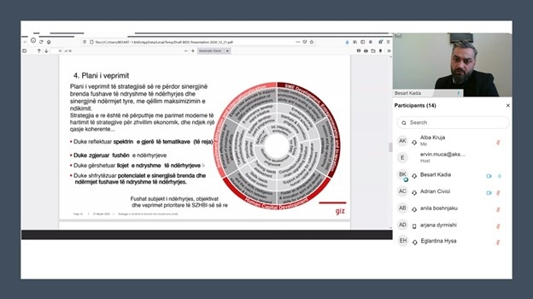The Ministry of Finance and Economy (MFE) is in the last year of implementation of the Action Plan for the period 2014-2020, the Business Development and Investment Strategy. MFE with the support of GIZ ProSeed project, in February 2020 started the work for drafting the new Business Development and Investment Strategy (BIDS) 2021-2027.

On January 19th, an online consultation meeting was held with representatives of private and public universities, to discuss together the measures proposed in the draft Business Development and Investment Strategy (BIDS) 2021-2027. In this meeting were present representatives of MFE, Deputy Minister Mr. Kadia and the international expert who assisted in drafting the Strategy. Dr. Alba Kruja, Entrepreneurship Lecturer at Department of Business Administration and Assoc. Prof. Dr. Eglantina Hysa, Economics and Development Lecturer at Department of Economics, were invited from the Ministry of Finance and Economy to take part in this consultative meeting.

* **The Future of Innovative Tirana**

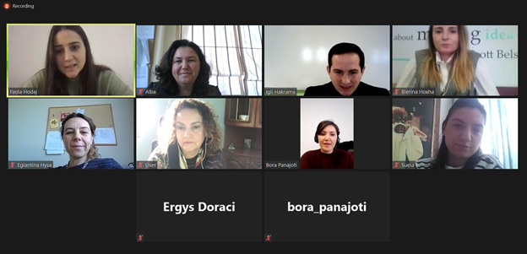

On January 25th, the Directorate of Innovation at Municipality of Tirana organized a virtual round table with representatives from universities. The meeting aimed to create a friendly environment to promote in-depth discussions on the ecosystem of entrepreneurship and innovation in Albania, stimulate cooperation, identify best practices that address the innovation challenges faced due to changes in technology and industry as well as gathering the main problems and challenges of the ecosystem in setting up the Innovation strategy of the Municipality in order for this strategy to better serve the community and all actors of the ecosystem. In this meeting were invited Dr. Alba Kruja, Entrepreneurship Lecturer at Department of Business Administration, Assoc. Prof. Dr. Eglantina Hysa, Economics and Development Lecturer at Department of Economics, and Dr. Igli Hakrama, Software Engineering Lecturer at the Department of Computer Engineering.

* **Second International Scientific Conference “HAPPINESS AND CONTEMPORARY SOCIETY” March 21, 2021, Lviv (Ukraine), co-hosted by Epoka University**

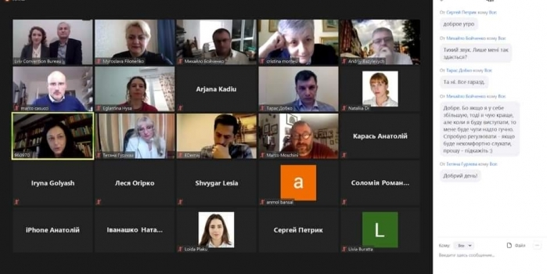

The Department of Economics and the Department of Business Administration together with several other international academic institutions co-hosted the Second International Scientific Conference “HAPPINESS AND CONTEMPORARY SOCIETY” held during March 20 – 21, 2021 in Lviv, Ukraine for the 2nd year consecutively.

This conference aims to create a European platform of interdisciplinary international discussion on happiness and to attract scientific and public attention to the relevance of happiness problem for contemporary societies.

Interdisciplinary researchers from philosophy, medicine, neuroscience, biochemistry, biology, psychology, sociology, political science, economics, management, pedagogy, and anthropology were invited to present their research studies and discuss topics on happiness and economic development; happiness and education system; happiness, civil society, law and state management; happiness and culture etc.

Assoc. Prof. Dr. Eglantina Hysa and Dr. Esmir Demaj held welcoming speeches for the conference participants and academic staff members from Epoka University presented their research in the conference too.

Link of the conference: <http://ukr-happiness-institute.com/international-scientific-conference-happiness-and-contemporary-society-march-20-21-2021-lviv-ukraine/>

* **3rd Social Business Day**

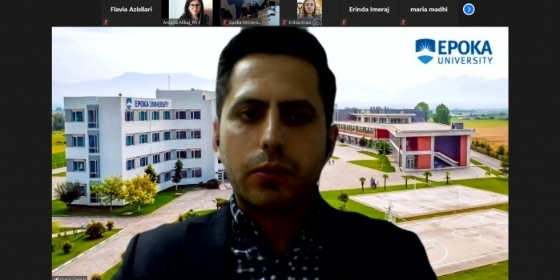

Dr. Esmir Demaj, Head of Business Administration Department and Assoc. Prof. Dr. Xhimi Hysa, Lecturer at Business Administration Department participated in the “3rd Social Business Day” at Epoka University.

“3rd Social Business Day” at Epoka University was held on 21st of May 2021, hosted by YCSBS. 3rd SBD was organized in form of online symposium and brought together representatives of different international Yunus Centers, national and international stakeholders, social business entrepreneurs, professors and students.

The third social business day was organized into two sessions. The first session was opened with the welcome speech of the director of Yunus Center for Social Business and Sustainability of Epoka University, Dr. Erinda Imeraj.

Dr. Malgorzata Bonikowska, Yunus Social Business Chair in Poland, shared with the audience her experience in the social business field. Coming from a cooperative system, Poland and Albania share quite similarities on business booming after the 90s. But the new generations are not choosing to work only for money but for a social global change.

Dr. Enrico Testi, Director of the research center ARCO and Yunus Social Business Centre University of Florence, shared with us his experience working as Director of a Yunus Center. In Italian culture, the term of social enterprises is quite popular compared with the philosophy of social businesses. Dr. Testi mentioned that pandemic give other perspectives in solving social problems.

Dr. Gelanda Shkurtaj, Lecturer at Epoka University made a great presentation about the Legislative View of Social Business in Albania. Dr. Shkurtaj concluded that there exists a lack of clear definition of social businesses in Albanian legislative system and they are mostly perceived as Non-Profit Organization or charity programs.

Assoc. Prof. Dr. Xhimi Hysa Lecturer at Business Administration Department, shared with our audience the reasons why a social business is sustainable, how the circular economy opened a new perspective for the social businesses.

Dr.Audrone Urmanaviciene, Lecturer at Tallinn University shared with us CA project SHINE presentation. Mrs Audrone made a presentation about the working groups, design thinking, and responsible innovation and innovative solutions to social challenges.

Mr. Arben Shamija, YAPS founder made a presentation of the Yaps activity and the social contribution they are offering through their operations. The successes story of YAPS lies behind the good management of people and funds.

Dr. Jorge Alejandro Garcia Ramirez shared with the guests and students the successes story of BIVE, social business operating on the healthcare system in Colombia. The incentive that they started as students now has become a sustainable social business that aims at closing the gap in healthcare system between rural and urban areas.

Prof. Dr. Gabriele Schäfer, Head of Start Up Center, Hochschule Kempten, Germany shared with the audience the reasons why Germany is not the best country for a social business enterprise. Prof. Schafer concluded that “Economy for the good” is the only solution and we should move in a model of a good life for all.

The second session of 3rd SBD was dedicated on the student’s initiatives. Moderated from Dr. Esmir Demaj, Head of Business Administration Department of Epoka University, this session was opened from Mrs. Ardiola Alikaj from Partners Albania. Mrs. Alikaj presented the new opportunities have students now through the new platform launched from them, Dua Partner Invest, the platform which train and support the start-ups initiatives of students and as well offer opportunity for professionals to share their experience through consultancy sessions. Mrs. Erilda Duzha Krasi re-shared with us her experience as a social business entrepreneur. 1001 Albanian Adventures is a great model operating in Berat, offering their social impact through employment.

The student’s competition gave space to four groups of students to present their social business plan ideas, which were very well prepared and presented. The winning idea was selected from the jury and was “BIOALPS”, presented from Aleksandra Kaba, Brijana Mekolli, Igli Mura, Orgest Tahiri, Ortencia Laci and Rei Kalo.

Social Business Day, a tradition now, hosted by YCSBS will hopefully motivate future collaborations, research and new entrepreneurs to do social business and make a difference.

## 4.7 Projects

* **Dr. Demaj attends the Virtual and Augmented Reality Project Meetings**

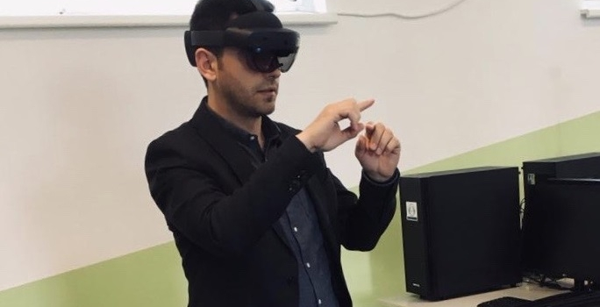Dr. Esmir Demaj, Head of the Department of Business Administration, attended the Project Management and Roundtable Meetings in the framework of VTECH Erasmus+ Project, to which Epoka University is a partner institution. The meetings were held in Tetova and Skopje, North Macedonia during May 20-21, 2021.

The Steering Committee Meeting was held at premises of the Southeast European University in Tetova. In this meeting the project progress, project management and financial issues that concern the project were discussed. The VTECH Virtual Reality Roundtable Meeting, was held at the premises of Mother Theresa University in Skopje. Among the topics of the round table was discussion on the possibilities of Virtual Reality / Augmented Reality and their implementation in the higher education sector and the need that the industry will have upon this, now and in the future.

* **The second Expert Forum on “Virtual Collaborative Learning Environment” of the VALEU-X project**

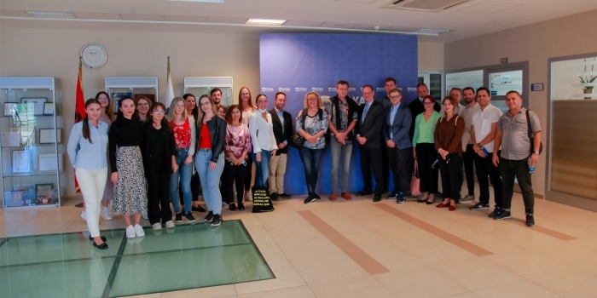

The second Expert Forum of the VALUE-X project was held, at the premises of the Aleksander Moisiu University in Durres during September 23-24, 2021. The Expert Forum was moderated by Prof. Dr. Eric Schoop from TU Dresden and was conceptualized as a best practice sharing and free room for discussion, which provided more advanced expertise about Virtual Collaborative Learning, digitalization, and virtual mobility for al l stakeholders. All participants were very committed to contribute with examples and other descriptions of experiences related to the project topics.

Epoka University was represented in the Expert Forum by several academic and administrative staff members. The group of students that attended the summer school organized by TU Dresden participated in the forum too.

The forum aimed at focusing the discussion around:

Designing and implementing an integrated Virtual Collaborative Learning environment

Designing didactical teaching and learning materials of selected pilot VCL courses

Organizing and facilitating local undergraduate pilot VCL course delivery

Availability and ability of experts in innovative teaching and learning practices to actively attend and contribute to the experts’ forum in the partner country.

The need to change our conception about nowadays students by highlighting the importance of teamwork through integrating participants form different partner organizations was stressed during the forum. This is further encouraged by the need to shift from ‘manufacturing’ workers to ‘knowledge’ workers. In addition, there is a need to shift from traditional vertical hierarchies to self-managing teams. Therefore, designing and implementing an integrated Virtual Collaborative Learning (VCL) environment is crucial for teamwork. VCL helps academicians to enhance flexibility in online teaching; focus on active learning processes; international teaching partnerships; formative assessment; access to data driven Social Learning Analytics etc.

The Expert Forum was organized in a hybrid mode, on-site for the students, academic and administrative staff travelling to Durres, and online for all participants from their home countries. The rationale was to maximize participation and allow everyone interested to join.

For more information about the VALEU-X Project please visit https://valeu-x.eu

- **Midterm Steering Committee meeting of the VALEU-X Project**

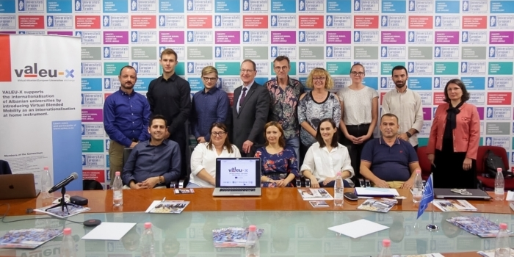

The Midterm Steering Committee Meeting of VALEU-X Project was organized during three days on September 22, 25, 27 at “Aleksander Moisiu” University in Durres, Epoka University, and European University of Tirana. Dr. Esmir Demaj and Dr. Nertil Mera attended the meetings as the project working group members representing Epoka University. Ms. Edra Sota attended the meeting on behalf of the Research and Projects Office.

Among the topics discussed during the meeting was the actual status of various work packages of the project taking into consideration the Covid-19 impact to the project deliverables. Quality assurance, financial management and the status of equipment purchased in the context of the project were discussed. The selection of local VCL Pilot courses as one of the deliverables of the project along the curriculum redesign to fit VCL and teaching/learning materials for the pilot collaborative learning courses were among the important points of the agenda discussed.

The Virtual Collaborative Learning Room at Epoka University equipped and installed with the equipment purchased from the VALEU-X project was inspected by the consortium partners. The VCL Room is designed as an interactive virtual learning space, where VCL based classes will be held providing students an international experience at their home university by developing and delivering technology-enhanced problem-based learning course materials in the virtual classroom.

For more information about the VALEU-X Project please visit https://valeu-x.eu/

# 5. Support, Resources & Representation

## 5.1 List of Students’ Internships

|  |  |  |  |
| --- | --- | --- | --- |
| Student BUS Department Company | | | |
| Joana | Hasanaj | Business Administration | **Megatek** |
| Qamile | Zdrava | MSc Business Administration | **Megatek** |
| Kristi | Bejko | Business Administration | **Dhoma Biznesit të Diasporës Shqiptare** |

## 5.2 Participation in Academic Events

* **Lockdown Economy: Helping Small Businesses to Overcome the Pandemic**

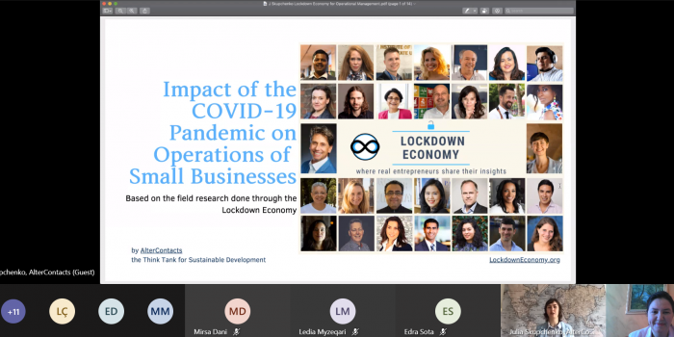

On November 9 and 10, Dr. Alba Kruja hosted in her Operations Management course lectures with third year students of Business Administration, Business Informatics, International Marketing and Logistics programs Mrs. Julia Skupchenko.

Mrs. Julia Skupchenko is an award-winning entrepreneur and innovator. She is the co-founder of Think Tank for Sustainable Development, AlterContacts.org. She is running LockdownEconomy.org, a United Nations registered non-profit socio-economic and educational initiative to help small businesses and self-employed professionals to overcome the challenges of the pandemic and reactivate the economy.

In the three open lectures delivered, Mrs. Julia shared with students the field research done through the Lockdown Economy on the impact of Covid-19 Pandemic in the operations of small businesses. At the same time, she invited them to be part and contribute to this global initiative by bringing interview cases from the Albanian entrepreneurs.

* **Virtual meeting on Entrepreneurial Opportunities: UK-Albania Tech Hub Experience**

On November 16, 2020, Dr. Alba Kruja organized a discussion session for the students of the Small Business Management and Entrepreneurship course in regard with the entrepreneurial ecosystem in Albania and the opportunities offered to youth.

Ms. Anisa Berisha is the program officer of UK-Albania Tech Hub project, implemented by British Embassy Tirana. The project is focused to tech start-ups helping them go global while strengthening the Albanian entrepreneurial ecosystem bringing an international perspective by the best British experts.

She had a great interaction with students discussing the opportunities of young people for entrepreneurial initiatives during this period where everything is moving towards digitalization while maintaining the balance between university and social life. She also emphasized the importance of learning the pitching skills for all the students that had a business idea and were looking for investors/clients.

* **Exploring Covid-19 Pandemic Impact on Albanian Businesses**

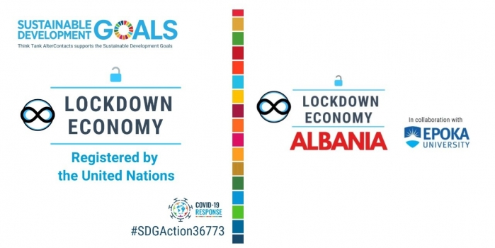Lockdown Economy was launched in 2020 to help small businesses and self-employed professionals overcome the challenges of the pandemic and reactivate the economy. It is a global non-profit and educational movement.

This initiative consists of 1) the interview series with entrepreneurs affected by the lockdown; and 2) the Academy which provides real-time education materials about entrepreneurship during the lockdown to students worldwide.

Dr. Alba Kruja invited Julia Skupchenko founder of Lockdown Economy, to present this initiative to all students of Operations Management Course and to offer them the opportunity to share stories of small business operating in Albania.

Albanian entrepreneurs get a forum to share their struggles, successes, and experiences of dealing with the COVID-19 pandemic, by learning from each other. Through the Lockdown Economy, they have a way to connect with a wider community of other entrepreneurs. In the YouTube Channel of AlterContacts are posted the interviews conducted by 3rd year students of Epoka University under the Lockdown Economy series. You can access them in the links below:

Group members: Rexhina Tare, Tuana Yozgatli, Kleida Sharra, Xhesika Samarxhiu

Interviewer: Rexhina Tare

Business Name: Golden Taste, a halal restaurant in Tirana

Interviewee: Besa Hoxha, Manager

Lockdown Economy Albania in a Halal Restaurant with Besa Hoxha

Group members: Ambra Mallunxa, Brajan Lloçi, Ketjona Lepuri, Suada Hoxha, Tomas Muça

Interviewer: Suada Hoxha

Business Name: Tirana Center of Technology

Interviewees: Rezart Alija and Gentjan Mejdani, co-founders

Lockdown Economy Albania in a Technology Center with Rezart Alija and Gentjan Mejdani

Group members: Loneta Sejdi, Melisa Miri, Albana Xhini, Rovena Noka

Interviewer: Melisa Miri

Business Name: Alba Fireplaces

Interviewee: Albana Xhini, HR Manager

Lockdown Economy Albania in a Fireplace Shop with Albana Xhini

Group members: Dea Durro, Deidamea Bajri, Sara Koni, Stiliana Jano, Amada Kazaferi

Interviewer: Dea Durro

Business Name: Restaurant IGMA, family- run restaurant

Interviewee: Englatin and Amada Kazaferi, owners

Lockdown Economy Albania in a Family-Run Restaurant with Englatin and Amada Kazaferi

Group members: Klajd Tabaku, Iris Çenga, Sanja Mulla, Siola Cevani

Interviewer: Iris Çenga

Business Name: Angel's Store

Interviewee: Sanja Mulla, owner

Lockdown Economy Albania in an Online Clothing Store with Sanja Mulla

Group members: Mishela Rapo, Ledia Myzeqari, Olesia Kamberi, Cetina Lukaj, Altea Stefa

Interviewers: Mishela Rapo, Ledia Myzeqari, Olesia Kamberi, Cetina Lukaj, Altea Stefa

Business Name: Sogni D'oro

Interviewee: Edlira Stefa, owner

Lockdown Economy Albania in a Baby Store with Edlira Stefa

Group members: Alesia Dalipi, Joana Balla, Majlinda Myftaraj, Suela Kola

Interviewer: Suela Kola

Business Name: Leo De Verzay Caffe in Durres

Interviewee: Gjon Kola

Lockdown Economy Albania in a Coffee Bar with Gjon Kola

Group members: Kübra Özdemir, Edisera Hidra, Elvira Samurri, Rashell Dehne

Interviewer: Kübra Özdemir

Business Name: Capitol Restaurant in Tirana

Interviewee: Fatmir Zhguni, General manager

Lockdown Economy Albania in a Halal Restaurant with Fatmir Zhguni

Group members: Igla Morinaj, Kristel Lapardhaja, Esi Binaj , Ersi Disha, Tea Pepa

Interviewer: Ersi Disha

Business Name: Easy Pay Albania

Interviewee: Stela Shkodrani, COO

Lockdown Economy Albania in a Payment Service Provider with Stela Shkodrani

Group members: Isena Lahi, Kantonisa Boci, Marios Malaj, Xhesika Leka, Aiwei Elvis Chen

Interviewer: Isena Lahi, Kantonisa Boci and Xhesika Leka.

Business Name: Sport Association Sauk

Interviewee: Delon Sina, CEO

Lockdown Economy Albania in a Sports Association with Delon Sina

Group members: Diona Halilaj, Edisa Rroji , Kedi Hoxha, Lusjela Doda, Noemi Balla

Interviewer: Lusjela Doda

Business Name: Market Rroji

Interviewee: Edlina Rroji, Owner

Lockdown Economy Albania in a Grocery Store with Eldina Rroji

* **Open lecture with Mr. Eric Panič , representative of Medex**

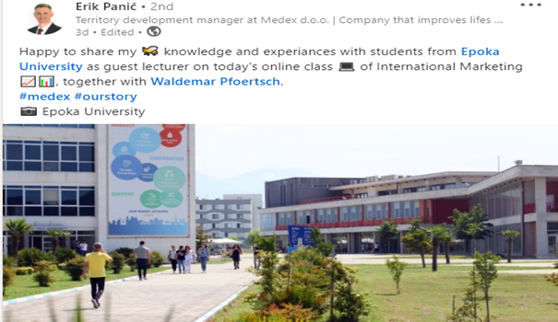On April 16, 2021, Prof. Dr. Waldemar Pfoertsch invited Mr. Erik Panič as a guest lecturer in the International Marketing and Management of Multinational Enterprises Cours. Mr. Erik Panič is representative of Medex, a Slovenian Company. Medex, having operated for more than 90 years in the market, is a leader in producing food supplements, composed of honey and other natural products. Founded in 1954, Medex is a privately-owned company.

During the virtual learning process, Mr.Panič shared with Epoka students his valuable experience of working as a territory development manager at Medex Company. He presented his approaches and the strategies taken on the internalization of the company in question. At this moment, Medex company, has entered the market of 30 countries across the world.

Mr. Panič expressed his enthusiasm for having an important, informative lecture session with students of Epoka University.

* **Guest lecture, Amazon Private Label**

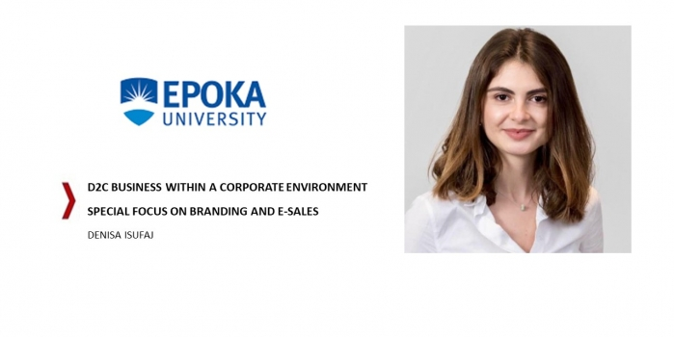

On June 3, 2021, in the online-Master class of Brand Management, taught by Professor Waldemar Pfoertsch, another guest lecturer was invited. Denisa Isufaj provided fresh insights about advance branding applications from her current knowledge of integrated marketing and branding.

In 2013, Ms. Denisa Isufaj had graduated with a Bachelor degree in Business Informatics at the Faculty of Economy at the University of Tirana and in 2015 with a Master’s in Management of Technology-Information System, from ESIEE Paris (Graduated with Distinction), In September 2014, she became part of Henkel AG & Co. KGaA is a German chemical and consumer goods company headquartered in Düsseldorf, Germany. During her 6 years tenure, she was promoted to different positions inside the company. Since May 2021, she joint Amazon in Munich with a new job position as a New Brands product manager for the companies Private Label division.

Denisa introduced first-hand insights about branding options for established consumer product companies and she shared newest principles and best practices about social media brand development. She also gave hints to the students about her job experiences by giving real examples how the students can apply the concepts they have learned in the Brand Management Course into practice. She also shared experience about personal development and job acquisitions. It was a great please having her at Epoka University Business Master Program.

## 5.3 Acknowledgements

Department Business Administration expresses its gratitude to all full-time staff, part-time staff, departments’ coordinator, research assistant, teaching assistants and students and for being highly dedicated the whole academic year.

**Department of Business Administration**

Epoka University

Rr. Tirane- Rinas, Km. 12 , 1039, Tirane/Albania

Phone: +355 4 2232 086

Fax: +355 4 2222 117

Email: [info@epoka.edu.al](mailto:info@epoka.edu.al) [bus@epoka.edu.al](mailto:bus@epoka.edu.al)