**ANNUAL REPORT**

1 September 2022 – 31 July 2023

**Annual Report**

1 September 2022 – 31 July 2023

Contents

A. Organization & Management 3

Study programs offered by the Department 4

B. Resources 5

Finance 6

IT Resources, Physical Infrastructure and Library Resources 7

C. The Curriculum 8

Graduate Teaching 10

D. Teaching, Learning, Assessment & Research 11

Graduate Students’ List of Theses 12

List of Incoming & Outgoing Students 12

Research Areas and Research Groups 13

List of Publications 13

Participation of Academic Staff in Academic Events 14

Projects 15

E. Support, Resources & Representation 15

List of Students’ Internships 16

Participation in Academic Events 16

Student Best Success Stories 18

Office Holders 19

Acknowledgements 20

## Organization & Management

Introduction

Dr. …. Head of Department

Some text here …

## Study programs offered by the Department

* **Bachelor in Business Administration**

**Bachelor Program in Business Administration:** Consists in 180 ECTS including the diploma thesis. The students that have successfully completed a total of 180 ECTS shall be entitled to graduate from the program and shall be conferred the diploma of Bachelor in Business Administration.

**Graduation:** A student who has been successful in all courses, summer practices, seminary course and diploma thesis and, through pursuing the academic program, his/her cumulative grade point average is to at least (2.00), without having a FD or FF grade shall be deemed to have met the requirements of graduation by the relevant board decision and be awarded Bachelor Diploma in Business Administration.

**Proffessional Status**

The Bachelor in Business Administration provides students with knowledge in management and in business administration, as well as with organizational skills to serve in the public and in private sector. The business administration program is structured around a group of technical courses, which exposes students to the basic tools of quantitative methods, accounting, and economic theory, and a core of management and leadership courses that integrate culture, language, and ethics, to enable future business leaders to meet the challenges of today’s global environment.

* **Bachelor in Business Informatics**

Bachelor's of Business Informatics program is comprised of a three year curriculum at EPOKA University. The educational workload for these three years is 180 ECTS. Each semester students are expected to cover at least 30 ECTS.

The Business Informatics program provides students with knowledge in management and informatics, as well as with organizational skills to serve in the public and private sectors. The Business Informatics program is structured around a group of technical courses, which exposes students to the basic tools of quantitative methods, accounting, and economic theory, and a core of informatics courses. The focus lies on the planning, development, implementation, operation, optimization and economic use of information and communication systems. Business Informatics specialists are often considered as the interpreters between IT and business administration staff that otherwise may live in completely different worlds and talk at cross purposes.

Bachelor Program in Business Informatics consists in 180 ECTS including the diploma thesis. The students that have successfully completed a total of 180 ECTS shall be entitled to graduate from the program and shall be conferred the diploma of Bachelor in Business Informatics.

* **Bachelor in International Marketing & Logistics**

Globalization is the keyword in today`s marketplace which is highly competitive. A switch of powers took place in the last decades from businesses towards customers. Marketing is one of the most important business` function that played a crucial role in this. Marketing is responsible of satisfying unlimited customer needs and wants through many important processes. These processes include: production, pricing, promotion and distribution of goods and services that have high quality and affordable prices. Customer retention and attraction of new customers is possible by building strong brands.

International Marketing & Logistics:

International Marketing & Logistics program aims to provide knowledge in the field of marketing and logistics to our students so they can be well-trained individuals, ready for today`s high competitive labor market. Through this program; our students are able to analyze how critical issues such as customer relationship management, international marketing, consumer behavior, logistics are applied in the market place by the companies. In total accordance with the mission and the vision of Epoka University International Marketing and Logistics Program also aims to provide well-educated individuals to satisfy the companies` needs in marketing and logistic departments.

* **Master of Science in Business Administration**

The normal duration of Master of Science study program is two academic years or four semesters with 120 ECTS. In the fourth semester, the student completes his or her master’s thesis.

The qualification from this department provides the students with knowledge in management and in business administration, as well as with organizational skills to serve in the public and in private sector.

The system of attendance is full time. Detailed information on the courses offered in the semester schedules is included in the academic plan. The list of departmental required and elective courses is provided in detail in the academic catalogue, including the theoretical lessons, recitation lessons, credits, equivalent credits according to ECTS credit system, and workload of each course. The objective of this department is to fulfill the need for qualified members in this field, and to prepare skilled people to work in different managing sectors. Demand from graduates of bachelor programs has also been an influent factor driving the creation of the Master of Science in Business Administration study program

Mission:

The mission of the Business Administration Department is to prepare and graduate students for careers in business, government and non-profit organizations by providing a broad professional education. The business administration program is structured around a group of technical courses, which exposes students to the basic tools of quantitative methods, accounting, and economic theory, and a core of management and leadership courses that integrate culture, language, and ethics, to enable future business leaders to meet the challenges of today’s global environment.

Opportunities:

* Appropriate and comfortable spaces for students and academicians.
* Recent catalogues and educational programs based on the global trade demand of work Diversified staff (foreign and Albanian) with long educational experience.
* Possibilities for internships during the studies in local and foreign companies. The spaces are supplied with wireless and cabled internet 24 hours a day so that students can use to develop their research.
* The possibility of employment for the graduated students is tightly connected with their academic advances, courage, and conditions that will be provided by the university.
* The graduated students will have consolidated knowledge on management, economics and human resources
* Students will be able to situate organizational work in the company and to find relevant solutions to the continuously appearing challenges.
* Through the gained experience, the graduated managers will be among the most preferred staff in the specific disciplines due to their profession ethics, acquired theoretical framework, and applied methodology when employed. The department aims at encouraging and motivating the graduated students to organize and manage their private activities.
* **Professional Master in Business Administration**

By the Decision No. 908 of the Council of Ministers of the Republic of Albania, dated 26 August 2009, Epoka University has been granted the license to open Second Cycle Study Programs which are as follows:

Professional Master Programs, which are part of the second cycle of studies, with 60 ECTS. After the fulfillment of all requirements of the abovementioned programs, the student is conferred a Professional Master Diploma in the respective field.

Professional Master in Business Administration consists in 48 ECTS of taken courses and a 12 ECTS Term Project (micro-thesis). The students that have successfully completed a total of 60 ECTS shall be entitled to graduate from the program and shall be conferred the diploma of Master Professional in Business Administration.

Graduation: A student at the graduation stage who has been successful in all courses, seminary courses and thesis of the study program, and his/her cumulative grade point average is to at least (2.00), without having a FD or FF grade shall be deemed to have met the requirements of graduation by the relevant board decision and be awarded Master Professional in Business Administration Diploma.

Professional Status

Professional Master in Business Administration provides students with knowledge in management and business administration, as well as with organizational skills to serve in the public and in private sector. The program harmonizes contemporary business theory with business practice and problems. The program gains mastery to graduates in the business management field.

* **PhD in Business Administration**

ligibility to apply to the PhD programme

The persons who are eligible for admission to the PhD programme should:

* have obtained a Master of Science/Master of Arts, integrated second cycle studies or any other equivalent diploma in the field of the Doctorate (PhD) program or in a close field previously defined in the requirements established by the respective of the Scientific Committee
* have a CGPA of at least 2.70 out of 4.00 or 8 out of 10 from the Master of Science/Master of Arts, integrated second cycle studies or any other equivalent diploma in the field of the Doctorate (PhD) program or in a close field previously defined in the requirements established by the respective Scientific Committee or an equivalent CGPA
* Applicants must demonstrate that they have reached the minimum acceptable level of proficiency in use of the English language:

1. having studied undergraduate degree in English
2. a TOEFL IBT score of at least 70 or
3. the equivalent score for the internationally recognized English Language Exams as stipulated in the Directive of the Minister of Education and Science No. 14, dated 28.03.2011 "On the recognition of English language exams for the second and third cycle study programs"

## Resources

Department Staff

Full time Academic Staff

**Head of Department**

Dr. Esmir DEMAJ

**Lecturer**

Prof.Dr. Waldemar Adam PFOERTSCH

**Lecturer**

Assoc.Prof.Dr. Alba KRUJA

**Lecturer**

Assoc.Prof.Dr. Nargiza ALYMKULOVA

**Lecturer**

Dr. Aida BITRI

**Lecturer**

Dr. Nurul Retno NURWULAN

**Assistant Lecturer**

MSc. Besjon ZENELAJ

**Assistant Lecturer**

MSc. Mariola MUÇI

**Assistant Lecturer**

MSc. Saimir MANSAKU

**Assistant Lecturer**

MSc. Sidorela META

**Assistant Lecturer**

MSc. Mikaela SÜSLÜ (Musta)

**Assistant Lecturer**

MSc. Ardita DORTI

**Assistant Lecturer**

MSc. Egla MANSI

**Assistant Lecturer**

MSc. Enesh ORAZOVA

**Assistant Lecturer**

MSc. Enesh ORAZOVA

**Assistant Lecturer**

MSc. Taskyn RAKHYM

**Part time Academic Staff**

1. Assoc. Prof. Dr. Alda Kika
2. Assoc. Prof. Dr. Albana Borici
3. Assoc.Prof.Dr. Blerina Zanaj
4. Dr. Enkelejda Koka
5. Dr. Idaver Sherifi
6. Dr. Rrezart Bozo
7. Dr. Olgerta Idrizi
8. MSc. Amela Buzi
9. MSc. Ada Mucina
10. MSc. Kristel Bozhiqi
11. MSc. Sonila Cela
12. MSc. Saimir Kokonozi
13. MSc. Ernaso Kërbizi
14. MSc. Edison Reshketa
15. MSc. Henri Haxhiu

**Academic Visitors (2022-2023)**

**Fall Semester 2022-2023**

|  |  |  |
| --- | --- | --- |
| **PROGRAM** | **YEAR** | **ADVISERS** |
| BA BINF | 1st Year  BINF A / BINF B / BINF C | MSc Aida Bitri |
| BA BINF | 2nd Year BINF A / BINF B / BINF C | MSc Aida Bitri / MSc. Egla Mansi / MSc. Egla Mansi |
| BA BINF | 3rd Year  BINF A / BINF B / BINF C | MSc. Mariola Muci |
| BA BUS | 1st Year | MSc. Saimir Mansaku |
| BA BUS | 2nd Year | MSc. Saimir Mansaku |
| BA BUS | 3rd Year | MSc. Besjon Zenelaj |
| BA IML | 1st Year, | MSc. Besjon Zenelaj |
| BA IML | 2nd Year | MSc. Besjon Zenelaj |
| BA IML | 3rd Year | MSc. Besjon Zenelaj |
| PM BUS | All Students | Dr. Esmir Demaj |
| M.Sc BUS | 1st Year | Dr. Esmir Demaj |
| M.Sc BUS | 2nd Year | Dr. Esmir Demaj |
| PhD BUS | 1st, 2nd, 3rd Year | Dr. Esmir Demaj |

**Spring Semester 2022-2023**

|  |  |  |
| --- | --- | --- |
| **PROGRAM** | **YEAR** | **ADVISERS** |
| BA BINF | 1st Year  BINF A / BINF B | MSc Aida Bitri |
| BA BINF | 1st Year  BINF C | MSc Taskyn Rakhim |
| BA BINF | 2nd Year BINF A / BINF B | MSc Enesh Orazova |
| BA BINF | 2nd Year BINF C | MSc Egla Mansi |
| BA BINF | 3rd Year  BINF A / BINF B | MSc Ardita Dorti |
| BA BINF | 3rd Year  BINF C | MSc Mariola Muci |
| BA BUS | 1st Year | MSc. Mikaela Suslu |
| BA BUS | 2nd Year | Dr. Nurul Nurwulan |
| BA BUS | 3rd Year | MSc. Mikaela Suslu |
| BA IML | 1st Year, | MSc. Besjon Zenelaj |
| BA IML | 2nd Year | Assoc. Prof. Nargiza Alymkulova |
| BA IML | 3rd Year | MSc. Besjon Zenelaj |

Administrative Staff

## Finance

Income and Expenditure Summary

Some text here …

## IT Resources, Physical Infrastructure and Library Resources

EPOKA University is located on the Tirana-Rinas road, on the 12th kilometer. The campus extends over a total area of 67,000 m2. The 2019-2020 academic year is being conducted regularly on the premises of two buildings with a total area of 14352 m2.

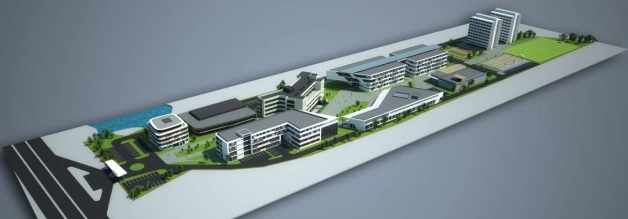

Figure 1: Master-Plan of the Campus.

Figure 2: Location of the campus on the Tirana-Rinas road

Figure 3: E-building

This building has a modern infrastructure and a central heating and cooling system. The classrooms are equipped with video projectors and smart boards that enable the normal conduct of the learning process.

Figure 4: Classrooms E-building

Figure 5: Auditoriums in E-building

In September 2013, the construction of A-Building the “Cultural Social Object of Epoka University” was completed. In addition to classrooms, there are plenty of recreational facilities for students such as cafeterias, libraries, internet cafés, facilities for the Student Council and student clubs, sports facilities, etc. Below are shown current pictures of the building.

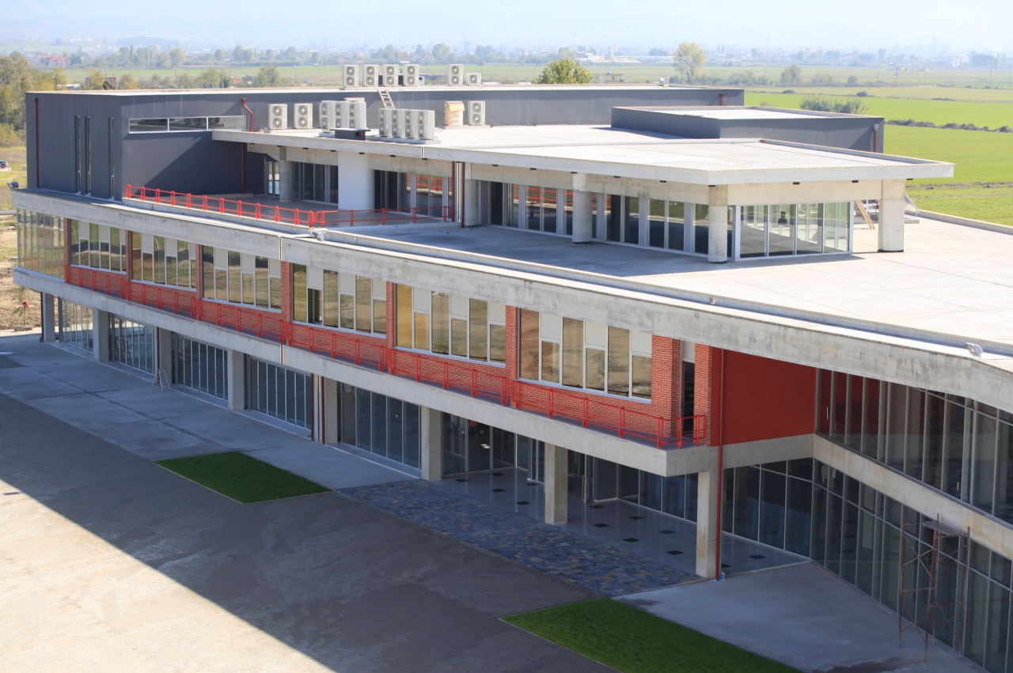

Figure 6: A-building, Cultural and Social Object

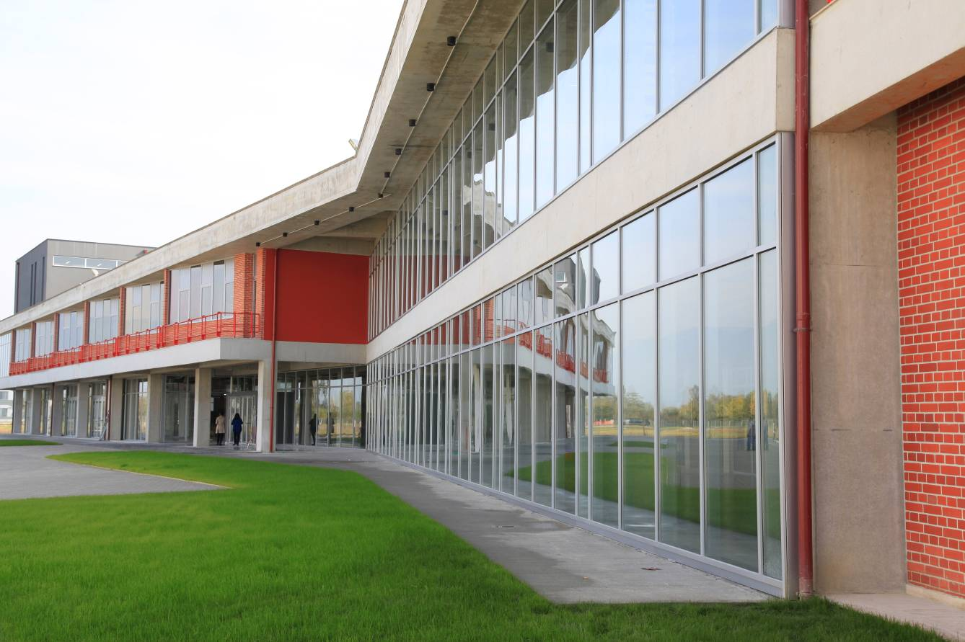

Figure 7: A-building, Cultural Social Object

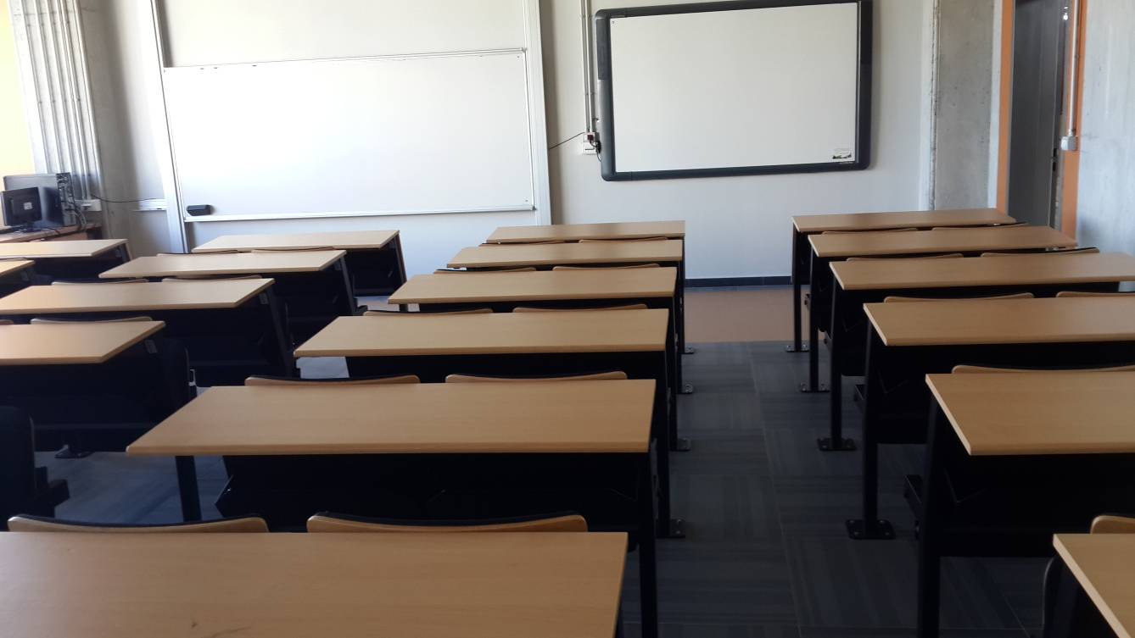

Figure 8: Classrooms in A-building

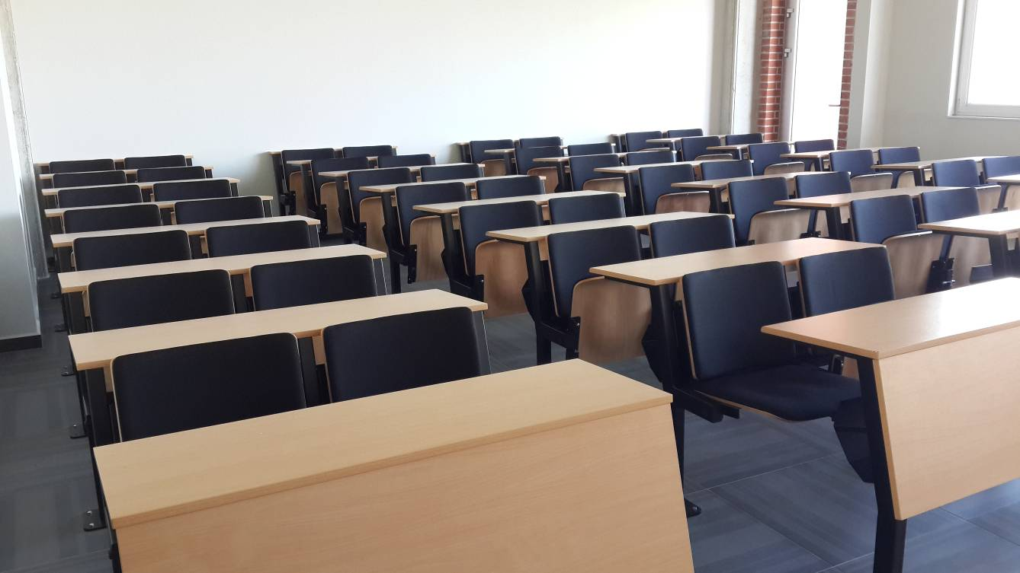

Figure 9: Classrooms in A-building

**Measurable indicators:**

Table 1: Premises of the Faculty

|  |  |  |
| --- | --- | --- |
| **Premises for the Faculties** | **Quantity** | **Surface** |
| Auditoria/Classrooms for lectures | 5 | 752 |
| Classrooms for seminars | 18 | 1604 |
| Premises for promotion activities | 1 | 128 |
| Classrooms for course/professional practice | 2 | 258 |
| Laboratories for courses | 4 | 233 |
| Informatics laboratories | 3 | 174.6 |
| Internet Room | 2 | 151.8 |
| Library Hall | 1 | 322 |
| Premises for photocopying, bookshop etc. | 1 | 33.6 |
| Student information office | 2 | 71 |
| Corridors/halls | 25 | 2707.4 |
| Sports premises | 5 | 463 |
| Premises for service to third parties | 1 | 56 |
| Restrooms (WC) for students | 54 | 327.2 |
| Restrooms (WC) for academic personnel | 35 | 212.1 |
| **Ratio m2/ per students** | 3.65 | |
| **Premises for personnel:** | **Quantity** | **Surface** |
| Offices for the Dean/Vice-Dean | 5 | 285.5 |
| Office for the Administrator | 1 | 25.4 |
| Offices for the Department Coordinators | 3 | 78.5 |
| Offices for departments/research centers | 12 | 328.5 |
| Offices for the academic personnel | 40 | 620 |
| Office for the Finance Office | 2 | 37 |
| Office for the Internal Quality Assurance Unit | 1 | 50 |
| Meeting rooms | 3 | 160.2 |
| Premises for service personnel | 11 | 30.2 |
| Premises for the activities of the Student Council | 1 | 30 |
| Recreation premises such as cafeteria/fast-food/ restaurant | 1 | 337 |
| **Ratio m2 per person** | **17.39** | |

For the 2017-2018 academic year, EPOKA University Campus uses 17 classrooms: (E-B10, E-B11, E-211, E-212, E-213, E-311, E-312, E-313, A 117, A118, A119, A120, A127, A128, A129, A130, A131), 5 auditoriums: (E-012, E-110, E-214, E-314 and A-005) a conference room (E-B01), three computer laboratories (E-011, E-015, A-126), an electronic lab (E-010) and a civil engineering laboratory. There are 3 internet rooms as it is reflected in the table above, but the University offers comprehensive wireless internet throughout its buildings. The facilities are equipped with central heating-cooling systems, video projectors, smart boards and sound systems and are presented in the tables and the photo gallery below.

Table 2: Classrooms used during the 2019-2020 academic year

|  |  |  |  |
| --- | --- | --- | --- |
| **No.** | **Name of the Class** | **Surface (m2)** | **Capacity** |
| 1 | E B10 | 75 | 56 |
| 2 | E B13 | 75 | 66 |
| 3 | E 211 | 64 | 36 |
| 4 | E 212 | 81.32 | 72 |
| 5 | E 213 | 81.72 | 72 |
| 6 | E 311 | 63.46 | 40 |
| 7 | E 312 | 81.32 | 48 |
| 8 | E 313 | 81.72 | 40 |
| 9 | A 117 | 138.0 | 35 |
| 10 | A 118 | 138.0 | 35 |
| 11 | A 119 | 138.0 | 35 |
| 12 | A 120 | 138.0 | 35 |
| 13 | A 126 | 72.41 | 42 |
| 14 | A 127 | 72.41 | 56 |
| 15 | A 128 | 73.53 | 56 |
| 16 | A 129 | 73.71 | 56 |
| 17 | A 130 | 72.02 | 56 |
| 18 | A 131 | 72.02 | 56 |
| **total** | **18** | **1591.64** | **892** |

Table 3: Auditoriums used during the 2019-2020 academic year

|  |  |  |  |
| --- | --- | --- | --- |
| **No.** | **Name of Auditorium** | **Surface (m2)** | **Capacity** |
| 1 | E 012 | 131.54 | 66 |
| 2 | E 110 | 130.82 | 136 |
| 3 | E 214 | 154.32 | 150 |
| 4 | E 314 | 154.32 | 134 |
| 5 | A 005 | 145.2 | 65 |
| **total** | **5** | **716.2** | **551** |

Table 4:Laboratories used during the 2019-2020 academic year

|  |  |  |  |
| --- | --- | --- | --- |
| **Name** | **Laboratories** | **Surface (m2)** | **Capacity** |
| E 011 | Computer Laboratory 2 | 96.64 | 42+1 |
| E 015 | Computer Laboratory 1 | 77.93 | 40+1 |
| E B11 | Computer Laboratory 3 | 123.7 | 47+1 |
| E 012 | Electronic Laboratory | 132 | 20+1 (24) |
| I 001 | Civil Engineering Laboratory | 283 | 40 |

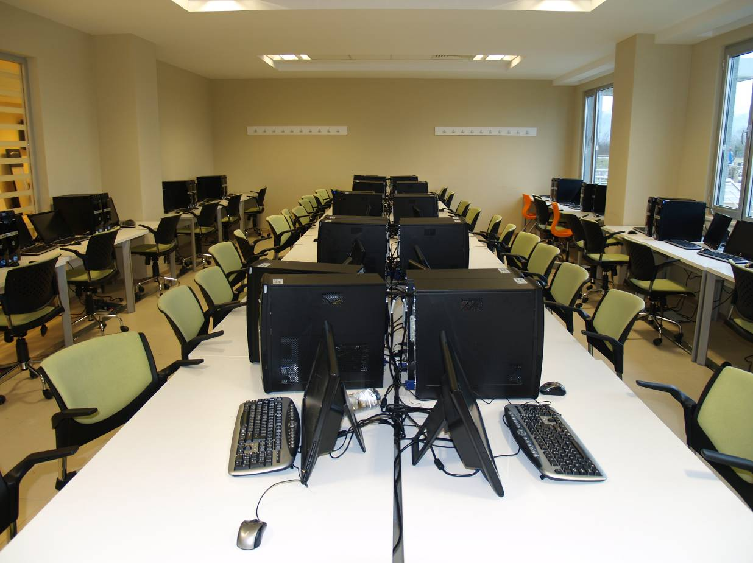

Figure 10: Informatics Laboratory 1

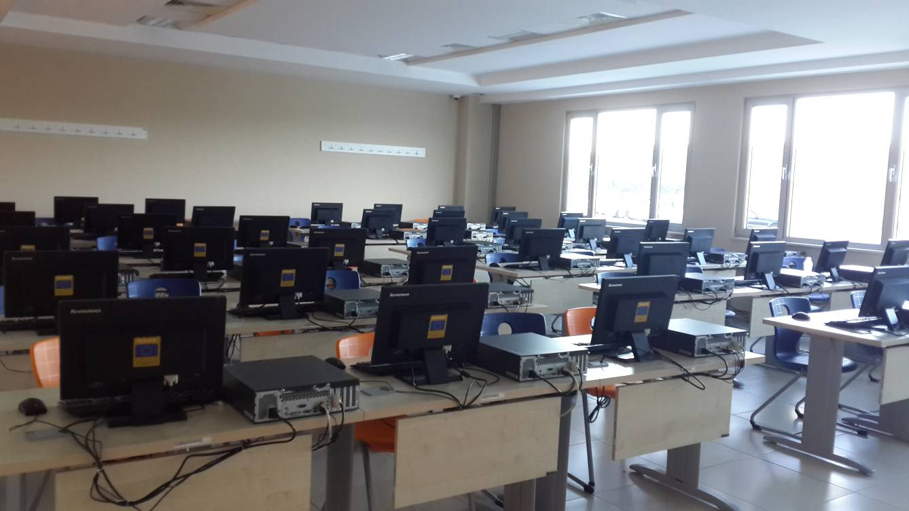

Figure 11: Informatics Laboratory 2

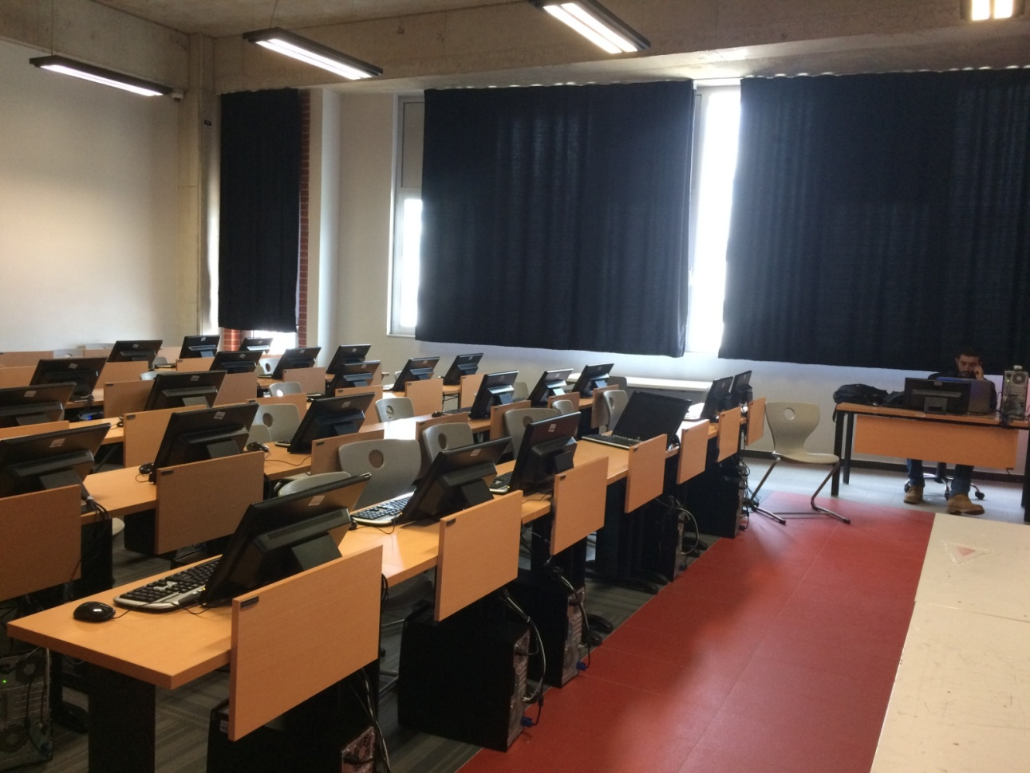

Figure 12: Informatics Laboratory 3

Figure 13: Conference Hall 1

Epoka University has a conference hall with anarea of128 m2 and a capacity of 99 persons. The conference hall is mainly used for social, cultural and various national and international conferences. The hall is equipped with central heating-cooling system, video projector, sound system and two cabins for simultaneous translation. In addition, a new conference hall is under construction on the premises of the “Cultural Social Object” building is with a surface of about 400 m2 and a capacity of 300 persons.

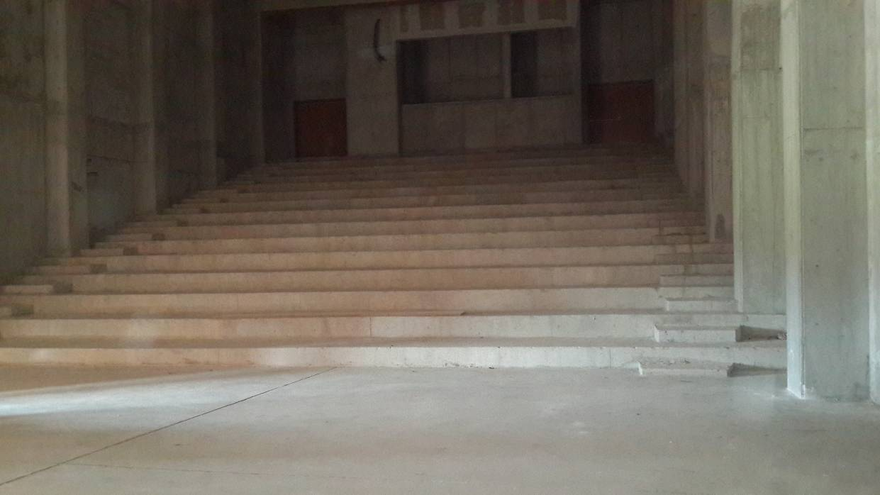

Figure 14: Conference Hall 2, under construction

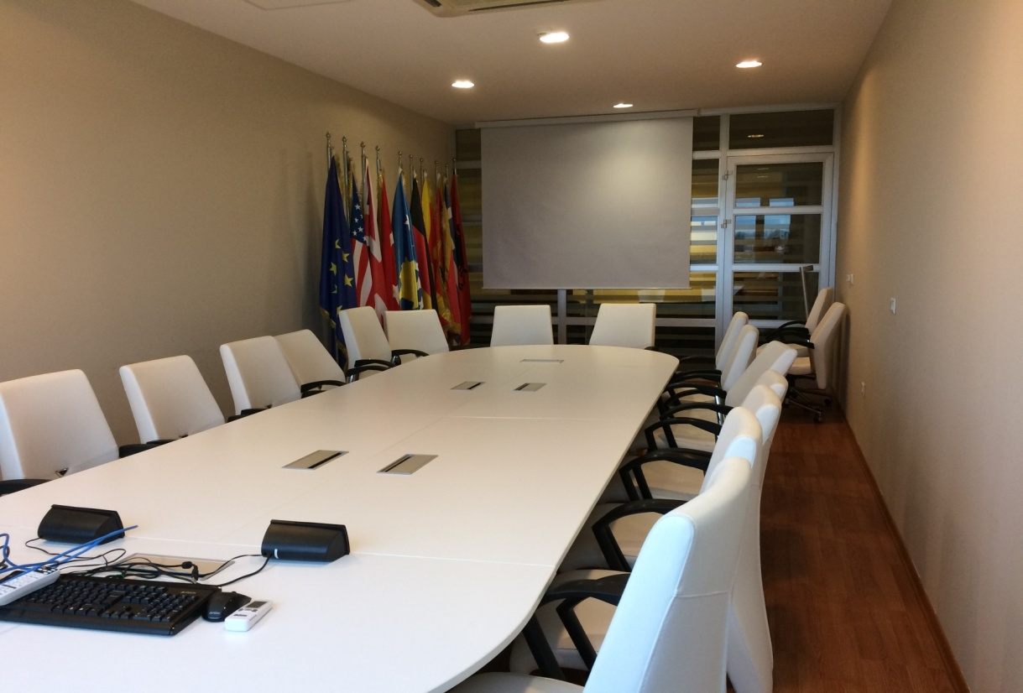

Figure 15: Eagle Meeting Room.

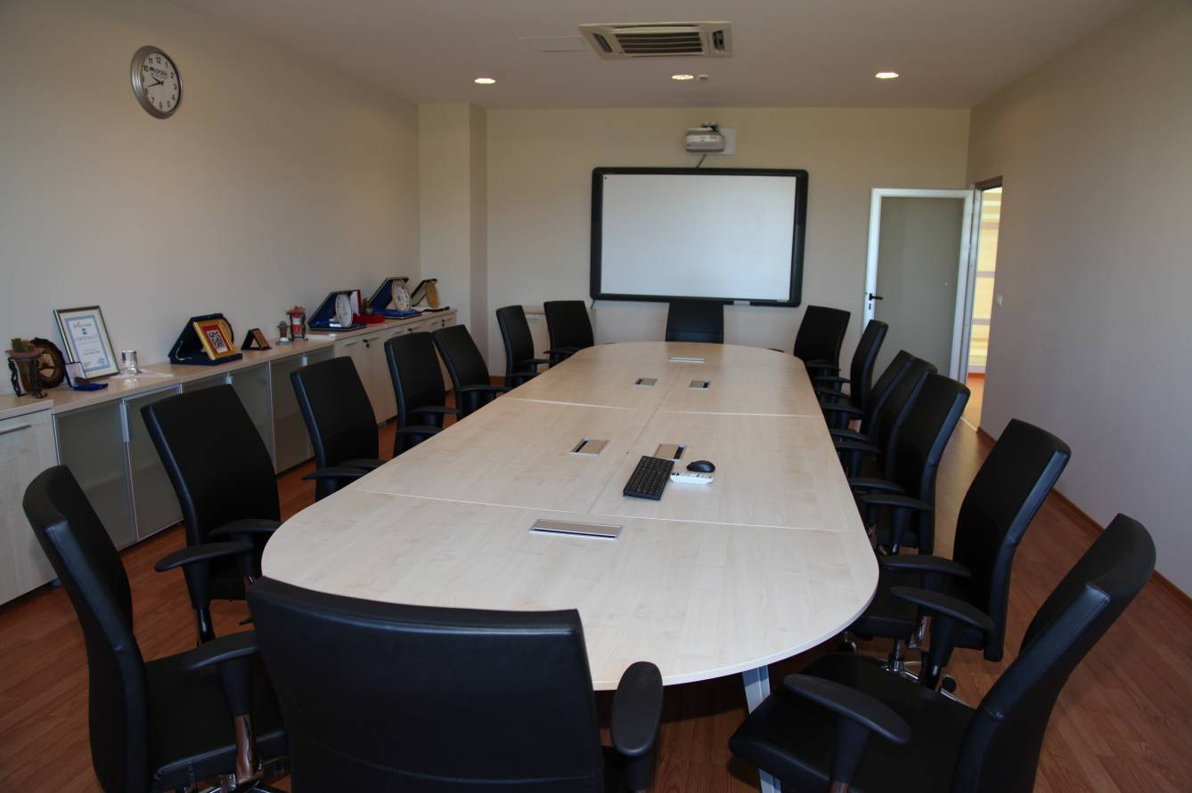

Figure 16: Diversity Meeting Room

**ICTC Office Services:**

The Information and Communication Technologies Coordinating Office (ICTCO) provides informatics services needed in the University. It plans the informatics infrastructure of the University, provides its security and ensures the continuation of its functions. ICTCO works on the project for effective, legal and extensive usage of the informatics services for students and personnel and provides the following services:

Chart 1: ICTCO Services

**Teaching Services:**

* **Turnitin** software helps users to understand and avoid plagiarism and develop their understanding of how to cite sources as part of an academic argument. ICTC office manages the users and trains the staff about how to use Turnitin.
* **Learning Management System (LMS)** – A service based on Moodle offered for students and instructors in order to access, coordinate and organize course materials online. Students and instructors can login to LMS using the provided official email account.
* **Library Automation System (Koha) -** Koha is an open-source Integrated Library System in use today by hundreds of libraries worldwide. Koha is web based, so there is no software to install on desktop computers.  Users can check the books online and reserve them via web. Its features are more than enough to manage the Epoka Library effectively and efficiently.
* **DSpace**– The institutional repository of Epoka University: DSpace is an open source repository software package typically used for creating open access repositories for scholarly and/or published digital content. The proceedings of the conferences which are organized by Epoka University can be accessed from this repository.  Epoka University is the only university who has digital repository in Albania *(*[*http://repositories.webometrics.info/en/Europe/Albania*](http://repositories.webometrics.info/en/Europe/Albania)*).* We also give services to other international journals to publish their publications *(*[*http://dspace.epoka.edu.al/handle/1/1378*](http://dspace.epoka.edu.al/handle/1/1378)*)* in our digital repository.

**Google Services:**

* **Webmail (Google account) –**Epoka University is using Google Apps for Education services and all students and academic and administrative staff are provided with an email address under epoka.edu.al domain which is a Google account. Beside official communication which is done through this email address, this account can be used for authentication to other online systems offered by university.
* **Google Classroom** – A more interactive service offered by Google as part of Google Apps for education in order to access, coordinate and organize course materials on cloud. By using Google Classroom, course materials can be integrated with other Google services where assigned users can collaborate. Students and instructors can access this service using the provided account.

**Microsoft Teams –** During the online classes, Epoka University used also Microsoft Teams for the teaching process. It brings together everything a class needs: chat and threaded conversations, meetings & video conferencing, assignments and quizzes.

**Education Information System (Curriculum)** – a website containing information related to study programs, curriculum and course syllabuses.

**Smart Card:** All students and staff are provided with Smart Card identification cards. The Smart Card is put as an e-ID application at three buildings, two PC labs, one Electronics Lab, and campus gate entry turnstiles and barriers. The e-wallet application is active for staff but has not started yet for students.

**Help Desk:** ICTCO is also responsible for the maintenance of personnel and PC Lab computers in respect to software and hardware. Its staff monitors the personal computers within the frame of distribution of duty and authority and brings the issues to a conclusion. At the same time, ICTCO plans servers and cabling services of the University. Staff can open ticket via help.epoka.edu.al for their ICTCO related problems and follow the process from here. You can share your opinions on every subject related to information technologies and informatics with help@epoka.edu.al and you can also write your complaints and suggestions for a better campus life.

**Software Opportunities**

Epoka University has a subscription of Microsoft Program which is called Dream Spark. It supports technical education by providing access to Microsoft software for learning, teaching and research purposes. Epoka University also provides Office 365 accounts to all staffs and students which includes all office applications for free.

**Network**

**Wireless:** Epoka University provides wireless internet connection to all Epoka members in the campus. As ICTCO, we ensure that the wireless signal is strong and covers everywhere in campus.

**Wired:** Besides wireless, there are three PC labs, one Civil Engineering lab, one Electronics lab, one PhD study room and a library where PCs serve students and staffs with wired internet. In the Epoka Library and one of the classrooms, there are plug and use stations next to each table where students and staff can use for wired internet and electricity for their laptops.

**Digital Signage:** There are four TVs in campus, which are used to inform Epoka members about latest news and announcements.

**Epoka Interactive Systems (EIS)**

Chart 2: Epoka Interactive Systems (EIS)

Recognizing the needs of campus community, Epoka has made a strategic decision to replace its aging, cumbersome, and vendor-supported student, instructors, and staff systems with a modern, nimble and effective internally built system that includes admissions, enrolment, registration, financial aid, student, instructor, and staff accounts, and advising in one platform.

EIS is developed by ICTCO at Epoka University. From the user interface, EIS is an online interactive system where users can log in using the provided official email account. It is a modular system organized by roles and respective units at the university and the information is stored in a centralized database. All users have access to their personal information, can update general details and CV and they can manage job related tasks and activities according to their role and job position.

* **Students:** Students in their profile can access their personal information and information related to their study program. Course registration is done through the system and after that, students can view the ongoing academic activity of the registered courses during the semester. They can check attendance, exam dates, interim grades and final grades. Also, in the system, they can access the program curriculum, transcript, grade calculation, weekly schedule, requests and notifications. The EIS prompts students when they are in the “warning zone” for financial or academic issues. It empowers students to create course plans to ensure timely graduation.
* **Instructors:** Academic staff including full-time and part-time lecturers can have access to their courses assigned in the current semester and can also view previously assigned courses. Lecturers can update the syllabus, complete student attendance, assign and finalize grades. Advisor lecturers can have access to academic information of the students assigned for advisory and they can approve student course registration.
* **Coordinators:** The opening of courses according to course appointment in each semester is done by department coordinators and approved by faculty coordinators. Coordinators can monitor the academic activity of the lecturers under respective department.
* **Admissions and Registrar’s Office:** Admissions Office enters all pre-registered student information and assigns scholarships. After the student has completed the registration, all the related information entered by Admissions office, is managed by Registrar’s office.
* **Finance:** Finance office can manage and follow up all student financial information related to tuition fees and scholarship.
* **Human Resources:** Human resources office can manage all staff information data and assigns roles and job position for each staff.
* **Curriculum:** a website containing information related to study programs, curriculum and course syllabus.

All users have access to their personalized reports according to their roles and respective units. Faculties and units are liberated from tedious manual tasks. EIS supplies them with new and most updated information that will empower them to make informed decisions based on data.

EIS can be continuously updated with new modules according to the university needs. EIS can be accessed via: https://eis.epoka.edu.al and users can log-in by their Epoka Mail account credentials.

**Measurable indicators:**

Table 5: Numbers on Tools and Equipment

|  |  |
| --- | --- |
| Number of PCs for graduate students | 120 |
| Number of PC furnished labs for graduate students | 4 |
| Number of PCs for academic staff | 87 |
| Number of PCs for administration | 53 |
| Number of printers | 15 |
| Number of photocopying machines | 15 |
| Number of head projectors | 1 |
| Number of video-projectors | 27 |
| Number of scanners | 10 |

**LIBRARY**

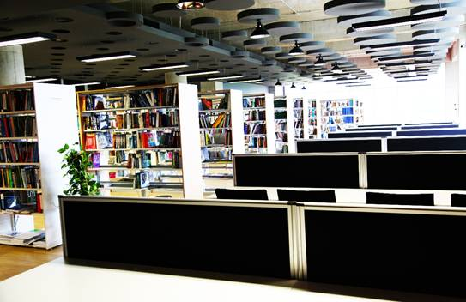

Figure 17: Library

The Epoka University Library, which is located on the first floor of A-Building in the Rinas Campus, was founded to support the education and research activities of the university by providing and organizing the needed documents.

With its 100-seating capacity, our library has 400 square meters area of use. Our University Library is composed of entrance, book and reading hall. In the entrance, there is a check out desk. The periodicals, including the exhibition of new arrivals, are also shelved in this section. The reading hall is equipped for students to study and to do research.

Epoka University is a member of Balkan Libraries Union which was founded on 29 July 2009 with the participation of 10 institutions from 6 Balkan countries.

Our library collection is enriched by purchases and donations. The books to buy are chosen in accordance with the needs and requests of the students, administrative and academic staff. Under the Department of Library and Documentation, the library has a total of about 7500 printed books.

**Digital Databases**

Epoka University has full membership in JSTOR, a shared digital library created in1995 that includes more than 2,000 academic journals. JSTOR was founded to help libraries and academic publishers transition their activities from print to digital operations, to expand access to scholarly content around the world and to preserve it for future generations.

Every member of Epoka staff can have access to JSTOR’s collections by going to http://www.jstor.org/ and searching or browsing for content and can download several articles periodically.

**Using the Library**

Our library works on the open shelf system enabling users to reach the books directly. The books in the open shelves are topically sorted in the book hall according to LC classification method. To find the book you are looking for, users should follow these steps:

1. Through the catalog search computers in the library users can search author’s name, book name, and publisher, topic, or keyword areas. Users can also search for books at *(*[*http://lib.epoka.edu.al/*](http://lib.epoka.edu.al/)*)*
2. To get the book, users can go to the shelves with the classification and location numbers of the books appearing on the screen as a result of the user’s search.

**Example of LC number** for the book: "Exchange rates and international finance", Laurence S. Copeland / Financial Times, 2008

**HG 3821/ C78 /2008**

The first part of the LC number "**HG**" represents the category of the book by its topic. In the LC system, the first letter **H**stands for **Social Science** class. Each subsequent letter indicates next level of subcategories of the main topic. In the given example **G** stands for **Finance**, **3821**indicates subcategories included between 3810-4000 (Foreign exchange, International finance, International monetary system), C78 indicates the first letter of authors surname, **2008**indicates book publication year.

**Regulations**

Students of associate degree, Bachelor’s Degree, and Master’s Degree and academic and administrative personnel are members of the library. They can borrow library materials in accordance with the rules.

Researchers coming from outside the university are not lent books, they are only allowed to use and copy the materials in the library. Readers in this group are requested to fill up the related Lending Service form.

Table 6: Circulation Rules

|  |  |  |  |
| --- | --- | --- | --- |
| **Resource** | **Patron** | **Loan period(days)** | **Maximum number of check-outs(items)** |
| **Book** | Pre-undergraduate/Undergraduate students | 15 | 3 |
| Graduate students | 15 | 5 |
| Staff | 20 | 5 |
| **Bound Journal** | Graduate students Staff | 5 | 2 |
| **Visual/Audio Resources** | Pre-undergraduate/Undergraduate students Graduate students Staff | 3 | 3 |

Source: *(*[*http://library.epoka.edu.al/cat-regulations-484.html*](http://library.epoka.edu.al/cat-regulations-484.html)*)*

## The Curriculum

**Undergraduate Teaching**

|  |  |  |  |  |  |  |  |  |  |  |  |  |  |  |  |
| --- | --- | --- | --- | --- | --- | --- | --- | --- | --- | --- | --- | --- | --- | --- | --- |
| **FACULTY OF ECONOMICS AND ADMINISTRATIVE SCIENCES** | | | | | | | | | | | | | | | |
| **DEPARTMENT OF BUSINESS ADMINISTRATION** | | | | | | | | | | | | | | | |
| **BACHELOR PROGRAM IN BUSINESS INFORMATICS (3 YEARS)** | | | | | | | | | | | | | | | |
| **First YEAR** | | | | | | | | | | | | | | | |
| **First Semester** | | | | | | | | | | | | | | | |
| COURSES | | Course Type | Compulsory /Elective | Weekly Course Distribution | | | | Epoka | Semestral Lecture and studying hours | | | | | | ECTS |
| Code | Course Name | Theory | Pract. | Lab. | Total | Credits | Lect. | Pract. | Lab. | Site W. | Other | Total |
| ECO 101 | Introduction to Economics I | A | Compulsory | 3 | 0 | 0 | 3 | 3 | 48 | 0 | 0 | 70 | 7 | 125 | 5 |
| BUS 103 | Introduction to Business | B | Compulsory | 3 | 0 | 0 | 3 | 3 | 48 | 0 | 0 | 70 | 7 | 125 | 5 |
| CEN 111 | Introduction to Algorithms and Programming I | B | Compulsory | 2 | 0 | 2 | 4 | 3 | 32 | 0 | 32 | 61 | 0 | 125 | 5 |
| BINF 101 | Fundamentals of Information Systems | D | Compulsory | 3 | 0 | 0 | 3 | 3 | 48 | 0 | 0 | 70 | 7 | 125 | 5 |
| BUS 101 | Math. for Economics and Business I | A | Compulsory | 4 | 0 | 0 | 4 | 4 | 64 | 0 | 0 | 61 | 0 | 125 | 5 |
| ENG 109 | Developing Reading and Writing Skills | D | Compulsory | 4 | 0 | 0 | 4 | 4 | 64 | 0 | 0 | 61 | 0 | 125 | 5 |
| Semestral Total | | | | 19 | 0 | 2 | 21 | 20 | 304 | 0 | 32 | 393 | 21 | 750 | 30 |
| **Second Semester** | | | | | | | | | | | | | | | |
| COURSES | | Course Type | Compulsory /Elective | Weekly Course Distribution | | | | Epoka | Semestral Course and studying hours | | | | | | ECTS |
| Code | Course Name | Theory | Pract. | Lab. | Total | Credits | Lect. | Pract. | Lab. | Site W. | Other | Total |
| ECO 102 | Introduction To Economics II | A | Compulsory | 3 | 0 | 0 | 3 | 3 | 48 | 0 | 0 | 70 | 7 | 125 | 5 |
| BUS 102 | Math. For Economics and Business II | A | Compulsory | 4 | 0 | 0 | 4 | 4 | 64 | 0 | 0 | 61 | 0 | 125 | 5 |
| BUS 132 | Introduction to Accounting | B | Compulsory | 3 | 0 | 0 | 3 | 3 | 48 | 0 | 0 | 70 | 7 | 125 | 5 |
| CEN 114 | Introduction to Algorithms and Programming II | B | Compulsory | 2 | 0 | 2 | 4 | 3 | 32 | 0 | 32 | 61 | 0 | 125 | 5 |
| BUS 112 | Management and Organization | B | Compulsory | 3 | 0 | 0 | 3 | 3 | 48 | 0 | 0 | 70 | 7 | 125 | 5 |
| BUS 108 | Business English | D | Compulsory | 4 | 0 | 0 | 4 | 4 | 64 | 0 | 0 | 61 | 0 | 125 | 5 |
| Semestral Total | | | | 19 | 0 | 2 | 21 | 20 | 304 | 0 | 32 | 393 | 21 | 750 | 30 |
| **Second YEAR** | | | | | | | | | | | | | | | |
| **Third Semester** | | | | | | | | | | | | | | | |
| COURSES | | Course Type | Compulsory /Elective | Weekly Course Distribution | | | | Epoka | Semestral Lecture and studying hours | | | | | | ECTS |
| Code | Course Name | Theory | Pract. | Lab. | Total | Credits | Lect. | Pract. | Lab. | Site W. | Other | Total |
| BUS 201 | Statistics I | A | Compulsory | 4 | 0 | 0 | 4 | 4 | 64 | 0 | 0 | 61 | 0 | 125 | 5 |
| BINF 251 | Database Management Systems | B | Compulsory | 2 | 0 | 2 | 4 | 3 | 32 | 0 | 32 | 61 | 0 | 125 | 5 |
| CEN 219 | Computer Organization | B | Compulsory | 3 | 0 | 0 | 3 | 3 | 48 | 0 | 0 | 70 | 7 | 125 | 5 |
| CEN 213 | Object Oriented Programing | B | Compulsory | 3 | 0 | 2 | 5 | 4 | 48 | 0 | 32 | 45 | 0 | 125 | 5 |
| BUS 205 | Principles of Marketing | B | Compulsory | 3 | 0 | 0 | 3 | 3 | 48 | 0 | 0 | 70 | 7 | 125 | 5 |
| **XXX xxx** | **Elective** | **C** | **Elective** | **3** | **0** | **0** | **3** | **3** | **48** | **0** | **0** | **70** | **7** | **125** | **5** |
| Semestral Total | | | | 18 | 0 | 4 | 22 | 20 | 288 | 0 | 64 | 377 | 21 | 750 | 30 |
| **Elective Courses** | | | | | | | | | | | | | | | |
| COURSES | | Course Type | Elective | Weekly Course Distribution | | | | Epoka | Semestral Course and studying hours | | | | | | ECTS |
| Code | Course Name | Theory | Pract. | Lab. | Total | Credits | Lect. | Pract. | Lab. | Site W. | Other | Total |
| LAW 203 | Business Law | C | Elective | 3 | 0 | 0 | 3 | 3 | 48 | 0 | 0 | 70 | 7 | 125 | 5 |
| BUS 231 | Financial Accounting I | C | Elective | 4 | 0 | 0 | 4 | 4 | 64 | 0 | 0 | 61 | 0 | 125 | 5 |
| BUS 209 | Innovation Management | C | Elective | 3 | 0 | 0 | 3 | 3 | 48 | 0 | 0 | 70 | 7 | 125 | 5 |
| BUS 207 | Project Management | C | Elective | 3 | 0 | 0 | 3 | 3 | 48 | 0 | 0 | 70 | 7 | 125 | 5 |
| BUS 107 | Essentials of Organizational Behaviour | C | Elective | 3 | 0 | 0 | 3 | 3 | 48 | 0 | 0 | 70 | 7 | 125 | 5 |
| BUS 337 | Total Quality Management | C | Elective | 3 | 0 | 0 | 3 | 3 | 48 | 0 | 0 | 70 | 7 | 125 | 5 |
| BUS 359 | Supply Chain Management | C | Elective | 3 | 0 | 0 | 3 | 3 | 48 | 0 | 0 | 70 | 7 | 125 | 5 |
| ECO 205 | Microeconomics | C | Elective | 3 | 0 | 0 | 3 | 3 | 48 | 0 | 0 | 70 | 7 | 125 | 5 |
| **Fourth Semester** | | | | | | | | | | | | | | | |
| COURSES | | Course Type | Compulsory /Elective | Weekly Course Distribution | | | | Epoka | Semestral Course and studying hours | | | | | | ECTS |
| Code | Course Name | Theory | Pract. | Lab. | Total | Credits | Lect. | Pract. | Lab. | Site W. | Other | Total |
| BUS 202 | Statistics II | A | Compulsory | 4 | 0 | 0 | 4 | 4 | 64 | 0 | 0 | 61 | 0 | 125 | 5 |
| BUS 226 | Management Information Systems | B | Compulsory | 3 | 0 | 0 | 3 | 3 | 48 | 0 | 0 | 70 | 7 | 125 | 5 |
| CEN 361 | Computer Networks | B | Compulsory | 2 | 0 | 2 | 4 | 3 | 32 | 0 | 32 | 61 | 0 | 125 | 5 |
| CEN 254 | Data Structures | B | Compulsory | 3 | 0 | 2 | 5 | 4 | 48 | 0 | 32 | 45 | 0 | 125 | 5 |
| XXX xxx | Elective I | B | Elective | 3 | 0 | 0 | 3 | 3 | 48 | 0 | 0 | 70 | 7 | 125 | 5 |
| XXX xxx | Elective II | C | Elective | 3 | 0 | 0 | 3 | 3 | 48 | 0 | 0 | 70 | 7 | 125 | 5 |
| Semestral Total | | | | 18 | 0 | 4 | 22 | 20 | 288 | 0 | 64 | 377 | 21 | 750 | 30 |
|  |  |  |  |  |  |  |  |  |  |  |  |  |  |  |  |
| **Elective Courses** | | | | | | | | | | | | | | | |
| COURSES | | Course Type | Elective | Weekly Course Distribution | | | | Epoka | Semestral Course and studying hours | | | | | | ECTS |
| Code | Course Name | Theory | Pract. | Lab. | Total | Credits | Lect. | Pract. | Lab. | Site W. | Other | Total |
| BINF 202 | Enterprise Resource Planning | B | Elective | 3 | 0 | 0 | 3 | 3 | 48 | 0 | 0 | 70 | 7 | 125 | 5 |
| BINF 204 | Ethical and Social issues in Information Systems | B | Elective | 3 | 0 | 0 | 3 | 3 | 48 | 0 | 0 | 70 | 7 | 125 | 5 |
| CEN 351 | Multimedia and Graphic Design | B | Elective | 3 | 0 | 0 | 3 | 3 | 48 | 0 | 0 | 70 | 7 | 125 | 5 |
| BINF 206 | Business Modelling and Simulation | B | Elective | 3 | 0 | 0 | 3 | 3 | 48 | 0 | 0 | 70 | 7 | 125 | 5 |
| BUS 232 | Financial Accounting II | C | Elective | 4 | 0 | 0 | 4 | 4 | 64 | 0 | 0 | 61 | 0 | 125 | 5 |
| BUS 204 | Entrepreneurial Management | C | Elective | 3 | 0 | 0 | 3 | 3 | 48 | 0 | 0 | 70 | 7 | 125 | 5 |
| BUS 358 | Knowledge Management | C | Elective | 3 | 0 | 0 | 3 | 3 | 48 | 0 | 0 | 80 | 22 | 150 | 6 |
| BUS 114 | Communication Skills | C | Elective | 3 | 0 | 0 | 3 | 3 | 48 | 0 | 0 | 70 | 7 | 125 | 5 |
| ECO 206 | Macroeconomics | C | Elective | 3 | 0 | 0 | 3 | 3 | 48 | 0 | 0 | 70 | 7 | 125 | 5 |
|  |  |  |  |  |  |  |  |  |  |  |  |  |  |  |  |
| **Third YEAR** | | | | | | | | | | | | | | | |
| **Fifth Semester** | | | | | | | | | | | | | | | |
| COURSES | | Course Type | Compulsory /Elective | Weekly Course Distribution | | | | Epoka | Semestral Lecture and studying hours | | | | | | ECTS |
| Code | Course Name | Theory | Pract. | Lab. | Total | Credits | Lect. | Pract. | Lab. | Site W. | Other | Total |
| CEN 311 | WEB Technologies and Programming | B | Compulsory | 2 | 0 | 2 | 4 | 3 | 32 | 0 | 32 | 61 | 0 | 125 | 5 |
| BAF 233 | Fundamentals of Corporate Finance | C | Compulsory | 3 | 0 | 0 | 3 | 3 | 48 | 0 | 0 | 70 | 7 | 125 | 5 |
| BUS 321 | Operations Management | B | Compulsory | 3 | 0 | 0 | 3 | 3 | 48 | 0 | 0 | 70 | 7 | 125 | 5 |
| BUS 309 | Professional Practice | D | Compulsory | 0 | 6 | 0 | 6 | 3 | 0 | 96 | 0 | 22 | 7 | 125 | 5 |
| XXX xxx | Elective I | B | Elective | 3 | 0 | 0 | 3 | 3 | 48 | 0 | 0 | 70 | 7 | 125 | 5 |
| XXX xxx | Elective II | C | Elective | 3 | 0 | 0 | 3 | 3 | 48 | 0 | 0 | 70 | 7 | 125 | 5 |
| Semestral Total | | | | 14 | 6 | 2 | 22 | 18 | 224 | 96 | 32 | 363 | 35 | 750 | 30 |
| **Electives** | | | | | | | | | | | | | | | |
| COURSES | | Course Type | Elective | Weekly Course Distribution | | | | Epoka | Semestral Course and studying hours | | | | | | ECTS |
| Code | Course Name | Theory | Pract. | Lab. | Total | Credits | Lect. | Pract. | Lab. | Site W. | Other | Total |
| BINF 301 | Data Science for Business | B | Elective | 2 | 0 | 2 | 4 | 3 | 32 | 0 | 32 | 61 | 0 | 125 | 5 |
| BINF 303 | Enterprise Architecture | B | Elective | 3 | 0 | 0 | 3 | 3 | 48 | 0 | 0 | 70 | 7 | 125 | 5 |
| CEN 352 | Artificial Intelligence | B | Elective | 2 | 0 | 2 | 4 | 3 | 32 | 0 | 32 | 61 | 0 | 125 | 5 |
| BINF 305 | Security Issues in Information Systems | B | Elective | 3 | 0 | 0 | 3 | 3 | 48 | 0 | 0 | 77 | 0 | 125 | 5 |
| BUS 331 | Cost Accounting | C | Elective | 3 | 0 | 0 | 3 | 3 | 48 | 0 | 0 | 70 | 7 | 125 | 5 |
| BUS 335 | Human Resources Management | C | Elective | 3 | 0 | 0 | 3 | 3 | 48 | 0 | 0 | 70 | 7 | 125 | 5 |
| BUS 339 | Innovation and Human Consciousness | C | Elective | 3 | 0 | 0 | 3 | 3 | 48 | 0 | 0 | 70 | 7 | 125 | 5 |
| BUS 251 | Digital Marketing | C | Elective | 3 | 0 | 0 | 3 | 3 | 48 | 0 | 0 | 70 | 7 | 125 | 5 |
| BUS 325 | Social Media Marketing | C | Elective | 3 | 0 | 0 | 3 | 3 | 48 | 0 | 0 | 70 | 7 | 125 | 5 |
| BUS 253 | Consumer Behavior | C | Elective | 3 | 0 | 0 | 3 | 3 | 48 | 0 | 0 | 77 | 0 | 125 | 5 |
| ECO 311 | Econometrics I | C | Elective | 2 | 0 | 2 | 4 | 3 | 32 | 0 | 32 | 61 | 0 | 125 | 5 |
|  |  |  |  |  |  |  |  |  |  |  |  |  |  |  |  |
|  |  |  |  |  |  |  |  |  |  |  |  |  |  |  |  |
| **Sixth Semester** | | | | | | | | | | | | | | | |
| COURSES | | Course Type | Compulsory /Elective | Weekly Course Distribution | | | | Epoka | Semestral Course and studying hours | | | | | | ECTS |
| Code | Course Name | Theory | Pract. | Lab. | Total | Credits | Lect. | Pract. | Lab. | Site W. | Other | Total |
| BUS 324 | Operations Research | B | Compulsory | 4 | 0 | 0 | 4 | 4 | 64 | 0 | 0 | 61 | 25 | 150 | 6 |
| CEN 318 | Operating Systems | B | Compulsory | 3 | 0 | 1 | 4 | **4** | 48 | 0 | 16 | 80 | 6 | 150 | 6 |
| CEN 302 | Software Engineering | B | Compulsory | 2 | 0 | 2 | 4 | 3 | 32 | 0 | 32 | 86 | 0 | 150 | 6 |
| *BINF 302 *BINF 304 | Graduation Project / Final Comprehensive Exam | E | Compulsory | 1 | 4 | 0 | 5 | 3 | 16 | 64 | 0 | 30 | 40 | 150 | 6 |
| XXX xxx | Elective | C | Elective | 3 | 0 | 0 | 3 | 3 | 48 | 0 | 0 | 80 | 22 | 150 | 6 |
| Semestral Total | | | | 13 | 4 | 3 | 20 | 17 | 208 | 64 | 48 | 337 | 93 | 750 | 30 |
| **Electives** | | | | | | | | | | | | | | | |
| COURSES | | Course Type | Elective | Weekly Course Distribution | | | | Epoka | Semestral Course and studying hours | | | | | | ECTS |
| Code | Course Name | Theory | Pract. | Lab. | Total | Credits | Lect. | Pract. | Lab. | Site W. | Other | Total |
| CEN 340 | Smartphone Applications | C | Elective | 2 | 0 | 2 | 4 | 3 | 64 | 0 | 0 | 61 | 25 | 150 | 6 |
| BINF 306 | Data Visualization and Dashboard | C | Elective | 3 | 0 | 0 | 3 | 3 | 48 | 0 | 0 | 80 | 22 | 150 | 6 |
| CEN 380 | Machine Learning | C | Elective | 2 | 0 | 2 | 4 | 3 | 64 | 0 | 0 | 61 | 25 | 150 | 6 |
| BUS 336 | Managerial Accounting | C | Elective | 3 | 0 | 0 | 3 | 3 | 48 | 0 | 0 | 80 | 22 | 150 | 6 |
| BUS 348 | Customer Relationship Management | C | Elective | 3 | 0 | 0 | 3 | 3 | 48 | 0 | 0 | 80 | 22 | 150 | 6 |
| ECO 312 | Econometrics II | C | Elective | 2 | 0 | 2 | 4 | 3 | 64 | 0 | 0 | 61 | 25 | 150 | 6 |
| BUS 354 | Branding and Brand Management | C | Elective | 3 | 0 | 0 | 3 | 3 | 48 | 0 | 0 | 80 | 22 | 150 | 6 |
| BUS 356 | Strategic Logistic Management | C | Elective | 3 | 0 | 0 | 3 | 3 | 48 | 0 | 0 | 80 | 22 | 150 | 6 |
| BUS 352 | International Marketing and Management of International Enterprises | C | Elective | 3 | 0 | 0 | 3 | 3 | 48 | 0 | 0 | 80 | 22 | 150 | 6 |

|  |  |  |  |  |  |  |  |  |  |  |  |  |  |  |  |  |  |
| --- | --- | --- | --- | --- | --- | --- | --- | --- | --- | --- | --- | --- | --- | --- | --- | --- | --- |
| **FACULTY OF ECONOMICS AND ADMINISTRATIVE SCIENCES** | | | | | | | | | | | | | | | | | |
| **DEPARTMENT OF BUSINESS ADMINISTRATION** | | | | | | | | | | | | | | | | | |
| **BACHELOR PROGRAM IN BUSINESS ADMINISTRATION (3 YEARS)** | | | | | | | | | | | | | | | | | |
| **First YEAR** | | | | | | | | | | | | | | | | | |
| **First Semester** | | | | | | | | | | | | | | | | | |
| COURSES | | Course Type | Compulsory /Elective | Weekly Course Distribution | | | | Epoka | Semestral Lecture and studying hours | | | | | | | ECTS | |
| Code | Course Name | Theory | Pract. | Lab. | Total | Credits | Lect. | Pract. | Lab. | Site W. | Other | Total |  | |
| ECO 111 | Introduction to Economics | A | Compulsory | 3 | 0 | 0 | 3 | 3 | 48 | 0 | 0 | 70 | 7 | 125 | 5 | |
| BUS 103 | Introduction to Business | B | Compulsory | 3 | 0 | 0 | 3 | 3 | 48 | 0 | 0 | 70 | 7 | 125 | 5 | |
| LAW 105 | Introduction to Law | A | Compulsory | 3 | 0 | 0 | 3 | 3 | 48 | 0 | 0 | 70 | 7 | 125 | 5 | |
| BUS 107 | Essentials of Organizational Behavior | B | Compulsory | 3 | 0 | 0 | 3 | 3 | 48 | 0 | 0 | 70 | 7 | 125 | 5 | |
| BUS 101 | Math. for Economics and Business I | A | Compulsory | 4 | 0 | 0 | 4 | 4 | 64 | 0 | 0 | 61 | 0 | 125 | 5 | |
| ENG 109 | Developing Reading and Writing Skills | D | Compulsory | 4 | 0 | 0 | 4 | 4 | 64 | 0 | 0 | 61 | 0 | 125 | 5 | |
| Semestral Total | | | | 20 | 0 | 0 | 20 | 20 | 320 | 0 | 0 | 402 | 28 | 750 | 30 | |
|  | | | | | | | | | | | | | | | | | |
|  | | | | | | | | | | | | | | | | | |
| **Second Semester** | | | | | | | | | | | | | | | | | |
| COURSES | | Course Type | Compulsory /Elective | Weekly Course Distribution | | | | Epoka | Semestral Course and studying hours | | | | | | | ECTS | |
| Code | Course Name | Theory | Pract. | Lab. | Total | Credits | Lect. | Pract. | Lab. | Site W. | Other | Total |  | |
| BUS 106 | Principles of Programming | A | Compulsory | 3 | 0 | 0 | 3 | 3 | 48 | 0 | 0 | 70 | 7 | 125 | 5 | |
| BUS 112 | Management and Organization | B | Compulsory | 3 | 0 | 0 | 3 | 3 | 48 | 0 | 0 | 70 | 7 | 125 | 5 | |
| BUS 114 | Communication Skills | C | Compulsory | 3 | 0 | 0 | 3 | 3 | 48 | 0 | 0 | 70 | 7 | 125 | 5 | |
| BUS 132 | Introduction To Accounting | B | Compulsory | 3 | 0 | 0 | 3 | 3 | 48 | 0 | 0 | 70 | 7 | 125 | 5 | |
| BUS 102 | Math. for Economics and Business II | A | Compulsory | 4 | 0 | 0 | 4 | 4 | 64 | 0 | 0 | 61 | 0 | 125 | 5 | |
| BUS 108 | Business English | D | Compulsory | 4 | 0 | 0 | 4 | 4 | 64 | 0 | 0 | 61 | 0 | 125 | 5 | |
| Semestral Total | | | | 20 | 0 | 0 | 20 | 20 | 320 | 0 | 0 | 402 | 28 | 750 | 30 | |
| **Second YEAR** | | | | | | | | | | | | | | | | | |
| **Third Semester** | | | | | | | | | | | | | | | | | |
| COURSES | | Course Type | Compulsory /Elective | Weekly Course Distribution | | | | Epoka | Semestral Lecture and studying hours | | | | | | | ECTS | |
| Code | Course Name | Theory | Pract. | Lab. | Total | Credits | Lect. | Pract. | Lab. | Site W. | Other | Total |  | |
| ECO 205 | Microeconomics | B | Compulsory | 3 | 0 | 0 | 3 | 3 | 48 | 0 | 0 | 70 | 7 | 125 | 5 | |
| BUS 121 | Marketing I | B | Compulsory | 3 | 0 | 0 | 3 | 3 | 48 | 0 | 0 | 70 | 7 | 125 | 5 | |
| BUS 201 | Statistics I | A | Compulsory | 4 | 0 | 0 | 4 | 4 | 64 | 0 | 0 | 61 | 0 | 125 | 5 | |
| BUS 231 | Financial Accounting I | B | Compulsory | 4 | 0 | 0 | 4 | 4 | 64 | 0 | 0 | 61 | 0 | 125 | 5 | |
| XXX xxx | Elective I | D | Elective | 3 | 0 | 0 | 3 | 3 | 48 | 0 | 0 | 70 | 7 | 125 | 5 | |
| XXX xxx | Elective II | C | Elective | 3 | 0 | 0 | 3 | 3 | 48 | 0 | 0 | 70 | 7 | 125 | 5 | |
| **Semestral Total** | | | | **20** | **0** | **0** | **20** | **20** | **320** | **0** | **0** | **402** | **28** | **750** | **30** | |
|  |  |  |  |  |  |  |  |  |  |  |  |  |  |  |  | |
| **Elective Courses - Third Semester** | | | | | | | | | | | | | | | | | |
| COURSES | | Course Type | /Elective | Weekly Course Distribution | | | | Epoka | Semestral Course and studying hours | | | | | |  | |
| Code | Course Name | Theory | Pract. | Lab. | Total | Credits | Lect. | Pract. | Lab. | Site W. | Other | Total | ECTS | |
| BUS 251 | Digital Marketing | C | Elective | 3 | 0 | 0 | 3 | 3 | 48 | 0 | 0 | 70 | 7 | 125 | 5 | |
| FL 201 | Turkish I | D | Elective | 3 | 0 | 0 | 3 | 3 | 48 | 0 | 0 | 70 | 7 | 125 | 5 | |
| FL 203 | German I | D | Elective | 3 | 0 | 0 | 3 | 3 | 48 | 0 | 0 | 70 | 7 | 125 | 5 | |
| FL 205 | Italian I | D | Elective | 3 | 0 | 0 | 3 | 3 | 48 | 0 | 0 | 70 | 7 | 125 | 5 | |
| FL 207 | French I | D | Elective | 3 | 0 | 0 | 3 | 3 | 48 | 0 | 0 | 70 | 7 | 125 | 5 | |
| LAW 203 | Business Law | C | Elective | 3 | 0 | 0 | 3 | 3 | 48 | 0 | 0 | 70 | 7 | 125 | 5 | |
| BUS 207 | Project Management | C | Elective | 3 | 0 | 0 | 3 | 3 | 48 | 0 | 0 | 70 | 7 | 125 | 5 | |
| BUS 209 | Innovation Management | C | Elective | 3 | 0 | 0 | 3 | 3 | 48 | 0 | 0 | 70 | 7 | 125 | 5 | |
|  | | | | | | | | | | | | | | | | | |
| **Fourth Semester** | | | | | | | | | | | | | | | | | |
| COURSES | | Course Type | Compulsory /Elective | Weekly Course Distribution | | | | Epoka | Semestral Course and studying hours | | | | | | | ECTS | |
| Code | Course Name | Theory | Pract. | Lab. | Total | Credits | Lect. | Pract. | Lab. | Site W. | Other | Total |  | |
| BUS 122 | Marketing II | B | Compulsory | 3 | 0 | 0 | 3 | 3 | 48 | 0 | 0 | 70 | 7 | 125 | 5 | |
| ECO 206 | Macroeconomics | A | Compulsory | 3 | 0 | 0 | 3 | 3 | 48 | 0 | 0 | 70 | 7 | 125 | 5 | |
| BUS 226 | Management Information Systems | B | Compulsory | 3 | 0 | 0 | 3 | 3 | 48 | 0 | 0 | 70 | 7 | 125 | 5 | |
| BUS 202 | Statistics II | B | Compulsory | 4 | 0 | 0 | 4 | 4 | 64 | 0 | 0 | 61 | 0 | 125 | 5 | |
| BUS 232 | Financial Accounting II | B | Compulsory | 4 | 0 | 0 | 4 | 4 | 64 | 0 | 0 | 61 | 0 | 125 | 5 | |
| XXX xxx | Elective | C | Elective | 3 | 0 | 0 | 3 | 3 | 48 | 0 | 0 | 70 | 7 | 125 | 5 | |
| **Semestral Total** | | | | **20** | **0** | **0** | **20** | **20** | **320** | **0** | **0** | **402** | **28** | **750** | **30** | |
| **Elective Courses - Fourth Semester** | | | | | | | | | | | | | | | | | |
| **COURSES** |  | Course | Compulsory | Weekly Course Distribution | | | | Epoka | Semestral Course and studying hours | | | | | | | ECTS | |
| Code | Course Name | Type | /Elective | Theory | Pract. | Lab. | Total | Credits | Lect. | Pract. | Lab. | Site W. | Other | Total |  | |
| BAF 222 | Public Finance | C | Elective | 3 | 0 | 0 | 3 | 3 | 48 | 0 | 0 | 70 | 7 | 125 | 5 | |
| BAF 102 | Money and Banking | C | Elective | 3 | 0 | 0 | 3 | 3 | 48 | 0 | 0 | 70 | 7 | 125 | 5 | |
| PIR 162 | Introduction to Public Administration | C | Elective | 3 | 0 | 0 | 3 | 3 | 48 | 0 | 0 | 70 | 7 | 125 | 5 | |
| BUS 210 | Corporate Governance: Theory and Practice | C | Elective | 3 | 0 | 0 | 3 | 3 | 48 | 0 | 0 | 70 | 7 | 125 | 5 | |
| BUS 204 | Entrepreneurial Management | C | Elective | 3 | 0 | 0 | 3 | 3 | 48 | 0 | 0 | 70 | 7 | 125 | 5 | |
| BUS 234 | Sales Techniques and Management | C | Elective | 3 | 0 | 0 | 3 | 3 | 48 | 0 | 0 | 70 | 7 | 125 | 5 | |
| **Third YEAR** | | | | | | | | | | | | | | | | | |
| **Fifth Semester** | | | | | | | | | | | | | | | | | |
| COURSES | | Course Type | Compulsory /Elective | Weekly Course Distribution | | | | Epoka | Semestral Lecture and studying hours | | | | | | | ECTS | |
| Code | Course Name | Theory | Pract. | Lab. | Total | Credits | Lect. | Pract. | Lab. | Site W. | Other | Total |  | |
| BUS 309 | Professional Practice | D | Compulsory | 0 | 6 | 0 | 6 | 3 | 0 | 96 | 0 | 22 | 7 | 125 | 5 | |
| BUS 321 | Operations Management | B | Compulsory | 3 | 0 | 0 | 3 | 3 | 48 | 0 | 0 | 70 | 7 | 125 | 5 | |
| BUS 335 | Human Resource Management | B | Compulsory | 3 | 0 | 0 | 3 | 3 | 48 | 0 | 0 | 70 | 7 | 125 | 5 | |
| BAF 233 | Fundamentals of Corporate Finance | B | Compulsory | 3 | 0 | 0 | 3 | 3 | 48 | 0 | 0 | 70 | 7 | 125 | 5 | |
| XXX xxx | Elective I | B | Elective | 3 | 0 | 0 | 3 | 3 | 48 | 0 | 0 | 70 | 7 | 125 | 5 | |
| XXX xxx | Elective II | C | Elective | 3 | 0 | 0 | 3 | 3 | 48 | 0 | 0 | 70 | 7 | 125 | 5 | |
| **Semestral Total** | | | | **15** | **6** | **0** | **21** | **18** | **240** | **96** | **0** | **372** | **42** | **750** | **30** | |
| **Elective Courses - Fifth Semester** | | | | | | | | | | | | | | | | | |
| **COURSES** | | Course Type | Compulsory /Elective | Weekly Course Distribution | | | | Epoka | Semestral Course and studying hours | | | | | | | ECTS | |
| Code | Course Name | Theory | Pract. | Lab. | Total | Credits | Lect. | Pract. | Lab. | Site W. | Other | Total |  | |
| BUS 323 | E-Marketing | B | Elective | 3 | 0 | 0 | 3 | 3 | 48 | 0 | 0 | 70 | 7 | 125 | 5 | |
| BUS 331 | Cost Accounting | B | Elective | 3 | 0 | 0 | 3 | 3 | 48 | 0 | 0 | 70 | 7 | 125 | 5 | |
| BUS 253 | Consumer Behavior | B | Elective | 3 | 0 | 0 | 3 | 3 | 48 | 0 | 0 | 70 | 7 | 125 | 5 | |
| BUS 337 | Total Quality Management | B | Elective | 3 | 0 | 0 | 3 | 3 | 48 | 0 | 0 | 70 | 7 | 125 | 5 | |
| ECO 311 | ECONOMETRICS I | C | Elective | 2 | 0 | 2 | 4 | 3 | 32 | 0 | 32 | 61 | 0 | 125 | 5 | |
| ECO 321 | International Economics I | C | Elective | 3 | 0 | 0 | 3 | 3 | 48 | 0 | 0 | 70 | 7 | 125 | 5 | |
| ECO 331 | Monetary Theory and Policy I | C | Elective | 3 | 0 | 0 | 3 | 3 | 48 | 0 | 0 | 70 | 7 | 125 | 5 | |
| BAF 331 | Banking Operations and Service | C | Elective | 3 | 0 | 0 | 3 | 3 | 48 | 0 | 0 | 70 | 7 | 125 | 5 | |
| BAF 321 | Financial Institutions and Markets | C | Elective | 3 | 0 | 0 | 3 | 3 | 48 | 0 | 0 | 70 | 7 | 125 | 5 | |
| BUS 325 | Social Media Marketing | B | Elective | 3 | 0 | 0 | 3 | 3 | 48 | 0 | 0 | 70 | 7 | 125 | 5 | |
| BUS 339 | Innovation and Human Consciousness | B | Elective | 3 | 0 | 0 | 3 | 3 | 48 | 0 | 0 | 70 | 7 | 125 | 5 | |
| BUS 353 | Marketing Research | B | Elective | 3 | 0 | 0 | 3 | 3 | 48 | 0 | 0 | 70 | 7 | 125 | 5 | |
| BUS 359 | Supply Chain Management | B | Elective | 3 | 0 | 0 | 3 | 3 | 48 | 0 | 0 | 70 | 7 | 125 | 5 | |
| **Sixth Semester** | | | | | | | | | | | | | | | | | |
| COURSES | | Course Type | Compulsory /Elective | Weekly Course Distribution | | | | Epoka | Semestral Course and studying hours | | | | | | | ECTS | |
| Code | Course Name | Theory | Pract. | Lab. | Total | Credits | Lect. | Pract. | Lab. | Site W. | Other | Total |  | |
| BUS 336 | Managerial Accounting | B | Compulsory | 3 | 0 | 0 | 3 | 3 | 48 | 0 | 0 | 80 | 22 | 150 | 6 | |
| BUS 324 | Operations Research | B | Compulsory | 4 | 0 | 0 | 4 | 4 | 64 | 0 | 0 | 61 | 25 | 150 | 6 | |
| *BUS 302 *BUS 304 | Graduation Project Final Comprehensive Exam | E | Compulsory | 1 | 4 | 0 | 5 | 3 | 16 | 64 | 0 | 30 | 40 | 150 | 6 | |
| XXX xxx | Elective I | B | Elective | 3 | 0 | 0 | 3 | 3 | 48 | 0 | 0 | 80 | 22 | 150 | 6 | |
| XXX xxx | Elective II | C | Elective | 3 | 0 | 0 | 3 | 3 | 48 | 0 | 0 | 80 | 22 | 150 | 6 | |
| **Semestral Total** | | | | **14** | **4** | **0** | **18** | **16** | **224** | **64** | **0** | **331** | **131** | **750** | **30** | |
| * According to the minimum CGPA at the end of the fifth semester. | | | | | | | | | | | | | | | | | |
| **Elective Courses - Sixth Semester** | | | | | | | | | | | | | | | | | |
| **COURSES** | | Course Type | Compulsory /Elective | Weekly Course Distribution | | | | Epoka | Semestral Course and studying hours | | | | | | | ECTS | |
| Code | Course Name | Theory | Pract. | Lab. | Total | Credits | Lect. | Pract. | Lab. | Site W. | Other | Total |  | |
| BUS 314 | Import And Export Management | C | Elective | 3 | 0 | 0 | 3 | 3 | 48 | 0 | 0 | 80 | 22 | 150 | 6 | |
| BAF 338 | Capital Markets and Law | C | Elective | 3 | 0 | 0 | 3 | 3 | 48 | 0 | 0 | 80 | 22 | 150 | 6 | |
| ECO 322 | International Economics II | C | Elective | 3 | 0 | 0 | 3 | 3 | 48 | 0 | 0 | 80 | 22 | 150 | 6 | |
| ECO 332 | Monetary Theory and Policy II | C | Elective | 3 | 0 | 0 | 3 | 3 | 48 | 0 | 0 | 80 | 22 | 150 | 6 | |
| [ECO 312](https://eis.epoka.edu.al/curricula/5152/58/syllabus_redirect) | [Econometrics II](https://eis.epoka.edu.al/curricula/5152/58/syllabus_redirect) | C | Elective | 2 | 0 | 2 | 4 | 3 | 64 | 0 | 0 | 61 | 25 | 150 | 6 | |
| BUS 348 | Customer Relationship Management | B | Elective | 3 | 0 | 0 | 3 | 3 | 48 | 0 | 0 | 80 | 22 | 150 | 6 | |
| BUS 356 | Strategic Logistic Management | B | Elective | 3 | 0 | 0 | 3 | 3 | 48 | 0 | 0 | 80 | 22 | 150 | 6 | |
| BUS 352 | International Marketing and Management of Multinational Enterprises | B | Elective | 3 | 0 | 0 | 3 | 3 | 48 | 0 | 0 | 80 | 22 | 150 | 6 | |
| BUS 358 | Knowledge Management | B | Elective | 3 | 0 | 0 | 3 | 3 | 48 | 0 | 0 | 80 | 22 | 150 | 6 | |
| BAF 234 | Financial Management | B | Elective | 3 | 0 | 0 | 3 | 3 | 48 | 0 | 0 | 70 | 7 | 125 | 5 | |
| BUS 354 | Branding and Brand Management | B | Elective | 3 | 0 | 0 | 3 | 3 | 48 | 0 | 0 | 80 | 22 | 150 | 6 | |

|  |  |  |  |  |  |  |  |  |  |  |  |  |  |  |  |  |  |  |  |  |  |  |  |  |  |  |  |  |  |
| --- | --- | --- | --- | --- | --- | --- | --- | --- | --- | --- | --- | --- | --- | --- | --- | --- | --- | --- | --- | --- | --- | --- | --- | --- | --- | --- | --- | --- | --- |
| **FACULTY OF ECONOMICS AND ADMINISTRATIVE SCIENCES** | | | | | | | | | | | | | | | | | | | | | | | | | | | | | |
| **DEPARTMENT OF BUSINESS ADMINISTRATION** | | | | | | | | | | | | | | | | | | | | | | | | | | | | | |
| **BACHELOR PROGRAM IN INTERNATIONAL MARKETING AND LOGISTIC MANAGEMENT PROGRAM (3 YEARS)-** | | | | | | | | | | | | | | | | | | | | | | | | | | | | | |
| **First YEAR** | | | | | | | | | | | | | | | | | | | | | | | | | | | | | |
| **First Semester** | | | | | | | | | | | | | | | | | | | | | | | | | | | | | |
| COURSES | | | Course Type | | Compulsory /Elective | | Weekly Course Distribution | | | | | | | | Epoka | | Semestral Lecture and studying hours | | | | | | | | | | | | ECTS |
| Code | Course Name |  | |  | | Theory | | Pract. | | Lab. | | Total | | Credits | | Lect. | | Pract. | | Lab. | | Site W. | | Other | | Total | |  | |
| ECO 111 | Introduction to Economics | A | | Compulsory | | 3 | | 0 | | 0 | | 3 | | 3 | | 48 | | 0 | | 0 | | 70 | | 7 | | 125 | | 5 | |
| BUS 103 | Introduction to Business | B | | Compulsory | | 3 | | 0 | | 0 | | 3 | | 3 | | 48 | | 0 | | 0 | | 70 | | 7 | | 125 | | 5 | |
| LAW 105 | Introduction to Law | A | | Compulsory | | 3 | | 0 | | 0 | | 3 | | 3 | | 48 | | 0 | | 0 | | 70 | | 7 | | 125 | | 5 | |
| BUS 121 | Marketing I | B | | Compulsory | | 3 | | 0 | | 0 | | 3 | | 3 | | 48 | | 0 | | 0 | | 70 | | 7 | | 125 | | 5 | |
| BUS 101 | Math. for Economics and Business I | A | | Compulsory | | 4 | | 0 | | 0 | | 4 | | 4 | | 64 | | 0 | | 0 | | 61 | | 0 | | 125 | | 5 | |
| ENG 109 | Developing Reading and Writing Skills | D | | Compulsory | | 4 | | 0 | | 0 | | 4 | | 4 | | 64 | | 0 | | 0 | | 61 | | 0 | | 125 | | 5 | |
| Semestral Total | | | | | | | 20 | | 0 | | 0 | | 20 | | 20 | | 320 | | 0 | | 0 | | 402 | | 28 | | 750 | | 30 |
| **Second Semester** | | | | | | | | | | | | | | | | | | | | | | | | | | | | | |
| COURSES | | | Course Type | | Compulsory /Elective | | Weekly Course Distribution | | | | | | | | Epoka | | Semestral Course and studying hours | | | | | | | | | | | | ECTS |
| Code | Course Name |  | |  | | Theory | | Pract. | | Lab. | | Total | | Credits | | Lect. | | Pract. | | Lab. | | Site W. | | Other | | Total | |  | |
| BUS 106 | Principles of Programming | A | | Compulsory | | 3 | | 0 | | 0 | | 3 | | 3 | | 48 | | 0 | | 0 | | 70 | | 7 | | 125 | | 5 | |
| BUS 114 | Communication Skills | B | | Compulsory | | 3 | | 0 | | 0 | | 3 | | 3 | | 48 | | 0 | | 0 | | 70 | | 7 | | 125 | | 5 | |
| BUS 132 | Introduction To Accounting | B | | Compulsory | | 3 | | 0 | | 0 | | 3 | | 3 | | 48 | | 0 | | 0 | | 70 | | 7 | | 125 | | 5 | |
| BUS 122 | Marketing II | B | | Compulsory | | 3 | | 0 | | 0 | | 3 | | 3 | | 48 | | 0 | | 0 | | 70 | | 7 | | 125 | | 5 | |
| BUS 102 | Math. For Economics and Business II | A | | Compulsory | | 4 | | 0 | | 0 | | 4 | | 4 | | 64 | | 0 | | 0 | | 61 | | 0 | | 125 | | 5 | |
| BUS 108 | Business English | D | | Compulsory | | 4 | | 0 | | 0 | | 4 | | 4 | | 64 | | 0 | | 0 | | 61 | | 0 | | 125 | | 5 | |
| Semestral Total | | | | | | | 20 | | 0 | | 0 | | 20 | | 20 | | 320 | | 0 | | 0 | | 402 | | 28 | | 750 | | 30 |
| **Second YEAR** | | | | | | | | | | | | | | | | | | | | | | | | | | | | | |
| **Third Semester** | | | | | | | | | | | | | | | | | | | | | | | | | | | | | |
| COURSES | | | Course Type | | Compulsory /Elective | | Weekly Course Distribution | | | | | | | | Epoka | | Semestral Lecture and studying hours | | | | | | | | | | | | ECTS |
| Code | Course Name |  | |  | | Theory | | Pract. | | Lab. | | Total | | Credits | | Lect. | | Pract. | | Lab. | | Site W. | | Other | | Total | |  | |
| ECO 205 | Microeconomics | B | | Compulsory | | 3 | | 0 | | 0 | | 3 | | 3 | | 48 | | 0 | | 0 | | 70 | | 7 | | 125 | | 5 | |
| BUS 251 | Digital Marketing | B | | Compulsory | | 3 | | 0 | | 0 | | 3 | | 3 | | 48 | | 0 | | 0 | | 70 | | 7 | | 125 | | 5 | |
| BUS 201 | Statistics I | B | | Compulsory | | 4 | | 0 | | 0 | | 4 | | 4 | | 64 | | 0 | | 0 | | 61 | | 0 | | 125 | | 5 | |
| BUS 253 | Consumer Behavior | B | | Compulsory | | 3 | | 0 | | 0 | | 3 | | 3 | | 48 | | 0 | | 0 | | 70 | | 7 | | 125 | | 5 | |
| XXX xxx | Elective I | D | | Elective | | 3 | | 0 | | 0 | | 3 | | 3 | | 48 | | 0 | | 0 | | 70 | | 7 | | 125 | | 5 | |
| XXX xxx | Elective II | C | | Elective | | 3 | | 0 | | 0 | | 3 | | 3 | | 48 | | 0 | | 0 | | 70 | | 7 | | 125 | | 5 | |
| Semestral Total | | | | | | | 19 | | 0 | | 0 | | 19 | | 19 | | 304 | | 0 | | 0 | | 411 | | 35 | | 750 | | 30 |
| **Elective Courses - Third Semester** | | | | | | | | | | | | | | | | | | | | | | | | | | | | | |
| COURSES | | | Course Type | | Compulsory /Elective | | Weekly Course Distribution | | | | | | | | Epoka | | Semestral Course and studying hours | | | | | | | | | | | |  |
| Code | Course Name |  | |  | | Theory | | Pract. | | Lab. | | Total | | Credits | | Lect. | | Pract. | | Lab. | | Site W. | | Other | | Total | | ECTS | |
| FL 201 | Turkish I | D | | Elective | | 3 | | 0 | | 0 | | 3 | | 3 | | 48 | | 0 | | 0 | | 70 | | 7 | | 125 | | 5 | |
| FL 203 | German I | D | | Elective | | 3 | | 0 | | 0 | | 3 | | 3 | | 48 | | 0 | | 0 | | 70 | | 7 | | 125 | | 5 | |
| FL 205 | Italian I | D | | Elective | | 3 | | 0 | | 0 | | 3 | | 3 | | 48 | | 0 | | 0 | | 70 | | 7 | | 125 | | 5 | |
| FL 207 | French I | D | | Elective | | 3 | | 0 | | 0 | | 3 | | 3 | | 48 | | 0 | | 0 | | 70 | | 7 | | 125 | | 5 | |
| BUS 107 | Essentials of Organizational Behaviour | C | | Elective | | 3 | | 0 | | 0 | | 3 | | 3 | | 48 | | 0 | | 0 | | 70 | | 7 | | 125 | | 5 | |
| BUS 231 | Financial Accounting I | C | | Elective | | 4 | | 0 | | 0 | | 4 | | 4 | | 64 | | 0 | | 0 | | 61 | | 0 | | 125 | | 5 | |
| LAW 203 | Business Law | C | | Elective | | 3 | | 0 | | 0 | | 3 | | 3 | | 48 | | 0 | | 0 | | 70 | | 7 | | 125 | | 5 | |
| BUS 207 | Project Management | C | | Elective | | 3 | | 0 | | 0 | | 3 | | 3 | | 48 | | 0 | | 0 | | 70 | | 7 | | 125 | | 5 | |
| BUS 209 | Innovation Management | C | | Elective | | 3 | | 0 | | 0 | | 3 | | 3 | | 48 | | 0 | | 0 | | 70 | | 7 | | 125 | | 5 | |
| **Fourth Semester** | | | | | | | | | | | | | | | | | | | | | | | | | | | | | |
| COURSES | | | Course Type | | Compulsory /Elective | | Weekly Course Distribution | | | | | | | | Epoka | | Semestral Course and studying hours | | | | | | | | | | | | ECTS |
| Code | Course Name |  | |  | | Theory | | Pract. | | Lab. | | Total | | Credits | | Lect. | | Pract. | | Lab. | | Site W. | | Other | | Total | |  | |
| BUS 112 | Management and Organization | A | | Compulsory | | 3 | | 0 | | 0 | | 3 | | 3 | | 48 | | 0 | | 0 | | 70 | | 7 | | 125 | | 5 | |
| ECO 206 | Macroeconomics | B | | Compulsory | | 3 | | 0 | | 0 | | 3 | | 3 | | 48 | | 0 | | 0 | | 70 | | 7 | | 125 | | 5 | |
| BUS 234 | Sales Techniques and Management | B | | Compulsory | | 3 | | 0 | | 0 | | 3 | | 3 | | 48 | | 0 | | 0 | | 70 | | 7 | | 125 | | 5 | |
| BUS 202 | Statistics II | B | | Compulsory | | 4 | | 0 | | 0 | | 4 | | 4 | | 64 | | 0 | | 0 | | 61 | | 0 | | 125 | | 5 | |
| XXX xxx | Elective I | B | | Elective | | 3 | | 0 | | 0 | | 3 | | 3 | | 48 | | 0 | | 0 | | 70 | | 7 | | 125 | | 5 | |
| XXX xxx | Elective II | C | | Elective | | 3 | | 0 | | 0 | | 3 | | 3 | | 48 | | 0 | | 0 | | 70 | | 7 | | 125 | | 5 | |
| Semestral Total | | | | | | | 19 | | 0 | | 0 | | 19 | | 19 | | 304 | | 0 | | 0 | | 411 | | 35 | | 750 | | 30 |
| **Elective Courses - Fourth Semester** | | | | | | | | | | | | | | | | | | | | | | | | | | | | | |
| COURSES | | | Course Type | | Compulsory /Elective | | Weekly Course Distribution | | | | | | | | Epoka | | Semestral Course and studying hours | | | | | | | | | | | | ECTS |
| Code | Course Name |  | |  | | Theory | | Pract. | | Lab. | | Total | | Credits | | Lect. | | Pract. | | Lab. | | Site W. | | Other | | Total | |  | |
| BUS 208 | Intercultural Understanding | B | | Elective | | 3 | | 0 | | 0 | | 3 | | 3 | | 48 | | 0 | | 0 | | 70 | | 7 | | 125 | | 5 | |
| PIR 230 | Ethics and International Affairs | C | | Elective | | 3 | | 0 | | 0 | | 3 | | 3 | | 48 | | 0 | | 0 | | 70 | | 7 | | 125 | | 5 | |
| BAF 222 | Public Finance | C | | Elective | | 3 | | 0 | | 0 | | 3 | | 3 | | 48 | | 0 | | 0 | | 70 | | 7 | | 125 | | 5 | |
| PIR 162 | Introduction to Public Administration | C | | Elective | | 3 | | 0 | | 0 | | 3 | | 3 | | 48 | | 0 | | 0 | | 70 | | 7 | | 125 | | 5 | |
| PIR 103 | Introduction to Political Sociology | C | | Elective | | 3 | | 0 | | 0 | | 3 | | 3 | | 48 | | 0 | | 0 | | 70 | | 7 | | 125 | | 5 | |
| BUS 232 | Financial Accounting II | C | | Elective | | 4 | | 0 | | 0 | | 4 | | 4 | | 64 | | 0 | | 0 | | 61 | | 0 | | 125 | | 5 | |
| BUS 226 | Management Information Systems | C | | Elective | | 3 | | 0 | | 0 | | 3 | | 3 | | 48 | | 0 | | 0 | | 70 | | 7 | | 125 | | 5 | |
| BUS 204 | Entrepreneurial Management | C | | Elective | | 3 | | 0 | | 0 | | 3 | | 3 | | 48 | | 0 | | 0 | | 70 | | 7 | | 125 | | 5 | |
| BAF 102 | Money and Banking | C | | Elective | | 3 | | 0 | | 0 | | 3 | | 3 | | 48 | | 0 | | 0 | | 70 | | 7 | | 125 | | 5 | |
| **Third YEAR** | | | | | | | | | | | | | | | | | | | | | | | | | | | | | |
| **Fifth Semester** | | | | | | | | | | | | | | | | | | | | | | | | | | | | | |
| COURSES | | | Course Type | | Compulsory /Elective | | Weekly Course Distribution | | | | | | | | Epoka | | Semestral Lecture and studying hours | | | | | | | | | | | | ECTS |
| Code | Course Name |  | |  | | Theory | | Pract. | | Lab. | | Total | | Credits | | Lect. | | Pract. | | Lab. | | Site W. | | Other | | Total | |  | |
| BAF 233 | Fundamentals of Corporate Finance | B | | Compulsory | | 3 | | 0 | | 0 | | 3 | | 3 | | 48 | | 0 | | 0 | | 70 | | 7 | | 125 | | 5 | |
| BUS 309 | Professional Practice | D | | Compulsory | | 0 | | 6 | | 0 | | 6 | | 3 | | 0 | | 96 | | 0 | | 22 | | 7 | | 125 | | 5 | |
| BUS 353 | Marketing Research | B | | Compulsory | | 3 | | 0 | | 0 | | 3 | | 3 | | 48 | | 0 | | 0 | | 70 | | 7 | | 125 | | 5 | |
| BUS 359 | Supply Chain Management | B | | Compulsory | | 3 | | 0 | | 0 | | 3 | | 3 | | 48 | | 0 | | 0 | | 70 | | 7 | | 125 | | 5 | |
| XXX xxx | Elective I | B | | Elective | | 3 | | 0 | | 0 | | 3 | | 3 | | 48 | | 0 | | 0 | | 70 | | 7 | | 125 | | 5 | |
| XXX xxx | Elective II | C | | Elective | | 3 | | 0 | | 0 | | 3 | | 3 | | 48 | | 0 | | 0 | | 70 | | 7 | | 125 | | 5 | |
| Semestral Total | | | | | | | 15 | | 6 | | 0 | | 21 | | 18 | | 240 | | 96 | | 0 | | 372 | | 42 | | 750 | | 30 |
| **Elective Courses - Fifth Semester** | | | | | | | | | | | | | | | | | | | | | | | | | | | | | |
| COURSES | | | Course Type | | Compulsory /Elective | | Weekly Course Distribution | | | | | | | | Epoka | | Semestral Course and studying hours | | | | | | | | | | | | ECTS |
| Code | Course Name |  | |  | | Theory | | Pract. | | Lab. | | Total | | Credits | | Lect. | | Pract. | | Lab. | | Site W. | | Other | | Total | |  | |
| BUS 311 | Advertising and Public Relations | B | | Elective | | 3 | | 0 | | 0 | | 3 | | 3 | | 48 | | 0 | | 0 | | 70 | | 7 | | 125 | | 5 | |
| BUS 321 | Operations Management | C | | Elective | | 3 | | 0 | | 0 | | 3 | | 3 | | 48 | | 0 | | 0 | | 70 | | 7 | | 125 | | 5 | |
| BUS 335 | Human Resource Management | C | | Elective | | 3 | | 0 | | 0 | | 3 | | 3 | | 48 | | 0 | | 0 | | 70 | | 7 | | 125 | | 5 | |
| BUS 325 | Social Media Marketing | B | | Elective | | 3 | | 0 | | 0 | | 3 | | 3 | | 48 | | 0 | | 0 | | 70 | | 7 | | 125 | | 5 | |
| BUS 331 | Cost Accounting | C | | Elective | | 3 | | 0 | | 0 | | 3 | | 3 | | 48 | | 0 | | 0 | | 70 | | 7 | | 125 | | 5 | |
| BUS 337 | Total Quality Management | C | | Elective | | 3 | | 0 | | 0 | | 3 | | 3 | | 48 | | 0 | | 0 | | 70 | | 7 | | 125 | | 5 | |
| BUS 339 | Innovation and Human Consciousness | C | | Elective | | 3 | | 0 | | 0 | | 3 | | 3 | | 48 | | 0 | | 0 | | 70 | | 7 | | 125 | | 5 | |
| ECO 321 | International Economics I | C | | Elective | | 3 | | 0 | | 0 | | 3 | | 3 | | 48 | | 0 | | 0 | | 70 | | 7 | | 125 | | 5 | |
| ECO 331 | Monetary Theory and Policy I | C | | Elective | | 4 | | 0 | | 0 | | 4 | | 4 | | 64 | | 0 | | 0 | | 61 | | 0 | | 125 | | 5 | |
| BAF 331 | Banking Operations and Service | C | | Elective | | 3 | | 0 | | 0 | | 3 | | 3 | | 48 | | 0 | | 0 | | 70 | | 7 | | 125 | | 5 | |
| BAF 321 | Financial Institutions and Markets | C | | Elective | | 3 | | 0 | | 0 | | 3 | | 3 | | 48 | | 0 | | 0 | | 70 | | 7 | | 125 | | 5 | |
|  |  |  | |  | |  | |  | |  | |  | |  | |  | |  | |  | |  | |  | |  | |  | |
| **Sixth Semester** | | | | | | | | | | | | | | | | | | | | | | | | | | | | | |
| COURSES | | | Course Type | | Compulsory /Elective | | Weekly Course Distribution | | | | | | | | Epoka | | Semestral Course and studying hours | | | | | | | | | | | | ECTS |
| Code | Course Name |  | |  | | Theory | | Pract. | | Lab. | | Total | | Credits | | Lect. | | Pract. | | Lab. | | Site W. | | Other | | Total | |  | |
| BUS 356 | Strategic Logistic Management | B | | Compulsory | | 3 | | 0 | | 0 | | 3 | | 3 | | 48 | | 0 | | 0 | | 80 | | 22 | | 150 | | 6 | |
| BUS 352 | International Marketing and Management of Multinational Enterprises | B | | Compulsory | | 3 | | 0 | | 0 | | 3 | | 3 | | 48 | | 0 | | 0 | | 80 | | 22 | | 150 | | 6 | |
| *IML 302 *IML 304 | Graduation Project Final Comprehensive Exam | E | | Compulsory | | 1 | | 4 | | 0 | | 5 | | 5 | | 16 | | 64 | | 0 | | 30 | | 40 | | 150 | | 6 | |
| XXX xxx | Elective I | C | | Elective | | 3 | | 0 | | 0 | | 3 | | 3 | | 48 | | 0 | | 0 | | 80 | | 22 | | 150 | | 6 | |
| XXX xxx | Elective II | C | | Elective | | 3 | | 0 | | 0 | | 3 | | 3 | | 48 | | 0 | | 0 | | 80 | | 22 | | 150 | | 6 | |
| Semestral Total | | | | | | | 13 | | 4 | | 0 | | 17 | | 17 | | 208 | | 64 | | 0 | | 350 | | 128 | | 750 | | 30 |
| * According to the minimum CGPA at the end of the fifth semester. | | | | | | | | | | | | | | | | | | | | | | | | | | | | | |
| **Elective Courses - Sixth Semester** | | | | | | | | | | | | | | | | | | | | | | | | | | | | | |
| COURSES | | | Course Type | | Compulsory /Elective | | Weekly Course Distribution | | | | | | | | Epoka | | Semestral Course and studying hours | | | | | | | | | | | | ECTS |
| Code | Course Name |  | |  | | Theory | | Pract. | | Lab. | | Total | | Credits | | Lect. | | Pract. | | Lab. | | Site W. | | Other | | Total | |  | |
| BUS 314 | Import and Export Management | C | | Elective | | 3 | | 0 | | 0 | | 3 | | 3 | | 48 | | 0 | | 0 | | 80 | | 22 | | 150 | | 6 | |
| BUS 324 | Operations Research | C | | Elective | | 4 | | 0 | | 0 | | 4 | | 4 | | 64 | | 0 | | 0 | | 61 | | 25 | | 150 | | 6 | |
| BUS 354 | Branding and Brand Management | C | | Elective | | 3 | | 0 | | 0 | | 3 | | 3 | | 48 | | 0 | | 0 | | 80 | | 22 | | 150 | | 6 | |
| BAF 338 | Capital Markets and Law | C | | Elective | | 3 | | 0 | | 0 | | 3 | | 3 | | 48 | | 0 | | 0 | | 80 | | 22 | | 150 | | 6 | |
| ECO 322 | International Economics II | C | | Elective | | 3 | | 0 | | 0 | | 3 | | 3 | | 48 | | 0 | | 0 | | 80 | | 22 | | 150 | | 6 | |
| BUS 336 | Managerial Accounting | C | | Elective | | 3 | | 0 | | 0 | | 3 | | 3 | | 48 | | 0 | | 0 | | 80 | | 22 | | 150 | | 6 | |
| ECO 332 | Monetary Theory and Policy II | C | | Elective | | 3 | | 0 | | 0 | | 3 | | 3 | | 48 | | 0 | | 0 | | 80 | | 22 | | 150 | | 6 | |
| BUS 348 | Customer Relationship Management | C | | Elective | | 3 | | 0 | | 0 | | 3 | | 3 | | 48 | | 0 | | 0 | | 80 | | 22 | | 150 | | 6 | |

## Graduate Teaching

|  |  |  |  |  |  |  |  |  |  |  |  |  |  |  |  |  |  |  |
| --- | --- | --- | --- | --- | --- | --- | --- | --- | --- | --- | --- | --- | --- | --- | --- | --- | --- | --- |
| **FACULTY OF ECONOMICS AND ADMINISTRATIVE SCIENCES** | | | | | | | | | | | | | | | | | | |
| **DEPARTMENT OF BUSINESS ADMINISTRATION** | | | | | | | | | | | | | | | | | | |
| **MASTER OF SCIENCE IN BUSINESS ADMINISTRATION (2 YEARS)** | | | | | | | | | | | | | | | | | | |
| **FIRST YEAR** | | | | | | | | | | | | | | | | | | |
| **First Semester** | | | | | | | | | | | | | | | | | | |
| **COURSES** | | Course Type | Compulsory /Elective | Weekly Course Distribution | | | | | Epoka | | Semestral Lecture and studying hours | | | | | | ECTS | |
| Code | Course Name |  |  | Theory | Pract. | Lab. | Total | Credits | | Lect. | | Pract. | Lab. | Site W. | Other | Total |  | |
| ENG 401 | Academic Reading and Writing | A | Compulsory | 3 | 0 | 0 | 3 | 3 | | 48 | | 0 | 0 | 100 | 39.5 | 187.5 | 7.5 | |
| BUS 423 | Small Business Management and Entreprenership | B | Compulsory | 3 | 0 | 0 | 3 | 3 | | 48 | | 0 | 0 | 100 | 39.5 | 187.5 | 7.5 | |
| XXX xxx | Elective I | B | Elective | 3 | 0 | 0 | 3 | 3 | | 48 | | 0 | 0 | 100 | 39.5 | 187.5 | 7.5 | |
| **XXX xxx** | **Elective II** | **C** | **Elective** | **3** | **0** | **0** | **3** | **3** | | **48** | | **0** | **0** | **100** | **39.5** | **188** | **7.5** | |
| **Semestral Total** | | | | **12** | **0** | **0** | **12** | **12** | | **192** | | **0** | **0** | **400** | **158** | **750** | **30** | |
| **Elective Courses - First Semester** | | | | | | | | | | | | | | | | | | |
| **COURSES** | | Course Type | Compulsory /Elective | Weekly Course Distribution | | | | | Epoka | | Semestral Course and studying hours | | | | | | ECTS | |
| Code | Course Name |  |  | Theory | Pract. | Lab. | Total | Credits | | Lect. | | Pract. | Lab. | Site W. | Other | Total |  | |
| BUS 407 | Business Ethics | B | Elective | 3 | 0 | 0 | 3 | 3 | | 48 | | 0 | 0 | 100 | 39.5 | 187.5 | 7.5 | |
| BUS 425 | Comparative Business Law | B | Elective | 3 | 0 | 0 | 3 | 3 | | 48 | | 0 | 0 | 100 | 39.5 | 187.5 | 7.5 | |
| **BUS 451** | **International Business** | **C** | **Elective** | **3** | **0** | **0** | **3** | **3** | | **48** | | **0** | **0** | **100** | **39.5** | **188** | **7.5** | |
| ECO 421 | Development and Growth I | **C** | Elective | 3 | 0 | 0 | 3 | 3 | | 48 | | 0 | 0 | 100 | 39.5 | 187.5 | 7.5 | |
| BAF 411 | Portofolio Management and Investment Analysis | **C** | Elective | 3 | 0 | 0 | 3 | 3 | | 48 | | 0 | 0 | 100 | 39.5 | 187.5 | 7.5 | |
| BAF 415 | Financial Analysis | **C** | Elective | 3 | 0 | 0 | 3 | 3 | | 48 | | 0 | 0 | 100 | 39.5 | 187.5 | 7.5 | |
| **PIR 431** | **World Politics** | **C** | **Elective** | **3** | **0** | **0** | **3** | **3** | | **48** | | **0** | **0** | **100** | **39.5** | **188** | **7.5** | |
| **PIR 413** | **Nationalism and Ethnic Studies** | **C** | **Elective** | **3** | **0** | **0** | **3** | **3** | | **48** | | **0** | **0** | **100** | **39.5** | **188** | **7.5** | |
| **PIR 443** | **Human Rights and Humanitarian Interventions** | **C** | **Elective** | **3** | **0** | **0** | **3** | **3** | | **48** | | **0** | **0** | **100** | **39.5** | **188** | **7.5** | |
| **PIR 449** | **Conflict Resolution & Diplomatic Language** | **C** | **Elective** | **3** | **0** | **0** | **3** | **3** | | **48** | | **0** | **0** | **100** | **39.5** | **188** | **7.5** | |
| **Second Semester** | | | | | | | | | | | | | | | | | | |
| **COURSES** | | Course Type | Compulsory /Elective | Weekly Course Distribution | | | | | Epoka | | Semestral Course and studying hours | | | | | | ECTS | |
| Code | Course Name |  |  | Theory | Pract. | Lab. | Total | Credits | | Lect. | | Pract. | Lab. | Site W. | Other | Total |  | |
| BUS 426 | Strategic Management | B | Compulsory | 3 | 0 | 0 | 3 | 3 | | 48 | | 0 | 0 | 100 | 39.5 | 187.5 | 7.5 | |
| BUS 434 | Auditing | B | Compulsory | 3 | 0 | 0 | 3 | 3 | | 48 | | 0 | 0 | 100 | 39.5 | 187.5 | 7.5 | |
| XXX xxx | Elective I | B | Elective | 3 | 0 | 0 | 3 | 3 | | 48 | | 0 | 0 | 100 | 39.5 | 187.5 | 7.5 | |
| **XXX xxx** | **Elective II** | **C** | **Elective** | **3** | **0** | **0** | **3** | **3** | | **48** | | **0** | **0** | **100** | **39.5** | **188** | **7.5** | |
| **Semestral Total** | | | | **12** | **0** | **0** | **12** | **12** | | **192** | | **0** | **0** | **400** | **158** | **750** | **30** | |
| **Elective Courses - Second Semester** | | | | | | | | | | | | | | | | | | |
| **COURSES** | | Course Type | Compulsory /Elective | Weekly Course Distribution | | | | | Epoka | | Semestral Course and studying hours | | | | | | ECTS | |
| Code | Course Name |  |  | Theory | Pract. | Lab. | Total | Credits | | Lect. | | Pract. | Lab. | Site W. | Other | Total |  | |
| BUS 414 | Strategic Analyses on Business | B | Elective | 3 | 0 | 0 | 3 | 3 | | 48 | | 0 | 0 | 100 | 39.5 | 187.5 | 7.5 | |
| **BUS 432** | **Advertisement Management and Creativity** | **C** | **Elective** | **3** | **0** | **0** | **3** | **3** | | **48** | | **0** | **0** | **100** | **39.5** | **188** | **7.5** | |
| ECO 422 | Development and Growth II | C | Elective | 3 | 0 | 0 | 3 | 3 | | 48 | | 0 | 0 | 100 | 39.5 | 187.5 | 7.5 | |
| BUS 406 | Albanian Tax Law | B | Elective | 3 | 0 | 0 | 3 | 3 | | 48 | | 0 | 0 | 100 | 39.5 | 187.5 | 7.5 | |
| BAF 432 | Bank Management | C | Elective | 3 | 0 | 0 | 3 | 3 | | 48 | | 0 | 0 | 100 | 39.5 | 187.5 | 7.5 | |
| **BUS 524** | **Brand Management** | **B** | **Elective** | **3** | **0** | **0** | **3** | **3** | | **48** | | **0** | **0** | **100** | **39.5** | **188** | **7.5** | |
| BAF 422 | Risk Management and Insurance | C | Elective | 3 | 0 | 0 | 3 | 3 | | 48 | | 0 | 0 | 100 | 39.5 | 187.5 | 7.5 | |
|  |  |  |  |  |  |  |  |  | |  | |  |  |  |  |  |  | |
|  | **SECOND YEAR** | | | | | | | | | | | | | | | | |
| **Third Semester** | | | | | | | | | | | | | | | | | | |
| **COURSES** | | Course Type | Compulsory /Elective | Weekly Course Distribution | | | | | Epoka | | Semestral Course and studying hours | | | | | | ECTS | |
| Code | Course Name |  |  | Theory | Pract. | Lab. | Total | Credits | | Lect. | | Pract. | Lab. | Site W. | Other | Total |  | |
| BUS 501 | Research Methods in Business | B | Compulsory | 3 | 0 | 0 | 3 | 3 | | 48 | | 0 | 0 | 100 | 39.5 | 187.5 | 7.5 | |
| BUS 505 | Seminar on Business Administration | B | Compulsory | 3 | 0 | 0 | 3 | 3 | | 48 | | 0 | 0 | 100 | 39.5 | 187.5 | 7.5 | |
| XXX xxx | Elective I | B | Elective | 3 | 0 | 0 | 3 | 3 | | 48 | | 0 | 0 | 100 | 39.5 | 187.5 | 7.5 | |
| XXX xxx | Elective II | B | Elective | 3 | 0 | 0 | 3 | 3 | | 48 | | 0 | 0 | 100 | 39.5 | 187.5 | 7.5 | |
| Semestral Total | | | | 12 | 0 | 0 | 12 | 12 | | 192 | | 0 | 0 | 400 | 158 | 750 | 30 | |
| Elective Courses - Third Semester | | | | | | | | | | | | | | | | | | |
| COURSES | | Course Type | Compulsory /Elective | Weekly Course Distribution | | | | | Epoka | | Semestral Course and studying hours | | | | | | ECTS | |
| Code | Course Name |  |  | Theory | Pract. | Lab. | Total | Credits | | Lect. | | Pract. | Lab. | Site W. | Other | Total |  | |
| BUS 527 | International Accounting and IFRS | B | Elective | 3 | 0 | 0 | 3 | 3 | | 48 | | 0 | 0 | 100 | 39.5 | 187.5 | 7.5 | |
| BUS 517 | Advanced Managerial Accounting | B | Elective | 3 | 0 | 0 | 3 | 3 | | 48 | | 0 | 0 | 100 | 39.5 | 187.5 | 7.5 | |
| BUS 503 | Advanced Organizational Behavior | B | Elective | 3 | 0 | 0 | 3 | 3 | | 48 | | 0 | 0 | 100 | 39.5 | 187.5 | 7.5 | |
| BUS 507 | New Concepts and Trends in Business Management | B | Elective | 3 | 0 | 0 | 3 | 3 | | 48 | | 0 | 0 | 100 | 39.5 | 187.5 | 7.5 | |
| ECO 505 | Managerial Economics | B | Elective | 3 | 0 | 0 | 3 | 3 | | 48 | | 0 | 0 | 100 | 39.5 | 187.5 | 7.5 | |
| BUS 509 | Leadership | B | Elective | 3 | 0 | 0 | 3 | 3 | | 48 | | 0 | 0 | 100 | 39.5 | 187.5 | 7.5 | |
| BUS 513 | Strategic Marketing | B | Elective | 3 | 0 | 0 | 3 | 3 | | 48 | | 0 | 0 | 100 | 39.5 | 187.5 | 7.5 | |
| BUS 515 | Advanced Operations Management | B | Elective | 3 | 0 | 0 | 3 | 3 | | 48 | | 0 | 0 | 100 | 39.5 | 187.5 | 7.5 | |
| **Fourth Semester** | | | | | | | | | | | | | | | | | | |
| COURSES | | Course Type | Compulsory /Elective | Weekly Course Distribution | | | | | Epoka | | Semestral Course and studying hours | | | | | | ECTS | |
| Code | Course Name |  |  | Theory | Pract. | Lab. | Total | Credits | | Lect. | | Pract. | Lab. | Site W. | Other | Total |  | |
| BUS 520 | Thesis | E | Compulsory | 3 | 0 | 0 | 3 | 3 | | 48 | | 0 | 0 | 660 | 42 | 750 | 30 | |
| Semestral Total | | | | 3 | 0 | 0 | 3 | 3 | | 48 | | 0 | 0 | 660 | 42 | 750 | 30 | |

|  |  |  |  |  |  |  |  |  |  |  |  |  |  |  |  |
| --- | --- | --- | --- | --- | --- | --- | --- | --- | --- | --- | --- | --- | --- | --- | --- |
| **FACULTY OF ECONOMICS AND ADMINISTRATIVE SCIENCES** | | | | | | | | | | | | | | | |
| **DEPARTMENT OF BUSINESS ADMINISTRATION** | | | | | | | | | | | | | | | |
| **PROFESSIONAL MASTER IN BUSINESS ADMINISTRATION -2020-2021** | | | | | | | | | | | | | | | |
| **First Semester** | | | | | | | | | | | | | | | |
| **COURSES** | | Course Type | Compulsory /Elective | Weekly Course Distribution | | | | Epoka | Semestral Course and studying hours | | | | | | ECTS |
| Code | Course Name | Theory | Pract. | Lab. | Total | Credits | Lect. | Pract. | Lab. | Site W. | Other | Total |
| BUS 501 | Research Methods in Business | A | Compulsory | 3 | 0 | 0 | 3 | 3 | 48 | 0 | 0 | 100 | 39.5 | 187.5 | 7.5 |
| BUS 514 | Professional Practice | **D** | Compulsory | 1 | 4 | 0 | 5 | 3 | 16 | 64 | 0 | 107.5 | 0 | 187.5 | 7.5 |
| XXX xxx | Elective I | **C/B** | Elective | 3 | 0 | 0 | 3 | 3 | 48 | 0 | 0 | 100 | 39.5 | 187.5 | 7.5 |
| XXX xxx | Elective II | **C/B** | Elective | 3 | 0 | 0 | 3 | 3 | 48 | 0 | 0 | 100 | 39.5 | 187.5 | 7.5 |
| **Semestral Total** | | | | **10** | **4** | **0** | **14** | **12** | **160** | **64** | **0** | **407.5** | **119** | **750** | **30** |
| **Elective Courses -First Semester** | | | | | | | | | | | | | | | |
| **COURSES** | | Course Type | Compulsory /Elective | Weekly Course Distribution | | | | Epoka | Semestral Course and studying hours | | | | | | ECTS |
| Code | Course Name | Theory | Pract. | Lab. | Total | Credits | Lect. | Pract. | Lab. | Site W. | Other | Total |
| BUS 527 | International Accounting and IFRS | C | Elective | 3 | 0 | 0 | 3 | 3 | 48 | 0 | 0 | 100 | 39.5 | 187.5 | 7.5 |
| BUS 517 | Advanced Managerial Accounting | C | Elective | 3 | 0 | 0 | 3 | 3 | 48 | 0 | 0 | 100 | 39.5 | 187.5 | 7.5 |
| BUS 503 | Advanced Organizational Behavior | **C** | Elective | 3 | 0 | 0 | 3 | 3 | 48 | 0 | 0 | 100 | 39.5 | 187.5 | 7.5 |
| BUS 507 | New Concepts and Trends in Business Management | B | Elective | 3 | 0 | 0 | 3 | 3 | 48 | 0 | 0 | 100 | 39.5 | 187.5 | 7.5 |
| BUS 509 | Leadership | **C** | Elective | 3 | 0 | 0 | 3 | 3 | 48 | 0 | 0 | 100 | 39.5 | 187.5 | 7.5 |
| BUS 513 | Strategic Marketing | **C** | Elective | 3 | 0 | 0 | 3 | 3 | 48 | 0 | 0 | 100 | 39.5 | 187.5 | 7.5 |
| BUS 515 | Advanced Operations Management | **B** | Elective | 3 | 0 | 0 | 3 | 3 | 48 | 0 | 0 | 100 | 39.5 | 187.5 | 7.5 |
|  |  |  |  |  |  |  |  |  |  |  |  |  |  |  |  |
| **Second Semester** | | | | | | | | | | | | | | | |
| **COURSES** | | Course Type | Compulsory /Elective | Weekly Course Distribution | | | | Epoka | Semestral Course and studying hours | | | | | | ECTS |
| Code | Course Name | Theory | Pract. | Lab. | Total | Credits | Lect. | Pract. | Lab. | Site W. | Other | Total |
| BUS 518 BUS 512 | Micro Thesis* Final Comprehensive Exam* | **E** | Compulsory | 3 | 0 | 0 | 3 | 3 | 48 | 0 | 0 | 100 | 39.5 | 187.5 | 7.5 |
| XXX xxx | Elective I | **B** | Elective | 3 | 0 | 0 | 3 | 3 | 48 | 0 | 0 | 100 | 39.5 | 187.5 | 7.5 |
| XXX xxx | Elective II | **B** | Elective | 3 | 0 | 0 | 3 | 3 | 48 | 0 | 0 | 100 | 39.5 | 187.5 | 7.5 |
| XXX xxx | Elective III | **B/C** | Elective | 3 | 0 | 0 | 3 | 3 | 48 | 0 | 0 | 100 | 39.5 | 187.5 | 7.5 |
|  | **Semestral Total** |  |  | **12** | **0** | **0** | **12** | **12** | **192** | **0** | **0** | **400** | **158** | **750.0** | **30** |
|  | * **According to the CGPA at the end of the first semester. Students with CGPA 3.5 and above – can take micro thesis or final comprehensive exam  Students with CGPA lower than 3.5 – can take only the final comprehensive exam** | | | | | | | | | | | | | | |
| **Elective Courses -Second Semester** | | | | | | | | | | | | | | | |
| **COURSES** | | Course Type | Compulsory /Elective | Weekly Course Distribution | | | | Epoka | Semestral Course and studying hours | | | | | | ECTS |
| Code | Course Name | Theory | Pract. | Lab. | Total | Credits | Lect. | Pract. | Lab. | Site W. | Other | Total |
| BUS 502 | Strategy and Management | B | Elective | 3 | 0 | 0 | 3 | 3 | 48 | 0 | 0 | 100 | 39.5 | 187.5 | 7.5 |
| BUS 504 | Advanced Management Information System | **C** | Elective | 3 | 0 | 0 | 3 | 3 | 48 | 0 | 0 | 100 | 39.5 | 187.5 | 7.5 |
| BUS 508 | Financial Statements Analysis for Managerial Staff | **B** | Elective | 3 | 0 | 0 | 3 | 3 | 48 | 0 | 0 | 100 | 39.5 | 187.5 | 7.5 |
| BUS 524 | Brand Management | B | Elective | 3 | 0 | 0 | 3 | 3 | 48 | 0 | 0 | 100 | 39.5 | 187.5 | 7.5 |
| BUS 506 | Social Business And Sustainability | **B** | Elective | 3 | 0 | 0 | 3 | 3 | 48 | 0 | 0 | 100 | 39.5 | 187.5 | 7.5 |

|  |  |  |  |  |  |  |  |  |  |  |  |  |  |  |  |
| --- | --- | --- | --- | --- | --- | --- | --- | --- | --- | --- | --- | --- | --- | --- | --- |
| **FACULTY OF ECONOMICS AND ADMINISTRATIVE SCIENCES** | | | | | | | | | | | | | | | |
| **BUSINESS ADMINISTRATION DEPARTMENT** | | | | | | | | | | | | | | | |
| **PhD IN BUSINESS ADMINISTRATION** | | | | | | | | | | | | | | | |
|  |  |  |  |  |  |  |  |  |  |  |  |  |  |  |  |
| **First Semester** | | | | | | | | | | | | | | | |
| **COURSES** | | Course Type | Compulsory /Elective | Weekly Course Distribution | | | | Epoka | Semestral Course and studying hours | | | | | | ECTS |
| Code | Course Name | Theory | Pract. | Lab. | Total | Credits | Lect. | Pract. | Lab. | Site W. | Other | Total |
| BUS 811 | Research Techniques in Business Administration | B | Compulsory | 3 | 0 | 0 | 3 | 3 | 48 | 0 | 0 | 202 | 0 | 250 | 10 |
| XXX xxx | Elective I | B/C | Elective | 3 | 0 | 0 | 3 | 3 | 48 | 0 | 0 | 202 | 0 | 250 | 10 |
| XXX xxx | Elective II | B/C | Elective | 3 | 0 | 0 | 3 | 3 | 48 | 0 | 0 | 202 | 0 | 250 | 10 |
| **Semestral Total** | | | | **9** | **0** | **0** | **9** | **9** | **144** | **0** | **0** | **606** | **0** | **750** | **30** |
| **Elective Courses -First Semester** | | | | | | | | | | | | | | | |
| **COURSES** | | Course Type | Compulsory /Elective | Weekly Course Distribution | | | | Epoka | Semestral Course and studying hours | | | | | | ECTS |
| Code | Course Name | Theory | Pract. | Lab. | Total | Credits | Lect. | Pract. | Lab. | Site W. | Other | Total |
| BUS 801 | Accounting Theory | B | Elective | 3 | 0 | 0 | 3 | 3 | 48 | 0 | 0 | 202 | 0 | 250 | 10 |
| BUS 803 | Strategic Management | B | Elective | 3 | 0 | 0 | 3 | 3 | 48 | 0 | 0 | 202 | 0 | 250 | 10 |
| BUS 807 | Operations Management | B | Elective | 3 | 0 | 0 | 3 | 3 | 48 | 0 | 0 | 202 | 0 | 250 | 10 |
| BUS 809 | Entrepreneurship Perspectives | B | Elective | 3 | 0 | 0 | 3 | 3 | 48 | 0 | 0 | 202 | 0 | 250 | 10 |
| ECO 807 | Game Theory | C | Elective | 3 | 0 | 0 | 3 | 3 | 48 | 0 | 0 | 202 | 0 | 250 | 10 |
| BAF 801 | Finance Theory and Management | C | Elective | 3 | 0 | 0 | 3 | 3 | 48 | 0 | 0 | 202 | 0 | 250 | 10 |
| **Second Semester** | | | | | | | | | | | | | | | |
| **COURSES** | | Course Type | Compulsory /Elective | Weekly Course Distribution | | | | Epoka | Semestral Course and studying hours | | | | | | ECTS |
| Code | Course Name | Theory | Pract. | Lab. | Total | Credits | Lect. | Pract. | Lab. | Site W. | Other | Total |
| BUS 808 | Advanced Quantitative Methods For Management Science Research | B | Compulsory | 3 | 0 | 0 | 3 | 3 | 48 | 0 | 0 | 202 | 0 | 250 | 10 |
| XXX xxx | Elective I | B | Elective | 3 | 0 | 0 | 3 | 3 | 48 | 0 | 0 | 202 | 0 | 250 | 10 |
| XXX xxx | Elective II | B | Elective | 3 | 0 | 0 | 3 | 3 | 48 | 0 | 0 | 202 | 0 | 250 | 10 |
| **Semestral Total** | | | | **9** | **0** | **0** | **9** | **9** | **144** | **0** | **0** | **606** | **0** | **750** | **30** |
| **Elective Courses -Second Semester** | | | | | | | | | | | | | | | |
| **COURSES** | | Course Type | Compulsory /Elective | Weekly Course Distribution | | | | Epoka | Semestral Course and studying hours | | | | | | ECTS |
| Code | Course Name | Theory | Pract. | Lab. | Total | Credits | Lect. | Pract. | Lab. | Site W. | Other | Total |
| BUS 802 | Advanced Human Resources Management | B | Elective | 3 | 0 | 0 | 3 | 3 | 48 | 0 | 0 | 202 | 0 | 250 | 10 |
| BUS 804 | Knowledge Management | B | Elective | 3 | 0 | 0 | 3 | 3 | 48 | 0 | 0 | 202 | 0 | 250 | 10 |
| BUS 810 | Strategic Management Accounting | B | Elective | 3 | 0 | 0 | 3 | 3 | 48 | 0 | 0 | 202 | 0 | 250 | 10 |
| BUS 812 | Strategic Brand Management | B | Elective | 3 | 0 | 0 | 3 | 3 | 48 | 0 | 0 | 202 | 0 | 250 | 10 |
| BUS 814 | Systemic Management and Complexity | B | Elective | 3 | 0 | 0 | 3 | 3 | 48 | 0 | 0 | 202 | 0 | 250 | 10 |
| BUS 816 | Strategic Marketing | B | Elective | 3 | 0 | 0 | 3 | 3 | 48 | 0 | 0 | 202 | 0 | 250 | 10 |
|  |  |  |  |  |  |  |  |  |  |  |  |  |  |  |  |
| **Writing of dissertation stage** | | | | | | | | | | | | | | | |
| **COURSES** | | Course Type | Compulsory /Elective | Weekly Course Distribution | | | | Epoka | Semestral Course and studying hours | | | | | | ECTS |
| Code | Course Name | Theory | Pract. | Lab. | Total | Credits | Lect. | Pract. | Lab. | Site W. | Other | Total |
| BUS 800 | Thesis | F | Compulsory | 0 | 0 | 0 | 0 | 0 | 0 | 0 | 0 | 0 | 0 | 0 | 120 |
| Semestral Total | | | | 0 | 0 | 0 | 0 | 0 | 0 | 0 | 0 | 0 | 0 | 0 | 120 |

## Teaching, Learning, Assessment & Research

Undergraduate Students’ List of Theses

1. **Name Surname: Elif Tusha**

**Title of Thesis**: Market Intermediaries in Albanian Market

**APPENDIX B**

**Thesis supervisor: MSc. Besjon Zenelaj**

**APPENDIX C**

**Thesis Summary:** *COVID-19 became a pandemic officially was declared a global pandemic on 11th March 2020 by the World Health Organization. The COVID-19 pandemic has impacted the field of marketing in many ways. Below, while focusing on Marketing Intermediaries, we have explained both of them, from their meaning to what they encompass, from what they are, their importance to the advantages and disadvantages of marketing intermediaries. The impact of the pandemic on us and on marketing intermediaries as a whole with information gathered from multiple credible sources. Lastly, we have observed a concrete case of how the COVID-19 pandemic impacted an actual marketing intermediary in the country of Albania, in this case, AGNA Group, what the company encompasses, which areas were affected, and whether the pandemic proved to be a positive or negative effect on AGNA Group as a whole, completely based on information retrieved directly from the company.*

1. **Name Surname: Altea Sema**

**Title of Thesis**: Influencer Marketing and its Impact on Generation Z.

**APPENDIX B**

**Thesis supervisor: MSc. Besjon Zenelaj**

**APPENDIX C**

**Thesis Summary:** *Marketing has evolved significantly from traditional methods to digital ones, and it has also shifted the consumer’s perception and interest about products, services, and brands. Consumers used to rely massively on the messages introduced through advertisements, but nowadays there is a new approach to focus on the perception and influence of others about brands. This study aims to make an analysis of influencer marketing and its effect on Generation Z based on their behaviors and attitudes as consumers. The objective of this study is to adopt a qualitative approach by collecting and interpreting data. To analyze the effect of influencer marketing and provide the necessary findings of this study, I conducted research at “Epoka University” by interviewing 16 students about the impact that influencer marketing has on them mainly based on their information search, purchase intention, and trustworthiness. The responses reflected that the influence is significant and influencer marketing is considered a highly effective strategy in marketing, especially for younger generations.*

1. **Name Surname: Erisa Shehu**

**Title of Thesis**: The Implementation Possibility of the “Do It Yourself” Concept with Regard to Paint in the Albanian Market

**APPENDIX B**

**Thesis supervisor: MSc. Mariola Muçi**

**APPENDIX C**

**Thesis Summary:** *The “Do It Yourself” Concept is very popular amongst many developed countries around the world and this dissertation’s aim is to discover if it could be implemented in the Albanian market as well, with special regard to the paint industry. The backstory of Albania and their inclination towards performing household tasks themselves was revealed during the literature review and the hypothesis was later stated. The hypothesis was that the implementation of the trend would be successful if the appropriate tools were offered in the market, and that the Albanian mentality is mouldable in terms of this concept, regarding the paint industry. The methods used in this study are interviews with professionals of the field, surveys with random participants, focus groups and secondary data analysis. The results of these methods proved the hypothesis to be correct; the concept is feasible in the Albanian market if provided with the correct tools and the mentality of Albanian individuals can experience a shift to accept and embrace this concept. Both quantitative and qualitative data were used in order to obtain the most accurate and reliable results and overall, this field has a potential future in the market of Albania, regarding paint.*

1. **Name Surname: Meri Spiro**

**Title of Thesis**: Exploring Consumer Response and Strategies for Customer Retention: A

**APPENDIX B**

Comparative Study of Three Store Types

**Thesis supervisor: MSc. Mariola Muçi**

**APPENDIX C**

**Thesis Summary:** *The purpose of this paper is to explore the customer response to strategies businesses of different sizes in Albania use. Today’s market has become highly competitive having multiple shops offering similar products under the same industry. This thesis aims to uncover what base strategies should be followed by start-ups. The effectiveness, cost and applicability of each strategy will be taken into consideration. These findings can be used to ensure that even small businesses can retain their customers and grow. A thorough literature review was done to fully understand the concept of customer retention as well as its importance. From this it was able to identify the main strategies followed most commonly internationally. Secondary data was collected about the three businesses that would be analysed. The last step was to conduct a survey with the businesses customers. This survey aimed to collect primary data that would help gain a better understanding of the most valued strategies as well as the reasons. As a result of all this research the main strategies to follow for a start-up business were categorised into steps needed to be taken before the launch and during, as well as a few more extra strategies to help the growth of the business. In conclusion this research aims to grow the understanding of the concept of customer retention as well as provide a starter guide for businesses and even function as a foundation for future research that can be done in similar topics.*

1. **Name Surname: Eni Balla**

**Title of Thesis**: Effect of Digital Marketing on Small and Medium Enterprises

**APPENDIX B**

**Thesis supervisor: MSc. Mariola Muçi**

**APPENDIX C**

**Thesis Summary:** *The thesis studies the impact of digital marketing on small businesses, with an emphasis on clothing stores in Durres. First, an introduction to the research graduate project is provided, followed by a study of the literature review to show how the topic has been studied by previous researchers. The statistics are quantitative and qualitative, acquired using face-to-face surveys conducted in-store, with respondents required to answer 15 questions. Data will be analyzed using a Google spreadsheet, and the results are expected to support the thesis hypothesis that "digital marketing has an effect on SMEs."*

1. **Name Surname: Sindi Spahiu**

**Title of Thesis**: The Impact of Green Marketing on Consumer Behavior: Case of Albanian Market

**APPENDIX B**

**Thesis supervisor: MSc. Mariola Muçi**

**APPENDIX C**

**Thesis Summary:** *This research highlights the increasing importance of environmental sustainability and the subsequent shift in consumer behavior towards environmentally friendly products and services. It acknowledges that while green marketing initiatives aim to encourage sustainable consumption patterns, the impact on consumer behavior is not always consistent according to previous studies. To address these gaps, the study focuses on investigating the influence of green marketing on consumer behavior specifically within the Albanian market, with a particular emphasis on the younger generation age 18 to 29. According to the findings of the analysis of the survey data, a significant percentage of customers in Albania consider environmental considerations into consideration when making purchasing decisions. They prioritize environmentally friendly qualities in products or services and believe in the positive impact of their choices on the environment. Additionally, many consumers are willing to pay a premium for eco-friendly options and have demonstrated a willingness to boycott companies with a negative environmental impact. Companies that prioritize environmental practices are perceived as more trustworthy and are more likely to gain consumer loyalty.*

1. **Name Surname: Klevis Piciri**

**Title of Thesis**: Marketing Analysis of the five biggest banks in Albania.

**APPENDIX B**

**Thesis supervisor: MSc. Besjon Zenelaj**

**APPENDIX C**

**Thesis Summary:** *This study analyses five prominent Albanian banks, including OTP, BKT, Credins, Intesa Sanpaolo, and Raiffeisen. It employs SWOT analysis and the 7Ps of marketing to evaluate internal and external variables and to identify areas where marketing strategies can be strengthened.*

*The literature evaluation highlights the importance of SWOT analysis and the 7Ps of marketing in developing effective marketing strategies for businesses. The SWOT framework analyses each bank individually, emphasising their unique characteristics and advantages. In addition, their product offerings, pricing strategies, distribution channels, promotional activities, customer service, employee training, and physical evidence are evaluated using the 7Ps of marketing.*

*The analysis results offer insights into each bank's assets, vulnerabilities, opportunities, and threats and suggestions for improving their marketing strategies and competitiveness in the Albanian banking sector. These recommendations aim to capitalise on strengths, resolve deficiencies, capitalise on opportunities, and reduce threats.*

*This research is a valuable resource for the selected banks and the broader Albanian banking sector in their efforts to better their marketing strategies, accomplish sustainable development, and adapt to a dynamic banking environment. It is essential to note that this study is based on a literature review and that additional empirical research may be required to validate and refine the findings.*

1. **Name Surname: Efa Cami**

**Title of Thesis**: The Evolving Role of Artificial Intelligence in Marketing

**APPENDIX B**

**Thesis supervisor: MSc. Besjon Zenelaj**

**APPENDIX C**

**Thesis Summary:** *The purpose of this research is to undertake a theoretical approach to understanding how Artificial Intelligence (AI) has affected marketing, to study its current use, and to predict future applications for this recent technology. Data has been retrieved using two methodologies: a randomly selected focus group, on which a semi-structured interview guide was deployed, and a survey passed around in a random selection of 100 (a hundred) people. The results of these methods will be used to furtherly discern the public’s reaction to AI and anticipate forthcoming trends in marketing which will be taken over by the technology. This research concludes on how the development of AI has bettered consumer analytics and purchase predictions for the marketing industry and how it can be weighed against human marketers.*

1. **Name Surname: Kejsi Bushi**

**Title of Thesis**: An analysis of the impact of infrastructure development on the Albania economy.

**APPENDIX B**

**Thesis supervisor: MSc. Egla Mansi**

**APPENDIX C**

**Thesis Summary:** *Investments in infrastructure have long been considered a key driver of the economy and their effects on the country's growth have been studied and analyzed. One of the most important factors that can help boost the country's growth is the availability of infrastructure. The purpose of this study is to identify the effects of investments in infrastructure in the economy of Albania from 2012 to 2022. The methodology of the work on the topic is that of empirical research, which consists of the growth rate of infrastructure with the growth rate of GDP - real per capita. The methods used in this study are quantitative methods. The collected data will be presented in an Excel format and will be analyzed using the SPSS program, with the help of which simple linear regression was performed. This paper provides estimates of the effect that per capita GDP growth has on infrastructure growth. In this study, the different types of infrastructure that are commonly used in Albania, such as telecommunications, transport, and water supply and sanitation.*

1. **Name Surname: Aleksandra Kaba**

**Title of Thesis**: How Has the Use of Customer Relationship Management, Revolutionized Business Operations: An In-Depth Analysis Within an Albanian Company.

**APPENDIX B**

**Thesis supervisor: MSc. Mariola Muçi**

**APPENDIX C**

**Thesis Summary:** *This graduation project explores the profound impact of Customer Relationship Management (CRM) on modern business operations. As technology continues to advance and consumer expectations evolve, organizations are compelled to adopt innovative strategies that enhance customer satisfaction and drive sustainable growth. This study investigates how CRM has emerged as a game-changing solution, revolutionizing the way businesses interact with their customers, streamline operations, and optimize overall performance.*

*The project begins by establishing a comprehensive understanding of CRM, its evolution, and its fundamental components. Through extensive research within an Albanian company, the study examines the key benefits that CRM brings to the business, such as improved customer engagement, enhanced data management, personalized marketing campaigns, and streamlined sales processes. Furthermore, the project explores the challenges and considerations associated with CRM implementation within the company, including data privacy, system integration, and organizational change management. It examines successful CRM adoption strategies and offers insights into overcoming potential hurdles and maximizing the return on investment. The study also discusses the role of CRM in fostering collaboration across departments, breaking down hierarchy, and facilitating a customer-centric culture within organizations.*

*In conclusion, this graduation project highlights the significant role of CRM in revolutionizing business operations. It emphasizes the transformative power of CRM in fostering customer loyalty, driving operational efficiency, and enabling data-driven decision-making. The findings provide valuable insights for organization, seeking to harness the full potential of CRM, guiding them towards a successful integration of CRM system and realizing the benefits of this revolution in their own operations.*

1. **Name Surname: Laura Mehmeti**

**Title of Thesis**: Employee Training and Development Programs: Analyzing the Effectiveness of Different Types of Training and Development Programs, such as Online Learning, Mentorship Programs, or On-The-Job Training.

**APPENDIX B**

**Thesis supervisor: MSc. Saimir Mansaku**

**APPENDIX C**

**Thesis Summary:** *To achieve great success for your organization, you should provide your company with a good training session, Waweru, and Waititu (2020). The aim of this paper is to show how effective the training and development programs are on employee formation by analyzing different literature published in different years. One of the paper's main points is the necessity of training and development programs for enhancing employee knowledge, skills, and competencies. Most of the reviewed literature agrees on the benefits of training and development programs. This paper will be analyzing on how people in Albania see the*

*training and development programs in their personal formation by analyzing the survey conducted by me asking questions related to this topic. Many participants were happy with the training sessions they took part in and planned to attend more in the future. In conclusion, training initiatives are viewed as excellent chances for workers to broaden their knowledge and improve their effectiveness and productivity at work. While investing in training is an expense for the business, it is ultimately beneficial. The return on investment from employee training may help a firm in several ways as staff can utilize their training to stay current with technological improvements and provide better customer service.*

1. **Name Surname: Adela Kaçorri**

**Title of Thesis**: The Impact of Technology Tools on Employee Engagement

**APPENDIX B**

**Thesis supervisor: MSc. Saimir Mansaku**

**APPENDIX C**

**Thesis Summary:** *Technology has been able to affect a lot of activities in our life including employee engagement. Since the changes of technology tools are updating all the time around the world, it is expected to create a great effect in Albania too. Therefore, this study aims to find relationships, in order to see if the decision for adoption of tools is affected by anything in particular from the work environment like job position or general feelings of employees toward the job. Another reason is to find if it has an effect on employees, starting from work overload to engagement by also being based on previous research studies. If it seems to create positive and expected results, one of the main purposes is to encourage technology usage as much as possible.*

*The four variables needed to be study were: work environment, adaption of tools, work overload and employee engagement. Firsthand data were collected by a survey which had a target of employees working in different companies like: Security System Protector and*

*Learning centers. These industries were chosen because of the wide number of young people working and also learning. Therefore, they could be more exposed to technology adoption and a clearer view could be created. The research methods used are based on the nature of the data. Since there are qualitative and quantitative data retrieved from the survey, the method required are Descriptive Statistical analysis, Chi-Square test of independence and correlation. The main focus is on graphs and concrete percentages in order to visualize it as much as possible.*

*The findings were able to conclude there is not any relationship between work environment and adoption of technology. Therefore, people in Albania are not really affected from it. On the other hand, organizations having technology tools adopted and providing training for those tools tend to increase the employee performance, development and overall engagement. At the end, the literature about increased work overload does not fit as more tools are being adopted.*

1. **Name Surname: Sara Cami**

**Title of Thesis**: The Impact of Social Media on Recruitment and The Selection Process. A Comparative Analysis of Traditional Methods Versus Social Media Recruitment.

**APPENDIX B**

**Thesis supervisor: MSc. Saimir Mansaku**

**APPENDIX C**

**Thesis Summary:** *Human Resource Management (HRM) plays a significant role in attracting, selecting, and hiring top-talent employees for organizations. With the help of social media platforms and technology development, the recruitment stage has undergone a dramatic transformation. This research examines the impact of social media recruitment and the comparison of it with traditional methods. The research methodology applied in this study involves a review of the literature and an analysis of empirical studies on social media recruitment and traditional methods. The findings highlight the advantages of social media recruitment, including its widespread, targeted advertising, and the ability to showcase the employer’s brand and culture. All these factors combined contribute to increasing visibility, attracting a diverse pool of candidates with skills and experience, offers a cost-effective and efficient alternative to traditional methods. In contrast, traditional methods of recruitment, including job fairs, advertising, newspapers, and recruitment agencies, have their own merits and limitations. Traditional methods excel in personal interactions, and targeted audience reaches but they can be time-consuming and costly. Overall, this study emphasizes the potential of social media in recruitment and highlights the importance of applying a balanced approach that leverages the strengths of both social media and traditional methods to achieve recruitment success.*

1. **Name Surname: Megi Saliaj**

**Title of Thesis**: The Impact of Social Media on Recruitment in Albania

**APPENDIX B**

**Thesis supervisor: MSc. Saimir Mansaku**

**APPENDIX C**

**Thesis Summary:** *This study examines the impact of social media on recruitment practices in Albania. Through a comprehensive analysis of recruiters' preferences, practices, and perceptions, this research sheds light on the transformative influence of social media on traditional recruitment methods. The findings reveal that social media has revolutionized candidate sourcing, improved the quality and speed of the hiring process, and influenced recruiters' future outlook on its importance. The study provides valuable insights and practical recommendations for employers, job seekers, and recruitment professionals operating within the evolving digital landscape of Albania.*

1. **Name Surname: Arlina Duxha**

**Title of Thesis**: The Impact of Financial and Non-Financial Incentives on Employee Motivation: A Case Study of Tirana Employees in Albania

**APPENDIX B**

**Thesis supervisor: MSc. Saimir Mansaku**

**APPENDIX C**

**Thesis Summary:** *This study examined the impact of financial and non-financial incentives on employee motivation. To understand the impacts, the study surveyed employees across both small and large companies in various industries. Employee motivation leads to the desire to work hard and increases output as a result. Data was collected using a questionnaire from a sample of 100 respondents from Tirana employees. The data were analyzed using both descriptive and inferential statistical analysis. In the study, it was determined that many employees agree that financial incentives such as salary raises, cash rewards, and performance-based bonuses help them perform better. Another important factor is the amount of financial incentives. The higher the incentive, the more motivated the employee will be. Many of the employees strongly agreed that supportive work environments, a positive organizational culture, and career advancement opportunities were significant motivators for them. We recommend the establishment of a reward system that incorporates both monetary and non-monetary incentives. Financial incentives such as pay increases and performance-based bonuses can be used to reinforce and recognize high-quality performance, while non-financial incentives, such as recognition and praise, opportunities for career advancement, a supportive work environment, flexible work arrangements, and training and development opportunities, can provide employees with overall job satisfaction and motivation.*

1. **Name Surname: Ariadni Harri**

**Title of Thesis**: From Waste to Wealth: An Exploration of Young Adults' Perceptions and

**APPENDIX B**

Practices of Circular Economy in Their Everyday Consumption Behaviors in Albania.

**Thesis supervisor: MSc. Arjona Çela**

**APPENDIX C**

**Thesis Summary:** *The linear model of production and consumption has proven to be environmentally unsustainable and economically inefficient, necessitating a shift towards a circular economy. This study looks into how young adults in Albania perceive and act in relation to the circular economy in terms of regular consumption. This study intends to offer important insights into the current condition of circular economy activities among young Albanians by analyzing the degree of awareness, comprehension, and application of circular economy principles including recycling, upcycling, and waste reduction. Employing a mixed-methods approach involving both qualitative and quantitative surveys, data will be collected to gain firsthand perspectives and experiences of young adults. Additionally, the study seeks to identify the variables that affect decision-making and the difficulties individuals encounter while implementing circular behaviors into their daily lives. The ultimate goal of this research is to broaden the understanding of young adults' role in Albania's transition to a more sustainable and prosperous future.*

1. **Name Surname: Aldi Hamati**

**Title of Thesis**: The effects of various economic factors on the middle class in the United States

**APPENDIX B**

**Thesis supervisor: MSc. Egla Mansi**

**APPENDIX C**

**Thesis Summary:** *The middle class in the United States is defined as households earning between $47,189 and $141,568 per year, according to the PEW Research Center (2022). With the median income we identify the middle-class group. Several studies have been conducted by scholars who draw out several factors that affect the middle-income group. Mostly, these studies have not been conducted in more recent years and do not have a more expanded view of the situation. From these papers we have drawn out several variables in order to construct a model. We examine how different economic variables have affected historical median income. The Gini index between 1974 and 2020, GDP per capita growth between 1961 and 2021, income shares held by the bottom 20% between 1974 and 2020, the labor force participation rate between 1960 and 2021, historical median income using alternative price indices between 1967 and 2020, and lastly household debt between 1960 and 2021. The hypotheses are that each of these variables have a significant positive impact on the historical median income. After conducting a time series model regression, we find out that only the labor force participation rate is statistically significant, which in turn, we reject the hypotheses for the other variables. The significance of this result is that the increase of the labor force participation rate should be the focus if we want the middle class, as identified by the median income, to economically flourish. This objective could mainly be achieved by the policy-makers and the government.*

1. **Name Surname: Glen Liperi**

**Title of Thesis**: The COVID-19 Pandemic and Its Effects on The United States’ Housing Market

**APPENDIX B**

**Thesis supervisor: MSc. Egla Mansi**

**APPENDIX C**

**Thesis Summary:** *This study analyzed the impact of the COVID-19 pandemic on the US housing market, focusing primarily on the prices of US housing, and how the price level was affected by the number of COVID-19 infection cases. The study used a panel-data regression model, taking monthly county data from January 2020 to July 2022, and regressing two different models, one for urban counties, and the other for rural counties. The categorization of counties into either urban or rural was done using county population data. The models used are fixed effects regression model, using robust standard errors, which include different independent variables to account for and analyze the relationship between the county’s economic activity level, economy health as expressed by county unemployment rates, long-term interest rates, and COVID-19 infection cases with the national housing market’s prices. The results of the study indicate that the US housing market prices were influenced by the number of COVID- 19 infection cases, as well as by the economic factors mentioned. A difference in magnitude can be observed, with hous price changes having more range in urban counties, as opposed to their rural counterparts. Additionally, the demand for housing changed, with people preferring housing in less-dense areas over those in highly-populated ones.*

1. **Name Surname: Dea Rucaj**

**Title of Thesis**: Customer Satisfaction in the Banking Sector

**APPENDIX B**

**Thesis supervisor: MSc. Mariola Muçi**

**APPENDIX C**

**Thesis Summary:** *We are aware of the fact that nowadays brand loyalty is the most crucial goal that companies are striving to accomplish. However, we should emphasize that in the banking sector this is more complex since having a good reputation is not enough. Besides the potential that you hold in the market as a regular business, a much greater responsibility is assigned to banks regarding the safety of customers’ data and money.*

*In this research thesis, we are interested in deepening our knowledge in the services provided that fulfill the customers’ requirements and their expectations. The aim of this study is to analyze the mechanisms which influence the customers’ satisfaction in different banks in Albania, made possible by the usage of several interviews conducted.*

*This study will serve as a sense of direction for the banking sector, by giving them the detailed framework of the environment. In this way, they can manage to build better customer relationships and capture value in the long-term experience. To this extent, they can now incorporate more thoroughly their instruments used in their internal policies.*

1. **Name Surname: Klea Lala**

**Title of Thesis**: The Impact of Social Media on Self-Esteem

**APPENDIX B**

**Thesis supervisor: MSc. Ardita Dorti**

**APPENDIX C**

**Thesis Summary:** *As technology becomes more and more integrated into society, particularly the widespread use of social media platforms, concerns about how digital media is affecting the minds of teens and adults alike regarding their self-perception and self-confidence have become increasingly prevalent. While apps such as Facebook, Instagram, and Snapchat allow their users to freely communicate with each other and connect people from one side of the globe to the other, it has also led to great concerns regarding the contents on these apps and how they influence the way that users think about themselves. This project aims to explore the connection between the use of social media apps and self-confidence, with a focus on how digital platforms impact attitudes towards oneself and one's abilities.*

*In order to achieve this goal, a survey was conducted, which was distributed to a diverse group of participants, including both women and men of different ages. The survey inquired about the respondent’s age, gender, and their social media platform usage patterns as well as about their agreement or disagreement with the 10 statements of the Rosenberg Self-Esteem Scale.*

*The results of this research have shown that between the time individuals spend on social media and their level of self-esteem and negative feelings exists a positive, significant relationship. However, according to our data, this relationship does not appear to be strong.*

1. **Name Surname: Eria Dhespollari**

**Title of Thesis**: Inter-generational Differences in Emigration Thoughts

**APPENDIX B**

**Thesis supervisor: MSc. Taskyn Rakhym**

**APPENDIX C**

**Thesis Summary:** *This thesis analyzes the distinct inter-generational variations in thoughts surrounding emigration. Given that numerous factors have influenced this global trend, the relevance of examining such differences must be considered. Specifically, this research compares and contrasts the attitudes and opinions of Generation Z and X on emigration to provide a more comprehensive understanding of their unique perspectives. The research methodology being utilized is qualitative surveys to collect information on the participants’ emigration-related motives, perspectives, and attitudes. These surveys capture participants' perspectives on motivation, perception, and attitude toward emigration. A thorough examination of these responses allows us to unravel their standard themes and patterns while highlighting how varied they can be across generations.*

*Specific areas were surveyed to reveal a deeper understanding of this phenomenon that stood out in eliciting differences between generations. For starters, we found that most individuals spent an average of 4.9 years abroad before returning to Albania, suggesting various challenges within the foreign legal framework and environmental complications when adapting to new places.*

*As expected with emigration patterns, there is variation among preferred destinations mainly predicated by proximity, language familiarity, and economic considerations. However, these are not limited to geography - familial relationships carry almost equal weight across both generations.*

1. **Name Surname: Klea Laro**

**Title of Thesis**: The Role of Data Analytics in Albanian Healthcare Industry.

**APPENDIX B**

**Thesis supervisor: MSc. Taskyn Rakhym**

**APPENDIX C**

**Thesis Summary:** *My thesis will serve as an overview of the implementation and importance of data analytics in Albanian healthcare institutions. The health industry in Albania has undergone through radical changes related to the collection and maintenance of patients’ data. The main change is switching from the traditional collection to electronic storage. Electronic data records and analysis are being executed in these institutions. The importance of this study is to highlight the several benefits electronic data analytics has brought to the Albanian system of healthcare, physicians and patients. Data collection in this paper has been done through interviews in several healthcare institutions of different purpose such as laboratories, clinics, pharmacies, private and public hospitals. The paper will describe the specific software platforms being used, advantages of electronic records and programs, examples of data analytics usage and security measures to ensure patients’ sensitive data safety. After categorizing and analyzing the gathered information, conclusions are drawn. The insights from this paper show that all the institutions in Albanian healthcare system have adapted the electronic patient data storage and they all use different software to maintain these data and utilize them for further analysis. Doctors and physicians have agreed and come to the conclusion that electronic platforms have enabled a better condition analysis, improved performance and patient outcomes, a quicker diagnoses and a drastic reduction of medical expenditures.*

1. **Name Surname: Redi Nikolli**

**Title of Thesis**: Causes of Brain Drain from Albanian Students and its Impact on the Country’s Economy.

**APPENDIX B**

**Thesis supervisor: MSc. Taskyn Rakhym**

**APPENDIX C**

**Thesis Summary:** *Brain drain is a pressing matter in Albania and it significantly affects the population of students. To emphasize this, I created a survey among 104 students of “Epoka” University and used descriptive analyses to determine the severity of the issue, its causes and what it means for the economic future if the country. The result was in favor of students leaving with most of them wanting to pursue a Master Degree and only 19% of them choosing to stay here to reach that goal. The study delved deeper on why students left with a strong emphasis on wealth creation and yet the opportunity to return and invest in Albania seemed an appealing to most with varying result many of which were about investing in their respective fields, a trait commonly shared among Business Informatics students. Worth analyzing was the relationship between parents and emigration with 79.8% of students clamming their parents advise them to leave the country while only 17.3% of the students would accompany them if they left. Overall it can be assessed that Brain Drain affects the youth of Albania and can be detriment to continued growth if left unchecked.*

1. **Name Surname: Ilirjana Didani**

**Title of Thesis**: The Role of Artificial Intelligence in Business Process Automation: Opportunities and Challenges

**APPENDIX B**

**Thesis supervisor: MSc. Taskyn Rakhym**

**APPENDIX C**

**Thesis Summary:** *This research paper analyzes the role of artificial intelligence (AI) in business process automation, zeroing in on the opportunities and challenges affiliated with its integration. The study's objective is to explore how AI can enhance efficiency, accuracy, and decision-making within business processes by analyzing industry reports and surveys. The conclusions aim to contribute to the ongoing discussion on AI adoption in business and provide practical recommendations for companies seeking to implement AI-powered business process automation solutions.*

*Based on the analysis, automation is common in organizations inside Albania, with every company studied automating at least one activity. These automated procedures include hiring, processing invoices, detecting fraud, managing inventories, analyzing sales data, producing, and designing. Most businesses have found it advantageous to incorporate AI into business processes since, according to 80% of them, it has freed up time for other activities. 20% of respondents also reported a decrease in manual labor or a change in the roles of the workforce.*

*To ensure successful AI incorporation, businesses emphasize the importance of monitoring, with 60% acknowledging the need for ongoing oversight. Other key considerations include employee training, adherence to legal and ethical standards, data security and privacy, and collaboration with AI experts. By addressing these factors, companies can maximize the benefits of AI integration while mitigating potential risks.*

*Furthermore, the study indicates that AI implementation has had positive impacts on customer experience and cost reduction. Sixty percent of companies reported improvements in customer experience, while also noting enhanced accuracy, efficiency, and reduced time-to-hire new staff. However, it is noteworthy that all surveyed businesses highlighted the significance of maintaining a balance between automation and the human touch to ensure industry innovation and customer satisfaction.*

1. **Name Surname: Katia Haveri**

**Title of Thesis**: Development of a Library Management System for Universities

**APPENDIX B**

**Thesis supervisor: Dr. Aida Bitri**

**APPENDIX C**

**Thesis Summary:** *This thesis is concerned with developing a library management system designed specifically to fulfill the requirements and needs of academic institutions’ libraries. Its aim is to handle the difficulties that universities have in efficiently managing their library resources and addressing the various demands of students, professors, and staff. The thesis goes through different library management systems, their key features and the current library management systems that are more popular in the world. It also emphasizes the importance of library management systems for academic institutions, giving a clear example of its need. The thesis goes even deeper in detail, while identifying the LMS user requirements using Software Engineering approaches such as surveying students and interviewing staff members. Based on these approaches and the gather information, the system design including the LMS's architecture, features, and user interface is proposed. Its development process make makes use of cutting-edge technologies like HTML, CSS, Bootstrap, JavaScript, and PHP. The proposed LMS' implementation includes crucial components including user registration, login, search capabilities, reservation, borrowing, account management, and administrative duties. The final product provides universities and schools with a useful tool to improve user experiences, streamline library operations, and create a positive learning environment.*

1. **Name Surname: Minella Bishka**

**Title of Thesis**: The Effect of Inflation on Economic Growth of Albania

**APPENDIX B**

**Thesis supervisor: MSc. Sidorela Meta**

**APPENDIX C**

**Thesis Summary:** *This graduation project aims to examine the relationship between inflation and economic growth using a mathematical analysis framework. Inflation, defined as the persistent increase in the general price level of goods and services in an economy, has long been a topic of interest for economists and policymakers due to its potential impact on economic performance. The objective of this study is to provide a comprehensive mathematical analysis of how inflation influences economic growth and to explore the underlying dynamics of this relationship.*

*The results of this study should add to the body of knowledge by offering insightful information on the quantitative aspects of the inflation-growth link. The quantitative analysis will reveal the strength and direction of the link, allowing for a more complex comprehension of the dynamics at play. Policymakers, central banks, and other economic*

*stakeholders will benefit from the project's results, which will make it easier to develop evidence-based policies that will encourage sustainable economic growth while successfully managing inflationary pressures.*

1. **Name Surname: Irsi Hida**

**Title of Thesis**: The effect of Emigration on the Economy

**APPENDIX B**

**Thesis supervisor: MSc. Taskyn Rakhym**

**APPENDIX C**

**Thesis Summary:** *This purpose of this project is to find out the causes of emigration and what is the effect on the economy. My hypothesis is that emigration negatively affects the economy by lowering the working force and causing brain drain. After conducting the necessary research, by collecting random sample data from Albanian citizens, I was able to get a general overview of the emigration situation of the country. It showed that a lot of people wanted to emigrate, and especially to richer western countries with a much better economic situation. The results were not surprising as this is a trend in other regional countries as well but some changes have to be made to lower it.*

1. **Name Surname: Megi Lala**

**Title of Thesis**: Managing Remote Teams by Incorporating Technological Tools and Human Resources Strategies to Optimize Their Performance

**APPENDIX B**

**Thesis supervisor: MSc. Saimir Mansaku**

**APPENDIX C**

**Thesis Summary:** *Nowadays remote work has become the new norm in the business environment and many companies are in need of effective management strategies to lead them. This thesis aims to explore the challenges of working remotely, introduce some of the most useful technological tools and human resources strategies to optimize their performance and show if the frequency of usage of the tools and practices affects the perceived effectiveness on them.*

*Through the literature review and survey conducted with employees who worked remotely during the time of the research, it identifies the biggest challenges faced by the workers in two main industries such as gaming industry and professional services industry in Albania which are communication and building trust among members. Regarding the actual technological tools, most of the teams use project management tools and communication tools. The most common HR practices they use in their teams to accomplish their tasks effectively included frequent trainings and feedback. From the study conducted, it resulted that a significant relationship was between the frequency of usage of tools and practices with the perceived effectiveness on them.*

*Companies, managers and also anyone who works remotely can benefit from this research by gaining insights on the common pain points in virtual environments and create tailored strategies by incorporating the practices mentioned in this study together with the platforms and software that help the team to effectively communicate and collaborate in real time.*

1. **Name Surname: Eden Pere**

**Title of Thesis**: Implementation of SAP: The main modules

**APPENDIX B**

**Thesis supervisor: MSc. Mikaela Süslü**

**APPENDIX C**

**Thesis Summary:** *The age of information has brought about significant changes in the business landscape, necessitating transformative measures for organizations to achieve sustained success. In this context, the implementation of enterprise resource planning (ERP) systems, such as SAP, has emerged as a critical tool for addressing organizational challenges, streamlining processes, and leveraging modern technologies to maximize project management effectiveness and success.*

*SAP, the world's most widely used ERP system, comprises integrated modules that cater to*

*various aspects of running a business. With a global presence, encompassing over 140,000 installations and 75,000 clients in 120 countries as of 2010, SAP has become an essential component for businesses worldwide. Its ability to facilitate seamless communication and*

*data exchange among different departments, including sales, finance, production, inventory, and human resources, plays a pivotal role in organizational success.*

*To adapt successfully to the age of information, businesses and organizations must embrace a well-defined transformation strategy that encompasses the adoption and optimization of*

*SAP and other relevant technologies. This involves aligning business processes with SAP modules, configuring the system to meet specific organizational requirements, and training employees to effectively utilize the ERP system's capabilities. Furthermore, businesses should emphasize change management and embrace a culture of continuous improvement to ensure the successful implementation and long-term utilization of SAP.*

1. **Name Surname: Marsela Horeshka**

**Title of Thesis**: The impact of social media on customer purchases. A statistical analyse.

**APPENDIX B**

**Thesis supervisor: MSc. Sidorela Meta**

**APPENDIX C**

**Thesis Summary:** *This graduation project is about the impact of social media on customer purchases. The inspiration for this diploma topic arose from a desire to investigate the relationship between two elements that are part of our lives: social media and consumer purchases. Nowadays, using social media and going shopping are practically necessities of life for everyone.*

*The relationship between these two elements will serve as the project's foundation. The aim of this study is to determine how social media affects customer purchases. It can be regarded as one of the best illustrations of how technology and human life are intertwined. Social media, which is at the peak of its evolution, has ingrained itself into everyone's decisions, especially when it comes to purchases. The motivation behind this study's development is the curiosity of how much social networks effect people. This research aims to conduct a statistical examination of how social media affects consumer purchasing.*

*This study will be based on 61 replies to a survey that was created with questions about the subject. How much of an influence social media has on purchases will be determined by analysing various components and their interactions. Gender, age, the number of purchases influenced by social media during a year, time spent on social networks, the influence of various elements, and many other aspects are the primary factors that this study attempts to evaluate. All of these will be examined using various statistical techniques, including the correlation and regression method between the hours spent on social media per day and the number of purchases influenced by social media in a year, as well as various graphics, including histograms, pie charts, bar graphs, and others, to describe and illustrate the relationship between the factors mentioned above that were discovered through the survey. The result from all statistical analyses will be that social media has a significant impact on daily purchases and that this impact is gradually growing.*

1. **Name Surname: Erdita Kumaraku**

**Title of Thesis**: Exploring the challenges and opportunities in implementing Blockchain Technology in voting systems.

**APPENDIX B**

**Thesis supervisor: MSc. Ardita Dorti**

**APPENDIX C**

**Thesis Summary:** *Online voting is getting more popular in modern culture because it has the ability to reduce costs and improve voter turnout. However, there are still worries concerning the reliability and authenticity of online voting systems. By enabling decentralized nodes and end-to-end verification, blockchain technology has emerged as a possible solution to these difficulties. The aim of this paper is to view the present status of blockchain-based voting systems, and their problems and future potential. The research investigates the theoretical framework and properties of blockchain tech in respect to online voting. Privacy and transaction speed have been cited as critical considerations in blockchain applications. To enable a long-term blockchain-based voting system, remote participation security and transaction speed must be addressed. To be effective in voting systems, current frameworks must be improved. The study also examines previous research on blockchain-based voting systems, such as protocols, safety precautions, and performance evaluation. The social and political repercussions of these technologies are also examined, including voters’ privacy, accessibility, and faith in democratic institutions. While blockchain-based systems for voting have the ability to overcome traditional voting system constraints, they also create new issues that must be carefully considered.*

1. **Name Surname: Idi Xhengo**

**Title of Thesis**: Evaluating Impact of Artificial Intelligence in Today’s Society: Case Study of ChatGPT

**APPENDIX B**

**Thesis supervisor: MSc. Ardita Dorti**

**APPENDIX C**

**Thesis Summary:** *Artificial intelligence is establishing itself as a game-changing technology that has the power to completely disrupt a number of facets of daily life. It is essential to evaluate both the advantages and disadvantages of AI systems as they develop in sophistication. The goal of this diploma thesis is to examine the many effects of AI, with a particular focus on ChatGPT, a sophisticated language model created by OpenAI. The research seeks to guide the responsible development and application of AI technology by educating policymakers, developers, and consumers about the possible benefits and drawbacks of AI systems.*

1. **Name Surname: Amber Tepshi**

**Title of Thesis**: Women in Leadership Positions

**APPENDIX B**

**Thesis supervisor: MSc. Mikaela Süslü**

**APPENDIX C**

**Thesis Summary:** *This research aims to study the goals and intentions of women in the professions they practice. The main point on which this study will be based is the career advancement of women to high management positions. By asking some short questions, we will try to find out how great is their desire to reach these positions and what drives them to pursue this ambition. To walk toward the path of success, especially when you are a woman, is hard, and you may encounter many obstacles. There exist sorts of prejudices, stereotypes, harassment, and other reasons that make women feel weak and not work hard to get where they want to be. To find out more about these dark sides, the women interviewed will tell us about their experiences with this phenomenon. At the end of this study, we will summarize the overall situation and provide some recommendations on how women should be supported and encouraged to get to the top, where they imagine and want.*

1. **Name Surname: Ana Maria Hysa**

**Title of Thesis**: Social Media Marketing in the Clothing Industry: Is It More Efficient for Targeted Men or Women Segment?

**APPENDIX B**

**Thesis supervisor: MSc. Mikaela Süslü**

**APPENDIX C**

**Thesis Summary:** *Social Media Marketing has become the most preferred medium of product promotion in the clothing industry, also referred to as the garment industry. In a market such as this, where competition is fierce, marketers must fight to create a brands image, scheduling campaigns, predicting trends, ensuring customer loyalty and identifying a target audience a brand seeks to appeal to, just to name a few. Online marketing in such a widespread and important industry, is the easiest and most efficient way a brand can grow and, best case scenario, establish their name. In this project, there will be an emphasis on the benefit of targeting the women segment of this industry over the men segment. By analyzing and comparing data collected from both men and women on their social media experiences when it comes to clothes, referring statistical data collected by market specialist for average female expenditures as well as the engagement both genders show in social media platforms, we will be able to pinpoint why it is far easier for women to fall prey to the tactics social media marketers use to almost lure these women into buying the clothing they want. Results show that the clothing industry does in fact benefit more from targeting the fairer sex, their decision-making style differs from that of men and that social media marketing impacts them more, which makes them the marketers ideal demographic.*

1. **Name Surname: Griselda Ramadani**

**Title of Thesis**: The effect of leadership styles on employee motivation in Albanian IT companies

**APPENDIX B**

**Thesis supervisor: MSc. Mikaela Süslü**

**APPENDIX C**

**Thesis Summary:** *This research paper aims to observe different leadership styles, distinguishing the two most common styles, transformational and delegative leadership styles, and their effect on employee motivation. The observation is made on IT companies in Albania through a survey completed by 100 IT employees. The focus of this survey is threefold, which one is the most common leadership between the two chosen styles, which type of leadership motivates employees the most, and what other leadership behaviors employees find motivating. Based on the results of this study, the most common leadership style in IT companies in Albania is transformational leadership, and employees are more motivated by this style rather than delegative leadership style. Behaviors of other leadership styles that motivate employees were identified. This research provides valuable information regarding effective leadership styles in Albanian IT companies, however it does not take into consideration other factors, hence further research can be done in this area.*

1. **Name Surname: Oksana Kadriu**

**Title of Thesis**: Vodafone Customer Satisfaction.

**APPENDIX B**

**Thesis supervisor: MSc. Sidorela Meta**

**APPENDIX C**

**Thesis Summary:** *Vodafone is a key participant in the telecommunications sector and has an important influence on both society and the global economy. A research paper on "Vodafone customer satisfaction" might be written with the intention of exploring and analysing various aspects of customer satisfaction in the telecom sector, specifically using Vodafone as a case study. The thesis could look into how satisfied customers are with Vodafone's services and identify areas for improvement. Surveys, interviews, and focus groups may be used to gather information for the study in order to learn how customers feel about Vodafone's offerings. Additionally, the study could look at how other elements like network quality, cost, customer service, and brand image affect consumer satisfaction.*

*The thesis's ultimate objective might be to offer Vodafone with information and suggestions it can utilize to raise customer satisfaction levels, boost customer retention rates, and keep a competitive edge in the market. The thesis's findings may also add to the body of knowledge already available on customer satisfaction in the telecom sector and provide guidance for further study in this area.*

1. **Name Surname: Xhesi Qordja**

**Title of Thesis**: The Impact of Foreign Direct Investment and Trade on the Economic Growth of Albania

**APPENDIX B**

**Thesis supervisor: MSc. Sidorela Meta**

**APPENDIX C**

**Thesis Summary:** *The effects of foreign direct investment on trade and economic growth in Albania are investigated in this paper. In order to determine if foreign trade and investment have a favorable or unfavorable impact on the rate at which the GDP grows, this study examines its undeniable effects. Due to the multiple advantages, it provides, foreign direct investments and trade are important factors that influence activity in a nation. Albania changed from a centrally planned society to a free one after communism was overthrown in 1990, and the contrasts in the economy as a whole were immediately noticeable. The findings show that trade and FDI have a considerable impact on Albania's expansion. EG is significantly boosted by domestic economic factors including domestic investment and human capital.*

1. **Name Surname: Sonia Osmani**

**Title of Thesis**: Enhancing text mining techniques for document classification in diverse domains.

**APPENDIX B**

**Thesis supervisor: MSc. Enesh Orazova**

**APPENDIX C**

**Thesis Summary:** *The effects of foreign direct investment on trade and economic growth in Albania are investigated in this paper. In order to determine if foreign trade and investment have a favorable or unfavorable impact on the rate at which the GDP grows, this study examines its undeniable effects. Due to the multiple advantages, it provides, foreign direct investments and trade are important factors that influence activity in a nation. Albania changed from a centrally planned society to a free one after communism was overthrown in 1990, and the contrasts in the economy as a whole were immediately noticeable. The findings show that trade and FDI have a considerable impact on Albania's expansion. EG is significantly boosted by domestic economic factors including domestic investment and human capital.* *This thesis investigates the application of text mining techniques for document classification across diverse domains. The main objective is to explore the effectiveness of various classifiers, including J48, Decision table, Simple logistic, Naive Bayes, SMO, and Random Forest, in accurately categorizing textual data. The research employs the "10Dataset Text Document Classification" dataset from Kaggle, encompassing a wide range of domains.*

*The study begins with a statement of the problem, which revolves around the need to develop robust text classification models capable of handling different types of documents efficiently. By leveraging the power of text mining, this research aims to uncover patterns and extract meaningful insights from textual data.*

*To achieve this objective, several classifiers are implemented and compared using the Weka framework. The classifiers are trained and tested on the dataset, employing stratified cross-validation to evaluate their performance. Furthermore, the study delves into the implementation and experimental setup of each classifier, ensuring a comprehensive assessment of their capabilities.*

*The main findings of this research highlight the varying performance of the classifiers across different domains. The J48 decision tree exhibits strong accuracy and interpretability, while Naive Bayes showcases its simplicity and efficiency. SMO demonstrates its effectiveness in handling large-scale datasets, and Random Forest exhibits robustness against noise and overfitting. Decision table shows how to classify texts using a rule-based method, where classification conclusions are made based on specified conditions and actions, while Simple Logistic calculates probability for various classes based on the correlation between input data and output labels. These results highlight the significance of choosing the right classifiers based on the properties of the dataset and the application's requirements.*

*This study's contribution to text mining and document classification is what makes it significant. The comparative analysis of classifiers provides valuable insights into their strengths and limitations, aiding researchers and practitioners in selecting suitable techniques for their specific needs. By leveraging the extracted knowledge, decision-makers can make informed decisions based on the accurate classification of textual data.*

1. **Name Surname: Heidi Llagami**

**Title of Thesis**: Creating and Implementing of a Customer Relationship Management Software in PHP

**APPENDIX B**

**Thesis supervisor: MSc. Enesh Orazova**

**APPENDIX C**

**Thesis Summary:** *The importance of customer relationship management is increasing day by day. In the modern business environment, most companies are aware of this fact, and make efforts to improve their CRM by using various software of the sort. This paper presents the creation and implementation of Customer Relationship Management Software, using the PHP server scripting language, HTML, MySQL, and JavaScript. This software aims to improve customer experiences and enhance the overall efficiency in Customer Relationship Management. The software provides a centralized platform for managing contacts, tracking sales, by featuring several functionalities appropriate. Through a well-structured documentation, this paper provides insights into the design and implementation of SCRMS, enabling businesses to improve customer engagement, streamline sales processes, and calculate the overall efficiency of customer relationship management.*

1. **Name Surname: Arjola Sinaj**

**Title of Thesis**: ERP implementation trends and success factors: A case study in Albanian market.

**APPENDIX B**

**Thesis supervisor: MSc. Ardita Dorti**

**APPENDIX C**

**Thesis Summary:** *The aim of this paper is to describe the ERP implementation trends and what makes ERP so essential in the business. The purpose of this thesis is to highlight the success factors of ERP by making a thorough analysis in a literature review and analyzing them through a case study. The analysis and the result will help to answer the following research questions. Through the findings there will be given answers to the research questions provided in the first chapter. This chapter will be categorized in three main sections. The first section will present the experts' point of view on the use of ERP systems in Albanian industry. There are two main industries taken as examples in the analysis: a postal service and a governmental organization. The second section will present the experts’ point of view on the ERP critical success factors. In the third section some other empirical findings will be presented, followed by a summary as the last part. In this study, the approach used will be interpretive. Since the goal is to have a deep understanding of the ERP implementation and its success factors, a literature review is conducted and the full understanding of this domain will be reached by the interviews with the experts. The results will be interpreted so the knowledge can be presented according to the interpretative approach.*

1. **Name Surname: Sofia Treska**

**Title of Thesis**: ETL infrastructure for data visualization

**APPENDIX B**

**Thesis supervisor: Dr. Aida Bitri**

**APPENDIX C**

**Thesis Summary:** *Data is becoming extremely critical for businesses to make informed decisions in today’s world. This is the reason why today engineers are focusing on creating and maintaining specialized systems which provide clean and accurate data, making decision making and analysis easier and more efficient. The ability to extract, transform and load (ETL) data is a crucial step in this process.*

*This is why the project’s key focus is on building a stable architecture that can handle large volumes of data and run without interruptions, in a continuous way. To achieve this goal, industry-standard techniques, and tools such as cloud-based services, monitoring and automation will be used. Automating this process means that a more efficient way of gathering and cleaning data will be implemented, which can be useful in many different real-life scenarios. This kind of infrastructure can be used independently, and anyone with access rights can access its data, but it can also be integrated into larger systems or applications to serve as a data supplier.*

1. **Name Surname: Kristiana Stefa**

**Title of Thesis**: Business Digitalization Through the Development of a Learning Management System Web Application: The Case of CES Albania.

**APPENDIX B**

**Thesis supervisor: Dr. Aida Bitri**

**APPENDIX C**

**Thesis Summary:** *In recent years, the financial sector in Albania has embraced digital advancements through E-Billing platforms and financial software. However, further development and digitization are still needed. CES Albania, a small business in the financial services sector, has embarked on the ConnectIT project to upgrade its web application and offer online financial courses. This thesis focuses on integrating a Learning Management System (LMS) into the company's operations. The objective is to create a functional and beneficial web application that will incorporate online learning platforms, aiming to enhance workforce skills and digitize business processes. The method used for the creation of this Web application is the Agile method. Also, a study of LMS platforms’ benefits and drawbacks is done to analyze the importance of its implementation in CES. The findings demonstrate the potential of the LMS to improve graduates' skills, streamline processes, and foster collaboration between students and businesses. CES Albania strives to provide a user-centric experience, supporting professional development and promoting the digitization of financial services.*

1. **Name Surname: Alesia Lybeshari**

**Title of Thesis**: Enhancing learning experiences: Exploring the impact of BrainBoost, an innovative e-learning platform in Albania

**APPENDIX B**

**Thesis supervisor: MSc**. **Enesh Orazova**

**APPENDIX C**

**Thesis Summary:** *BrainBoost presents an exceptional e-learning management system that commits to transforming the way people access and engage with educational content. The platform accommodates diverse user requirements, comprising learners, experts, and instructors by providing a comprehensive yet uncomplicated online learning experience. One of BrainBoost's standout advantages is its huge library of courses and learning materials. We provide a diverse range of courses, from academic fields to practical skills and professional growth. Whether you're interested in mathematics, programming, business management, or the creative arts, BrainBoost has a course for you. Our platform provides learners with access to a large and diversified variety of content, allowing them to learn and develop new skills. We believe that great education should be available to everyone, regardless of geography or background. As a result, our platform is designed to give equitable chances for learners from all backgrounds. BrainBoost provides a flexible and accessible option for students in remote areas, working professionals with limited time, and those seeking ongoing learning. Our online structure allows students to access courses at their own speed, allowing them to accommodate their education around their hectic schedules.*

1. **Name Surname: Deniz Daka**

**Title of Thesis**: Medical Store Management System Project

**APPENDIX B**

**Thesis supervisor: MSc**. **Enesh Orazova**

**APPENDIX C**

**Thesis Summary:** *The Medical Store Management System is a comprehensive software system that simplifies and fully automates many aspects of medical store management. This project intends to give pharmacists and store managers an efficient and user-friendly system for effectively managing inventory, sales, orders, customer management, and reporting.*

*The system includes tools for keeping an up-to-date inventory, tracking stock levels, and controlling expiration dates. Pharmacists may simply add, update, and delete medications, ensuring that the store's inventory is managed efficiently. The system also features sophisticated sales and invoicing capabilities, allowing for the development of sales transactions, invoice production, and discount application. It accepts a variety of payment methods and keeps track of funds received for precise financial management.*

*The system includes reporting and analytics, which provide pharmacists and store managers with informative insights on sales, inventory levels, sales, and other pertinent variables.*

*These reports help businesses make informed decisions, discover trends, and optimize shop operations. The system emphasizes security and user classifications, ensuring that various users have appropriate access levels and permissions.*

*Medical stores can improve operational efficiency, decrease manual errors, and increase overall production by deploying the Medical Store Management System. The system delivers a dependable and scalable solution to match the changing needs of medical stores,*

*resulting in streamlined procedures and better customer service.*

1. **Name Surname: Ania Keçi**

**Title of Thesis**: Dent-Assist: A Dental Clinic Management System

**APPENDIX B**

**Thesis supervisor: MSc**. **Enesh Orazova**

**APPENDIX C**

**Thesis Summary:** *Record keeping in clinics offering dental services as well as healthcare in general, has evolved tremendously over the years. The traditional methods of managing information include outdated, paper-based systems that are error-prone and a bit difficult to manage.*

*Nonetheless, the current advances in technology could not possibly leave this sector unaffected, and a digital shift has also occurred in the management of health-related fields.*

*Dent-Assist is a web-based application that aims to make use of these technologies and provide a system that can be used for overseeing and managing processes in dental clinics,*

*where students also take part in providing services to patients. This is an application that can be applied and used by any dental clinic, having apprentices or not.*

*The purpose of this application is to create an environment that facilitates better and easier management of dental clinic services, efficient and effective record keeping, and ease of access for patients. The system will safely store and maintain data about all the users that can access the application as well as other entities that are important in operations. This*

*way, employees can spend less time dealing with paperwork and documentation in order to focus more on patient care.*

*Through requirements analysis, system design, and detailed software implementation, this*

*application has been developed to deliver a suitable and functional end product to the users while improving patient results, operational efficiency, and overall performance.*

1. **Name Surname: Klaudia Rapaj**

**Title of Thesis**: “Student Community” Web Application

**APPENDIX B**

**Thesis supervisor: Dr. Aida Bitri**

**APPENDIX C**

**Thesis Summary:** *This thesis presents the development of a web application dedicated to a student community. The goal of this project is to develop a platform that improves student involvement, communication, and collaboration in a university. The thesis begins with an overview of current student community software around the world and emphasizes the significance of creating a solution specifically tailored to the needs of Epoka University. Application of software engineering principles is used to comprehend user requirements and collect relevant data. A survey is conducted to discover the needs of the students and techniques of data analysis are then used to derive insightful information. Based on the requirements, system modeling and design techniques are used to speed up the design and development process. This involves creating a thorough model as well as creating the system's architecture, database, and user interface. Fundamental components for the application are log in & register, user profile, home page feed, discussion forums, posting permissions, notifications, feedback and bookmarks. Several software tools and technologies contribute into the development process such as PHP in the Laravel framework, HTML, JavaScript, CSS, Bootstrap, MySQL. The product intends to give students a useful platform to connect, share knowledge, work together and have conversations. The importance of this work is found in its ability as an innovative idea to improve student life on campus and create a lively, engaging community.*

1. **Name Surname: Gloria Muskaj**

**Title of Thesis**: Cybersecurity: How safe are online businesses in Albania?

**APPENDIX B**

**Thesis supervisor: Dr. Aida Bitri**

**APPENDIX C**

**Thesis Summary:** *It goes without saying that technology and network connections increasingly rule our world, which necessitates a greater interest in cyber security and effective use of it. The risk of having critical information stolen or exploited increases in lockstep with technological advancement. Every organization needs policies and processes that function to protect its data, whether it is an IT company or not. The advances in technology lead to advances in hacking methods so every new system designed to protect information must be ten times better than the last one and must be ten steps ahead of malicious threats. As more corporate procedures are automated and as more computers are used to store sensitive data, the need for secure computer systems becomes more apparent. Because sensitive data (like personal information, intellectual property, and financial data) is accumulated and stored in large quantities by crucial organizations like the military, governments, financial, and medical institutions, cyber security is crucial to prevent hackers from stealing and abusing this data. The use of security measures will secure data whose unauthorized access could result in problems. Cyber security can only be reached through purposeful development. Applying software engineering methods to the issue is a good first step. Software developers must be aware of the security risks and issues when designing, developing, and deploying network-based software. This study focuses on understanding what measures do businesses take to ensure a safe online communication with clients.*

1. **Name Surname: Klea Luka**

**Title of Thesis**: Web Scraping Through Automatic Robots

**APPENDIX B**

**Thesis supervisor: Dr. Aida Bitri**

**APPENDIX C**

**Thesis Summary:** *This work describes the impact of web scraping and introduces Dexi platform as a new technology in the web scraping world. The work focuses first in the web scraping concept as an essential activity in the decision-making process and presents various alternatives of its usage in different industries. Later it is proceeded with the Dexi technology and alternatives of using it by three specific types of robots. Each robot has its own method of collecting data. Extractors are used to collect each type of data and use steps to build their structure. The mango extractor case is demonstrated by using different connected steps, each of identified by its own functionality. Crawlers are used to collect the links data and use page processors to build their structure. Audi case is demonstrated by using a page processor’s actions and conditions to determine which type of links is needed to collect from the website. Pipes or super robots are used to collect data which are generated by interleaving different crawlers and extractors with each other. Mango case is used to provide a general demonstration of its construction and the results generated. Despite the benefits that web scraping and Dexi technology have, they have to work in accordance to the laws and ethics that webpages have.*

1. **Name Surname: Alesia Gjana**

**Title of Thesis**: Traffic Management and Monitoring through Agent-Based Modelling: Case of Tirana

**APPENDIX B**

**Thesis supervisor: Dr. Aida Bitri**

**APPENDIX C**

**Thesis Summary:** *In metropolitan areas, traffic poses a significant problem in daily life. Such cities undoubtedly have a dynamic nature and are always expanding and growing. Inevitably this causes changes and challenges, particularly concerning infrastructure. One of the biggest and most persistent challenges in developing urban areas is traffic congestion and without a doubt, its management. Road traffic management is a complex system, and agent-based modeling can be a great approach to simulate and analyze the behavior of different agents. This study explores the application of agent-based modeling as a promising approach for traffic monitoring and management. In a virtual environment, this modeling technique utilizes individual agents to replicate the behaviors and interactions of drivers, vehicles, and transportation infrastructure, thus providing insights into traffic flow patterns, congestion hotspots, and the efficiency of various management measures by representing the intricate dynamics of traffic systems. The goal of this study is to create an ABM framework that is specifically designed for traffic control and monitoring in the city of Tirana. Through data collection, agent specification, and environment modeling, the model will simulate realistic traffic scenarios and evaluate the impact of different interventions in the city. We believe that the results of this study will contribute to a better understanding of traffic dynamics, aid in the creation of effective traffic management plans, and possibly serve as a guiding principle or point of reference for decision-makers in the field of urban planning.*

1. **Name Surname: Livia Kadisi**

**Title of Thesis**: Assessing Human Perception of AI-Generated Deepfake Videos

**APPENDIX B**

**Thesis supervisor: Dr. Aida Bitri**

**APPENDIX C**

**Thesis Summary:** *The current developments in the use of Artificial Intelligence to manipulate all types of media have become a growing concern not only to researchers and individuals but also governments. Deepfakes, a product of advanced generative AI, challenges our perception of truth in the digital era. This study examines human detection capabilities of deepfakes through a survey-based approach (n=140), comparing them to previous studies of the same kind. The research highlights the need for continuous innovation and public education to address the evolving sophistication of deepfake technology. By promoting media literacy and leveraging technological advancements, we can mitigate the risks posed by undetectable deepfakes and create a safer digital environment.*

1. **Name Surname: Eriselda Deda**

**Title of Thesis**: Artificial Intelligence Governance: A Study of the Legal Framework in the Balkan Region

**APPENDIX B**

**Thesis supervisor: Dr. Aida Bitri**

**APPENDIX C**

**Thesis Summary:** *Artificial Intelligence (AI) is one of the most transformative technologies that is currently developing at an accelerating speed. Its subfields, including machine learning and deep learning, are finding applications across all fields of life, thus impacting everyone on an individual and societal level. However, many ethical and social dilemmas arise with AI's growth and development. Issues such as data privacy, bias and discrimination, job displacement, and legal accountability are just a few examples of how AI could cause harm. In order to ensure the responsible and proper development of these technologies, governments should take proactive action for establishing proper legal frameworks. The responsible development and deployment of AI technologies require comprehensive regulatory practices to ensure that they align with societal values and serve the common good. These regulations should be able to foresee possible issues and address them in appropriate manners. Effective laws should be designed to strike a balance between fostering innovation and progress while safeguarding individual rights, promoting fairness, and mitigating potential harm. This study explores the current attempts of developing countries, such as those of the Balkan Region, at forming comprehensive legislation regarding the above-mentioned issues, by looking up to directives from the European Union.*

1. **Name Surname: Favio Kushta**

**Title of Thesis**: Enhancing Cyber Security of e-Government Platforms through Deep

**APPENDIX B**

Learning: e-Albania Cyber Attack Case Study

**Thesis supervisor: Dr. Aida Bitri**

**APPENDIX C**

**Thesis Summary:** *E-Government, or electronic government, aims to enhance interactions between the government, citizens, businesses, and other entities through the use of information technologies. Protecting sensitive information in e-government systems is crucial due to cybersecurity threats. While traditional methods provide some level of security, recent major breaches have highlighted the need for more robust measures. Deep learning methods, including supervised and unsupervised algorithms, can improve cybersecurity in e- government platforms. However, limited documentation exists on specific applications in this domain, likely due to data sensitivity. This study analyzes the weaknesses in e-Albania's cybersecurity infrastructure through a case study of the security breach that occurred in July 2022. The study proposes the implementation of Extended Detection and Response (XDR) with AI and deep learning capabilities for e-government platforms. Governments should invest in technological infrastructure and a skilled cybersecurity workforce while promoting cybersecurity education for the general public.*

1. **Name Surname: Kejsi Telhaj**

**Title of Thesis**: The Factors that Influence University Student’s intentions Toward Digital Entrepreneurship when Starting a new business in Albania.

**APPENDIX B**

**Thesis supervisor: Dr. Aida Bitri**

**APPENDIX C**

**Thesis Summary:** *This study investigates the factors that influence university students' intentions toward digital entrepreneurship when starting a new business in Albania. Digital entrepreneurship has emerged as a significant avenue for economic growth and innovation, particularly in the context of Albania's developing digital economy. Understanding the determinants that shape students' intentions toward digital entrepreneurship is crucial for fostering an entrepreneurial ecosystem and promoting economic development. Through a comprehensive literature review, this study examines the individual characteristics, educational environment, social influences, and technological infrastructure that influence students' intentions toward digital entrepreneurship. The findings highlight the importance of factors such as attitude toward*

*entrepreneurship, subjective norm, perceived desirability, innovativeness, digital entrepreneurial education, entrepreneurial intention, entrepreneurial behavior, and access to funding and investment opportunities in shaping students' intentions. The study provides insights for policymakers, educators, and stakeholders to design strategies that encourage and support university students in pursuing digital entrepreneurship in Albania, thus contributing to the growth of the digital economy and entrepreneurial environment in the country.*

1. **Name Surname: Reina Hoxhaj**

**Title of Thesis**: Leveraging ChatGPT for the Digital Transformation of Small and Medium-Sized Enterprises in Post- COVID-19

**APPENDIX B**

**Thesis supervisor: Dr. Esmir Demaj**

**APPENDIX C**

**Thesis Summary:** *The COVID-19 pandemic has had a significant impact on businesses globally, with small and medium-sized enterprises (SMEs) bearing the brunt of the economic fallout. To succeed in the post- pandemic era, SMEs must adopt digital transformation and adopt innovative technologies. Unfortunately, many SMEs lack the resources and knowledge required to make this transition. In this paper, we explore the potential of using ChatGPT, an AI-powered language model, to help SMEs with their digital transformation efforts. We review the research on digital transformation and the obstacles faced by SMEs in this process. The COVID-19 pandemic has caused unprecedented disruptions, and we believe that ChatGPT can aid SMEs in achieving a smooth digital transformation, allowing them to succeed in the post-pandemic world. Our results indicate that ChatGPT could be a valuable tool for SMEs navigating the challenging digital transformation landscape. Nevertheless, we recognize some difficulties and problems that need to be resolved to completely realize its potential. We conclude with suggestions for further study and practical implications for SMEs and other stakeholders.*

## Graduate Students’ List of Theses

1. **Name Surname: Edoardo Pascucci**

**Title of Thesis**: Exploring the Impact of Artificial Intelligence on H2h Marketing: Is it Possible for Artificial Intelligence to Emulate Human Emotions in Marketing??

**APPENDIX B**

**Thesis supervisor: Dr. Esmir Demaj**

**APPENDIX C**

**Thesis Summary:** *This thesis analyses the use of artificial intelligence (AI) in marketing and consumer behavior, including the advantages, disadvantages, influence on customer behavior and attitudes, and ethical implications. A mixed study design including both qualitative and quantitative data collection methodologies was used. Specialists in marketing and consumer behavior, consumer experts in AI- based marketing, and undergraduate and doctoral students from all over the world participated. The fundamental research question that generated the creation of this paper is: "Is it possible for Artificial Intelligence to emulate human emotions in Marketing?", precisely because marketing is moving towards the new H2H Marketing paradigm that relies heavily on emotions. A sample analysis was carried out with a questionnaire and the latter analysed with statistical hypotheses. According to the results, the use of AI in marketing has several advantages, including better personalization, efficiency and decision-making ability. However, it presents substantial obstacles, such as data privacy concerns, job losses and over-reliance on technology. The survey also found that AI has a considerable impact on customer behaviour and attitude, with personalised suggestions as the most visible consequence. In addition, ethical concerns about the use of AI in marketing were found, including issues of transparency, accountability and fairness. These findings have several*

*implications for practice, including the need for companies to balance the benefits and constraints of AI adoption, prioritise customer privacy, and ensure ethical use of AI in marketing. Finally, the study emphasises the need for further research to fully investigate the potential of AI in marketing, address ethical difficulties and concerns, and provide guidance to companies and governments in designing and implementing AI-based marketing strategies.*

1. **Name Surname: Gledis Lushaj**

**Title of Thesis**: “Exploring the key Factors of Stock Price Variations – The Case of Microsoft”

**APPENDIX B**

**Thesis supervisor: Dr. Chrysanthi Balomenou**

**APPENDIX C**

**Thesis Summary:** *The stock price is an important tool for forecasting organizations predicted future profitability. Given its significance in the financial landscape, the primary goal of this thesis is to investigate the key determinants of stock price fluctuations. The company chosen for the study is Microsoft, an American international technology enterprise. A time series study is made on the stock price of Microsoft for the time frame of 10 years, from 2012 to 2022, taking into account quarterly data. The data is studied with the Ordinary Least Squared method on Econometric Views 12 as a software. The results showed that overall, 89% of stock price variations of Microsoft was explained by the chosen explanatory variables. Out of four variables, three were found statistically significant (Return on Equity, Earnings per Share and Inflation), while only Price-to-book ratio variable was found statistically insignificant in this study. Generally, the results were in accordance with previous similar studies. This study holds significance for stakeholders such as: individual and institutional investors, company executives, traders and market researchers.*

1. **Name Surname: Fjoralba Zere**

**Title of Thesis**: Patients Satisfaction and Evaluation of Private Healthcare Institutions’ Quality Service in Tirana

**APPENDIX B**

**Thesis supervisor: Dr. Nurul Retno Nuwulan**

**APPENDIX C**

**Thesis Summary:** *In Albania, as well as in the countries of the region, there are two health care systems: the State Health System and the Private Health System. Based on the need to benefit and receive a health service as soon as possible, a good part of the population turns to private health structures, having the latter as the first choice to close the required medical cycle that a patient needs in the shortest possible time. This study aims to evaluate and determine the factors that influence the satisfaction of these patients who choose to receive medical services in private structures in Albania, following the SERVQUAL model (Parasuraman et al., 1988), where the latter is widely used. to see how patients/clients evaluate the service received. The five standards for service quality in this paradigm are reliability, security, tangibles, sensitivity and responsiveness. In this quantitative study, 253 results were collected by randomly distributing questionnaires. All the results were analyzed using SPSS software to reflect a more detailed analysis on the quality of the medical service received in private structures.*

1. **Name Surname: Erjona Balla**

**Title of Thesis**: The structure of food, drink and tobacco market and its adaptation to EU accession: The Western Balkans Case

**APPENDIX B**

**Thesis supervisor: Prof. Dr. Güngör TURAN**

**APPENDIX C**

**Thesis Summary:** *This thesis’s primary goal is to examine market dynamics of the food, drink, and tobacco industries in Western Balkan and how they have changed and what are the following changes that should be made to join the EU. The EU-specific legislation serves as a guide for many food, beverage, and tobacco firms operating in the Western Balkans. In addition, this study aims to determine whether regional food, drink, and tobacco industries can comply with EU laws and regulations. The report also includes a list of all certifications available in the food, beverage, and tobacco industries. A survey where participated 45 companies (n=32 Albania, n=6 Kosovo, n=1 BiH, n=3 Montenegro, n=2 North Macedonia, n=1 Serbia) of the regions from food, drink, and tobacco market were conducted for research purposes in order tounderstand the significance that these companies place on product quality policies in the relevant industries, gauge the level of supervision and advancement they intend to achieve difficult situations that these companies have encountered. Overall findings show that all Western Balkan countries have many companies which mean that the market is competitive. The Western Balkan have the ability to adopt their laws and policies in the food, drink, and tobacco industries, particularly with regard to product quality, by following the example of the EU member states. A helpful strategy for the food, drink and tobacco market adaptation to the EU's may the obligatory product quality certification which will bring increased number of exports and also simplified actions and governmental financial help on EU laws implementation.*

1. **Name Surname: Glenard Bitri**

**Title of Thesis**: “The Western Balkans Tourism Market & Its Adaptations for European Union Accession”

**APPENDIX B**

**Thesis supervisor: Dr. Nurul Retno Nurwulan**

**APPENDIX C**

**Thesis Summary:** *To address the lack of updated literature regarding non-EU/3rd party opinions on WB assimilation into the EU, the focus of this study is primary data gathered by asking numerous travel agencies from each of the WB states via a multiple-choice survey with results analyzed via Aside from the data gathered from this survey, a background analysis determined all member states have yet to reach sufficient accordance with even previous literature recommendations,, as well as that the firms are reliable for judging their own situation, and that this is overwhelmingly a result of insufficient politicalwill/execution.*

1. **Name Surname: Mirsa Dani**

**Title of Thesis**: Comparative Analysis of Board of Directors' Practices as Corporate Governance Mechanisms: Insights from the Albanian Context

**APPENDIX B**

**Thesis supervisor: Dr. Esmir Demaj**

**APPENDIX C**

**Thesis Summary:** *Corporate governance has emerged as a prominent concern, closely monitored by regulators, investors, and the general public, particularly in rapidly growing countries. This study explores the state of corporate governance in Albania, focusing on the practices, challenges, and potential areas for improvement. The study intends to offer insights on the corporate governance mechanisms adopted by companies operating in Albania.*

*The study assesses the Board of Directors' Practices in Albania as a Corporate Governance mechanism including board composition, board size and ownership concentration. The study utilizes a mix of secondary data, and proposes a qualitative exploratory study which examines the prevailing governance practices in Albania.*

*The empirical findings show both the strengths and drawbacks of the Albanian corporate governance landscape. While some companies demonstrate effective governance, others face challenges due to conflicts of interest, a lack of board independence, and inadequate disclosure. The researcher identifies areas for development, such as the need for better regulatory frameworks, diverse boards, and increased shareholder engagement. Lastly, this study contributes to the understanding of the country's corporate governance practices, providing the foundations for further studies and recommends some practices which are intended to foster a corporate governance culture that values transparency accountability and ensure the protection of stakeholders' rights.*

1. **Name Surname: Mishela Rapo**

**Title of Thesis**: Remote Teamwork, the Post-COVID-19 "New Normal". An Exploratory Analysis on the Case of Albania

**APPENDIX B**

**Thesis supervisor: Dr. Esmir Demaj**

**APPENDIX C**

**Thesis Summary:** *The COVID-19 pandemic has pushed remote work to the forefront, disrupting traditional workplace dynamics. Individuals and organizations have faced many challenges during this transition, but teamwork has been one of the most significant. The primary objective of this thesis is to explore the impact of remote teamwork in Albania, with a focus on the post- Covid period. It aims to explain how the phenomenon of "going remote" affects a wide range of aspects, such as team productivity, interpersonal communication, interpersonal relations, and work-life balance management within teams. The study will investigate the strengths, weaknesses, opportunities, and threats of remote teamwork, as well as the strategies and technologies utilized by organizations to enhance collaboration and communication. The thesis will employ a mixed-methods approach, including focus group discussions with remote employees, individual interviews with staff comprising managerial and employee roles, and cross-industry surveys. Study findings will contribute to remote work and team dynamics literature, offering insights into the most effective strategies for maintaining successful teamwork through online means in the post-Covid period. Furthermore, this research will provide a set of practical recommendations that can be applied by organizations and policymakers who wish to promote remote teamwork in Albania.*

1. **Name Surname: Olesia Kamberi**

**Title of Thesis**: The Impact of TV Advertisements through TV Shows in Albania on Brand Loyalty towards Energetic Drinks. Comparison of Golden Eagle Energy Drink, Before and After Big Brother VIP Albania

**APPENDIX B**

**Thesis supervisor: Assoc. Prof. Dr. Nargiza Alymkulova**

**APPENDIX C**

**Thesis Summary:** *Recently, channel media has become a powerful marketing tool for businesses. Businesses have chosen to spend large amount of money on this type of marketing, such as TV advertising, in order to increase their sales and consequently attract more individuals to be loyal to their brand. In recent months, a higher demand for the Golden Eagle energy drink product was noticed in the Albanian market. This came as a result of advertising this product on the television show Big Brother VIP 2 Albania. The high number of fans of this show, who were engaged in social networks, by promoting further the product Golden Eagle, led to a boom in the Albanian energy drink market. This study focuses on analyzing how customer brand loyalty has changed for Golden Eagle in the period before and after Big Brother VIP 2, taking into account TV advertising. In order to achieve the purpose of this study, a questionnaire was distributed by email. The questionnaire contained 32 questions, which aimed to find out if TV advertising, TV shows, brand awareness, the use of energy drinks, consumer behavior and demographic factors have an effect on brand loyalty for Golden Eagle. The study proved that television advertising, consumer behavior and the use of energy drinks influence brand loyalty. Meanwhile, on the other hand, demographic factors such as age or income do not actually make an individual more loyal to Golden Eagle. Also, whether or not the individual is a Big Brother VIP viewer or the taste of the drink, are not considered factors of an individual being loyal to the Golden Eagle product.*

1. **Name Surname: Xhesika Peco**

**Title of Thesis**: A Management Perspective of the Impact of Low-Cost Carriers on Tirana International Airport | 2018-2022: A Case Study.

**APPENDIX B**

**Thesis supervisor: Prof. Dr. Osman Koroglu**

**APPENDIX C**

**Thesis Summary:** *This master's thesis conducts a comprehensive examination of the profound impact of low- cost carriers (LCCs) on Tirana International Airport from an airport management perspective, spanning the years 2018 to 2022. By exclusively relying on a rigorous analysis of primary and secondary data sources, this research thoroughly investigates the multifaceted dimensions of TIAM's operations that have been significantly shaped by the emergence and expansion of LCCs. The findings reveal substantial transformations in airport management strategies and operations due to the presence of LCCs, including new update in pricing strategies, service offerings, passenger experience and investments. Furthermore, the expansion of LCCs has resulted in notable effects on the airport's route network, leading to the establishment of new connections, more flights and increased passenger traffic that leads to higher revenue for the airport. Consequently, adjustments to airport infrastructure, such as terminal facilities, security measures, and ground handling services, have become imperative. This study contributes to the existing body of literature by providing a comprehensive analysis of the unique dynamics and implications of LCCs on Tirana International Airport's management, offering valuable insights for airport managers operating in a highly competitive market.*

1. **Name Surname: Eliona Hoxhalli**

**Title of Thesis**: Factors Impacting Customer Behavioral Intention to Use Cryptocurrency in Albania.

**APPENDIX B**

**Thesis supervisor: Assoc. Prof. Dr. Nargiza Alymkulova**

**APPENDIX C**

**Thesis Summary:** *Current society is adopting more into the virtual reality, and by adopting many day to day life parts become part of it as well. This situation has also led to the creation of virtual forms of currency, called cryptocurrency. This paper’s primary purpose is to investigate the effects that various variables have on customer behavioral intention to use cryptocurrency in Albania. There aren’t many studies that examine these factors, and the existing research references more developed countries, so their results may not apply in the case of Albania. There aren’t many empirical studies that look at the variables impact, in the case of Albania, so the aim of this study is to fill this research gap by using the United Theory of Acceptance and the Use of Technology (UTAUT2), which was considered the most suitable model, since it focuses on the customer and technology. A survey research design method was conducted to analyze the variables, and it was applied to a sample size of 262 Albanian citizens. For the variables, social influence, technology access and use, price value, security risks and regulatory support, hypotheses were raised to prove the effect between them and the customer behavioral intention and empirical research was conducted to identify each effect. The study shows that all the variables had a positive effect with CBI, but for SR and RS the effect was insignificant. Also, CBI had a negative effect with the use of cryptocurrency. This can mean that Albanians have the intention to use cryptocurrency, but in the end they don’t fulfill this process.*

1. **Name Surname: Juliana Vezi**

**Title of Thesis**: Customer Perception Effect on Using Mobile Banking in Albania

**APPENDIX B**

**Thesis supervisor: Assoc. Prof. Dr. Nargiza Alymkulova**

**APPENDIX C**

**Thesis Summary:** *Despite the continuous technological developments, the use of mobile banking services has not met expectations, especially in developing countries. Studies have highlighted underutilization and limited awareness on mobile banking applications and services. Factors such as ease of use and perceived value play a crucial role in influencing consumer adoption on mobile banking. This study aims to investigate the factors influencing bank clients' utilization of mobile banking services in Albania. The main objective seeks to address this knowledge gap by exploring all the factors influencing customer perception effect on the use of mobile banking services in the Albanian banking environment. A questionnaire was conducted and 201 responses regarding Relative advantages (RA), Perceived usefulness (PU), Perceived ease of use (PEU), Suitability (COM), Perceived Trust (PT), Awareness (AW), and Perceived Risk (PR) perception effect on mobile banking were collected. Using the TAM based framework the data collected was analyzed and the conclusions are that the perception of bank customers on the new technology of mobile banking, has a big impact on the actual use of the service. Those who percept mobile banking services as a good solution and downloaded the e-banking application, actually use the application in their daily life.*

1. **Name Surname: Klajd Tabaku**

**Title of Thesis**: The Impact of Covid-19 on SMEs in Albania

**APPENDIX B**

**Thesis supervisor: Dr. Nurul Retno Nurwulan**

**APPENDIX C**

**Thesis Summary:** *The research findings obtained from this study will be disseminated through various channels to ensure broad visibility and reach. Academic publications will be produced, enabling the research outcomes to be shared with the scholarly community, fostering knowledge exchange, and contributing to the existing body of literature on the impact of the COVID-19 pandemic on SMEs. These publications will undergo rigorous peer review processes to ensure their academic rigor and credibility. These platforms provide opportunities for researchers, practitioners, and policymakers to engage in discussions, exchange ideas, and gain insights from the study's outcomes. The presentations will facilitate knowledge dissemination, foster collaboration, and encourage further research and action in addressing the challenges faced by SMEs in Albania.*

*To bridge the gap between research and policy, policy briefs and reports will be prepared based on the research findings. These concise and accessible documents will condense the key insights, implications, and recommendations of the study. They will be specifically tailored for policymakers, government agencies, and relevant stakeholders involved in supporting SMEs in Albania. The policy briefs and reports will serve as valuable resources, providing evidence-based guidance for decision-making and policy development. Moreover, the research outcomes will be used to generate practical recommendations aimed at guiding future policy development, business strategies, and support mechanisms for SMEs in Albania. These recommendations will be derived from a thorough analysis of the research findings, taking into account the specific challenges identified and the contextual factors influencing SMEs in the country. By offering actionable insights, the recommendations will help inform the formulation of policies and strategies that foster the resilience, growth, and sustainability of SMEs in the post-pandemic recovery phase. Overall, the wide dissemination of the research findings through academic publications, conferences, presentations, policy briefs, reports, and practical recommendations will maximize the impact of the study. It will ensure that the insights gained reach the appropriate stakeholders and inform decision-making processes, enabling a more effective and targeted approach to support SMEs in Albania during and beyond the COVID-19 pandemic.*

1. **Name Surname: Ramiz Xheka**

**Title of Thesis**: Motivation of work force in furniture production companies in Albania

**APPENDIX B**

**Thesis supervisor: Dr. Nurul Retno Nurwulan**

**APPENDIX C**

**Thesis Summary:** *Working conditions during the COVID-19 pandemic have changed all over the world, because it highlighted the importance of the health and well-being of workers in every profession. The pandemic has caused negative effect on workers, affecting their economy and social well-being. In this study, I have chosen the furniture sector since I grew up in the area that has only furniture production and is one of the areas that produces more furniture in all of Albania and the Balkans. Analyzing the responses of 400 furniture workers throughout Albania, I will present the analysis of the working conditions that are affecting the connection between the workers motivation. Also their intention to quit the workplace, and from Albania as well. This analysis is done in two dimensions of motivation (internal and external). Internal motivation consists of salary, working conditions, the duration of the work process and the facilities that the individual has in the Albanian society to live happily and work peacefully in the work environment. External motivation is influenced by factors outside Albania that encourage workers to leave the work environment in Albania. These proposed hypotheses were tested using structural equation modeling (SEM)A fulfilled and driven workforce might definitely assist to maintain productivity. Some qualities of workers than can influence their magnitude of satisfaction include demographic factors such as : education, job position, gender age, and duration of work process .According to Smith (1992), he believed that job satisfaction can leads to cost reduction by reducing absenteeism and errors, which leads to better productivity and growth of economy would come naturally. Time has shown that if a company gives the convenience of working with convenient hours, time to fulfill personal needs, good salary, good environments to work efficiently, so it won’t be cold in winter and not so hot in summer, that work becomes easy because everything is hand working.*

1. **Name Surname: Ramiz Xheka**

**Title of Thesis**: Motivation of work force in furniture production companies in Albania

**APPENDIX B**

**Thesis supervisor: Dr. Nurul Retno Nurwulan**

**APPENDIX C**

**Thesis Summary:** *Working conditions during the COVID-19 pandemic have changed all over the world, because it highlighted the importance of the health and well-being of workers in every profession. The pandemic has caused negative effect on workers, affecting their economy and social well-being. In this study, I have chosen the furniture sector since I grew up in the area that has only furniture production and is one of the areas that produces more furniture in all of Albania and the Balkans. Analyzing the responses of 400 furniture workers throughout Albania, I will present the analysis of the working conditions that are affecting the connection between the workers motivation. Also their intention to quit the workplace, and from Albania as well. This analysis is done in two dimensions of motivation (internal and external). Internal motivation consists of salary, working conditions, the duration of the work process and the facilities that the individual has in the Albanian society to live happily and work peacefully in the work environment. External motivation is influenced by factors outside Albania that encourage workers to leave the work environment in Albania. These proposed hypotheses were tested using structural equation modeling (SEM)A fulfilled and driven workforce might definitely assist to maintain productivity. Some qualities of workers than can influence their magnitude of satisfaction include demographic factors such as : education, job position, gender age, and duration of work process .According to Smith (1992), he believed that job satisfaction can leads to cost reduction by reducing absenteeism and errors, which leads to better productivity and growth of economy would come naturally. Time has shown that if a company gives the convenience of working with convenient hours, time to fulfill personal needs, good salary, good environments to work efficiently, so it won’t be cold in winter and not so hot in summer, that work becomes easy because everything is hand working.*

1. **Name Surname: Elson Allaraj**

**Title of Thesis**: Impact of Management and Staff Motivation Business’ Financial Performance

**APPENDIX B**

**Thesis supervisor: Dr. Nurul Retno Nurwulan**

**APPENDIX C**

**Thesis Summary:** *The impact of staff management and motivation on the financial performance of a business is an essential area of study in contemporary organizational research. This paper aims to investigate the relationship between effective management practices, employee motivation and financial performance through primary data analysis. The study examines various factors and strategies related to effective management practices that positively affect financial growth. Additionally, the research explores the role of employee motivation in driving financial performance and identifies key factors that enhance motivation within organizations. The study uses a mixed methods approach, combining quantitative data analysis and qualitative insights from surveys conducted in two companies, Albanian Distribution & Development and Agroblend LLC. Data analysis reveals valuable findings regarding the impact of management practices and employee motivation on financial performance in both organizations. Based on the research findings, the paper concludes that organizations can increase their financial performance by investing in effective management practices and fostering employee motivation. It suggests that organizations should focus on creating a supportive and empowering work environment, providing opportunities for growth and development, and establishing robust performance management systems.*

## List of Incoming & Outgoing Students

A student exchange program is a program where students from a certain university study abroad at one of their institution's partners. Students can gain additional knowledge by being a participant in the student- exchange. By attending a different university, they can experience life in another country, find out about potential graduate school opportunities, and overall, develop a sense of personal growth.

For the Academic Year 2022-2023, three students were part of the exchange program. The list of students is as follows:

|  |  |
| --- | --- |
| **INCOMING STUDENTS** | **OUTGOING STUDENTS** |
| 1. Edoardo Pascucci at Epoka University during 2022-2023 | 1. Inva Xhafa, University of Applied Sciences, Hochschule Mainz, during 2022-2023 Academic Year |
| 2. Ledia Myzeqari, University of Applied Sciences, Hochschule Mainz, 2022-2023 Academic Year |
| 3. Sindi Kalo, University of Applied Sciences, Hochschule Mainz, during 2022-2023 Academic Year |
| 4. Artemisa Themeli, University of Applied Sciences, Hochschule Mainz, 2022-2023 Academic Year |
| 5. Fiona Xhaferi, UNINT, Italy, during Spring Semester 2022-2023 |
| 6. Alket Çaushi, Salerno University, Spring Semester 2022-2023 |
| 7. Enio Yzeiri, Technische Universitaet Dresden, Spring Semester 2022-2023 |
| 8. Egi Dajzmaili, Technische Universitaet Dresden, Spring Semester 2022-2023 |

## Research Areas and Research Groups

Business Administration Department has ensured the direct link of PhD research work of PhD candidates to the departmental **Research Areas**, which are disclosed as follows:

Research Areas in the department span among various disciplines as follows,

* **Management and Organization** - (Strategy, Leadership, Systems Thinking and Complexity Management, Organizational Behavior, International Business, Operations Management, Supply Chain Management
* **Accounting -**(Critical Accounting Perspectives, Financial Accounting, Cost Accounting, International Accounting and IFRS, Auditing
* **Marketing -**(Consumer Behavior, Brand Management, Digital Marketing, Hospitality Management, B2B Marketing and Branding, H2H Marketing, Service Marketing)
* **Entrepreneurship and Innovation Management -**(Entrepreneurship ecosystems, Entrepreneurship and regional development, Social entrepreneurship, Business Incubation, New Product Development, Digital Transformation, Social Business, Sustainability, SMEs, Blockchain)

## List of Publications

* **Koroglu, O.** (2023). Can AIXR (AI and XR) enhance communication and happiness? In 4th International Scientific Conference «Happiness and Contemporary Society», Lviv, Perugia, Ploieşti, Kyiv, Tirana, A Coruña, Albacete. Organized by The Ukrainian Institute for Happiness Research (Ukraine). March 20-21, 2023.
* **Koroglu, O**. (2023). Ethics in AI, XR and Digitalization: A Systematic Literature Review. In Book of Proceedings, IFEES/GEDC/EPOKA Challenges in the Western Balkans: Infrastructure and Development in the Region International Conference, 29-30 March 2023 (p. 109).
* **Koroglu, O**. (2023). AI and XR (AIXR) marketing in Industry 5.0 or Society 5.0. In B. Akkaya, E. Hysa, M. Panait, & S. Apostu (Eds.), Digitalization, Sustainable Development, and Industry 5.0: An Organizational Model for Twin Transitions (pp.). Emerald Publishing.
* Popescu, C., Hysa, E., **Kruja, A**., & **Mansi, E**. (2022). Social innovation, circularity and energy transition for environmental, social and governance (ESG) practices—a comprehensive review. Energies, 15(23), 9028.
* Ahmetaj, B., **Kruja, A. D.,** & Hysa, E. (2023). Women Entrepreneurship: Challenges and Perspectives of an Emerging Economy. *Administrative Sciences*, *13*(4), 111.
* Berisha, A., **Kruja, A**., & Hysa, E. (2022). Perspective of Critical Factors toward Successful Public–Private Partnerships for Emerging Economies. *Administrative Sciences*, *12*(4), 160.
* Panait, M., Hysa, E., Raimi, L**., Kruja, A.** and Rodriguez, A. (2022), "Guest editorial: Circular economy and entrepreneurship in emerging economies: opportunities and challenges", Journal of Entrepreneurship in Emerging Economies, Vol. 14 No. 5, pp. 673-677.
* **Kruja, A**., Bullari, A. (2023). Factors Critical to a Successful ERP Implementation: Evidence from an Emerging Economy. *International Conference Resilnat-3c "Resilience And Competitiveness Of The National Economies - Under The Sign Of Creativity, Crisis And Conflicts" 2023 Edition Smart Sustainable Development & Digital Transformational*. Romanian Academy. Bucharest, Romania. June, 2023.
* **Kruja, A**., Bedo, N. (2022). Building Circular Economy Business Models in Albania: What can Further be Improved?. *XVIII. IBANESS Congress Series on Economics, Business and Management*. Ohrid / Republic of North Macedonia. November 26-27, 2022
* **Kruja, A**. D., & TACE, S. (2022). Factors Driving Albanian Students Study Abroad. “Victor Slăvescu” Centre for Financial and Monetary Research, Bucharest, Romania. October, 2022.
* **Alymkulova, N**., & Ohaegbu, N. E. (2023). Monetary Policy Shocks and Output Growth in Nigeria: Which Shocks are more Important? Journal of Accounting, Finance and Auditing Studies, 9(2), 74-95.
* Amali, E., **Alymkulova, N**., Ejila, S.A. (2023). Banks' credit to the private sector and economic growth in Nigeria: The moderating role of digitalization, Journal of Global Economics and Business 4 (13), 17-35.
* Osunnaiye, A. V., & **Alymkulova, N**. (2022). The Impact of Non-performing Loans on Nigerian Economic Growth, 2011-2020. London Journal of Social Sciences, 2(3), 53-71.
* Left-handedness and musculoskeletal discomfort in students. **N Nurwulan**, G Selamaj - Journal of Accessibility and Design for All, 2022
* Impact of School Chair on Left-Handed Students. **NR Nurwulan** - Indonesian Journal of Computing, Engineering and Design, 2023
* Cultural differences and happiness of foreign lecturers. **NR Nurwulan -** Third International Scientific Conference “Happiness And Contemporary Society”
* Implementation of SWOT analysis and quantitative strategic planning matrix on a low-cost private school. **NR Nurwulan -** 28th International Scientific Conference Strategic Management and Decision Support Systems in Strategic Management, May 2023
* Lean-green manufacturing to sustain environmentally friendly industry: A review. **N Nurwulan,** 28th International Scientific Conference Strategic Management and Decision Support Systems in Strategic Management, May 2023
* Galia Marinova, **Aida Bitri**., Vassil Guliashki.” Data Analytics, Viability Modeling and Investment Plan Optimization of EDA Companies in Case of Disruptive Technological Event.” Future Technologies Conference (FTC), 20-21 October 2022.
* **Egla Mansi, Aida Bitri**, “The Effect of Global Events in the Price of Gold” , European Conference of Financial Services ECFS 2023, 7th edition, 23 – 24 of March 2023
* Marinova, G., **Bitri, A**., Guliashki, V. (2023). Data Analytics, Viability Modeling and Investment Plan Optimization of EDA Companies in Case of Disruptive Technological Event. In: Arai, K. (eds) Proceedings of the Future Technologies Conference (FTC) 2022, Volume 1. FTC 2022 2022. Lecture Notes in Networks and Systems, vol 559. Springer, Cham. <https://doi.org/10.1007/978-3-031-18461-1_44>
* Djokoto, J., Hysa, E., & **Mansi, E.** (2023). Foreign Divestment and Domestic Investment in Eastern European Countries. Post-Communist Economies

## Participation of Academic Staff in Academic Events

1. **Lecturers from Business Administration Department visited TU Dresden in Germany**

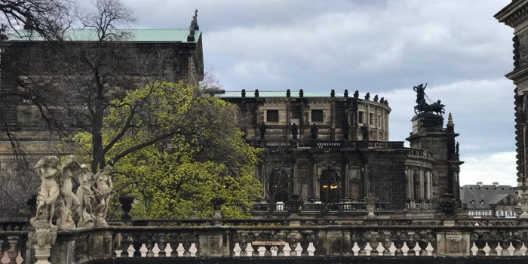

In the framework of the Erasmus+ teaching mobility, Professors Aida Bitri and Egla Mansi from the Business Administration department at Epoka University visited TU Dresden in Germany from the 2nd of April to the 7th of April 2023. The primary schedule consisted of meetings with professors, students, and administrative staff from the Business Informatics and Economics domain. They were part of the first workshop of an international course project activity on case study design, which was arranged by the two institutions and funded by the European Commission. Since, both universities have previously worked together on successful projects, and during this visit, they exchanged ideas and insights on teaching and research practices, perspectives on current research trends, and possible avenues for future collaboration. Additionally, visiting Dresden, a city with a rich history and cultural heritage, was an enriching experience for them.

## Projects

1. **Start-up Program and Competition in the framework of SUCCESS Erasmus+ Project**

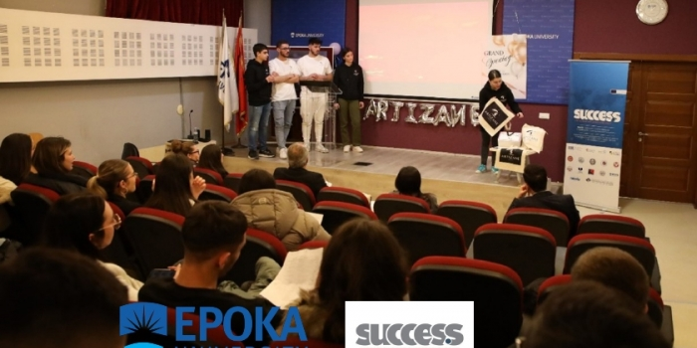

During January 31st and February 1st, 2023, EPOKA University in collaboration with the SUCCESS Erasmus+ CBHE Project organized the first phase of the “Success Arena Boot Camp Start Up Program and Competition” among the students of the BUS 103 Introduction to Business Course taught by Dr. Esmir Demaj.

Students from the BA Business Informatics study program were divided into 20 teams composed of 105 students in total, who worked for 2 months to prepare their business ideas. For 2 days students presented their start-up ideas to the jury and the audience. The jury assigned to evaluate the start-up projects was composed of Prof. Dr. Gungor Turan, Dr. Erinda Imeraj, Dr. Esmir Demaj and MSc. Mariola Muci. The jury selected 9 teams that will be further trained and will participate in the final phase of the competition within EPOKA.

The 2 winning teams will represent EPOKA University in the “Success Arena Boot Camp Start Up Program and Competition” in Sarajevo, Bosnia-Herzegovina during May 22-26, 2023, together with many other student teams from the Western Balkans region.

Rewards for the Winning Teams in the final pitch in Sarajevo include,

Paid 4 day trip to Sarajevo

Certificate for Bootcamp Participation

4000+ EUR reward

Opportunity to Pitch to Audience of Investors and Company Partners

Startup Study Visit for winning teams to one of the partner countries of the project

The Department of Business Administration congratulates students for their efforts and energy and wishes them good luck in Sarajevo!

## List of Students’ Internships

|  |  |  |  |  |  |
| --- | --- | --- | --- | --- | --- |
| **NO** | **Name Surname** | **Study Program** | **Professional Practice Period** | **Company** | **Department/ Office** |
|
| 1 | David Dushi | BINF | 1 month | 3-SH | Finance Office |
| 2 | Anxhela Elezi | BINF | 1.5 months | Alba Konstruksion | Finance Office |
| 3 | Adnand Hoxha | BINF | 2 months | ALOEN 2018 Shpk | CA Office |
| 4 | Belita Hysaj | BINF | 1.5 months | B-Tech | Business Office |
| 5 | Amandas Gaci | BINF | 1 month | ETM Tax | Tax Office |
| 6 | Anjeza Ndoci | BINF | 1.5 months | Fastech Shpk | Fastech Shpk |
| 7 | Borena Hoxhaj | BINF | 1 month | FPD Shpk | FPD Shpk |
| 8 | Altea Maloku | BINF | 1.5 months | Fusion BPO Services | IT Office |
| 9 | Ardit Saraseli | BINF | 1 month | Intesa SanPaolo Bank | Intesa SanPaolo Bank |
| 10 | Darli Cara | BINF | 1.5 months | Majn Pharma | Majn Pharma |
| 11 | Ana Maria Hysa | BINF | 1 month | Marketing & Distribution | Investment Office |
| 12 | Adela Spaho | BINF | 1 month | Ministry of Finance | Budget Office |
| 13 | Almira Ferraj | BUS | 1 month | Ministry of Finance | Finance Directory |
| 14 | Amber Tepshi | BINF | 2 months | One Telecommunication | One Telecommunication |
| 15 | Ania Keci | BINF | 3 months | Pragmatic Software | IT Office |
| 16 | Alen Ferko | BINF | 1.5 months | Premium Games Shpk | Development Office |
| 17 | Armena Ballo | BINF | 2.5 months | Raiffeisen Bank | Raiffeise Bank |
| 18 | Alesia Jamaku | BINF | 1 month | Rootless Entrepreneurs LLC | Rootless Entrepreneurs LLC |
| 19 | Amarda Jamaku | BINF | 1.5 months | Rootless Entrepreneurs LLC | Rootless Entrepreneurs LLC |
| 20 | Andri Peti | BINF | 3 months | SDA by Protik | IT Office |
| 21 | Alesia Lybeshari | BINF | 2.5 months | Shana Agency | Shana Agency |
| 22 | Elisabeta Kati | BINF | 1 month | Sidnej Shpk | Sidnej Shpk |
| 23 | Alesia Gjana | BINF | 1 month | Smart Tech Solution | Head Office |
| 24 | Aldi Hamati | BINF | 1 month | Smart Tech Solution | Head Office |
| 25 | Argjend Skeja | BINF | 2 months | Soft & Solution Shpk | Soft & Solution Shpk |
| 26 | Artea Shalja | BINF | 1 month | Studio Kontabiliteti ''Hyseni'' | Accounting Office |
| 27 | Adela Kondakciu | BINF | 1 month | Xpert Systems | Xpert Systems |
| 28 | Adela Kacorri | BINF | 1 month | Xpert Systems | IT Office |
| 29 | Armando Gjura | BINF | 1.5 months | Zyre Kontabiliteti Haxhillari | Zyre Kontabiliteti Haxhillari |
| 30 | Enea Shkurta | BINF | 1 month | Zyre Kontabiliteti Mila | Finance Office |
| 31 | Eno Myderizi | BINF | 1.5 months | ATC | Finance |
| 32 | Erjon Doga | BINF | 2.5 months | Ballenja sh.p.k | Finance |
| 33 | Ermonela Drici | BINF | 1 month | CFO Pharma | Finance |
| 34 | Deniz Daka | BINF | 2 months | CIS Agency | Application Development and security specialist |
| 35 | Emla Kurti | BINF | 1.5 months | Credins Bank | Personal Banker |
| 36 | Gerta Dukaj | BINF | 1.5 months | DATECH | Data Science |
| 37 | Eriselda Deda | BINF | 1 month | Digita | Web development |
| 38 | Gerald Myrta | BINF | 3.5 months | Drejtoria e Pergjitheshme e Objekteve Publike | Finance |
| 39 | Erdita Kumaraku | BINF | 1 month | Fondi Besa SH.A | Finance |
| 40 | Esmeraldo Hoxhallari | BINF | 1 month | Haki Sinani sh.p.k | Finance |
| 41 | Erjola Avdiaj | BINF | 1 month | HEKO Construction sh.p.k | Finance |
| 42 | Dennis Elmadhi | BINF | 1 month | Hexa sh.p.k | IT |
| 43 | Denald Selimi | BINF | 1 month | iKanbi | IT support specialist |
| 44 | Fiona Kaci | BINf | 1 month | Intermedia | Web development |
| 45 | Eden Pere | BINF | 1 month | Intesa Sanpaolo Bank | Application Development in banking |
| 46 | Eria Dhespollari | BINF | 1.5 months | Intesa Sanpaolo Bank | Network division |
| 47 | Favio Kushta | BINF | 1 month | Intesa Sanpaolo Bank | Finance |
| 48 | Gridi Kasemi | BINF | 1 month | Orion Gjeci | IT |
| 49 | Dea Rucaj | BINF | 1 month | OSHE Group sh.a | IT |
| 50 | Elda Hysa | BINF | 1 month | OTP Bank Albania | Retal Risk |
| 51 | Fabio Allmeta | BINF | 1 month | Reve distibution sh.p.k | Finance |
| 52 | Greta Cerloj | BINF | 1 month | SALUS | IT |
| 53 | Frenkli Bajrami | BINF | 1 month | Serfin | IT |
| 54 | Glen Liperi | BINF | 1 month | Shoq Rajonale UK Durres | IT |
| 55 | Eleni Buzra | BINF | 1 month | Soft and Solution | IT |
| 56 | Eranda Baho | BINF | 1 month | Zyre kontabiliteti Kapo Rraku | Finance |
| 57 | Xhoslin Agovi | BINF | 3 months | 7th Block Technology Comunications | IT Office |
| 58 | Marsela Horeshka | BINF | 2 months | Arian - A | Finance Department |
| 59 | Rei Kalo | BINF | 3 months | Baskia Tiranë | DZHG Office |
| 60 | Resia Suvejda Kili? | BINF | 2 months | BKT | IADD Office |
| 61 | Minella Bishka | BINF | 1 month | Cristal Consulting | Accounting Office |
| 62 | Rindi Daja | BINF | 3 months | Deloitte | IT Office |
| 63 | Sonia Osmani | BINF | 1 month | Dominusoft | IT Office |
| 64 | Megi Spahiu | BINF | 2 months | Dynamics Conlting SHPK | Finance Office |
| 65 | Megi Lluca | BINF | 2 months | Elite Travel Group | IT Office |
| 66 | Maria Hazizaj | BINF | 1 month | Evolutilt | IT Office |
| 67 | Sergei Toluli | BINF | 2 months | Fastech | Programming Office |
| 68 | Oksana Kadriu | BINF | 2 months | GEO sh.p.k | Accounting Department |
| 69 | Redi Nikolli | BINF | 2 months | Green Recycling Sh.p.k | Finance Office |
| 70 | Xhoi Klosi | BINF | 2 months | Green Recycling Sh.p.k | Finance Office |
| 71 | Orgest Tahiri | BINF | 3 months | Impact Education | IT Office |
| 72 | Sabian Zhupa | BINF | 3 months | Impact Education | IT Office |
| 73 | Sued Jasimi | BINF | 1 month | Infosoft Software Developer | ISD Office |
| 74 | Sajmir Leka | BINF | 1 month | Intermedia shpk | Marketing and Programming Office |
| 75 | Ortencia La?i | BINF | 1 month | Lulja Shpk | Finance Office |
| 76 | Renis Garxenaj | BINF | 1 month | Power Color Shpk | Finance Office |
| 77 | Rugers Beci | BINF | 1 months | Raiffeisen Bank | IT Office |
| 78 | Vangjel Dhima | BINF | 1 month | Rolant Tito | Finance Office |
| 79 | Rei Dibra | BINF | 1 month | Smart Deal Electronics | Econimics Office |
| 80 | Sofia Treska | BINF | 2 months | Softics Data Science | IT Office |
| 81 | Ueda Shehu | BINF | 2 months | Solturo | IT Office |
| 82 | Reina Hoxhaj | BINF | 2 months | TRAJF | IT Office |
| 83 | Xhesi Qordja | BINF | 3 months | Trimark BPO | IT Office |
| 84 | Megi Lala | BINF | 2 months | Undo Studios AL Shpk | Developers Department |
| 85 | Viktoria Peshku | BINF | 2 months | Union Bank ShA | Finance Office |
| 86 | Jona Mehmeti | BINF | 2 months | ACC Tirana Sh.p.k | ACC Tirana Sh.p.k/ IT |
| 87 | Jorges Bardho | BINF | 1 month | AGNA SH.A | AGNA SH.A/ Finance Office |
| 88 | Klejdi Braho | BINF | 1 month | ALBITALCANON, shpk | ALBITALCANON, shpk/ IT |
| 89 | Livia Kadisi | BINF | 1 month | Balance Albania | Balance Albania/Administrative office |
| 89 | Ledia Aga | BINF | 3 months | Bashkia Tiranë | Bashkia Tiranë/ Drejtoria e Zhvillimit dhe GIS |
| 90 | Klea Merko | BINF | 3 months | Bashkia Tiranë | Bashkia Tiranë/ Drejtoria e Zhvillimit dhe GIS |
| 91 | Klea Luka | BINF | 1 month | DEXI AL | DEXI AL/IT Support |
| 92 | Katia Haveri | BINF | 1 month | Dominusoft | Dominusoft/Programming |
| 93 | Klaudia Rapaj | BINF | 1 month | Dominusoft | Dominusoft/Programming |
| 94 | Andrea Mano | BINF | 1 month | Drejtoria Rajonale Tatimore | Drejtoria Rajonale Tatimore/Tax Collection department |
| 95 | Kleard Jaupi | BINF | 1 month | Edemeli Sh.p.k | Edemeli Sh.p.k/IT office |
| 96 | Klarisa Gjoka | BINF | 2 months | Enor Technologies sh.p.k | Enor Technologies sh.p.k/ Developing |
| 97 | Kristiana Stefa | BINF | 4 months | Epoka University | Epoka University/BUS department |
| 98 | Kejsi Latifi | BINF | 2 months | Euro-Latifi sh.p.k | Euro-Latifi sh.p.k/ IT supprt |
| 99 | Igli Mura | BINF | 1 month | Hotel Termal | Hotel Termal/IT |
| 100 | Klea Laro | BINF | 1 month | Instituti Shqiptar I Shkencave | Instituti Shqiptar I Shkencave/Data Entry/IT |
| 101 | Klaiv Domi | BINF | 1 month | IXHEM parafabrikat | IXHEM parafabrikat/Finance |
| 102 | Irsi Hida | BINF | 3 months | Kreatx Sh.p.k | Kreatx Sh.p.k/ Programming |
| 103 | Heidi Llagami | BINF | 4 months | Ministry of Health and Social Protection | Ministry of Health and Social Protection/Project and Innovation |
| 104 | Kristjan Hadëri | BINF | 1 month | Postjer LTD | Postjer LTD/Programming |
| 105 | Ilirjana Didani | BINF | 1 month | Pragmatic Software | Pragmatic Software/Developing |
| 106 | Krisa Zhanasi | BINF | 1 month | Raiffeisen Bank | Raiffeisen Bank/Internship program |
| 107 | Kejsi Bushi | BINF | 2 months | Raiffeisen Bank | Raiffeisen Bank/Internship program |
| 108 | Idi Xhengo | BINF | 1 month | Raiffeisen Bank | Raiffeisen Bank/Internship program |
| 109 | Majk Bllako | BINF | 1 month | Reve Distribution sh.p.k | Reve Disribution sh.p.k/ Finance and IT department |
| 110 | Kejti Vakëflli | BINF | 1 month | SFC ALB | SFC ALB/Operations Management and Software Application |
| 112 | Julia Bogdani | BINF | 1 month | SFC ALB | SFC ALB/Operations Management and Software Application |
| 113 | Klea Lala | BINF | 3 months | Shega-Trans sh.A | Shega-Trans sh.A/ IT |
| 114 | Ledio Zyla | BINF | 1 month | T Connect | T Connect/ IT support |
| 115 | Iljad Juakj | BINF | 1 month | Technosoft | Technosoft/Java Developer/IT |
| 116 | Jonas Figu | BINF | 1 month | We Web sh.p.k | We Web sh.p.k/Programming |
| 117 | Griselda Ramadani | BINF | 2 months | Xpert systems | Xpert systems/ IT |
| 118 | Rovena Berhami | IML | 1 month | A&A International Logistic | Marketing |
| 119 | Sadrit Xhemalaj | BINF | 1 month | ANSI | Marketing |
| 120 | Ani Ishmaku | IML | 1 month | Atlas Mills | Marketing |
| 121 | Altea Sema | IML | 1 month | Autoriteti Portual Durres | Communications |
| 122 | Meri Spiro | IML | 1 month | Autoriteti Portual Durres | Communications |
| 123 | Adi Sulaj | IML | 1 month | AV Consulting | Finance |
| 124 | Luis Cenolli | IML | 1 month | Billi Al | Marketing |
| 125 | Erisa Shehu | IML | 1 month | Bojra Neon | Marketing |
| 126 | Anxhela Stavro | IML | 1.5 months | Digital Marketing Innovation | Digital Marketing |
| 127 | Era Gashi | IML | 1 month | EasyPay SHPK | Operations management |
| 128 | Barsi Bode | IML | 1 month | Edarb SHPK | Marketing |
| 129 | Ira Manuka | BINF | 1 month | Electronic Solutions | Marketing |
| 130 | Meraldo Zeneli | IML | 3 months | Fatmir Zeneli | Marketing |
| 131 | Ksenia Xhamo | IML | 2.5 months | Gama V SHPK | Marketing |
| 132 | Elif Tusha | IML | 1 month | Get Travel | Marketing |
| 133 | Eni Balla | IML | 1.5 months | Global Commerce Media | Digital Marketing |
| 134 | Elga Hoxha | IML | 2.5 months | Hysa Group SHPK | Marketing |
| 135 | Kristjana Bici | IML | 1 month | Joena 2 SHPK | Accounting |
| 136 | Andi Lala | IML | 1 month | Klinika Dentare "Manjani Dental" | Marketing |
| 137 | Midian Çaushllari | BINF | 3 months | New media digital | Marketing |
| 138 | Desara Mustafa | IML | 1 month | Novus Marketing & Advertising | Marketing |
| 139 | Kleida Kraja | IML | 1 month | Sinteza | Digital Marketing |
| 140 | Irsa Ago | IML | 1.5 months | TOK Digital Agency SHPK | Marketing |
| 141 | Klaudija Ndreu | IML | 2.5 months | Tradita Popullore | Marketing |
| 142 | Anastasia Maria Zoto | IML | 1.5 months | Zita SHPK | Marketing |
| 143 | Beha Koçishta | IML | 1 month | Zita SHPK | Marketing |
| 144 | Klevis Piciri | BUS | 2.5 months | Adra Albania | Project management |
| 145 | Ardit Disha | BUS | 1 month | Albuji SH.P.K | Management |
| 146 | Ardian Sheta | BUS | 1.5 months | Andi-2M SH.P.K | Administrative |
| 147 | Kiara Kokomani | BUS | 1 month | Argjendari "Miluna" | Administrative |
| 148 | Fjona Pëllumbi | BUS | 1.5 months | Arifaj SH.P.K | Management |
| 149 | Kejda Zaka | BUS | 1 month | Aroma jote | Sales |
| 150 | Arlina Duxha | BUS | 1 month | AT&C Company | Accounting |
| 151 | Bashkim Burimi | BUS | 1 month | Belavis SH.P.K | Management |
| 152 | Erind Krasniqi | BUS | 1 month | Blaed Trade | Sales |
| 153 | Nadire Bullari | BUS | 1 month | Bullari 08 SH.P.K | Finance |
| 154 | Aurel Çeta | BUS | 1.5 months | BUSA SH.P.K | Administrative |
| 155 | Sara Cami | BUS | 1 month | Confort SH.P.K | Accounting |
| 156 | Bersida Dedja | BUS | 1 month | Hotel Mamica | Management |
| 157 | Eder Dardha | BUS | 1 month | Implant EX SH.P.K | Economist |
| 158 | Laura Mehmeti | BUS | 1 month | MEBA96 | Administrative |
| 159 | Megi Saliaj | BUS | 1 month | Mercatus Group | Recruitment/HR |
| 160 | Savina Çelaj | BUS | 1 month | Mercatus Group | Recruitment/HR |
| 161 | Sindi Spahiu | BUS | 1 month | Mercatus Group | Recruitment/HR |
| 162 | Efa Cami | BUS | 2.5 months | Orthonet 360 SH.P.K | Administrative |
| 163 | Desara Çomo | BUS | 1 month | OUEN SH.P.K | Accounting |
| 164 | Ariadni Harri | BUS | 1 month | Raiffeisen Bank SH.A | Sales |
| 165 | Dea Kanina | BUS | 1.5 months | Rikupero Al SH.P.K | Marketing |
| 166 | Kejsi Telhaj | BUS | 1 month | SFC ALB SH.P.K | Customer Service |
| 167 | Eneida Shehu | BUS | 1 month | Shehu 2006 SH.P.K | Finance |
| 168 | Kamelia Shaba | BUS | 1 month | Shtepia e luleve "Kamelija" | Finance |
| 169 | Eni Devole | BUS | 1 month | SIGMA Interalbanian Vienna Insurance Group | Sales |
| 170 | Kristi Male | BUS | 1 month | Soal SH.P.K | Finance |

## Participation in Academic Events

**Design Thinking for Leading and Learning**

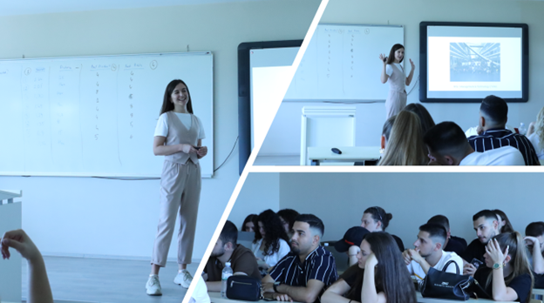

On May 29th, Ms. Kei Hysi, design thinking coach and our university graduate, was invited as a guest speaker to the course of ‘Entrepreneurial Management’ lectured by Assoc. Prof. Dr. Alba Kruja.

Ms. Hysi has been engaged for a long period with design thinking for start-ups and talked to our students about her international experience in the USA and Europe. Moreover Ms. Kei provided our students’ tips on how on how to design their life and shared with them learnings from her journey of graduate studies at Stanford design classes.

We are thankful to Ms. Kei for motivating our students through her insightful lecture and look forward to our future cooperations.

**Open Lecture: Insights for Young Entrepreneurs**

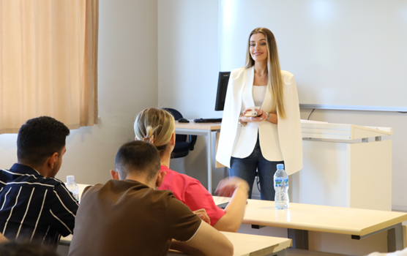

On May 22nd, Ms. Anisa Berisha, business consultant and our university graduate, was invited as a guest speaker to the course of ‘Entrepreneurial Management’ lectured by Assoc. Prof. Dr. Alba Kruja.

Ms. Anisa has been engaged for a long period with start-ups growth and their interaction with the entrepreneurial ecosystem, so she discussed with the students about the entrepreneurial ecosystem in Albania, their opportunities for new initiatives as independent alternatives of 9 to 5 job.

Moreover Ms. Anisa shared with students her insights on the importance of developing among other entrepreneurial skills the networking and pitching skills, and the various opportunities offered by start-up support donors in Albania.

We are thankful to Ms. Anisa for motivating our students through her insightful lecture and look forward to our future cooperations.

**Site Visit at the Museum of the Central Bank of Albania**

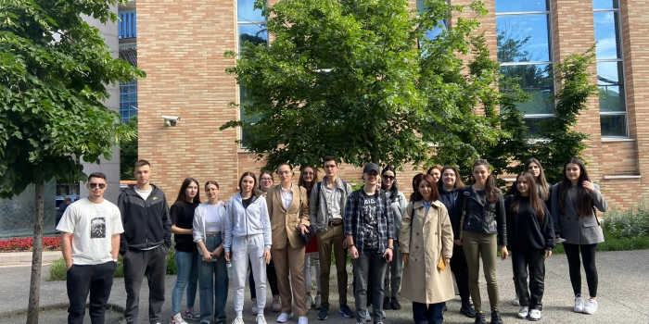

Students of Banking and Finance, Business Administration and Business Informatics had the opportunity to visit the Museum of the Central Bank of Albania on May 18th and 24th. This visit was organized by Professor Nargiza Alymkulova and teaching assistant Eliona Hoxhalli as part of the Macroeconomics course. During their visit, students learned about the different currencies used in Albanian territories and about the history of the Central Bank of Albania.

**Guest Lecturer - Mr. Klaus Coku**

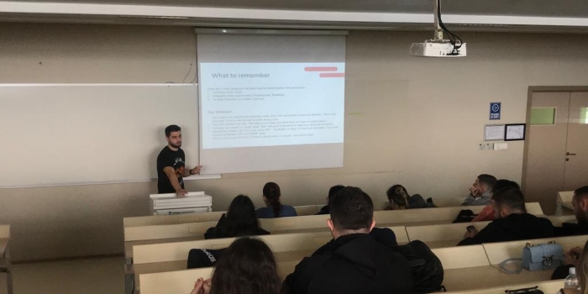

On May 16th, Klaus Coku, a software engineer at Raiffeisen Bank, was invited during the Software Engineering course, to deliver a lecture on Automated Software Testing.

During this lecture, students were introduced to the notion of automated testing, the testing pyramid, and the main tools used for test automation.

Furthermore, students were introduced to business practices, tools, and approaches businesses (in this case, Raiffeisen Bank) use to deliver effective software testing.

We thank Klaus for this insightful lecture and look forward to our future cooperation.

**Open Lecture-Mrs. Irida Kovi**

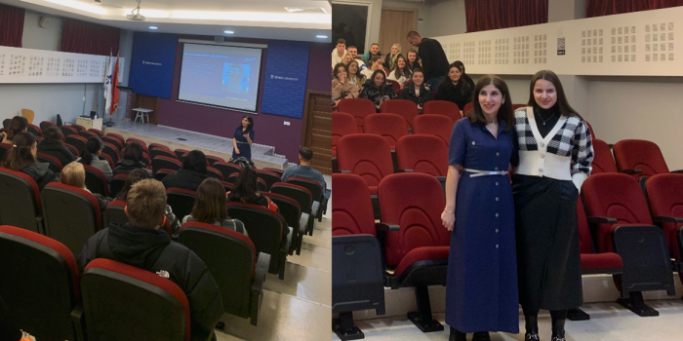Assistant Lecturer Ms. Mariola Muci organized on January 17-th an open lecture with Mrs. Irida Kovi, Human Resources Manager of British American Tobacco Albania, Kosovo & North Macedonia.

The topic of the open lecture was “HR Management in Organizations”.

The lecture set out to outline recruitment and selection processes, performance management and employee relations. Career opportunities and recruitment tips were offered to IML and BAFAL students by British American Tobacco which included Global Graduate Program and Battle of Minds 2023 competition.

**Open Lecture - BUS 205 Principles of Marketing course**

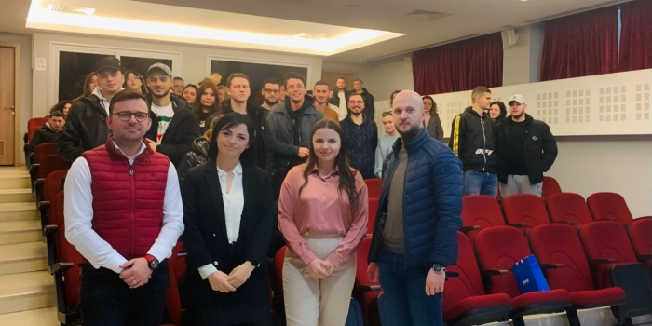

On December 22-nd, Assistant Lecturer Ms. Mariola Muci organized an open lecture activity in the BUS 205 Principles of Marketing course.

In this event was invited the Marketing Director of CCBS, Ms Blerina Rudi (Kerthi). Ms. Kerthi shared with the students her extensive experience in Marketing by focusing on the topic: “Introduction to Shelf-Savvy POP: Turning shoppers into buyers through effective and engaging messaging”.

Furthermore, Mr Erind Gjoni and Mr Brunaldo Bani, Brand Managers at Coca Cola engaged students in a research market analysis for Tepelena Water rebranding process. Many thanks go to the Coca Cola team for their fruitful collaboration,

We are looking forward to welcoming you again at Epoka University.

**International course activity for the students of MSc Business Administration**

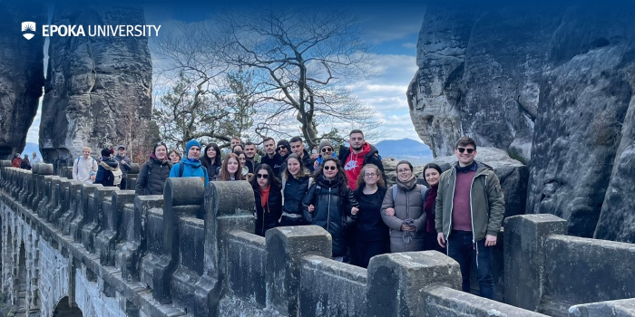

Fourteen students from the BUS 426 Strategic Management course of the MSc Business Administration study program visited TU Dresden, Germany, for the kick-off of an international course project activity on case study design arranged by the two institutions and funded by the European Commission.

This 2-month project is organized in a hybrid way,

Kick-off and 1st workshop in Germany @ TU Dresden was held from April 03 to April 08, 2023 (EPOKA students were hosted for one week at TUD).

Virtual collaboration in groups via MS Teams (asynchronously/virtually) from April 10 - June 02, 2023.

Final workshop and Case Presentations in Albania @ EPOKA University from June 05 to June 09 (TUD students will be hosted for one week at EPOKA)

The goal of this project is to have students from different backgrounds come together with their distinctive competencies and Design and Solve a Business Case study on a specific topic related to the Albanian/German market/industry context, adaptable for Virtual Collaborative Learning modules.

EPOKA students are supervised by Dr. Esmir Demaj, lecturer of the Strategic Management course, and their engagement load and credits for this activity are to be earned and allocated for the said course.

The 1-week visit to TU Dresden was an unforgettable experience for our 14 students. They were part of an international team working on this exciting project that challenged their skills and expanded their knowledge. They collaborated with students from different study backgrounds and cultures, learning from each other's perspectives and approaches. The project was intellectually stimulating and helped them improve their teamwork and communication skills.

Apart from the project work, they had plenty of opportunities for fun and exploration. Dresden is a beautiful city with a rich history and cultural heritage. They had a guided tour of the city, visiting its famous landmarks such as the Frauenkirche, Zwinger Palace, and Semperoper. They also explored the city's vibrant art scene, enjoyed local cuisine, and participated in various cultural events. As nature lovers, they went hiking in the nearby Bastei, Saxon Switzerland, which offered breathtaking countryside views.

As students state, "This week in TU Dresden was a fantastic way to broaden our horizons, make new friends, and gain valuable experience that will benefit us both personally and professionally. We worked on an exciting project with an international team, explored the city's cultural offerings, and enjoyed the natural beauty of the surrounding countryside. It was an adventure of a lifetime that we will always cherish".

We look forward to hosting TU Dresden students for one week at EPOKA during June 05-08, 2023, and going through the well-prepared Case Scenarios the groups will have to showcase.This project arrangement will continue for three years in the context of the inter-institutional Exchange Agreement funded by the European Commission.

## Student Best Success Stories

**Mr. Besjon Zenelaj Successfully Passed his PhD Dissertation Defense**

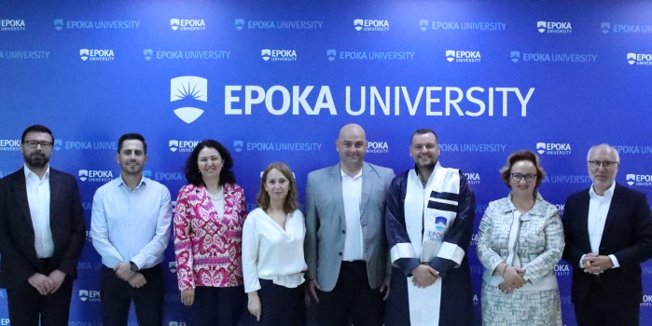Mr. Besjon Zenelaj from the Department of Business Administration successfully passed his PhD Dissertation Defense on September 26, 2023. His thesis, entitled "Brand Value Co-Creation and Brand Co-Evaluation: A Case Study from the Albanian Textile Industry," was supervised by Assoc. Prof. Dr. Mirdaim Axhami, and his defense took place in front of a diverse five-person jury, comprising distinguished Professors including Prof. Dr. Waldemar Pfoertsch from EPOKA University, Assoc. Prof. Dr. Manuela Mece from Albanian University, Prof. Dr. Klodiana Gorica from the Faculty of Economics at the University of Tirana, Prof. Dr. Kreshnik Bello from the European University of Tirana, and Prof. Dr. Osman Koroglu from EPOKA University.

The Department of Business Administration extends its heartfelt congratulations to Dr. Besjon Zenelaj. This accomplishment not only marks a personal milestone achievement but also signifies his contribution to the teaching and learning process of our department. As Dr. Zenelaj embarks on the next phase of his scholarly journey, EPOKA University wishes for his continued dedication and impact to the realm of academia.

**EPOKA students excel at SUCCESS Startup Competition and Demo Day 2023**

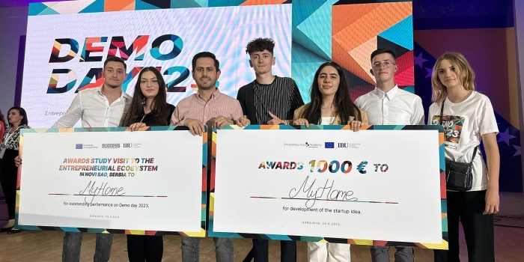

The SUCCESS Startup Competition and Demo Day were held at International Burch, University in Sarajevo, Bosnia & Hercegovina during May 21-26, 2023.

EPOKA University was represented by two student teams from the BA BINF study program of the Department of Business Administration, Trulo (Rigers Budlla, Drina Skënderi, Marvi Hoxha) and MyHome (Griselda Rexhmati, Erina Vladi, Sidita Dushaj, Valerian Dedaj) accompanied by their professor Dr. Esmir Demaj.

During the first two days of this international event, 20 competing student teams from 8 different universities from Albania, Bosnia and Herzegovina, and Montenegro showcased a diverse range of innovative ideas and solutions that could shape the future of the business landscape. They presented their ideas in the so-called SUCCESS Boot Camp in front of panels of mentors from 5 different categories: Problem/Opportunity; Customer/Marketing; Business Model/Finances; Technology; and Operations. Experts/mentors in these areas graded the teams and gave them advice and tips so that teams could work on improvements and get back on the second day with the final pitch.

Ten student startup teams were selected to present themselves and their innovative business ideas to potential investors at the Demo Day event on the 25th, 2023 at 18:00. Both EPOKA Teams Trulo and MyHome performed very well by ranking in the top 3 teams and thus making it to the Demo Day big final to pitch their startup ideas to potential business investors. The Demo Day was a big event with many participants from different fields and countries, including investors, business owners, academics, and students.

Again, EPOKA teams performed very well by getting the audience's attention for the interesting ideas and excellent pitch. At the end of the Demo Day, the MyHome team received two prizes consisting of 1000 Euros and a study trip to the University of Novi Sad as support to develop the startup idea further. You can follow the Demo Day gala show here (https://www.youtube.com/watch?v=CF4lwwAFNkQ).

Congratulations to both student teams and their professors. EPOKA University takes pride in the achievements of its bright students and will continue supporting them to excel in various fields of their life.

## Office Holders

The department would like to thank the following for their valuable contribution to teaching, administration and management over the past year:

-          Academic staff

-          Administrative staff

-          Students

-          CPAO

-          Finance Office

-          Rectors Office

-          Events’ Organizers and Participants

-          All other units of Epoka University

## Acknowledgements

In addition to the Office Holders listed above, the department would like to thank all the department academic and administrative staff for their valuable contribution through the academic year.

**Department of Business Administration**

Epoka University

Rr. Tirane- Rinas, Km. 12 , 1039, Tirane/Albania

Phone: +355 4 2232 086

Fax: +355 4 2222 117

Email: [info@epoka.edu.al](mailto:info@epoka.edu.al)